**Rabobank Customer Statement Processor**

Project – Folder Structure with Test case and Build success

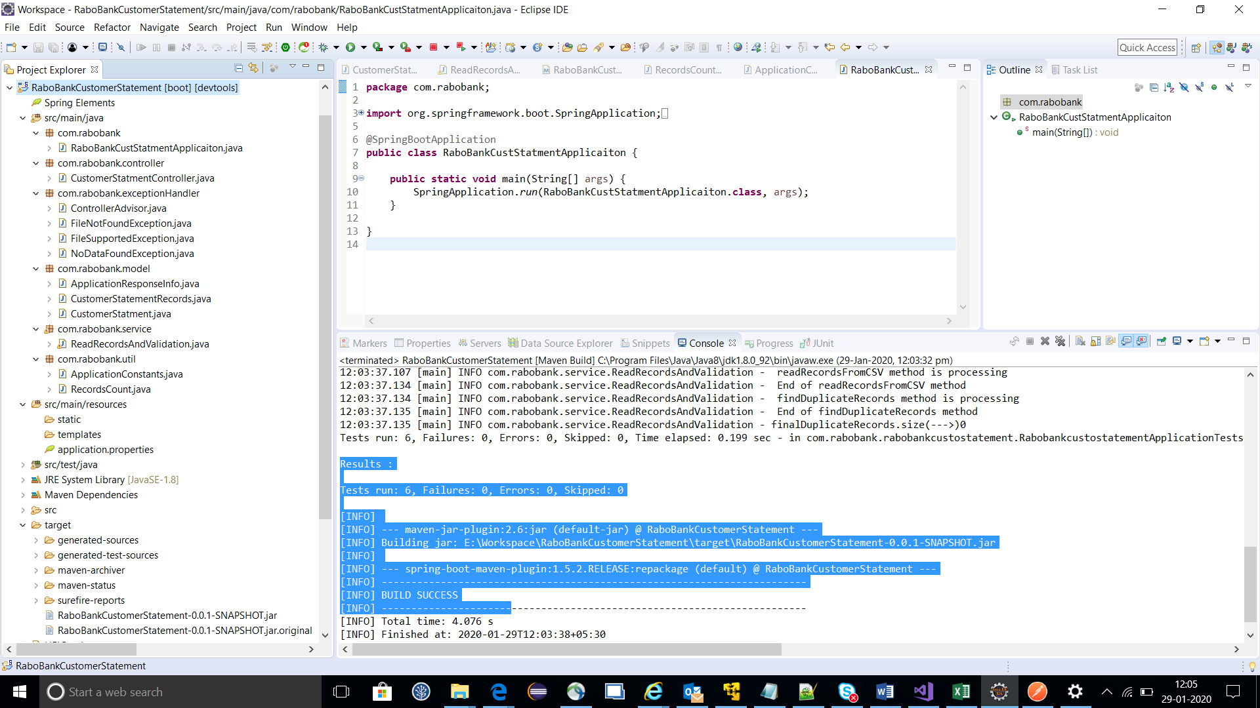

Start-up the Rabobankcustomerstatment application with port 8081

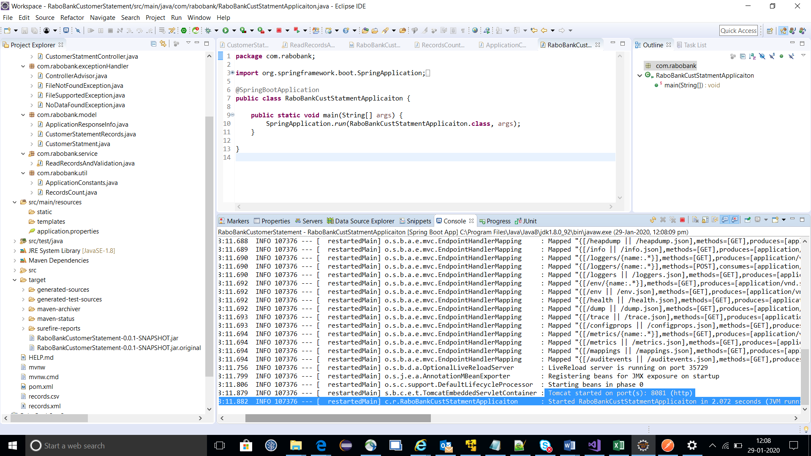

Test Results :

<http://localhost:8081/rabobank/> or http://localhost:8081/rabobank

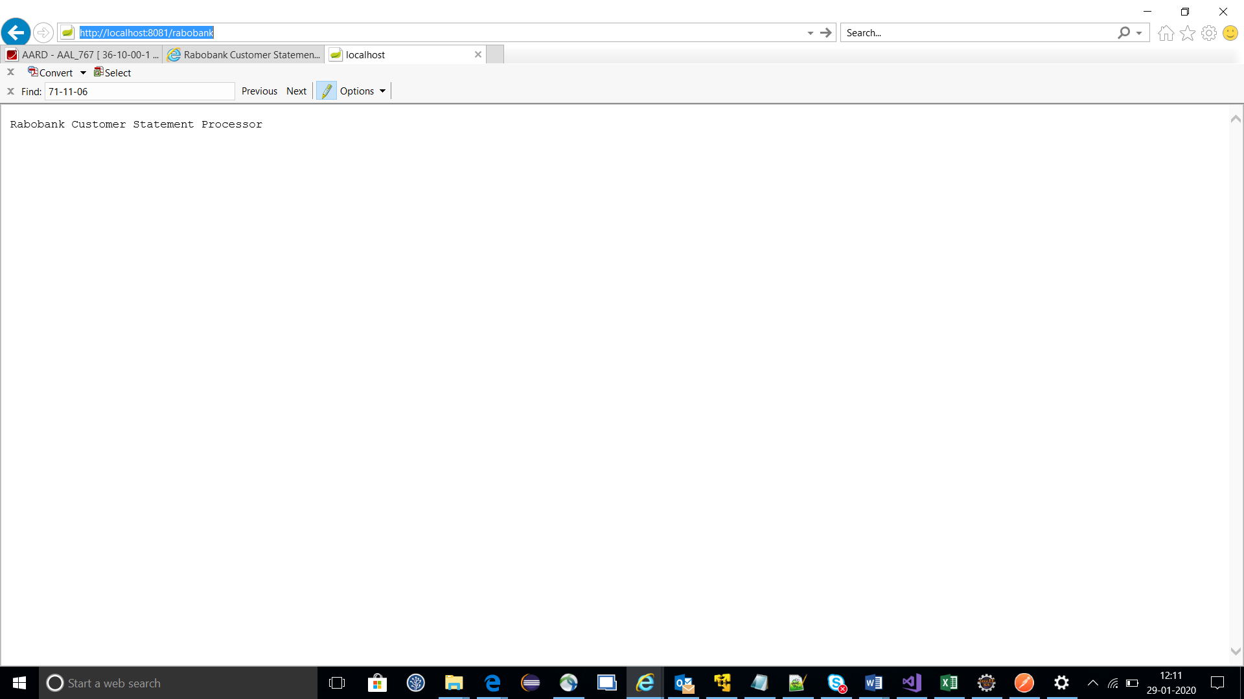

Testing for rest endpoint – Postman tool

Endpoint : <http://localhost:8081/rabobank/customerStatment>

Input is not given

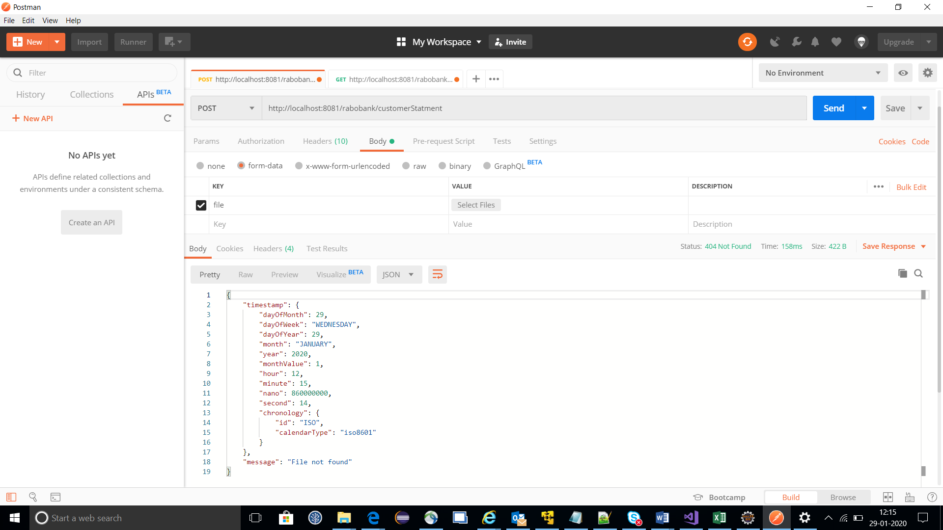

Data not found – empty file

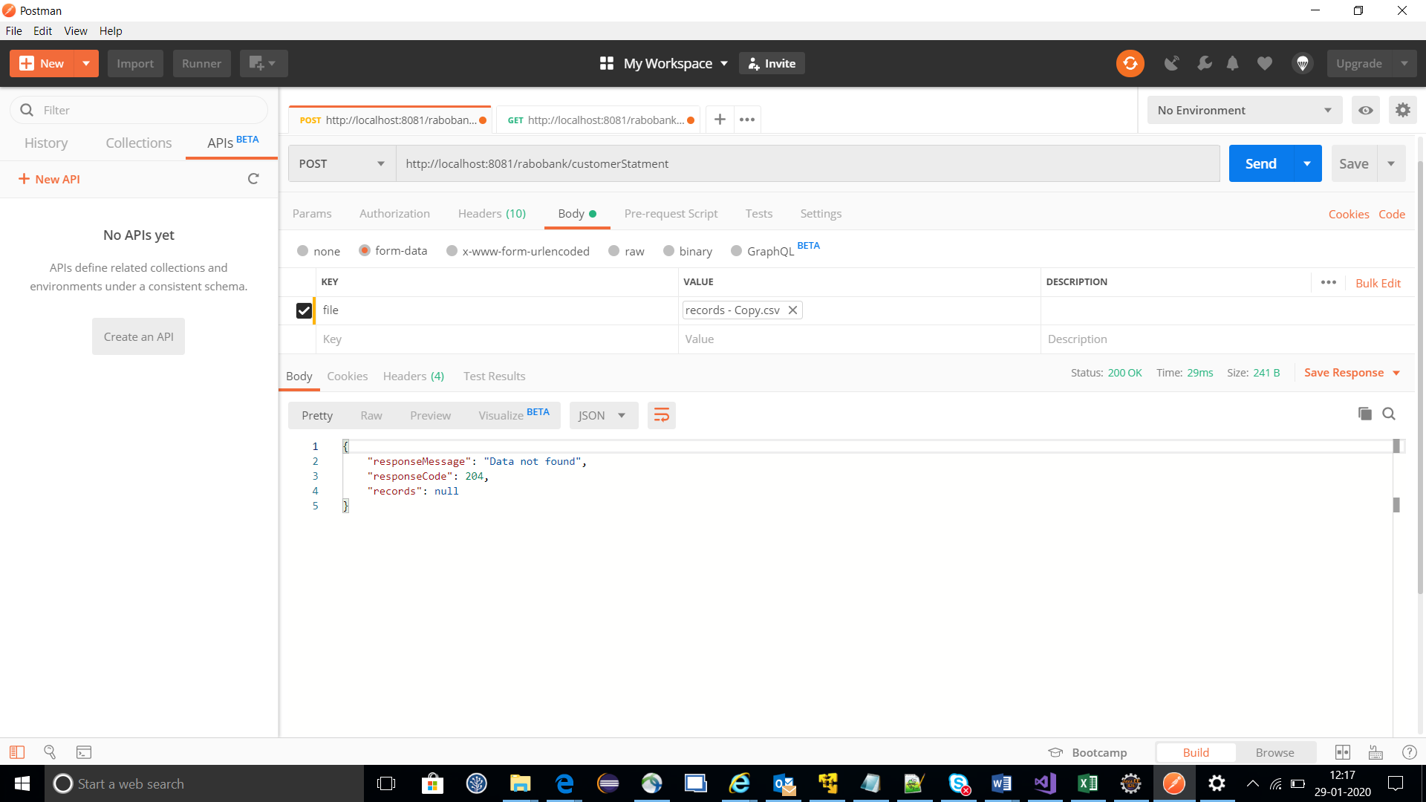

Unsupported file format ( only allowed now either CSV or XML)

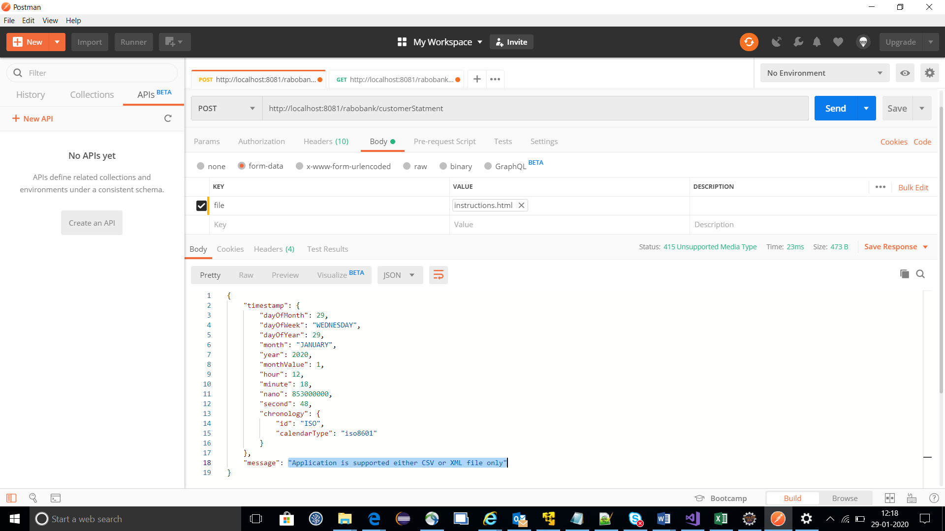

Right CSV file with data and return failure records based on validation of given assignment.

File input: Records.csv

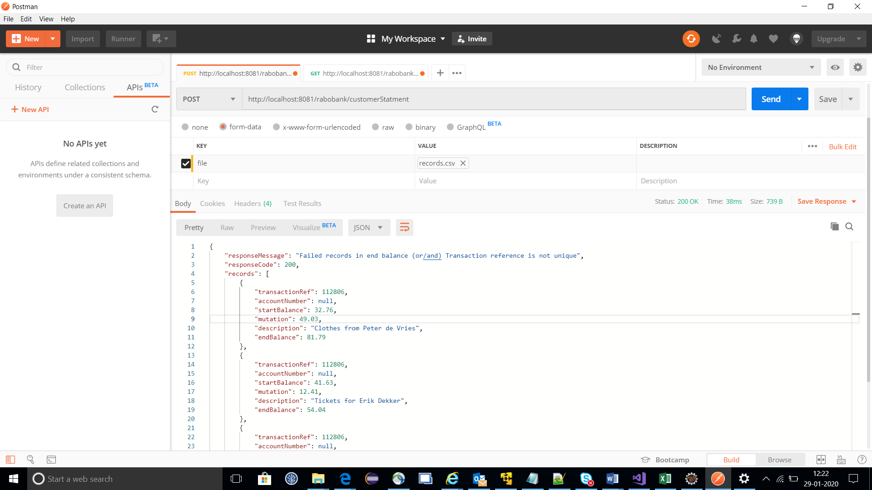

Right XML file with data and return failure records based on validation of given assignment.

File input : records.xml

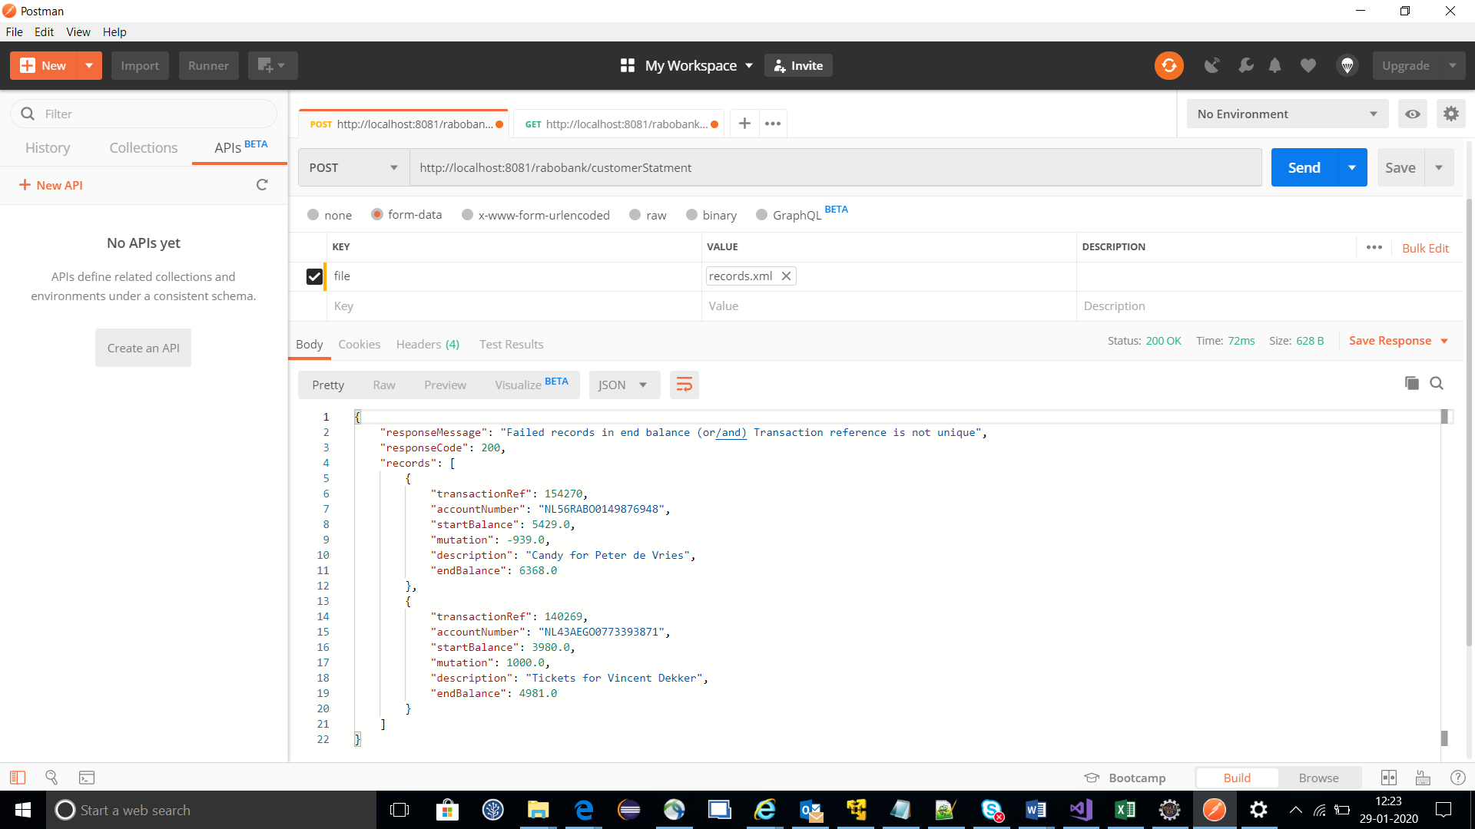

Logging in application:

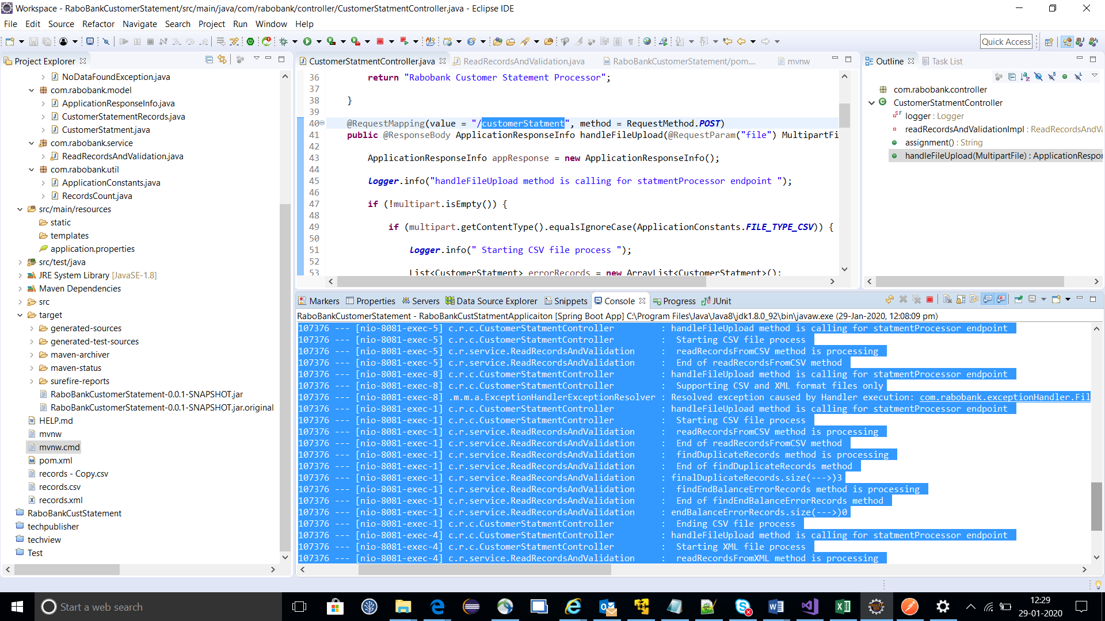

Running in command prompt using application Jar.

E:\>java -jar RaboBankCustomerStatement-0.0.1-SNAPSHOT.jar

And copy recoreds.xml,records.csv files copy to same location if you want test.

