Adaptive time/space sharing with SCOJO
Angela C. Sodan*
School of Computer Science
University of Windsor, Ontario N9B 3P4, Canada
E-mail: acsodan@cs.uwindsor.ca
*Corresponding author
Xuemin Huang
School of Computer Science
University of Windsor, Ontario N9B 3P4, Canada
E-mail: xueminh@hotmail.com
Abstract: Time-shared execution of parallel jobs via gang scheduling is known to yield better average response times than mere space sharing because providing more flexibility in CPU/node allocation via multiple virtual machines. However, gang scheduling increases the memory pressure and still involves the problem of fragmentation. We incorporate adaptive CPU/node-resource allocation into gang scheduling to consider varying system load and to reduce fragmentation. As main innovations, our approach is appropriate for clusters, provides a clear model when and how to adapt, and considers realistic job mixes with many moldable, some malleable and some rigid jobs. We demonstrate via a simulation study that average response times and average slowdowns are decreased by our adaptive SCOJO approach, even with a lower multiprogramming level than standard gang scheduling uses best. These benefits apply though the tested realistic job mixes limit the flexibility in resource allocation.
Keywords: job scheduling for parallel systems, adaptive resource allocation, system-load adaptation, fragmentation reduction
Reference to this paper should be made as follows: Sodan, A.C., and Huang, X. (2006) ‘Adaptive time/space sharing with SCOJO’, Int. J. High Performance Computing and Networking, Vol. ……….
Biographical notes: A. C. Sodan is an Associate Professor at the University of Windsor in Canada. She received her doctoral degree from the Technical University of Berlin in Germany. Her currrent research interests are job scheduling, grid scheduling, and middleware for clusters and grids, including adaptive resource allocation and time-shared execution of parallel jobs.
X. Huang received his Master degree from the University of Windsor in Winter 2004 and is currently working for FedEx in Toronto, Canada. His interest is higher-level systems software for parallel machines, including job scheduling.

- Introduction
Most job-scheduling approaches for parallel machines apply space sharing which means allocating CPUs/nodes to jobs in a dedicated manner. Still several jobs can run at the same time, each with a subset of the nodes. Some approaches apply time sharing (or better to say a combination of time and space sharing), i.e. use multiple time slices. Typically this is done via so-called gang scheduling with the time slices being synchronized over all nodes. This yields multiple virtual machines; and space sharing is applied to each virtual machine. Examples of gang-scheduling systems are SHARE (Franke et al., 1996), GangLL (Franke et al., 1999), and SCore-D (Hori et al, 1998). Time-shared execution via gang scheduling is shown in several studies to provide better response times and higher machine utilization than mere space sharing because the multiple virtual machines offer more flexibility and a higher probabilistic chance to get the jobs scheduled quickly (Feitelson, 1997; Franke et al., 1999; Moreira et al., 1998; Wong et al., 2000). A multiprogramming level of 5 (which means 5 time slices) was shown to provide almost as good results as can be obtained with infinite numbers of levels (Moreira et al., 1998). However, gang scheduling involves overhead (in many approaches, in the range of 10%) because of process switches, and gang scheduling increases the memory pressure. The latter is due to the fact that all jobs allocated for execution should stay in memory in order to enable fast context switches and that the jobs, then, need to share the available memory. The higher the multiprogramming level, the more critical becomes the memory pressure. Furthermore, gang scheduling leaves potential for better utilization: it is typically still not possible to pack jobs into the system with a perfect fit but there remains fragmentation.
Adaptive CPU/node-resource allocation can help to overcome these problems. The standard resource-allocation approach uses static job sizes, i.e. jobs are rigid and request a certain number of CPUs/nodes to run. Adaptive resource application means that the number of resources can be decided dynamically by the system. However, adaptive allocation requires the jobs to be adaptable to this dynamic resource allocation. Two options exist: that the jobs are moldable, i.e. the resource allocation can be decided once at job startup, or that the jobs are malleable, i.e. the resource allocation can also be changed during the job’s execution. Adaptation can be used 1) to reduce fragmentation by adjusting the jobs’ sizes to better fit into the available space and 2) to adapt to varying system load by reducing sizes if the system load is high and increasing sizes if the system load is low. Especially the latter kind of adaptation provides the prospect of needing fewer time slices to provide good response times and high utilization.
There exists little work on a combination of adaptation with gang scheduling. The work by Corbalan et al. (2001) proposes such an approach, mainly having the goal to reduce time-sharing overhead but missing a clear decision basis/model for the multiprogramming level. Furthermore, this work is for a DSM machine and, therefore, the adaptation cost is low. In addition, all jobs are considered to be malleable as does all other work considering malleable jobs. However, this is not realistic. Malleability requires a special formulation of the program because the work to be performed per node is dynamically changing—thus, we cannot expect every job to be malleable. However, moldability is easier to accomplish because often programs initialize themselves according to the size with which they are invoked anyway: a survey conducted among supercomputing-center users (Cirne and Berman, 2003) found that most jobs (98%) were moldable, i.e. able to configure themselves as needed at startup time. The figure, however, sounds a bit too optimistic—if users say that they can submit jobs as moldable, it does not necessarily mean that, in practice, they would do so and that applications would be moldable in such a high percentage of cases. Furthermore, there exist, so far, results from a single study only. Thus, we apply a more conservative view that we perceive to be more realistic: namely, that most jobs are moldable, many jobs are malleable, and some jobs are rigid; we also test for comparison exclusively moldable and exclusively malleable mixes of jobs.
Adaptation in combination with gang scheduling provides the additional prospect of reducing the memory pressure by needing a lower multiprogramming level to perform well.
According to the above discussion, we have the following goals for our own approach:
- employ gang scheduling
- adapt to varying system load
- reduce fragmentation
- reduce the multiprogramming level needed to obtain good results and, therefore, the memory pressure
- employ realistic job mixes
In our solution approach, we provide the following innovative contributions:
- combination of adaptive resource allocation with gang scheduling for distributed-memory machines
- employment of adaptation for both reduction of fragmentation and adjustment to differently high system load
- provision of heuristics for adaptation which are based on knowledge about the current system load and on a clear cost model
- capability to deal with mixtures of malleable, moldable, and rigid jobs
The solution is implemented in our SCOJO scheduler which is targeted to support time-shared coscheduling in grid-computing environments (Sodan and Huang, 2003). SCOJO was originally based on loosely coordinated coscheduling which permits to locally release the CPU if a process is waiting for an event and which, therefore, can hide communication and I/O latencies (Arpaci-Dusseau, 1998). However, effects of the jobs on each other are hard to estimate and depend on which jobs are scheduled together. For a more detailed discussion of the benefits and limitations of the different time-sharing approaches, see Sodan (2005). The original SCOJO did not support space sharing yet. We have now extended SCOJO to incorporate space sharing but restrict coscheduling to the slightly simpler-to-handle and more frequently used gang scheduling in the first step (see also, Sodan and Huang, 2004). Since our adaptive SCOJO works on clusters, resource allocation refers to cluster nodes.
We show experimental results for our adaptive SCOJO approach in comparison to standard gang scheduling via simulations with different workloads. Furthermore, we explore and compare different variants of our SOCJO scheduler. Our results prove that adaptive scheduling provides better response times than standard gang scheduling.
- Related Work
Almost all existing work on adaptive scheduling is for mere space sharing. A number of such approaches aim at minimizing the makespan, i.e. the overall runtime, for a static set of jobs, while focusing on the provision of tight worst-case bounds (Turek et al., 1982; Dutot and Trystram, 2001). These approaches apply a two-phase scheduling: they first determine the size for the jobs and, then, schedule the jobs. Realistic approaches need to consider dynamic job submission and they aim at a reduction of average response times and average bounded slowdowns. The latter expresses response times in relation to runtimes (e.g., Cirne and Berman, 2003; Naik et al., 1997). Furthermore, most adaptive approaches only exploit moldable applications. Mere molding of jobs bears the problem that a job might get a better response time if started later with more CPUs/nodes than earlier with fewer ones. Thus, the prediction quality regarding the best solution for the job is critical. The approach of Cirne and Berman (2003) molds jobs at the time of job submission without any central control, using predictions based on simulating the schedule for different job sizes and, then, selecting the size with the best response time. A few approaches are based on adaptation for malleable jobs (Naik et al., 1997; Parsons and Sevcik, 1997; Corbalan et al., 2001). Most of these approaches exploit adaptation with the goal to adapt to varying system load. The approach by Naik et al. (1997) adapts resource allocation only for medium- and long-running jobs. Short jobs are molded. Furthermore, certain reconfiguration intervals are applied to avoid configuration thrashing. The approach attempts to schedule all jobs from the queue but sets a limit for medium and long jobs to prevent starvation of short jobs. Dynamic adaptation for malleable jobs may keep jobs scheduled while adjusting the resource allocation (as done by Naik et al., 1997, and Corbalan et al., 2001). In the approach of Parsons and Sevcik (1997), jobs are check-pointed and preempted. The resource allocation is then newly decided if the job is scheduled again. All the latter approaches assume that all jobs are malleable.
The two basic approaches to decide about the job sizes are resource-based partitioning and efficiency-based partitioning. Resource-based partitioning typically comes in the form of EQUI partitioning which means assigning the same number of resources to each job. This approach yields suboptimal performance in the general case as it does not consider how well the jobs use the resources (Chiang and Vernon, 1996). However, resource-based allocation can be improved by defining different job-size classes like small, medium, large (Naik et al., 1997; Chiang et al., 1994) and applying EQUI per job-size class—which comes close to efficiency-based partitioning. Efficiency-based partitioning exploits the efficiency characteristics of the applications and allocates more resources to jobs that make better use of them, which typically leads to the overall best results (Chiang and Vernon, 1996). Similar to resource-based partitioning, efficiency-based partitioning may be applied in the form of providing equal efficiency to all jobs in the system (EQUI-EFF). In the approach of Parsons and Sevcik (1997), first the minimum size is allocated and, then, any leftover resources are assigned to reduce fragmentation. However, for efficiency-based partitioning, the processor working set (PWS) is a better target, i.e., the number of processors for which the ratio of runtime to efficiency is optimal (Ghosal et al., 1991): N_{PWS} = {N | with T_{N} / E_{N} = T₁ / N * 1 / E_{N}²) is minimal} with T_{N} being the runtime and E_{N} the efficiency for a corresponding job size N. No larger size should be chosen unless otherwise resources are idle. Furthermore, all partitioning approaches should consider minimum allocations (potentially defined by memory constraints), maximum allocations (beyond which speedup drops), and potential other job-size constraints like power-of-two (Naik et al., 1997; Feitelson et al., 1997; Cirne and Berman, 2001).
Information about efficiency characteristics may be provided by the compiler, be estimated by the user, or be measured at runtime. The latter can be done by increasing/decreasing allocations and measuring the efficiency effects (Nguyen et al., 1996; Corbalan et al., 2000). This approach was applied on a shared-memory machine, letting the applications converge to proper resource allocation in typically several adaptation steps. A corresponding solution on a distributed-memory machine would be too expensive. User estimates appear to be feasible if meaning to provide coarse information about optimum, minimum and maximum allocations (Cirne and Berman, 2001).
Gang scheduling is well investigated. The basic allocation scheme uses a matrix, the so-called Ousterhout matrix, with each row representing a time slice over all CPUs/nodes, and with each column representing one CPU/node (Ousterhout, 1982). Whereas the basic version of gang scheduling allocates all jobs that are submitted and adapts the number of time slices as needed, later approaches have introduced a limitation of the number of time slices and entry control with queuing (Zhang et al., 2001).
Gang scheduling is typically combined with other standard features of job scheduling, namely backfilling and priority scheduling. Backfilling means to move jobs ahead in the queue independent of their submission time or their priority if these jobs can fill holes in the schedule. Backfilling improves response times and utilization and was shown to further improve gang scheduling (Zhang et al., 2001). To support fairness, the basic conservative backfilling moves jobs ahead only if the backfilled jobs do not delay any job in front of them in the queue. EASY backfilling is a relaxed variant of backfilling, keeping the no-delay rule only for the first job in the queue. In a study with 5 different workloads from different supercomputing centers, EASY clearly performed better than standard conservative backfilling for some workloads (Mu’alem and Feitelson, 2001), whereas for others little benefit or even a slight disadvantage were found. In the approach of Frachtenberg et al. (2003), EASY was combined with gang scheduling. The basic ordering approach is first-come-first-served (FCFS). Widely used is nowadays priority scheduling which means to assign priorities in correspondence to estimated job runtime, giving higher priority to shorter jobs. This supports an approach similar to shortest-job-first, shown to provide the best response-time behaviour.
As already mentioned above, the approach of Corbalan et al. (2001) combines gang scheduling with adaptive resource allocation. Two variants to do so were presented. The first one adapts the number of CPUs allocated to each job for optimal efficiency, using measurements and a very fine time granularity to apply adaptation. The second approach is more global and allocates jobs to fit into fewer time slices of the matrix by compressing the jobs by up to 50%. Both approaches aim at a reduction of gang-switching overhead. As the environment is a DSM machine and a shared-data model is used, adaptation cost is relatively low and migration of data for adjusting to new sizes can implicitly and relatively cheaply be accomplished (though not discussed in the paper). Indirectly, the approach presents the idea of trading space vs. time but is rather ad hoc. No clear criteria are used to choose the number of time slices.
- OUR Adaptive SCOJO Time/Space Approach

The general scheduling approach
For our SCOJO scheduling approach, we apply gang scheduling with the following features which are typically found in modern gang schedulers:
- focus on allocation of node resources
- assumption that the jobs are independent of each other
- flexible partitioning of the node resources (non-contiguous allotment of nodes is possible)
- setting of a maximum multiprogramming level (MPL), while reducing it if the jobs fit into fewer time slices
- combination with priorities that are assigned according to the job-runtime classes which are short, medium, and long, i.e. short jobs get higher priorities, medium lower, and long jobs the lowest ones; an additional aging scheme (priority increase over time) prevents starvation
- use of the standard Ousterhout matrix (Ousterhout, 1982) with equal time slices and first-fit (first time slice into which job fits) allocation; the matrix allocation is calculated/re-calculated for departure/submission events though the effect of the calculation/recalculation is delayed until the completion of the current time slice
- combination with backfilling per virtual machine, i.e. per time slice, using either conservative backfilling or EASY backfilling

Workload and job characteristics
Regarding the workload, i.e. the overall set of jobs and their characteristics, we make the following basic assumptions:
- Jobs may be short, medium, and long but their runtime may or may not correspond in size, i.e. there may be short-narrow and long-wide but also short-wide and long-narrow jobs.
- A large percentage of the jobs is moldable, many are malleable, and some are rigid.
- Rigid jobs may occur in all classes; short and medium jobs may be moldable; and long and medium jobs may be malleable.
- The job’s speedup curves have convex shapes. (We ignore here that curves are not perfectly shaped and that they may have minor ups and downs along an overall trend.)
The assumption about speedup curves is important because adaptive resource allocation exploits the convexity property, meaning that speedup saturates and finally even drops with increasing numbers of nodes, see Figure 1. This typical shape is the reason why allocating fewer resources provides better average efficiency E, defined as speedup S divided by the number N of allocated CPU/node resources (size of the job), i.e. E = S/N. The better efficiency is the reason why indirectly average response times are reduced.

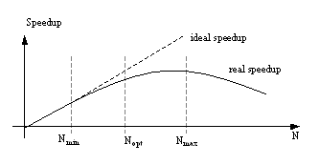
Figure 1 Simplified typical application speedup curve
We assume that the following information is provided about the jobs:
- functions fully describing the speedup curves and/or
- the minimum (N_{min}), the optimum (N_{opt}), and the maximum number of nodes (N_{max}) and the corresponding efficiencies E_{min}, E_{opt}, and E_{max;} N_{opt} would be the normal runtime without any adaptation
We assume that N_{min} is the size that guarantees that the jobs’ processes fit into the memories per node. Otherwise, we take N_{min} as the minimum number of resources we want to allocate to the job. It may be the point where the speedup curve starts to flatten, though the curve may already be sub linear below N_{min}, i.e. an increase in efficiency be obtainable by further decreasing the number of nodes. We assume that N_{max} is the number of nodes beyond which speedup drops, i.e. any larger resource allocation would harm the speedup of the application. N_{opt} is assumed to be the number of resources beyond which the curve flattens more clearly and the resources are clearly more effectively used for other applications. N_{opt} may be equal to N_{PWS} (the processor working set, see Section 2) but this is not necessary to provide efficiency benefits. If speedup curves are given, N_{min}, N_{opt}, and N_{max} may be derived from them as well as may be the efficiency resulting from adaptation. If no detailed speedup curves are provided, we take N_{min}, N_{opt}, and N_{max} and apply linear interpolation between these points. We assume that the estimate about the three special sizes is either constructed by compilers, extracted via monitoring, or provided by the user (a penalty scheme may apply to discourage intentionally wrong estimates to get more resources). However, this issue is beyond the scope of this paper.

The basic actions in adaptation
To implement system-load adaptation and fragmentation reduction, we divide the approach into the following major steps
- Determination of the target size per job in dependence on the system load
- Shrinkage or expansion of running malleable jobs to their target sizes; allocation of all new malleable and all new (short or medium) moldable jobs according to their target size
- During backfilling, potentially further shrinkage of new short or medium adaptable (moldable or malleable) jobs to fit them into the matrix
- Potentially expansion of new short or medium adaptable (moldable or malleable) jobs to use resources which otherwise are idle
The first two steps perform system-load adaptation; the latter two steps perform fragmentation reduction to fit jobs into the machine which otherwise cannot be scheduled and to exploit otherwise unused space. Adaptive allocation is not applied to long moldable jobs because otherwise jobs molded via shrinking may be in a disadvantage if later the load becomes lighter and jobs molded by expansion may have an unjustified benefit if later the load becomes higher. Currently, we also do not consider shrinking/expanding long malleable jobs in the step of fragmentation reduction though this would be meaningful and possible.
Though certain restrictions may apply such as the application only being able to adapt at certain reconfiguration points, we here assume that the resource allocation can be changed at any time the scheduler decides to do so. Furthermore, we assume in the following that arbitrary job sizes in the range [N_{min}, N_{max}] can be chosen, though in reality special constraints like power-of-two sizes may apply (Cirne and Berman, 2003). We are currently working on a refinement of the adaptation to include size constraints.
Figure 2 shows the abstract algorithm of our adaptive SCOJO scheduler.
Below, we explain system-load classification and target size determination in more detail.

//Step1: Classify current system load (low, normal, high)
workloadStatus = classifyWorkload ();

//Step2: Determine the job target size according to current
// workload
(for all jobs)
if (workloadStatus == high) //more jobs than fit into matrix
jobTargetSize = optimalJobSize * determineShrinkFactor ();
else if (workloadStatus == low)
jobTargetSize = optimalJobSize * determineExpandFactor ();
else //fewer jobs than fill single time slice
jobTargetSize = optimalJobSize;
//Step3: Workload adaptation for running malleable jobs

if (workloadStatus == high) shrinkMalleableJobs ();
if (workloadStatus == low) expandMalleableJobs ();
//Step4: Normal gang-matrix filling using TargetSize per job
for (allJobsInWaitingQueue)
if (jobFits) populateMatrix (); else break;

//Step5: Apply backfilling (conservative or EASY)
//with fragmentation reduction by potential shrinkage
BackfillWithPotentialSizeReduction ();

//Step6: Reduce fragmentation by potential expansion
for (allNewMoldableAndMediumMalleableJobs)
tryExpandTowardUnusedNodesPerRow ();
Figure 2 Adaptation algorithm

Rating the system load
We define the system load (in difference to workload as the description of the whole set of jobs tested) as the jobs currently running on the machine and as the jobs currently being in the waiting queue. We classify the current system load into low, normal, and high in the following way:
- If not all jobs that are currently in the system (running or in the waiting queue) can be scheduled with their optimum size for the maximum programming level, the system load is classified as high (WL_{high}).
- If all jobs that are currently in the system can be scheduled with optimum size for a multiprogramming level of 1 and there is still space left, the system load is rated as low (WL_{low}).
- All other system load is considered normal (WL_{normal}).
The rationale is that, in the first case, we have more jobs than fit into the machine without adaptation, and, in the second case, we have space left even if not exploiting multiple time slices.
The system-load classification is calculated in the following way:
- Determination of Nodes_{needed} = Σ_{i=1,jobsR}N_{opt}(job_{i}) + Σ_{i=1,jobsW}N_{opt}(job_{i}) which represents the sum of the size requirements of the currently running jobs jobsR and of the jobs in the waiting queue jobsW (however, very short jobs which can finish within one reconfiguration interval are ignored)
- Calculation of a high-load factor F_{high =} Nodes_{needed} / (Nodes*MPL) and a low-load factor F_{low =} Nodes_{needed} / Nodes with Nodes being the number of nodes in the machine, both assuming perfect packing without fragmentation
- Then,
If F_{high} > 1 → system load is high (WL_{high})
If F_{low} < 1 → system load is low (WL_{low})
Otherwise, the system load is normal (WL_{normal})

Determining job target sizes
If the system load is normal, optimum sizes can be used. As explained above, a high system load requires shrinking sizes; and a low system load suggests expanding sizes. However, the question is how much to shrink or expand. Basically, if many jobs want to be scheduled and have significant resource requests, job sizes should be shrunk more drastically than if the high-load situation is less pronounced. To decide the resource allocation among the jobs, we apply a mixture of optimum efficiency per job and relative resource allocation. This means, if the system load is normal, resources are allocated according to N_{opt}. This may come close to EQUI-EFF since we define N_{opt} according to flattening points in the curve though the efficiency may be different at N_{opt} for the different jobs. If expanding or shrinking, we decrease or increase sizes relative to the optimum size, i.e. we decrease/increase by a certain percentage. If efficiency behaviour is different for the different jobs, this means that the jobs may depart further from equal efficiency. The rationale for this approach is that other research (Chiang and Vernon, 1996) has found that EQUI-EFF may allocate over-proportionally many resources to large jobs and prevent other jobs from being scheduled. This is true if large jobs have good efficiency behaviour (in such case they may shrink little even if the system load is very high). Furthermore, target sizes can be directly calculated if reducing job sizes by a certain percentage.
The idea is to, under heavy system load, shrink jobs such that all running and waiting jobs fit into the matrix if possible. We calculate a relative shrinking factor vs. the optimum size (while excluding all rigid and the moldable running jobs whose size cannot be changed):

F_{shrink} = ( 1 – (Nodes_{needed-for-fixed} / (Nodes* MPL) ) ) /
(Nodes_{needed-for-rest} / (Nodes * MPL))
with Nodes_{needed-for-fixed} being the overall number of nodes needed for all rigid and running moldable jobs and Nodes_{needed-for-rest} the corresponding number for the remaining jobs. All jobs that can be adapted in size, then get N_{opt}*F_{shink} resources allocated. Note that if the system load is very high, the target size of adaptable jobs becomes their minimum size.
Under light system load, we correspondingly calculate to what extent the jobs can expand, while keeping one time slice.
To avoid configuration thrashing and adaptation with minor benefits, we apply some additional constraints. We consider reconfiguration only in certain time intervals T_{reconfig}. Furthermore, we apply a threshold, i.e. only adapt if the rated system load differs by a certain factor F_{adapt-diff} to the one in the previous interval.
Reconfiguration involves cost which can be relatively high—earlier work (Edjlali et al., 1995) found overhead in the range of multiple seconds. Reconfiguration consists of calculating a new application-internal work distribution, redistributing the work via communication, and reconfiguring the communication library. Since communication has, in the meantime, become user-space and, therefore, by about an order of magnitude faster, the overhead has, however, become somewhat lower. The overhead was also found to be dependent on the number of nodes by which the job size changes. Thus, we model the overhead by taking the difference in the number of allocated nodes (N_{diffnodes}) and multiplying it by a fixed overhead (O_{reconfig}) per node, i.e. N_{diffnodes} * O_{reconfig}.
- Experimental Results

Metrics applied
For our evaluations, we consider the following metrics:
- utilization of the machine: the average percentage of used machine nodes over the runtime of the overall workload, i.e. the set of tested jobs
- average response time and average bounded slowdown: these are standard metrics used to rate the effect on the jobs; the response time includes both runtime and waiting time and also includes slowdowns from multiprogramming overhead; the bounded slowdown relates the response time to the pure runtime of the job, while bounding the runtime to a lower minimum runtime to avoid that very low runtimes have an overly high impact on the average
- accumulated efficiency: E_{acc} = ∑_{i=1,Jobs} E_{Ni}*T_{Ni}*N_{i} = ∑_{i=1,Jobs} S_{Ni}*T_{Ni} for all Jobs in the workload, while considering varying resource allocations along the runtime of malleable jobs; this metric expresses how effectively the machine overall is used toward the applications’ computation progress

Experimental setup: workload and application modeling and scheduler configuration
The workload describes the overall set of jobs tested and their specific characteristics. We model two different workloads, Workload W1 and Workload W2 as described in Table 1. We apply random variation within specified ranges of runtimes and sizes (using simple equal distribution). Workload W1 is purely synthetic. Workload W2 is loosely modeled after the workload described by Chiang and Vernon (2001). Workload 1 models a lower percentage of long jobs and less extreme runtimes. We take real runtimes and not (over-)estimates jib(though our approach does not depend on this fact). The average of the inter-arrival times is set to
0.5 * (avgSize*avgRuntime*Jobs) / Nodes / Jobs =
0.5 * avgSize * avgRuntime / Nodes
In detail, we take the average sizes and average runtimes of the different job classes and weight their products by the contribution percentages of their classes. The rationale for the chosen model is to spread job creation over what would be the ideal makespan (assuming a perfect packing of jobs without fragmentation) of the job mix for a fully loaded machine, while further decreasing the interarrival time by a factor to create a highly loaded machine where adaptation makes sense. In both workloads, we cut the tail of the created schedule (the last 5% of the jobs in the schedule) to avoid that the drain phase (with a potentially only partially filled machine) influences the results too much.
We model the same percentages of rigid, moldable, and malleable jobs but different relations to job-size classes for the two workloads. We also test variants of the workloads with 100% moldable and 100% malleable jobs.
Regarding the speedup curves, we assume that the runtime given for the job corresponds to its E_{opt}. The points N_{min} and N_{max} are given via N_{min}=max {N_{opt}/2,1} and N_{max} = min{N_{opt}*2,Nodes}, and we apply the following general model to generate the curve: we assume that the speedup is 80% of the ideal at N_{min}, i.e. 0.8 * N_{min}; 65% at N_{opt}, i.e. 0.65 * N_{opt}; and 50% at N_{max}, i.e. 0.5 * N_{max}. As described above, the curves between the 3 speedup values are linearly interpolated which gives, e.g., 0.8 * N_{min} + (0.65 * N_{opt} - 0.8 * N_{min}) / (N_{opt} - N_{min}) * (N - N_{min}) for N in the interval (N_{min}, N_{opt}]. Thus, in our specific test setting (but only for it), the efficiency behaviour is the same for all jobs, and, thus, the use of the basic target size of N_{opt} and the relative size decrease/increase correspond to EQUI-EFF. The rationale for choosing N_{opt} this way is that we consider any E<0.65 and any corresponding number of node allocations as less desirable. However, with our setting, N_{opt} does not correspond to N_{PWS}.
The parameters used for the scheduler are shown in Table 2. The basic time-slice T_{slice} applies to the maximum multiprogramming level and increases whenever fewer time slices are needed, while the overall time to go once through the matrix rows remains constant. Thus, the overhead from gang scheduling decreases with fewer time slices. Note that we model relatively large time intervals and relatively high overhead though the relative overhead is in the range of what is reported for other systems. Thus, at least, the relativity of values is preserved. For our purposes, these parameter settings also help to speed up the simulation while not having any relevant negative impact on the simulation results.

Table 1 The parameters of the two workloads
 | Workload W1 | Workload W2 | Explanation
%short | 40% | 30% | percentage of short jobs
%medium | 40% | 35% | percentage of medium jobs
%long | 20% | 35% | percentage of long jobs
T_{short} | [1sec,1min] | [1sec,3min] | runtime range for short jobs
T_{medium} | (1min,30min] | (3min,1h] | runtime range for medium jobs
T_{long} | (30min,1h] | (1h,30h] | runtime range for long jobs
N_{short} | [1,8] | [1,8] | size range for short jobs
N_{medium} | [2,16] | [2,16] | size range for medium jobs
N_{long} | [4,32] | [4,32] | size range for long jobs
Jobs | 8,000 | 3,000 | number of jobs in the workload
%moldable | 60%  (35% short, 25% medium) | 60%  (30% short, 30%medium) | percentage of moldable jobs  (% short, % medium)
%malleable | 30%  (15% medium, 15% long) | 30%  (30% long) | percentage of malleable jobs  (% medium, % long)

Table 2 The parameters of the job scheduler
Parameter | Modeled values | Explanation
Nodes | 64 | number of nodes in machine
MPL | 1-5 | maximum multiprogramming level
T_{slice} | 2 secs * MPL/MPL_{curr} | time interval for maximum and potentially smaller current multiprogramming level MPL_{curr}
O_{switch} | 10% of T_{slice} for the maximum MPL | context-switching overhead
T_{reconfig} | 5 min | interval in which load is re-classified and policies for adaptation are potentially changed
F_{adapt} | 10% | threshold difference in workload adaptation factors to previous rating
O_{shrink}, O_{expand} | 0.1 sec * N_{diffnodes} | cost for adaptation, considering the difference in size

Test results
In the following, we present the benefits of our adaptive SCOJO scheduler by comparing it to standard gang scheduling. We test both approaches in combination with different standard features, i.e. FCFS vs. priorities and conservative vs. EASY backfilling. In some tests, we reduce scheduling to a multiprogramming level (MPL) of 1, i.e. to mere space sharing. Furthermore, we explore the benefits of different adaptation variants of our scheduler. In detail, we test standard gang scheduling with
- FCFS and no backfilling (FCFS),
- FCFS and conservative backfilling (FCFS-B),
- priorities and conservative backfilling (PRI-B),
- priorities and EASY backfilling (PRI-EB).
We test six different variants of our adaptive SCOJO gang scheduler, namely with:
- FCFS, EASY backfilling, system-load adaptation, and fragmentation adaptation (FCFS-EB-WA-FA),
- priorities, no backfilling, system-load adaptation and fragmentation adaptation (PRI-WA-FA),
- priorities, EASY backfilling, and system-load adaptation (PRI-EB-WA),
- priorities, EASY backfilling, and fragmentation adaptation (PRI-EB-FA),
- priorities, conservative backfilling, system-load adap-tation, and fragmentation adaptation (PRI-B-WA-FA),
- priorities, EASY backfilling, system-load adaptation, and fragmentation adaptation (PRI-EB-WA-FA).
Before comparing the different approaches and their variants, we take a look at results from varying the multiprogramming level. We have compared them for PRI-EB and PRI-EB-WA-FA which are—as we will later demonstrate—the best variant of standard gang scheduling and the best variant of our adaptive gang scheduler. See Figure 3 and Figure 4. We vary the maximum multiprogramming level from 1 to 5. The results for standard gang scheduling mostly confirm other results from the literature, namely that gang scheduling performs better with higher multiprogramming levels—except that we found the response times for W2 to become worse for MPL=4 and MPL=5. The improvements for higher multiprogramming levels are, however, not very pronounced: in the range of 10%—except a 30% improvement in bounded slowdowns for W2. We found more significant differences for FCFS (no figure shown): 13% improvements in response times and 15% in bounded slowdowns for W1. However, adaptive scheduling performs actually best for a multiprogramming level of 1—except regarding bounded slowdowns for W2 where higher multiprogramming levels provide an improvement of up to 24%. This gives initial confirmation of our hypothesis that adaptive scheduling can work well with a lower multiprogramming level. Thus, for the comparison of the scheduling approaches, we have used MPL=5 for all variants of standard gang scheduling and MPL=2 for all variants of our adaptive SCOJO scheduler. The rationale for the latter—in addition to the behaviour observed for W2—is that our final goal is exploiting time sharing to hide I/O and other long latencies which requires running at least two jobs together.
The results of the comparison of response times and bounded slowdowns for all different scheduling approaches and their variants are shown in Figure 5 and Figure 6. Most importantly, the results demonstrate that adaptive scheduling performs clearly better than standard gang scheduling: if comparing the best adaptive approach PRI-EB-WA-FA with the best standard gang approach PRI-EB, by 50% (W1) and 42% (W2) regarding average response times and by 45% (W1) and 11% (W2) regarding average bounded slowdowns. As expected, standard gang scheduling performs better with priorities than FCFS. This applies even though short jobs are typically also small in size and, therefore, moved ahead by backfilling anyway. EASY backfilling provides better results than conservative backfilling in both workloads.
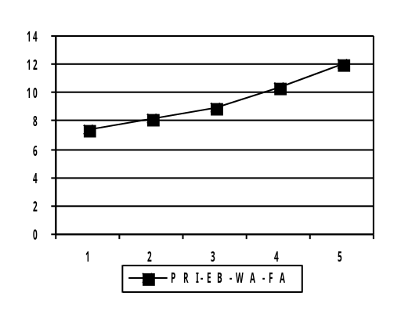

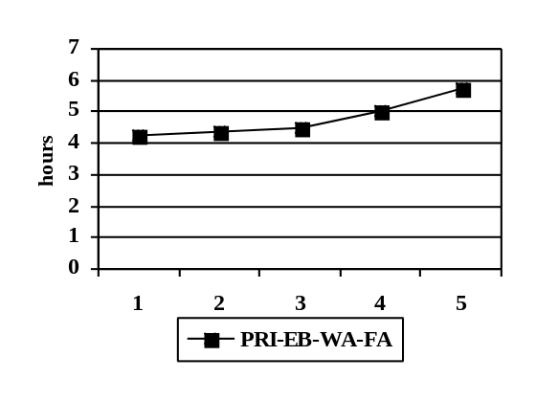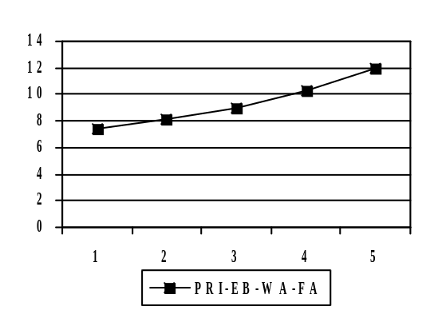

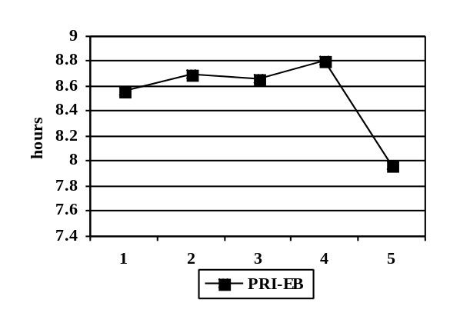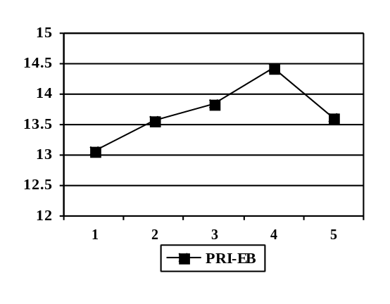

Figure 3 Different MPL and resulting average response times (left) and average bounded slowdowns (right) for the best standard gang scheduling approach (PRI-EB) and our best adaptive approach (PRI-EB-WA-FA) for Workload W1
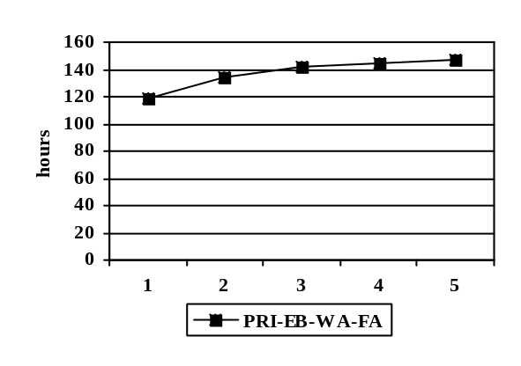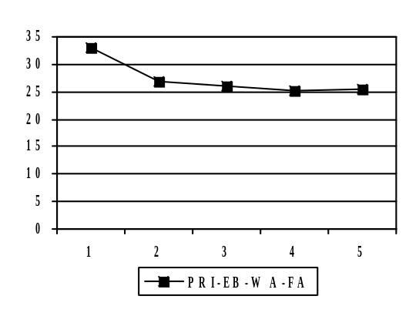

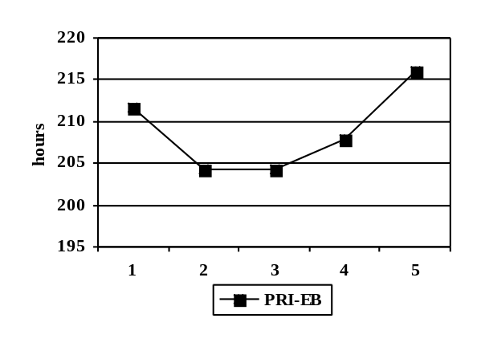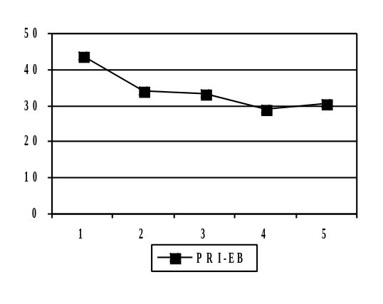

Figure 4 Different MPL and resulting average response times (left) and average bounded slowdowns (right) for the best standard gang scheduling approach (PRI-EB) and our best adaptive approach (PRI-EB-WA-FA) for Workload W2

Comparing the individual adaptive SCOJO variants, system-load adaptation provides the most benefits. The two best variants are PRI-EB-WA-FA and PRI-EB-WA. Whether fragmentation adaptation is added or not, makes only a slight positive difference. Also, fragmentation adaptation on its own does not perform well. The more global system-load approach to adjust all job sizes for more effective use of node resources, obviously has a higher positive impact on response times than individual adjustments, especially as the possibilities of fragmentation adaptation are very limited under the heavy workload modelled.

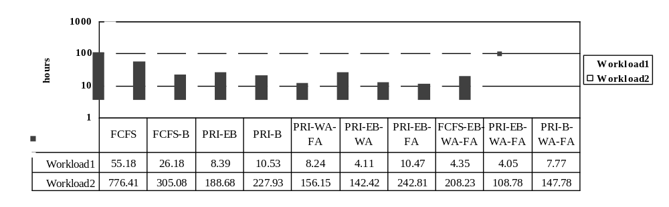

Figure 5 Average response times for the different scheduling approache (log scale)
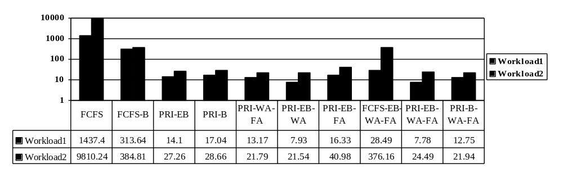

Figure 6 Average bounded slowdowns for the different scheduling approaches (log scale)

In the following, we look into makespans and accumulated efficiency. Figure 7 shows the makespans for all approaches. Adaptive gang scheduling has shorter makespans than standard gang scheduling. For instance, the improvements by PRI-EB-WA-FA vs. PRI-EB are about 12% for W1 and 18% for W2. Furthermore, system-load adaptation has shorter makespans than fragmentation adaptation. Thus, the makespans are consistent with the response times and the bounded slowdowns.
Figure 8 demonstrates that adaptive scheduling provides better accumulated efficiency, i.e. that the machine is more effectively used towards computation progress of the applications. Because standard gang scheduling always uses N_{opt} it has an accumulated efficiency of 0.65 in our test setting. The results also show that fragmentation adaptation on its own makes the results worse. This observation contributes to explaining why fragmentation adaptation has limited benefits: it may schedule jobs earlier but overall uses the resources less effectively.
We have also measured utilization (no figure shown considering the similarity of the results). For all approaches, the utilization of the machine is high (around 90%) because we simulate a heavy workload. We found that the final average fragmentation (after adaptation) is less than 0.5% for all approaches with our simulated workloads. This means that the benefits of our adaptive scheduling are due to a more effective use of the machine rather than a higher utilization. Also jobs may be scheduled earlier because of adaptation and later leave the machine slightly less utilized.

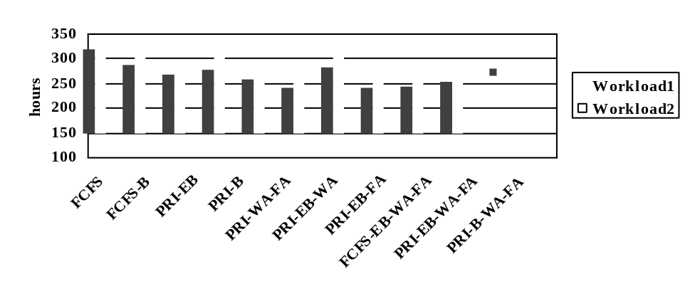

Figure 7 Makespans for different approaches (the makespan of Workload2 is scaled down by a factor of 10 to fit into the same graphic)

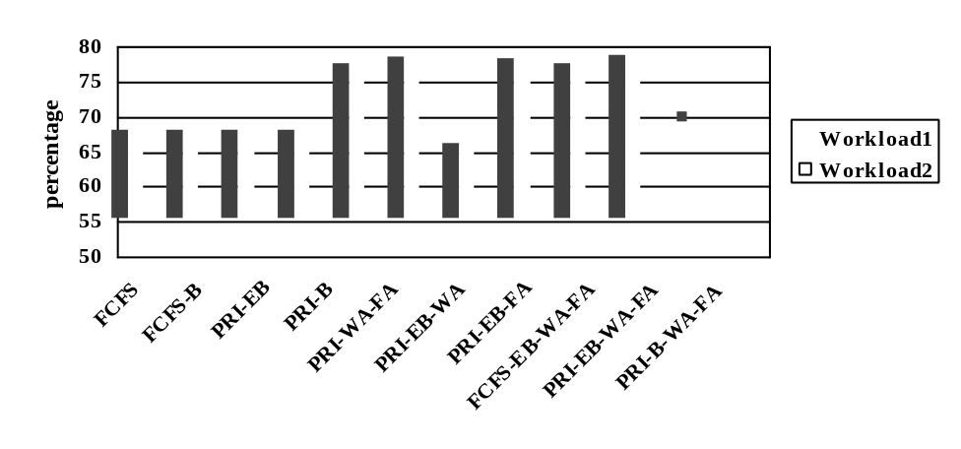

Figure 8 Accumulated Efficiency for all approaches (in percentage of machine usage)

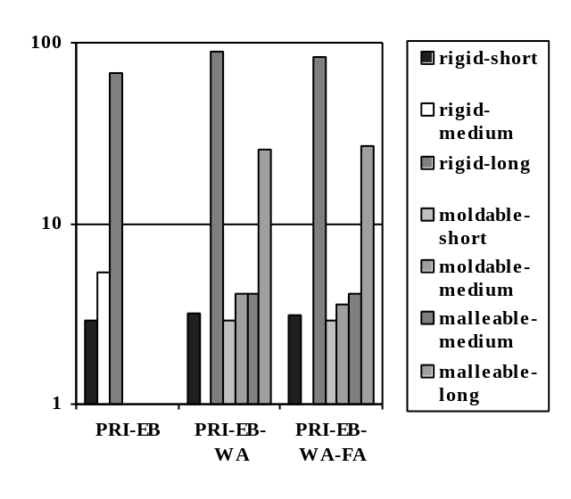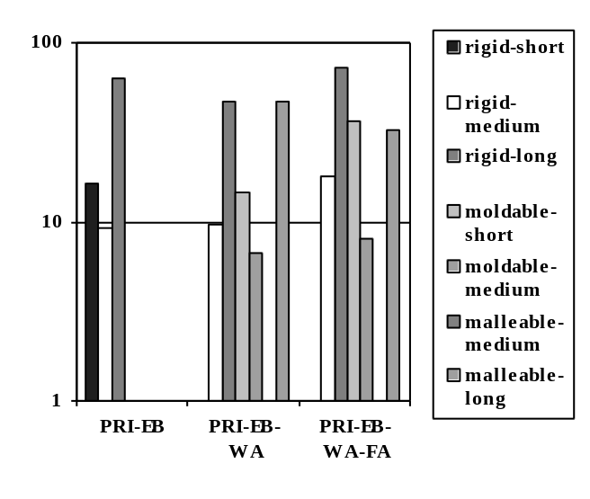

Figure 9 Average bounded slowdowns (log scale), differentiated according to different application classes and for Workload W1 (left) and Workload W2 (right)

In the following, we take a closer look at the bounded-slowdowns by differentiating between the different classes of jobs, see Figure 9. We compare the best standard variant PRI-EB with our two best adaptive variants PRI-EB-WA and PRI-EB-WA-FA. For both workloads and all scheduling approaches, we find that the results are good for small but worse for long jobs. Our adaptive approach serves rigid long jobs slightly worse than standard gang scheduling but improves the results for malleable long jobs. The results indicate that we might be able to further improve overall response times and bounded slowdowns by aging long jobs under certain conditions more aggressively. Malleable medium jobs (only available in W1) are improved via adaptation, too. Molding provides some benefits, too: especially medium jobs get better results than with standard gang scheduling. Rigid jobs, however, all suffer slightly in some cases with an adaptive approach.
Next, we investigate the influence from the flexibility of the jobs by including tests with all jobs being moldable or all jobs being malleable. We have tested both MPL=1 and MPL=2. Table 3 shows the number of size adaptations for all jobs. Considering that the workload is high, not surprisingly, mostly shrinkages in size occur. The number of adaptations is quite similar for our basic mixed workload (60% moldable and 30% malleable) and for the test with all jobs being malleable. However, the number of adaptations is much lower for the case that all jobs are moldable only—which is expected as no adaptations during the jobs’ runtime occur. These relations are similar for both workloads and for both MPL=1 and MPL=2.

Table 3 Total number of adaptations for the best adaptive approach PRI-EB-WA-FA with different workloads, different job mixes (our original job mix as defined in Table 1, all moldable jobs, and all malleable jobs), and different multiprogramming levels MPL=1 (1) and MPL=2 (2); S means the number of size shrinkages, E means the number of size expansions
 | 60/30  (1) | All moldable (1) | All malleable (1) | 60/30  (2) | All moldable (2) | All malleable (2)
Workload W1 | 8162  [S=4272,  E=3890] | 5916  [S=2173,  E=3743] | 8026  [S=3923,  E=4103] | 8181  [S=4610,  E=3571] | 5944  [S=2514,  E=3430] | 8480  [S=4601,  E=3879]
Workload W2 | 3021  [S=1656,  E=1365] | 2398  [S=1069,  E=1329] | 3295  [S=1816,  E=1479] | 3088  [S=1710,  E=1378] | 2409  [S=1091,  E=1318] | 3772  [S=2106,  E=1666]
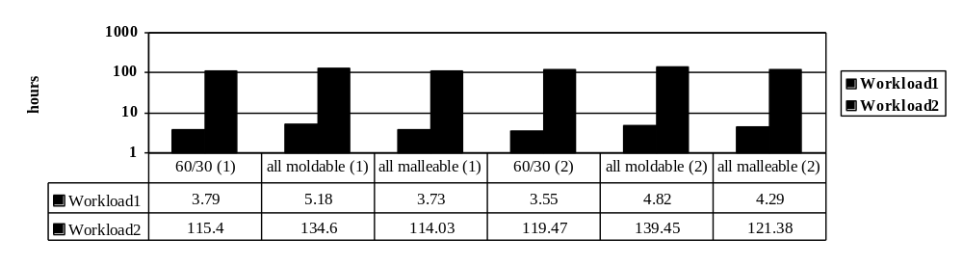

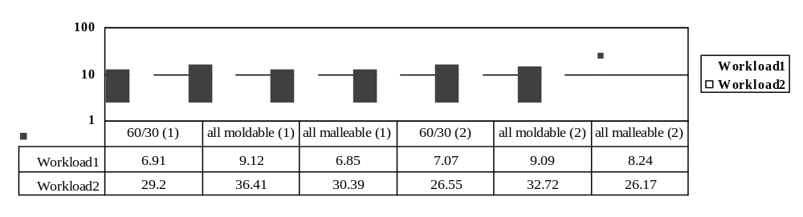

Figure 10 Comparison of response times (upper figure) and bounded slowdowns (lower figure), both log scale, for our original job mix as defined in Table 1, for all moldable jobs, and for all malleable jobs, using the PRI-EB-WA-FA approach and either MPL=1 (1) or MPL=2 (2).

Looking at the corresponding response-time and bounded-slowdown results for these test cases, we see that our approach performs almost equally well for the mixed and the all-malleable workloads—even slightly better for the mixed ones in some cases. This applies to both response times and bounded slowdowns, see Figure 10. The performance is, however, worse if all jobs are moldable only (e.g., by 37% for response times and by 32% for bounded slowdowns with Workload 1 and MPL=1). For more details, see Huang (2004).
Finally, we have investigated the sensitivity of the benefits of our best-performing adaptive approach PRI-EB-FA-WA to the overhead of the context switch and to the heaviness of the workload, comparing again to PRI-EB, see Figure 11. We have reduced the overhead from 10% to 5% and 0%. Regarding the workload, we have added a lighter workload variant by increasing the job inter-arrival times by a factor of 1.5. We find that adaptive scheduling performs relatively even better for 0% overhead (though slightly worse for 5%) which means that the lower overhead from the smaller number of time slices is not the reason why our adaptive SCOJO performs better than standard gang scheduling. Our adaptive approach performs much better for a lighter workload. This means our previous comparisons with standard gang scheduling have been on the conservative side. Considering the lighter workload, fragmentation reduction may have more positive impact with such a workload by having more chances to use resources which otherwise are idle and by potentially still fitting in jobs if the machine is almost full, whereas with a high workload backfilling may take over the role to fill the machine.

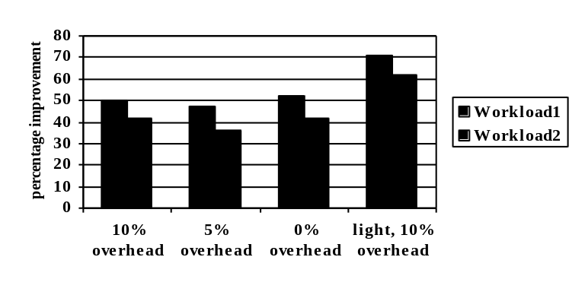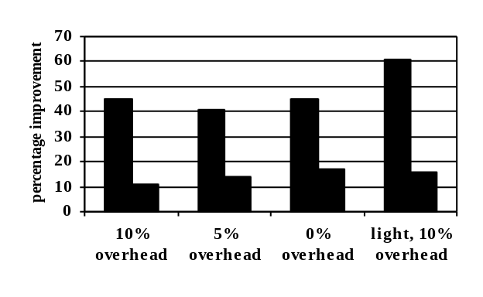

Figure 11 Relative improvements (in percentage) by adaptive gang scheduling (PRI-EB-FA-WA) vs. standard gang scheduling (PRI-EB) for different overheads (10%, 5%, and 0%). In addition, we show relative improvements for a lighter workload (see description in text) with 10% overhead. Left graphic are improvements for response times and right graphic are improvements for bounded slowdowns.

- Summary and Conclusion
We have presented our SCOJO approach for adaptive node allocation in clusters, applying adaptation in combination with gang scheduling. SCOJO integrates standard job-scheduling features like (EASY) backfilling and priorities, and it considers realistic mixes of rigid, moldable, and malleable jobs. The approach adapts job sizes to different system loads and reduces fragmentation. In a comparison with standard gang scheduling, we have shown by our experiments to accomplish significantly better average response times and better average bounded slowdowns (42% to 50% improvements in response times and 11% to 45% in bounded slowdowns). The main gain comes from system-load adaptation, whereas fragmentation adaptation contributes only small benefits for our tested workloads. Some of our additional tests indicate that fragmentation adaptation may have more positive impact if the workload is light. Most importantly, a low multiprogramming level works well with our SCOJO approach and provides even better results than higher levels, whereas higher multiprogramming levels improve the results for standard gang scheduling. The lower multiprogramming level has the essential benefits of decreasing context-switching overhead and memory pressure. Our results even suggest that gang scheduling may not be needed at all and that simple space sharing, i.e. MPL=1, in combination with adaptive resource allocation may provide the best results. For our future work, however, MPL=2 is still significant because we intend to exploit coscheduling for latency hiding. Important to stress is that these results have been obtained with only a certain percentage of malleable jobs (whereas many other researchers assume that all jobs are malleable) and with the more realistic assumption that the majority of jobs are at best moldable. Future work includes more sophisticated workload modelling (describing a fairly highly subscribed machine as the basic workload but also including feedback, i.e. the users’ expected reaction to better throughput being to submit more jobs), improvements /tuning of workload adaptation, a more sophisticated fragmentation-reduction approach, and usage of loosely coordinated coscheduling to exploit latency hiding.

Acknowledgement
This research was partially supported by NSERC and by CFI (Grant No. 6191) with contributions from OIT and IBM.
ReferencES
Arpaci-Dusseau, A. C., Culler, D. E., and Mainwaring, A. M. (1998) ‘Scheduling with Implicit Information in Distributed Systems’, Proc. SIGMETRICS’98/PERFORMANCE’98 Joint Conference on the Measurement and Modeling of Computer Systems, Madison/WI, USA, June.
Cirne, W., and Berman, F. A. (2001) ‘Model for Moldable Supercomputer Jobs’, Proc. Internat. Parallel and Distributed Processing Symposium (IPDPS), April.
Cirne, W., and Berman, F. (2003) ‘When the Herd is Smart: Aggregate Behavior in the Selection of Job Request’, IEEE Trans. on Parallel and Distributed Systems, Vol. 14, No. 2, Feb.
Chiang, S.-H., Mansharamani, R. K., and Vernon, M. K. (1994) ‘Use of Application Characteristics and Limited Preemption for Run-to-Completion Parallel Processor Scheduling Policies’, Proc. ACM SIGMETRICS Conf. on Measurement and Modeling of Computer Systems.
Chiang, S.-H., and Vernon, M. K. (1996) ‘Dynamic vs. Static Quantum-Based Parallel Processor Allocation’, Proc. Workshop on Job Scheduling Strategies for Parallel Processing (JSSPP), May, D. G. Feitelson and L. Rudolph (eds.), Springer Verlag, Lecture Notes in Computer Science Vol. 1162, pp. 200-223.
Chiang, S.-H., and Vernon, M. K. (2001) ‘Characteristics of a Large Shared Memory Production Workload’, Proc. Workshop on Job Scheduling Strrategies for Parallel Processing (JSSPP), Springer Verlag.
Corbalan, J., Martorell, X., and Labarta, J. (2000) ‘Performance-Driven Processor Allocation’, Proc. 4th Conf. on Operating System Design and Implementation (OSDI).
Corbalan, J., Mortarell, X., and Labarta, J. (2001) ‘Improving Gang Scheduling through Job Performance Analysis and Malleability’, Proc. 15th Int. Conf. on Supercomputing (ICS), June.
Dutot, P.-F., and Trystram, D. (2001) ‘Scheduling on Hierarchical Clusters Using Malleable Tasks’, Proc. Symp. on Parallel Algorithms and Architectures (SPAA), July.
Edjlali, G., Agrawal, G., Sussman, A., and Saltz, J. (1995) ‘Data Parallel Programming in an Adaptive Environment’, Proc. 9th Int’l Parallel Processing Symposium, Santa Barbara, USA, April.
Feitelson, D. G., Rudolph, L., Schwiegelsohn, U., Sevcik, K. C., and Parsons, W. (1997) ‘Theory and Practice in Parallel Job Scheduling’, Proc. Workshop on Job Scheduling Strategies for Parallel Processing (JSSPP), Springer Verlag, Lecture Notes in Computer Science, Vol. 1291.
Feitelson, D. G. (1997) ‘Job Scheduling in Multiprogrammed Parallel Systems, Extended Version’, Technical Report, IBM, RC 19790 (87657), August.
Frachtenberg, E., Feitelson, D., Petrini, F., and Fernandez, J. (2003) ‘Flexible CoScheduling: Mitigating Load Imbalance and Improving Utilization of Heterogeneous Resources’, Proc. Int. Parallel and Distributed Processing Symposium (IPDP), Nice, France, April.
Franke, H., Pattnaik, P., and Rudolph, L. (1996) ‘Gang Scheduling for Highly Efficient Distributed Multiprocessor Systems’, Proc. Frontier, Oct., pp. 1-9.
Franke, H., Jann, J., Moreira, J. E., Pattnik, P., and Jette, M.A. (1999) ‘An Evaluation of Parallel Job Scheduling for ASCI Blue-Pacific’, Proc. IEEE/ACM Supercomputing Conf. (SC).
Ghosal, D., Serazzi, G., and Tripathi, S. K. (1991) ‘The Processor Working Set and Its Use in Scheduling Multiprocessor Systems’, IEEE Trans. Software Engineering, Vol. 17, No. 5, May, pp. 443-453.
Hori, A., Tezuka, H., and Ishikawa, Y (1998) ‘Highly Efficient Gang Scheduling Implementation’, Proc. IEEE/ACM Supercomputing Conf. (SC), Orlando/FL, USA.
Huang, X. (2004) ‘Adaptive Space-Time Sharing with SCOJO’, Master Thesis, University of Windsor, January.
Moreira, J. E., Chan, W., Fong, L. L., Franke, H., and Jette, M. A. (1998) ‘An Infrastructure for Efficient Parallel Job Execution in Terascale Computing Environments’, Proc. Supercomputing (SC), Nov.
Mu'alem, A., and Feitelson, D. G. (2001) ‘Utilization, Predictability, Workloads and User Runtime Estimates in Scheduling the IBM SP2 with Backfilling’, IEEE Transactions Parallel & Distributed Systems, Vol. 12, No. 6, June.
Naik, V. K., Setia, S. K., and Squillante, M. S. (1997) ‘Processor Allocation in Multiprogrammed Distributed-Memory Parallel Computer Systems’, J. of Parallel and Distributed Computing, Vol. 46, No. 1, pp. 28-47.
Nguyen, T. D., Vaswani, R., and Zahorjan, J. (1996) ‘Using Runtime Measured Workload Characteristics in Parallel Processor Scheduling’, Proc. Job Scheduling Strategies for Parallel Processing (JSSPP), Springer Verlag, Lecture Notes in Computer Science 1162.
Ousterhout, J. K. (1982) ‘Scheduling Techniques for Concurrent Systems’, Proc. 3rd Intl. Conf. Distributed Comp. Systems, pp. 22-30.
Parsons, E. W., and Sevcik, K. C. (1997) ‘Implementing Multiprocessor Scheduling Disciplines’, Proc. IPPS Workshop on Job Scheduling Strategies for Parallel Processing (JSSPP), Geneva, Switzerland, Lecture Notes in Computer Science, Springer Verlag Vol. 1291, April.
Sodan, A. C., and Huang, X. (2003) ‘SCOJO—Share-Based Job Coscheduling with Integrated Dynamic Resource Directory in Support of Grid Scheduling’, Proc. Ann. Int. Symposium on High Performance Computing Systems (HPCS), Sherbrooke, Canada, May, pp. 213-221.
Sodan, A.C., and Huang, X. (2004) ‘Adaptive Time/Space Sharing with SCOJO’, Proc. Ann. Int. Symposium on High Performance Computing Systems (HPCS), Winnipeg, Canada, June.
Sodan, A. C. (2005) ‘Loosely Coordinated Coscheduling in the Context of Other Dynamic Approaches for Job Scheduling—A Survey.’, Technical Report 03-006, May 2003, and Concurrency & Computation: Practice & Experience, Wiley, online June 2005, in press for Vol. 17, No. 15, Dec.
Turek, J., Wolf, J. L., Pattipati, K. R., and Yu, P. S. (1982) ‘Scheduling Parallelizable Tasks: Putting it All on the Shelf’, SIGMETRICS Performance Evaluation Review: Proc. SIGMETRICS Conf. on Measurement and Modeling of Computer Systems, Vol. 20, No. 1, June.
Wong, A. T., Oliker, L., Kramer, W. T. C., Kaltz, T. L., and Bailey, D. H.’ (2000) ‘ESP: A System Utilization Benchmark’, Proc. Supercomputing (SC), Dallas/TX, Nov.
Zhang, Y., Franke, H., Moreira, J. E., and Sivasubramaniam, A. (2001) ‘An Integrated Approach to Parallel Scheduling Using Gang-Scheduling, Backfilling and Migration’, Proc. Workshop on Job Scheduling Strategies for Parallel Processing (JSSPP), June, Springer Verlag, Lecture Notes in Computer Science Vol. 2221, pp. 133-158.

