
UI Developer
Sentu Biswas
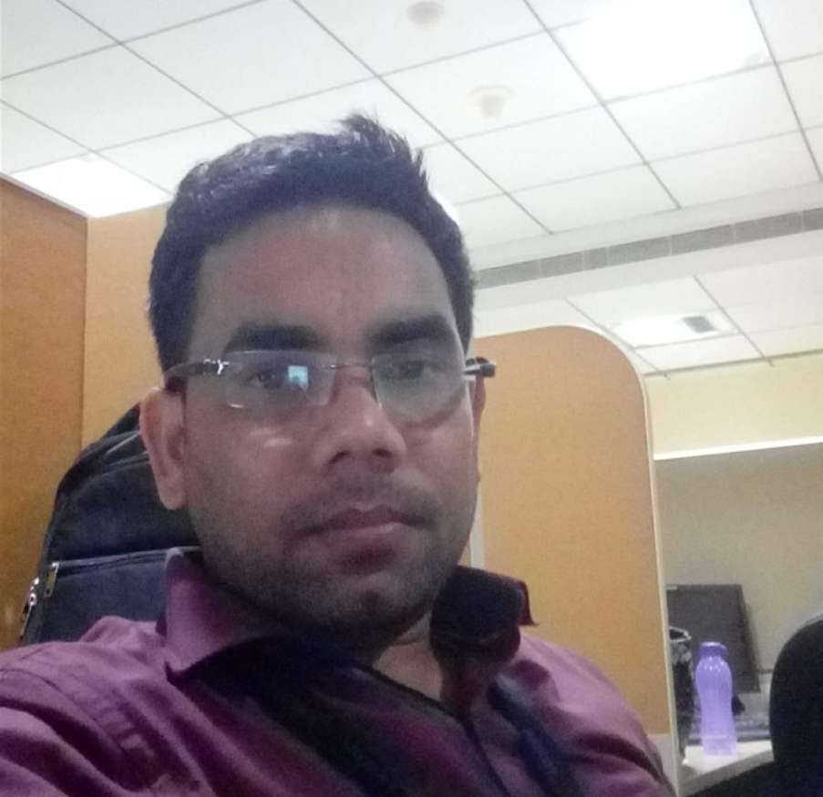

Mob: +91 9933687770 | Email: sentu.biswas@ust.com

Summary
Skilled UI Developer with expertise in HTML, CSS, JavaScript, and frameworks like React and Angular. Passionate about creating responsive, user-friendly interfaces that enhance UX. Have Some knowledge in Backend Java, Spring Boot microservice.
Technical Expertise
WEB TECHNOLOGIES
HTML5, CSS3, JavaScript, TypeScript, Angular17, ReactJS, Redux, Nx(Monorepos)
Database, Cloud and Build Tools
Java, Spring boot, MySQL (Have some work Knowledge)
OTHERS
Fuse Angular, Ag Grid, VMware Clarity, Bootstrap, Material UI, Responsive Web Design, Tailwind CSS,
MANAGEMENT AND DEV TOOLS
JIRA. GitHub, Bit-Bucket, VSCode, IntelliJ, Notepad++
UX Design Tools
Photoshop CS4, Sketch, Figma, Invision
Industry Experience

Banking, VMware Testing Tool

HealthCare, Rail Tickets

Web, Document Control Tool
Education
• BA(H) in the year 2006 Kalyani University
• MCA (appearing) from IGNOU.
- ITizen Program (Diploma) in ISAS (A div of Sikkim Manipal University).

Professional Experience
- Frontend Development: Expertise in building responsive, scalable, and performant web applications using HTML5, CSS3, JavaScript, jQuery, Angular 16, ReactJS, Redux, Nx, Angular Fuse, VMware Clarity, Bootstrap, Material UI, and Tailwind CSS.
- CSS Frameworks & Preprocessors: Strong experience with Tailwind CSS, SASS, Less, and custom media queries for designing responsive and visually consistent web applications.
- Angular Development: Extensive experience in writing Angular 16 components, pipes, and services to modularize functionality and enhance application scalability and maintainability.
- ReactJS & Redux: Hands-on experience with ReactJS to build Single Page Applications (SPA), utilizing Redux for state management, React Router for navigation, and React Forms and Events for dynamic user interaction.
- Cross-Browser Compatibility & Responsive Design: Proficient in Responsive Web Design using modern front-end technologies such as HTML5, CSS3, JavaScript, jQuery, Angular, ReactJS, and CSS frameworks like Bootstrap, Material UI, and Tailwind CSS.
- Authentication & Authorization: Worked with Spring Security Framework for user access management, implementing JWT token-based authentication and OAuth configuration for secure authentication and authorization in web applications.
- UI/UX Design: Experience in designing wireframes, prototypes, and visual elements for web applications using tools like Figma, Sketch, InVision, Craft, and Photoshop, adhering to usability principles for intuitive user interfaces.
- Containerization & CI/CD: Deployed applications using Docker and Jenkins to build Continuous Integration/Continuous Deployment (CI/CD) pipelines. Used GitHub for source control management and automated deployments for efficient software delivery.
- Version Control & Project Management: Proficient in using Git for version control and JIRA for tracking issues, coordinating tasks, and ensuring smooth project delivery.
- Agile Development: Actively participated in Agile development cycles, including sprint planning, daily standups, and retrospectives, ensuring timely delivery of new features and continuous improvement.

EXPERIENCE HIGHLIGHTS
UST Global  Sr. UI Developer | Aug 2018 – Till Date

Project Name | : RTM- Real Time Message– (Mar 2025 – Dec 2025)
Client | : BCBSA - Blue Card Modernization
Technologies | : JavaScript, Typescript, Angular, Angular Fuse, HTML5, CSS3, Rest API, Nx(Monorepos), Tailwind CSS
Description | - BCM stands for Blue Card modernization  That is an attempt to bring together a lot of existing legacy applications into one single portal, and even now, after the modernization and all these obligations are going to be working, stand alone, independently, without any connect within each other using Monorepos.
Activity | - Implemented a chat-based survey report form and interactive data visualization charts using FusionCharts, enabling real-time analytics, improved user engagement, and clear representation of survey insights.  - Integrated APIs to fetch, process, and present survey data with smooth transitions and responsive layouts.  - Implemented User and Organisation bulk upload functionality to allow uploading large volumes of user and organisation data efficiently, eliminating manual data entry and significantly reducing processing time.  - Designed an intuitive UI for uploading files (Excel/CSV) with validation and clear error messages.  - Developed preview screens to display parsed data before final submission.  - Integrated progress indicators, success/error notifications, and detailed validation reports.

Project Name | : Document Management System – (Dec 2024 – Apr 2025)
Client | : Hero MotoCorp Limited
Technologies | : JavaScript, Typescript, Angular, HTML5, CSS3, Rest API, Bootstrap, Material.
Description | - A web application used to enhance the Quality Assurance (QA) workflow using DSpace 7.6.2 for Hero Motors' HWS account. The purpose of the Hero HR Portal Site (HR Portal) is to create a secure system for data file sharing between internal and external users, including Hero MotoCorp vendors. The system allows users to upload, download, and share.
Features | - Worked on below module
  - Create, edit, view Folders and documents and download  - Upload Function, Files Listing | - Create User and access UI  - Delete Multi Files and folders  - Move Child Folder and files
Activity | - Design and implement various features of the HR portal based on client requirements, ensuring they are functional, efficient, and meet project specifications.  - Work closely with backend developers to seamlessly integrate UI with backend services, ensuring smooth data flow and functionality.  - Regularly connect with the team and clients to gather requirements, provide updates, and ensure the application meets their needs and expectations.

Project Name | : Portal – (Nov 2023 – Oct 2024)
Client | : BCBSA - Blue Card Modernization
Technologies | : JavaScript, Typescript, Angular, Angular Fuse, HTML5, CSS3, Rest API, Nx(Monorepos), Tailwind CSS,
Description | - BCM stands for Blue Card modernization  That is an attempt to bring together a lot of existing legacy applications into one single portal, and even now, after the modernization and all these obligations are going to be working, stand alone, independently, without any connect within each other using Monorepos.
Activity | - Designed and implemented reusable, modular Angular components using Agular’s component-based architecture, improving maintainability and reusability across the application.  - Worked on to Upgrade Ag Grid 28 to version 31 and fix the upgradation issue  - Implemented complex UI features, including Data Grids, Modals, and Multi-Select components, using Angular's reactive forms, directives, and services for dynamic user interactions.  - Enhanced the application's styling and responsiveness using Tailwind Css,

Project Name | : Harmony - VMware Test Workbench – (Aug 2018 – Nov 2023)
Client | : VMware
Technologies | : JavaScript, Typescript, Angular2.0/12/16, HTML5, CSS3, Rest API, NgRx, Clarity Framework, Fuse Angular, Jest, Karma, GitHub, Jenkins, Figma and Photoshop
Description | - Harmony is VMWare's Test Automation Portal which is designed specifically to be a centralized hub to perform end-to-end Automation Testing related activities & to maintain automation testing related artifacts.  The backbone to vTap is MySQL DB which is the back-end server to store the entire testing information (from automated test scripts till Reports)"
Activity | - Successfully migrated an application initially developed in Angular 2 to Angular 12, then further upgraded to Angular 18, ensuring modern best practices and optimal performance.  - Implemented and customized various UI components, including data grids, toolbars, tree menus, accordions, panels, combo boxes, and modals to enhance user experience, added styling and responsiveness using SASS.  - Managed asynchronous data handling with HTTP requests Promises, async/await, and Observables (with RxJS where needed), ensuring smooth data flow and user interaction.  - Created reusable TypeScript components and services within a component-based architecture to interact with REST APIs, supporting efficient development and scalability.

Agreeya Mobility India Pvt Ltd  Sr. UI Developer |  | Jan 2018 – Aug 2018
Project Name | : Jio Rail
Client | : Reliance Jio
Technologies | : JavaScript, ReactJS, NodeJS, HTML5, CSS3, KioOS Platform and Figma, Photoshop
Description | : Jio’s IRCTC service design to facilitate to search PNR, Seat Availability of Book ticket and user can book the ticket trough this application.
Activity | - Developing using JavaScript, ReactJS, HTML5, CSS, webservice  - Integrated Web Services to fetch and process data related to PNR status, Seat Availability, and Booking functionality, ensuring real-time updates and smooth interaction between front-end and back-end systems.

Sasken Technologies limited.  Sr. UI Developer |  | April 2017 – Dec 2017
Project Name | : Jio Chatbot
Client | : Reliance Jio
Technologies | : ReactJS, JavaScript, HTML5, CSS3, Index DB, KioOS Platform and Photoshop
Description | : Jio Chatbot is an app which is used to chat with various chatbots for hotel booking, restaurant booking, train booking and news, games and different.
Activity | - Worked on the basic UI navigation and flow in ReactJS.  - Actively worked on UI bug fixes and improvements to enhance the overall usability and visual appeal of the application.  - Using React Hooks (State Hook, Effect Hook and so on) to use state and lifecycle methods inside functional components.

Project Name | : Jio Voice Assistant
Client | : Reliance Jio
Technologies | : ReactJS, JavaScript, HTML5, CSS3, KioOS Platform and Photoshop
Description | : Jio’s speech based assistant design to facilitate search and Task completion for the feature phone user. Objective is to aid ease of use for key functions addressing the challenges faced by this TG related to readability, literacy and cumbersome keypad input
Activity | - Development using ReactJS, JavaScript, HTML5, CSS, Mozilla Web API.  - Implemented mapStateToProps, mapDispatchToProps, useSelector and use Dispatch to interact between Redux and React.js.

Project Name | : https://www.way.com/
Client | : Way.com
Technologies | : JavaScript, AngularJs1.6, jQuery, HTML5, CSS3, Bootstrap, Photoshop
Description | : Way.com is US based service application which offers services like Parking, Dining etc.
Kaliwood Consultancy Services March 2016 – April 2017  Sr. UI Developer |  |  | March 2016 – April 2017
  Project Name | : Berger Suvidha
  Client | : Berger Paint
  Play Store | : https://play.google.com/store/apps/details?id=com.berger.app.suvidha&hl=en_IN
  Technologies | : JavaScript, SQLite, ReactNative, Cordova, HTML5, CSS3 and Photoshop
  Description | : This application to used to update Profile information and KYC, Add/Edit Team Members. Scan Tokens
  Activity | - Collaborated with designers to implement user-friendly interfaces, ensuring seamless app navigation and interactions.  - Worked on different feature like modal, accordian, Left Navigation  - Involved in integrating UI with API and loading data using REST API
  Project Name | : Berger SPO(Nepal)
  Client | : Berger Paint
  Play Store | : https://play.google.com/store/apps/details?id=com.berger.app.suvidha&hl=en_IN
  Technologies | : jQuery, JavaScript, SQLite, React Native, Cordova, HTML5, CSS3 and Photoshop
  Description | : Mobile app for sales performance optimization.
  Project Name | : ShopEzay
  Client | : ShopEzay
  Technologies | : JavaScript, SQLite, ReactNative, Cordova, HTML5, CSS3 and Photoshop
  Description | : ShopEazy is a personalized shopping app. It provides aggregation of top online shopping sites. You can add shopping items to predefined categories for easy access.

ISIS Design Services  HTML5 Developer |  | March 2013 – March 2016
Project Name | : Assawarimusicfoundation
Client | : Asawari Music Foundation
Link | : http://www.asawarimusicfoundation.com/
Technologies | : jQuery, JavaScript, WordPress, MySQL, HTML5, CSS3 and Photoshop
Description | : Asawari Music Foundation is for the children who are looking for a platform to showcase their musical talent or be able to avail a scholarship.

Project Name | : https://www.unifiedinfotech.net/
Technologies | : jQuery, JavaScript, HTML5, CSS3, Wordpress, MySql and Photoshop
Description | : Unified Infotech is web development company who provides solution for website design, development, and scalable mobile apps to SaaS platforms.

DECLARATION
I hereby declare that the given above information is true and correct to the best of my knowledge and belief.
Place: Bangalore
Date:

