Can Şentürk

Project Report for ECE 748 - Convolutional Neural Networks for Visual Recognition

Lecturer: Dr. Shahram Taheri

Contents

Abstract 2

Introduction 2

Materials (or Equipment) 2

Procedures 3

Results 4

Discussion 5

Conclusion 5

Appendices 6

Further Reading 7

Compare Expected Results with Those Obtained 7

Analyze Experimental Error 7

Explain Your Results In Terms Of Theoretical Issues 8

Relate Results to Your Experimental Objective(S) 8

Compare Your Results to Similar Investigations 8

References 8

# Part I

In this part first I designed a Convolutional Neural Network model with Tensorflow and Keras at Python. Then I choosed 2 numbers each for 3 hyperparameters on my model. These Hyperparameters are,

|  |  |
| --- | --- |
|  |  |
|  |  |
|  |  |
|  |  |
|  |  |
|  |  |

Conculusion:

# Introduction

The introduction is more narrowly focused than the abstract. It states the objective of the experiment and provides the reader with background to the experiment. State the topic of your report clearly and concisely, in one or two sentences:

Example: The purpose of this experiment was to identify the specific element in a metal powder sample by determining its crystal structure and atomic radius. These were determined using the Debye-Sheerer (powder camera) method of X-ray diffraction.

A good introduction also provides whatever background theory, previous research, or formulas the reader needs to know. Usually, an instructor does not want you to repeat the lab manual, but to show your own comprehension of the problem. For example, the introduction that followed the example above might describe the Debye-Sheerer method, and explain that from the diffraction angles the crystal structure can be found by applying Bragg's law. If the amount of introductory material seems to be a lot, consider adding subheadings such as: Theoretical Principles or Background.

# Materials (or Equipment)

Can usually be a simple list, but make sure it is accurate and complete. In some cases, you can simply direct the reader to a lab manual or standard procedure: "Equipment was set up as in CHE 276 manual."

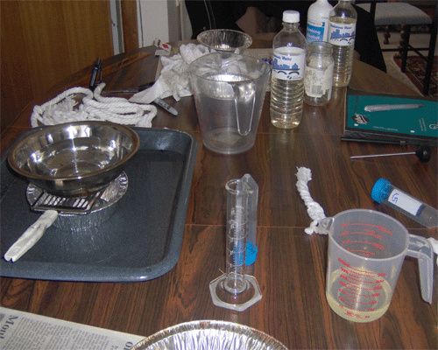

# Procedures

As the name implies, the materials and methods used in the experiments should be reported in this section. The difficulty in writing this section is to provide enough detail for the reader to understand the experiment without overwhelming him or her. When procedures from a lab book or another report are followed exactly, simply cite the work, noting that details can be found in that particular source. However, it is still necessary to describe special pieces of equipment and the general theory of the assays used. This can usually be done in a short paragraph, possibly along with a drawing of the experimental apparatus. Generally, this section attempts to answer the following questions:

* What materials were used?
* How were they used?
* Where and when was the work done? (This question is most important in field studies.)

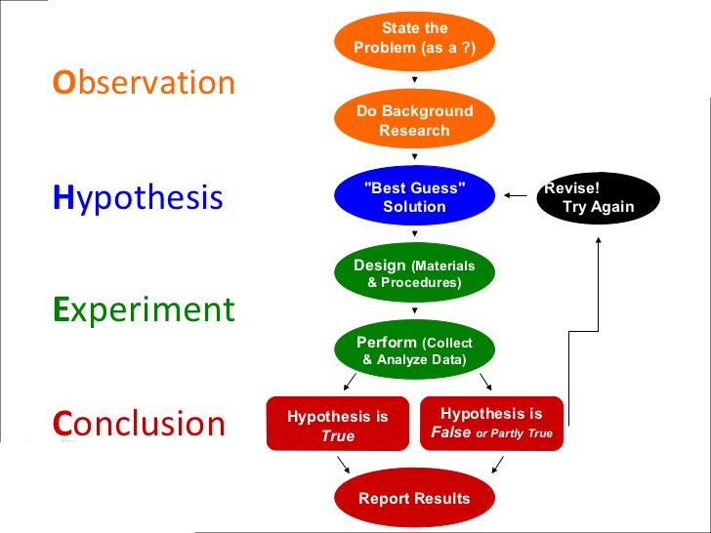

# Results

Systematically go through the relevant aspects of your data. Present tables and graphs of the DVs. The organization of these paragraphs will probably be in terms of the IVs. For example, "The change in value of voicing affects both vowel duration and consonant closure duration," rather than "The vowel duration is affected by speaking rate, vowel identity and voicing".)

Describe the important features of the data in the text. Lead the reader through the tables and figures (e.g., "As can be seen in the left side of Figure 1,"). Devise data presentation techniques that make the real meaning of the data as clear as possible. Be sure to label graphs and figures clearly. Organization of paragraphs would normally be in terms of the independent variables.

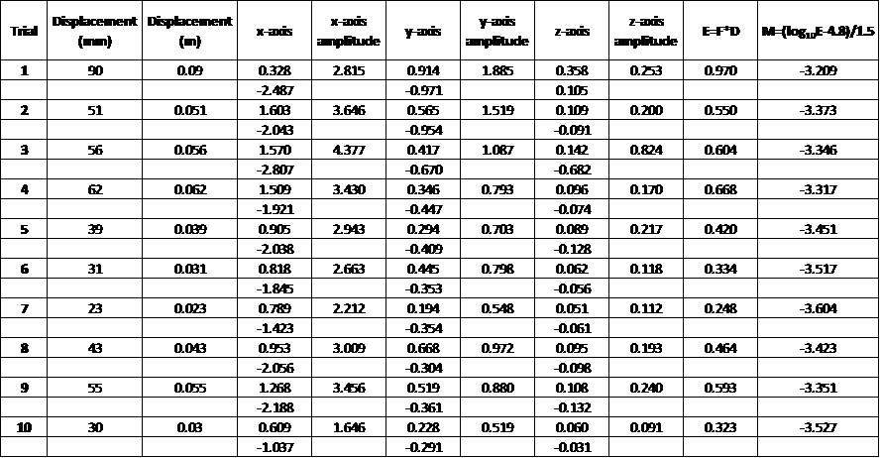

# Discussion

Discussion is the most important part of your report, because here, you show that you understand the experiment beyond the simple level of completing it. Explain. Analyze. Interpret. Some people like to think of this as the "subjective" part of the report. By that, they mean this is what is not readily observable. This part of the lab focuses on a question of understanding "What is the significance or meaning of the results?" To answer this question, use both aspects of discussion:

| Analysis | Interpretation |
| --- | --- |
| What do the results indicate clearly?  What have you found?  Explain what you know with certainty based on your results and draw conclusions: | What is the significance of the results? What ambiguities exist? What questions might we raise? Find logical explanations for problems in the data: |
| Since none of the samples reacted to the Silver foil test, therefore sulfide, if present at all, does not exceed a concentration of approximately 0.025 g/l. It is therefore unlikely that the water main pipe break was the result of sulfide-induced corrosion. | Although the water samples were received on 14 August 2000, testing could not be started until 10 September 2000. It is normally desirably to test as quickly as possible after sampling in order to avoid potential sample contamination. The effect of the delay is unknown. |

# Conclusion

In longer laboratory reports, a "Conclusion" section often appears. Whereas the "Results and Discussion" section has discussed the results individually, the "Conclusion" section discusses the results in the context of the entire experiment. Usually, the objectives mentioned in the "Introduction" are examined to determine whether the experiment succeeded. If the objectives were not met, you should analyze why the results were not as predicted. Note that in shorter reports or in reports where "Discussion" is a separate section from "Results," you often do not have a "Conclusion" section.

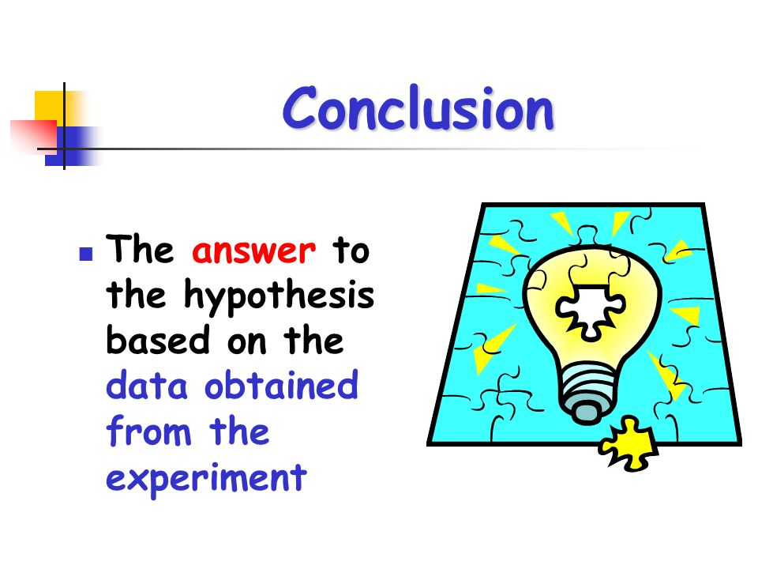

# Appendices

In a laboratory report, appendices often are included. One type of appendix that appears in laboratory reports presents information that is too detailed to be placed into the report's text. For example, if you had a long table giving voltage-current measurements for an RLC circuit, you might place this tabular information in an appendix and include a graph of the data in the report's text. Another type of appendix that often appears in laboratory reports presents tangential information that does not directly concern the experiment's objectives.

If the appendix is "formal," it should contain a beginning, middle, and ending. For example, if the appendix contains tables of test data, the appendix should not only contain the tabular data, but also formally introduce those tables, discuss why they have been included, and explain the unusual aspects that might confuse the reader. Because of time constraints, your instructor might allow you to include "informal" appendices with calculations and supplemental information. For such "informal" situations, having a clear beginning, middle, and ending is not necessary. However, you should still title the appendix, place a heading on each table, place a caption beneath each figure, and insert comments necessary for reader understanding.

# Further Reading

## Compare Expected Results with Those Obtained

If there were differences, how can your account for them? Saying "human error" implies you're incompetent. Be specific; for example, the instruments could not measure precisely, the sample was not pure or was contaminated, or calculated values did not take account of friction.

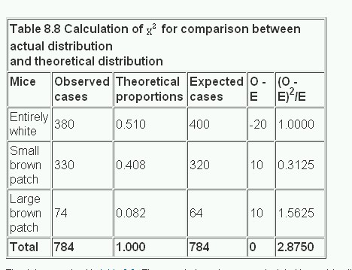

## Analyze Experimental Error

Was it avoidable? Was it a result of equipment? If an experiment was within the tolerances, you can still account for the difference from the ideal. If the flaws result from the experimental design explain how the design might be improved.

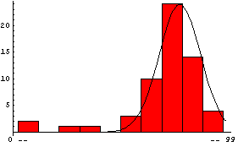

## Explain Your Results In Terms Of Theoretical Issues

Often undergraduate labs are intended to illustrate important physical laws, such as Kirchhoff's voltage law, or the Müller-Lyre illusion. Usually you will have discussed these in the introduction. In this section move from the results to the theory. How well has the theory been illustrated?

## Relate Results to Your Experimental Objective(S)

If you set out to identify an unknown metal by finding its lattice parameter and its atomic structure, you'd better know the metal and its attributes.

## Compare Your Results to Similar Investigations

In some cases, it is legitimate to compare outcomes with classmates, not to change your answer, but to look for any anomalies between the groups and discuss those.

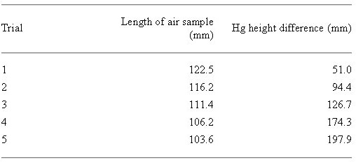

# References

References include your lab manual and any outside reading you have done. Check the site's documentation page to help you organize references in a way appropriate to your field.