**The application for the assignment: Todo List with Reminders Application**

GitHub URL:

The application which I created was a To-do application. It is a program with 218 lines of code any many features, such as editing the To-do List and further viewing the To-do list according to the user requirements. An additional facility provided by this application would be for certain Todo activities users can set reminders as well.

* In this Todo List application first, the console will show the welcome sign/note.

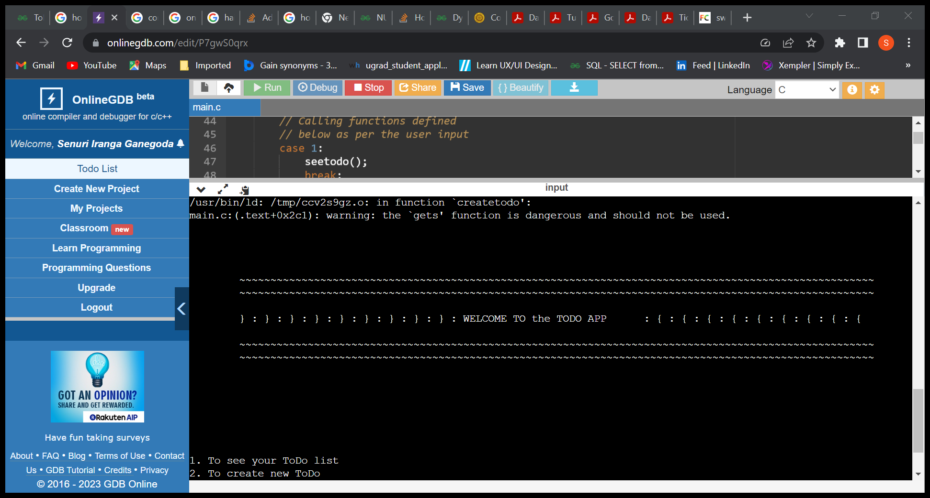

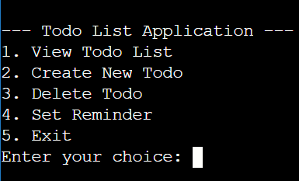

* Then there will be few options for the user to select.

And the options would be,

1. To see your Todo list
2. To create new Todo
3. To delete your Todo
4. To set a Reminder
5. Exit

Then the user can enter the relevant number to continue the process.

* A black background with white text

  Description automatically generatedIf in case the user enters a number which is not in the options an alert message will be given to the user.
* A black background with white lines

  Description automatically generatedPlease note for this application no Todo activities are already uploaded. Therefore, if the user selects option 1 which is view Todo list the application will show the user the empty Todo list as shown in the figure.
* Then again, the application will return to the very beginning showing the same options for the user to choose.
* When the user chooses option 2. To create new Todo, the program will ask the user to enter the Todo ID and the Todo description respectively. Further if the Todo was created successfully the program will give a message that the Todo was created. Additionally, the user can create a reminder if want.

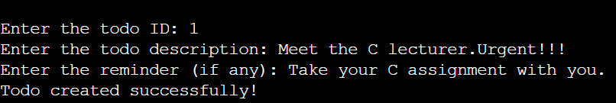

* Another advantage is that several numbers of Todo can be created for the same ID. So maybe the user can use the ID as a sign of a date etc.
* A black screen with white text

  Description automatically generatedThe next option would be deleting Todo. When user selects option 3. Delete Todo, the program will ask the user to enter the Todo ID that the user wants to delete. Then, When the ID is given the Todo will be deleted successfully and a message will be shown.
* A black background with white text

  Description automatically generatedIf in case user enters an invalid Todo ID to be deleted. The program will display an error message.
* When the user chooses option 4, the user will be able to set reminders for the Todo activities. Also user can set reminders when creating the Todo as well.

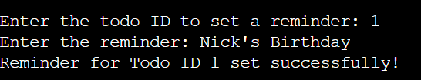

* Another option which was added later is that the user has the very option to hide characters of the Todo list so that the certain to-do activities can be masked. The user will be asked whether to mask or not when the Todo is created.

The result.

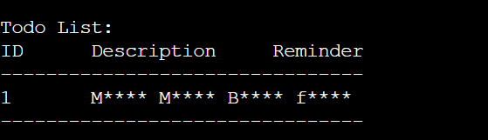

* A black background with white text

  Description automatically generatedAt the end when the user chose option 5. Which is exit, the program will give the goodbye message and exits from the program.