Q1.

Code:

***package Q_01;***

***import javax.swing.*;***

***public class Q1 {***

***public static void main(String[] args) {***

***JFrame frame = new JFrame();***

***frame.setVisible(true);***

***frame.setTitle("Welcome to Java.");***

***frame.setSize(800,600);***

***frame.setDefaultCloseOperation(JFrame.EXIT_ON_CLOSE);***

***}***

***}***

Output:

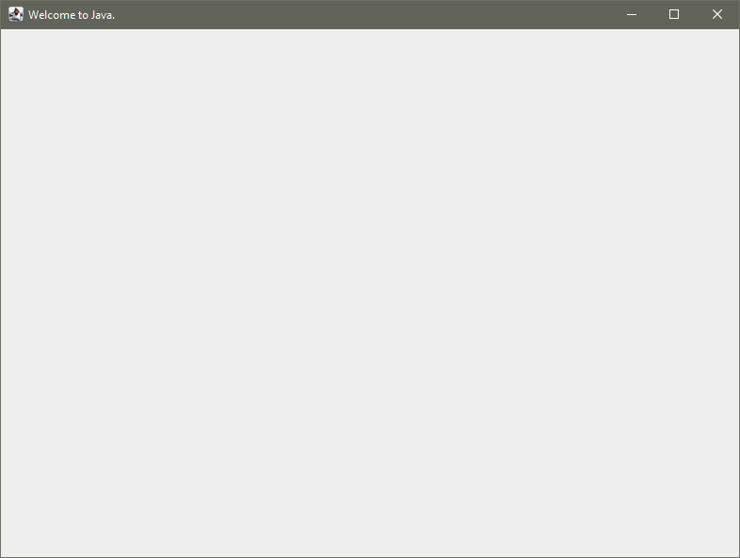

Q2.

Code:

***package Q_02;***

***import javax.swing.*;***

***import java.util.Scanner;***

***public class Q2 {***

***public static void main(String[] args) {***

***JFrame frame = new JFrame();***

***Scanner scanner = new Scanner(System.in);***

***String firstName;***

***System.out.println("Enter Your First Name");***

***firstName = scanner.next();***

***String lastName;***

***System.out.println("Enter Your Last Name");***

***lastName = scanner.next();***

***frame.setVisible(true);***

***frame.setTitle(firstName + " " + lastName);***

***frame.setSize(300,200);***

***frame.setDefaultCloseOperation(JFrame.EXIT_ON_CLOSE);***

***}***

***}***

Output:

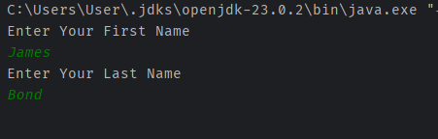

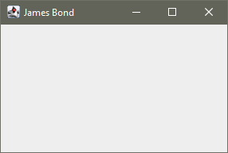

Q3.

Code:

***package Q_03;***

***import javax.swing.*;***

***import java.util.Scanner;***

***public class Q3 {***

***public static void main(String[] args) {***

***Scanner scanner = new Scanner(System.in);***

***String firstName;***

***System.out.println("Enter Your First Name");***

***firstName = scanner.next();***

***String middleName;***

***System.out.println("Enter Your Middle Name");***

***middleName = scanner.next();***

***String lastName;***

***System.out.println("Enter Your Last Name");***

***lastName = scanner.next();***

***String initial = new String(middleName.substring(0,1));***

***System.out.println(firstName + " " + initial + ". " + lastName);***

***}***

***}***

Output:

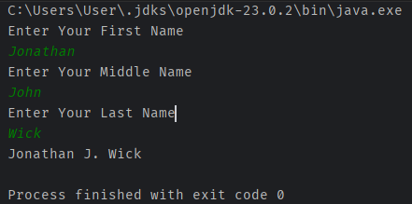

Q4.

Code:

***package Q_04;***

***import java.text.SimpleDateFormat;***

***import java.util.Date;***

***public class Q4 {***

***public static void main(String[] args) {***

***Date today = new Date();***

***SimpleDateFormat dmy = new SimpleDateFormat("dd MMMM yyyy");***

***System.out.println(dmy.format(today));***

***}***

***}***

Output:

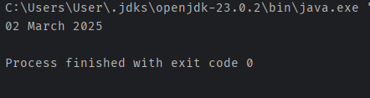

Q5.

Code:

***package Q_05;***

***import java.text.SimpleDateFormat;***

***import java.util.Date;***

***public class Q5 {***

***public static void main(String[] args) {***

***Date today = new Date();***

***SimpleDateFormat dmy = new SimpleDateFormat("EEEE, MMMM dd, yyyy");***

***System.out.println(dmy.format(today));***

***}***

***}***

Output:

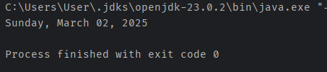

Q6.

Code:

***package Q_06;***

***import javax.swing.*;***

***import java.util.Scanner;***

***public class Q6 {***

***public static void main(String[] args) {***

***JFrame frame = new JFrame();***

***Scanner scanner = new Scanner(System.in);***

***int width;***

***System.out.println("Enter the width of window");***

***width = scanner.nextInt();***

***int height;***

***System.out.println("Enter the width of window");***

***height = scanner.nextInt();***

***String title;***

***System.out.println("Enter Title of window");***

***title = scanner.next();***

***frame.setVisible(true);***

***frame.setTitle(title);***

***frame.setSize(width,height);***

***frame.setDefaultCloseOperation(JFrame.EXIT_ON_CLOSE);***

***}***

***}***

Output:

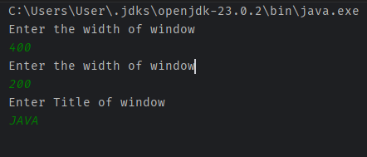

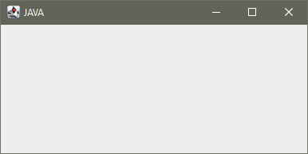

Q7.

Code:

***package Q_07;***

***import javax.swing.*;***

***import java.text.SimpleDateFormat;***

***import java.util.Date;***

***public class Q7 {***

***public static void main(String[] args) {***

***JFrame frame = new JFrame();***

***Date today = new Date();***

***SimpleDateFormat dmy = new SimpleDateFormat("hh:mm:ss a.");***

***frame.setVisible(true);***

***frame.setSize(400,400);***

***frame.setTitle(dmy.format(today));***

***frame.setDefaultCloseOperation(JFrame.EXIT_ON_CLOSE);***

***}***

***}***

Output:

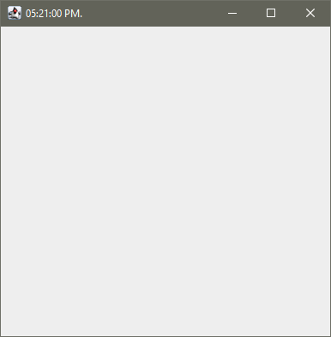

Q8.

Code:

***package Q_08;***

***import java.util.Scanner;***

***public class Q8 {***

***public static void main(String[] args) {***

***Scanner scanner = new Scanner(System.in);***

***System.out.println("Enter your phrase");***

***String phrase = scanner.nextLine();***

***int exclamationPlace = phrase.indexOf('!');***

***String before = phrase.substring(0,exclamationPlace);***

***String after = phrase.substring(exclamationPlace+1);***

***System.out.println(before);***

***System.out.println(after);***

***}***

***}***

Output:

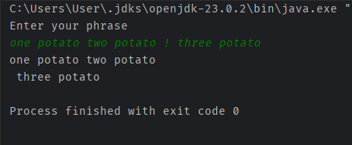

Q9.

Code:

***package Q_09;***

***import java.util.Scanner;***

***public class Q9 {***

***public static void main(String[] args) {***

***Scanner scanner = new Scanner(System.in);***

***System.out.println("Enter Your Sentence :");***

***String sentence = scanner.nextLine();***

***int charLength = sentence.length();***

***System.out.println(charLength);***

***System.out.println(sentence.substring(0,1));***

***System.out.println(sentence.substring(charLength-1, charLength));***

***}***

***}***

Output:

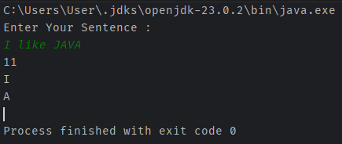

Q10.

Code:

***package Q_10;***

***import java.util.Scanner;***

***public class Q10 {***

***public static void main(String[] args) {***

***Scanner scanner = new Scanner(System.in);***

***System.out.println("Enter an odd-length word : ");***

***String text = scanner.nextLine();***

***if(text.length() % 2 == 1){***

***int textMiddle = text.length() / 2;***

***char middleCharacter = text.charAt(textMiddle);***

***System.out.println("Middle Character is : " + middleCharacter);***

***} else System.out.println("Not an odd-length word.");***

***}***

***}***

Output:

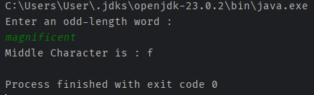

Odd length input

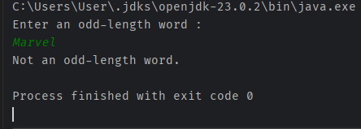

Even length input

Q11.

Code:

***package Q_11;***

***import java.util.Scanner;***

***public class Q11 {***

***public static void main(String[] args) {***

***Scanner scanner = new Scanner(System.in);***

***System.out.println("Enter your name (First Middle Last Format) : ");***

***String fullName = scanner.nextLine();***

***String[] NameParts = fullName.split(" ");***

***System.out.println(NameParts[2] + " " + NameParts[0] + " " + NameParts[1].charAt(0) + ".");***

***}***

***}***

Output:

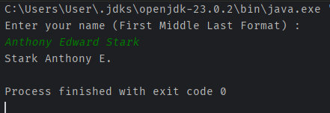

Q12.

Code:

***package Q_12;***

***import javax.swing.*;***

***public class Q12 {***

***public static void main(String[] args) {***

***JFrame frame = new JFrame();***

***frame.setVisible(true);***

***frame.setSize(300,200);***

***frame.setTitle("My First Frame");***

***frame.setLocation(100,50);***

***frame.setDefaultCloseOperation(JFrame.EXIT_ON_CLOSE);***

***}***

***}***

Output:

