Q1_a.

Code:

***package Q_01;***

***import java.util.Scanner;***

***public class a {***

***//a.***

***public static void main(String[] args) {***

***Scanner scanner = new Scanner(System.in);***

***System.out.println("Enter A : ");***

***double A = scanner.nextDouble();***

***System.out.println("Enter B : ");***

***double B = scanner.nextDouble();***

***System.out.println("Enter C : ");***

***double C = scanner.nextDouble();***

***double ANSWER = Math.sqrt(Math.pow(B, 2) + 4 * A * C);***

***System.out.println("your answer is : " + ANSWER);***

***}***

***}***

Output:

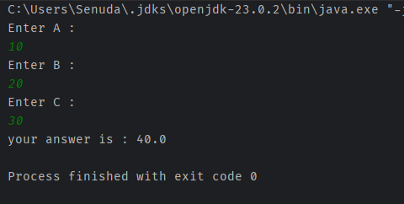

Q1_b.

Code:

***package Q_01;***

***import java.util.Scanner;***

***public class b {***

***//b.***

***public static void main(String[] args) {***

***Scanner scanner = new Scanner(System.in);***

***System.out.println("Enter X : ");***

***double X = scanner.nextDouble();***

***System.out.println("Enter Y : ");***

***double Y = scanner.nextDouble();***

***double ANSWER = Math.sqrt(X + 4 * Math.pow(Y, 3));***

***System.out.println("your answer is : " + ANSWER);***

***}***

***}***

Output:

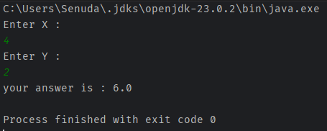

Q1_c.

Code:

***package Q_01;***

***import java.util.Scanner;***

***public class c {***

***//c.***

***public static void main(String[] args) {***

***Scanner scanner = new Scanner(System.in);***

***System.out.println("Enter X : ");***

***double X = scanner.nextDouble();***

***System.out.println("Enter Y : ");***

***double Y = scanner.nextDouble();***

***double ANSWER = Math.cbrt(X * Y);***

***System.out.println("your answer is : " + ANSWER);***

***}***

***}***

Output:

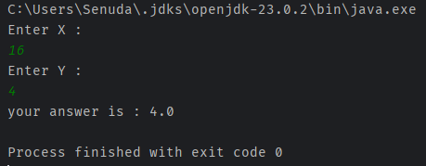

Q1_d.

Code:

***package Q_01;***

***import java.util.Scanner;***

***public class d {***

***//d.***

***public static void main(String[] args) {***

***Scanner scanner = new Scanner(System.in);***

***System.out.println("Enter radius : ");***

***double r = scanner.nextDouble();***

***double Area = Math.PI * (Math.pow(r, 2));***

***System.out.println("your Circle Area is : " + String.format("%.2f", Area));***

***}***

***}***

Output:

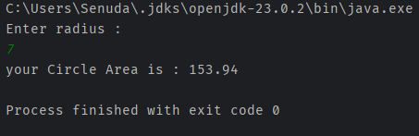

Q2.

Code:

***package Q_02;***

***import java.util.Scanner;***

***public class Q02 {***

***public static void main(String[] args) {***

***Scanner scanner = new Scanner(System.in);***

***System.out.println("Enter centimeter value : ");***

***double cm = scanner.nextDouble();***

***double in = cm / 2.54;***

***int feet = (int) (in / 12);***

***in = in % 12;***

***System.out.println("It's " + feet + " feet and " + String.format("%.2f", in) + " inches.");***

***}***

***}***

Output:

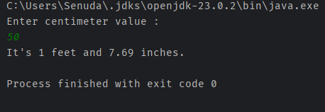

Q3.

Code:

***package Q_03;***

***import java.util.Scanner;***

***public class Q03 {***

***public static void main(String[] args) {***

***Scanner scanner = new Scanner(System.in);***

***System.out.println("Enter temperature in degrees Celsius : ");***

***double Celsius = scanner.nextDouble();***

***double Fahrenheit = (1.8 * Celsius) + 32;***

***System.out.println("your temperature is : " + Fahrenheit + " F");***

***}***

***}***

Output:

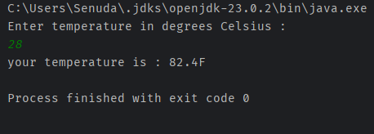

Q4.

Code:

***package Q_04;***

***import java.util.Scanner;***

***public class Q04 {***

***public static void main(String[] args) {***

***Scanner scanner = new Scanner(System.in);***

***System.out.println("Enter Body weight in pounds : ");***

***double weight = scanner.nextDouble();***

***double calories = weight * 19;***

***System.out.println("your Daily Calories intake is : " + calories);***

***}***

***}***

Output:

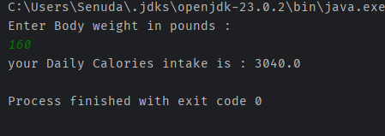

Q5.

Code:

***package Q_05;***

***import java.util.Scanner;***

***public class Q05 {***

***public static void main(String[] args) {***

***Scanner scanner = new Scanner(System.in);***

***System.out.println("Enter temperature in degrees Fahrenheit : ");***

***double Fahrenheit = scanner.nextDouble();***

***double Celsius = (5.0 / 9.0) * (Fahrenheit - 32);***

***System.out.println("your temperature is : " + String.format("%.2f", Celsius) + " C");***

***}***

***}***

Output:

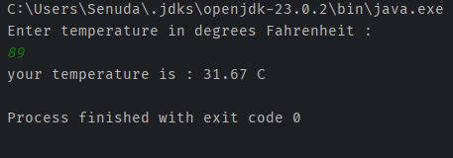

Q6.

Code:

***package Q_06;***

***import java.util.Calendar;***

***import java.util.GregorianCalendar;***

***import java.util.Scanner;***

***public class Q06 {***

***public static void main(String[] args) {***

***Scanner scanner = new Scanner(System.in);***

***GregorianCalendar calendar = new GregorianCalendar();***

***int currentYear = calendar.get(Calendar.YEAR);***

***System.out.println("Enter the year you born in : ");***

***int Year = scanner.nextInt();***

***int Age = currentYear - Year;***

***System.out.println("your were born in " + Year + " and will be " + Age + " this year.");***

***}***

***}***

Output:

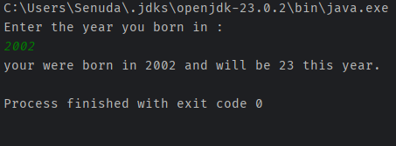

Q7.

Code:

***package Q_07;***

***import java.util.Scanner;***

***public class Q07 {***

***public static void main(String[] args) {***

***Scanner scanner = new Scanner(System.in);***

***System.out.println("Enter Weight in Kg: ");***

***int W = scanner.nextInt();***

***System.out.println("Enter Height in cm : ");***

***int H = scanner.nextInt();***

***double BMI = W / Math.pow((H / 100.0), 2);***

***System.out.println("your BMI is : " + String.format("%.2f", BMI));***

***}***

***}***

Output:

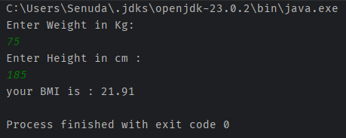

Q8.

Code:

***package Q_08;***

***import java.util.Scanner;***

***public class Q08 {***

***public static void main(String[] args) {***

***Scanner scanner = new Scanner(System.in);***

***System.out.println("Enter radius : ");***

***double r = scanner.nextDouble();***

***double V = (4.0 / 3.0) * (Math.PI * (Math.pow(r , 3)));***

***System.out.println("your sphere Volume is : " + String.format("%.2f", V));***

***}***

***}***

Output:

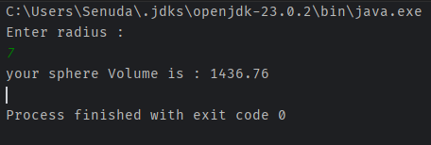

Q9.

Code:

***package Q_09;***

***import java.util.Scanner;***

***public class Q09 {***

***public static void main(String[] args) {***

***Scanner scanner = new Scanner(System.in);***

***System.out.println("Enter Dollar amount : ");***

***int P = scanner.nextInt();***

***System.out.println("Enter Annual Rate : ");***

***int R = scanner.nextInt();***

***System.out.println("Enter Years to invest : ");***

***int N = scanner.nextInt();***

***double Gain = P * (Math.pow((1 + (R / 100.0)), N));***

***System.out.println("your Gain after " + N + " years is " + String.format("%.2f", Gain));***

***}***

***}***

Output:

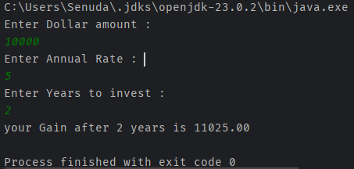

Q10.

Code:

***package Q_10;***

***import java.util.Scanner;***

***public class Q10 {***

***public static final int MONTHS_IN_YEAR = 12;***

***public static void main(String[] args) {***

***Scanner scanner = new Scanner(System.in);***

***System.out.println("Enter Loan amount : ");***

***int loanAmount = scanner.nextInt();***

***System.out.println("Enter Annual Interest Rate : ");***

***int rate = scanner.nextInt();***

***System.out.println("Enter Loan Period : ");***

***int loanPeriod = scanner.nextInt();***

***double MonthlyInterestRate = rate / 100.0 / MONTHS_IN_YEAR;***

***double NumberOfPayments = loanPeriod * MONTHS_IN_YEAR;***

***double monthlyPayment = (loanAmount * MonthlyInterestRate) / (1 - Math.pow(1 / (1 + MonthlyInterestRate), NumberOfPayments));***

***double totalPayment = monthlyPayment * NumberOfPayments;***

***System.out.println("your Monthly Payment is : " + String.format("%.2f", monthlyPayment));***

***System.out.println("your total Payment is : " + String.format("%.2f", totalPayment));***

***}***

***}***

Output:

