Q1.

Code:

***Minimum.JAVA*** Class

package Q_01;

import java.util.Scanner;

public class Minimum {

public static void main(String[] args) {

Scanner scan = new Scanner(System.in);

//User inputs for 3 integers

System.out.println("Enter Your First Integer : ");

int num1 = scan.nextInt();

System.out.println("Enter Your Second Integer : ");

int num2 = scan.nextInt();

System.out.println("Enter Your Third Integer : ");

int num3 = scan.nextInt();

//set minimun value to num1

int min = num1;

//find minimum value

if (num2 < min){

min = num2;

}

if(num3 < min){

min = num3;

}

//Display minimum value

System.out.println("Minimum Value : "+ min);

}

}

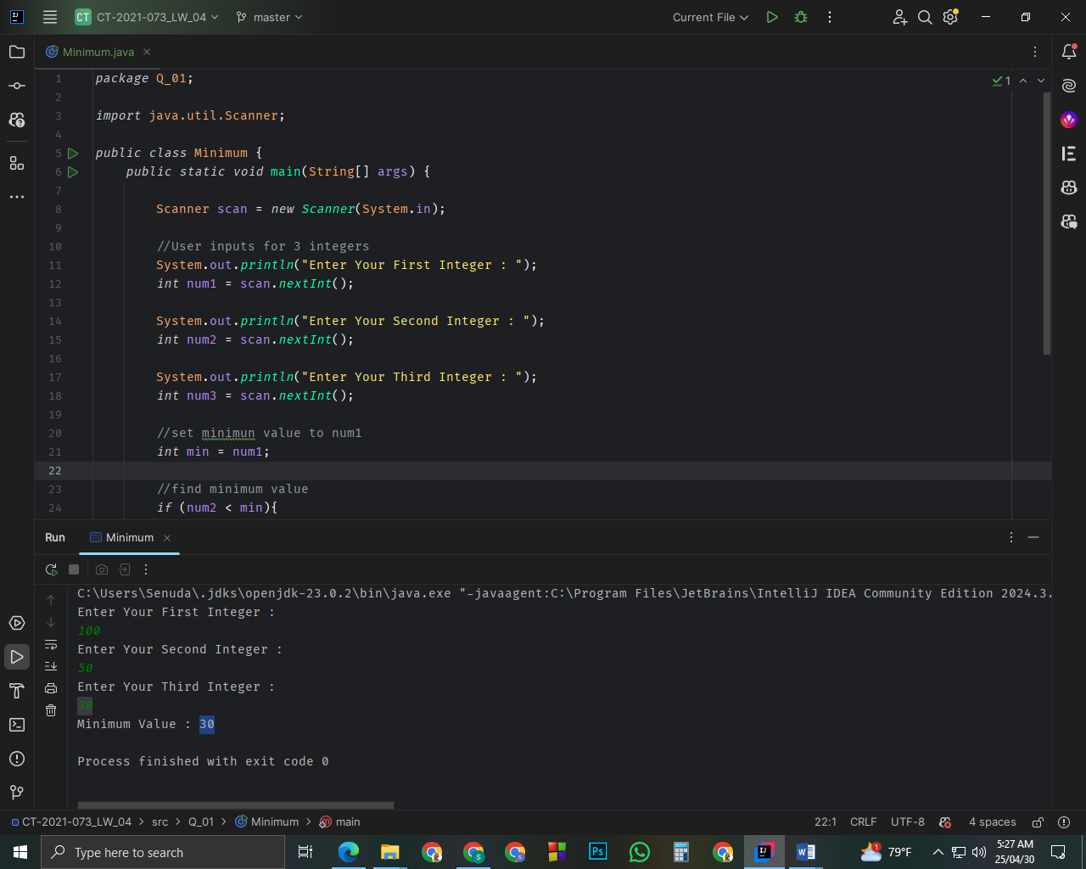

Q2.

Code:

***Main.JAVA*** Class

package Q_02;

import java.util.Scanner;

public class Main {

public static void main(String[] args) {

Scanner scanner = new Scanner(System.in);

// Color Choices

System.out.println("0.Magenta");

System.out.println("1.Cyan");

System.out.println("2.Red");

System.out.println("3.Blue");

System.out.println("4.Green");

System.out.println(" ");

//User Input

System.out.println("Select a number from (0 - 4) and get a color:");

int selection = scanner.nextInt();

String colorChoice;

//switch statement

switch (selection) {

case 0:

colorChoice = "Magenta";

break;

case 1:

colorChoice = "Cyan";

break;

case 2:

colorChoice = "Red";

break;

case 3:

colorChoice = "Blue";

break;

case 4:

colorChoice = "Green";

break;

default:

colorChoice = null;

break;

}

if (colorChoice == null){

System.out.println("Invalid Color Choice Selected!");

}else {

System.out.println("You selected : " + colorChoice);

}

}

}

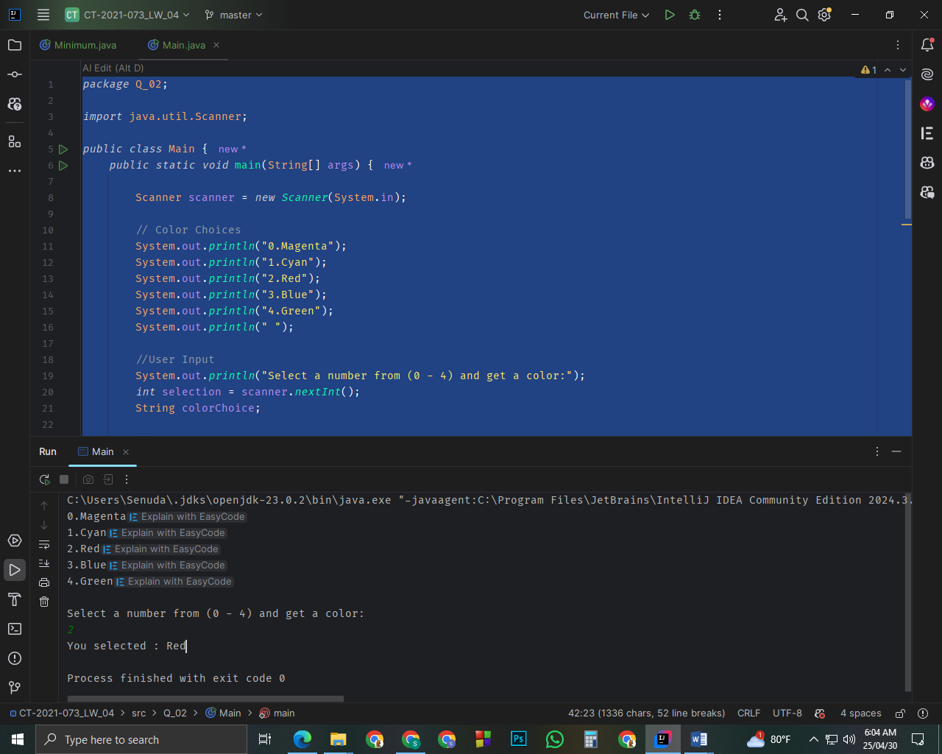

Q3.

Code:

package Q_03;

import java.util.Scanner;

public class PowerOf10 {

public static void main(String[] args) {

Scanner scanner = new Scanner(System.in);

//user input

System.out.println("Enter the power of 10 : ");

int power = scanner.nextInt();

String alert;

//switch statement

switch (power){

case 6:

alert="Million";

break;

case 9:

alert="Billion";

break;

case 12:

alert="Trillion";

break;

case 15:

alert="Quadrillion";

break;

case 18:

alert="Quintillion";

break;

case 21:

alert="Sextillion";

break;

case 30:

alert="Nonillion";

break;

case 100:

alert="Googol";

break;

default:

alert = null;

break;

}

if (alert == null) {

System.out.println("Invalid power selection");

} else {

System.out.println("You selected: " + alert);

}

}

}

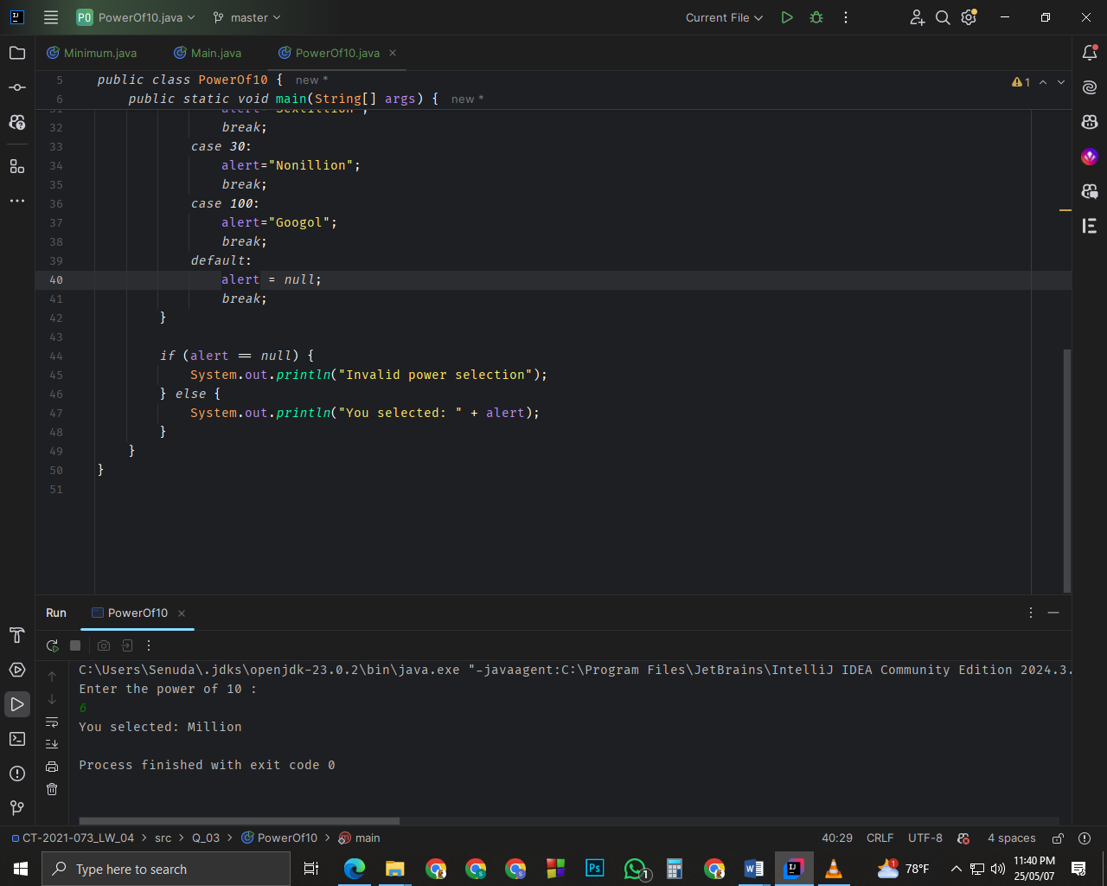

Q4.

Code:

package Q_04;

import java.util.Scanner;

public class LeapYear {

public static void main(String[] args) {

Scanner scanner = new Scanner(System.in);

//User input

System.out.println("Enter a year : ");

int year = scanner.nextInt();

boolean isLeapYear = true;

if ((year % 400 == 0) || (year % 4 == 0 && year % 100 != 0)){

System.out.println(year + " is a leap year.");

} else {

System.out.println(year + " is not a leap year.");

}

}

}

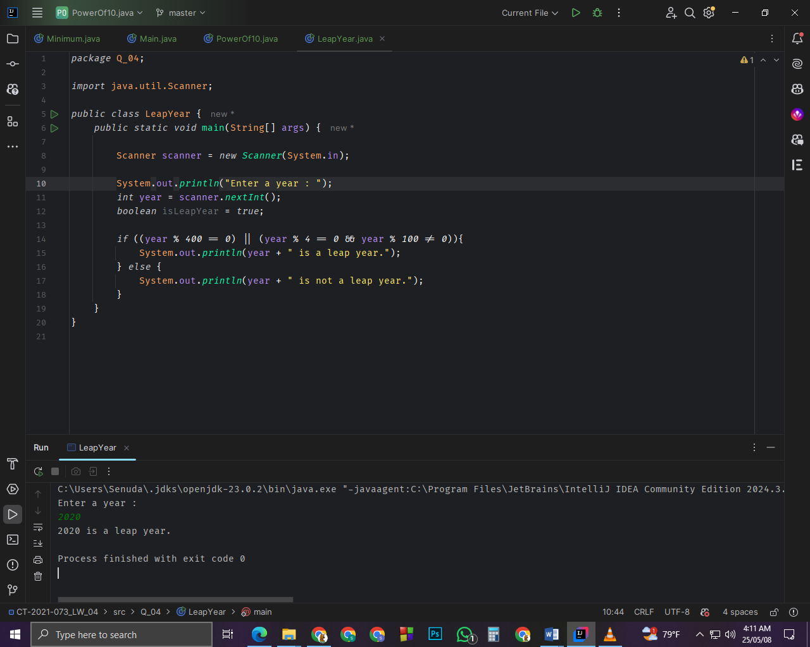

Q5.

Code:

package Q_05;

import java.util.Scanner;

public class Main {

public static void main(String[] args) {

Scanner input = new Scanner(System.in);

double total = 0.0;

System.out.println(" Welcome to Lo-Fat Burgers !!!");

System.out.println();

while (true) {

//Choosing category

System.out.println("Food Categories:");

System.out.println("1. Entrees");

System.out.println("2. Side Dishes");

System.out.println("3. Drinks");

System.out.println();

System.out.print("Enter the food category number: ");

int category = input.nextInt();

switch (category) {

case 1:

displayEntreeMenu();

break;

case 2:

displaySideDishMenu();

break;

case 3:

displayDrinkMenu();

break;

default:

System.out.println("Invalid Category Selection\n");

continue;

}

//Choosing items within category

System.out.println();

System.out.print("Enter the food item number: ");

int item = input.nextInt();

double price;

price = (category == 1) ? getEntreePrice(item)

: (category == 2) ? getSideDishPrice(item)

: getDrinkPrice(item);

if (price < 0) {

System.out.println("Invalid Item Selection\n");

} else {

System.out.printf("Item added");

total += price;

}

//Adding another step

System.out.print("Add another? (Yes - Any key / 0 - No): ");

if (input.next().equals("0")) {

break;

}

System.out.println();

}

//Printing total bill

System.out.println();

System.out.println("--------------------------------");

System.out.printf("Your total is: $%.2f%n", total);

System.out.println("Thank you for ordering at Lo-Fat Burgers!");

input.close();

}

//to display entree menu

public static void displayEntreeMenu() {

System.out.println();

System.out.println(" Entree Menu");

System.out.println("01. Tofu Burger $ 3.49");

System.out.println("02. Cajun Chicken $ 4.59");

System.out.println("03. Buffalo Wings $ 3.99");

System.out.println("04. Rainbow Fillet $ 2.99");

}

//to display side dish menu

public static void displaySideDishMenu() {

System.out.println();

System.out.println(" Side Dish Menu");

System.out.println("01. Rice Cracker $ 0.79");

System.out.println("02. No-Salt Fries $ 0.69");

System.out.println("03. Zucchini $ 1.09");

System.out.println("04. Brown Rice $ 0.59");

}

//to display drink menu

public static void displayDrinkMenu() {

System.out.println();

System.out.println(" Drink Menu");

System.out.println("01. Cafe Mocha $ 1.99");

System.out.println("02. Cafe Latte $ 1.90");

System.out.println("03. Espresso $ 2.49");

System.out.println("04. Oolong Tea $ 0.99");

}

//to get entree price

public static double getEntreePrice(int choice) {

switch (choice) {

case 1: return 3.49;

case 2: return 4.59;

case 3: return 3.99;

case 4: return 2.99;

default: return -1;

}

}

//to get side dish price

public static double getSideDishPrice(int choice) {

switch (choice) {

case 1: return 0.79;

case 2: return 0.69;

case 3: return 1.09;

case 4: return 0.59;

default: return -1;

}

}

//to get drink price

public static double getDrinkPrice(int choice) {

switch (choice) {

case 1: return 1.99;

case 2: return 1.90;

case 3: return 2.49;

case 4: return 0.99;

default: return -1;

}

}

}

