Q01.

Code:

package Q01;

public class Main {

public static void main(String[] args) {

for (int i = 10; i <50; i++) {

System.out.print(i + " ");

if (i % 10 == 9) {

System.out.println();

}

}

}

}

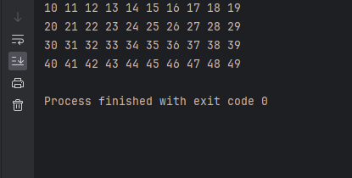

Q2.

Code:

package Q02;

import com.sun.glass.ui.Size;

import javax.swing.*;

import java.util.Scanner;

public class Main {

public static void main(String[] args) {

Scanner input = new Scanner(System.in);

int number;

do {

System.out.println("Enter a number : ");

number = input.nextInt();

if (number >= 0) {

int digit = digitCount(number);

System.out.println("The number " + number + " has " + digit + " numbers");

}

} while (number >= 0);

}

public static int digitCount(int number) {

int count = 0;

while (number > 0) {

number /= 10;

count++;

}

return count;

}

}

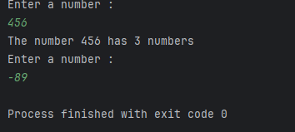

Q3.

Code:

package Q03;

import java.util.Scanner;

public class Main {

public static void main(String[] args) {

Scanner input = new Scanner(System.in);

System.out.println("Enter a number to get multiplications : ");

int N = input.nextInt();

for(int i=1; i<= 10; i++){

int result = N * 1;

System.out.println( N + " x " + i + " = " + result);

}

}

}

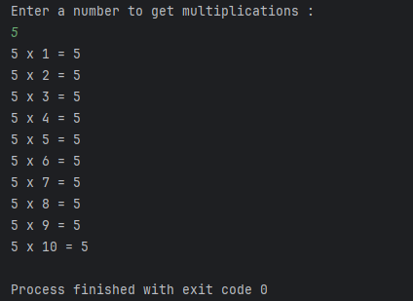

Q4.

Code:

package Q04;

import java.util.Scanner;

public class Main {

public static void main(String[] args) {

Scanner input = new Scanner(System.in);

System.out.println("Enter the number of line you want in Pyramid : ");

int height = input.nextInt();

int space = height - 1;

int asterisks = 1;

for (int i = 0; i <= height; i++) {

for (int j = 0; j <= space; j++) {

System.out.print(" ");

}

for (int k = 0; k < asterisks; k++) {

System.out.print("*");

}

System.out.println();

asterisks += 2;

space--;

}

}

}

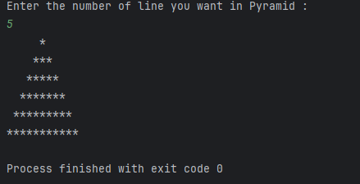

Q5.

Code:

package Q_05;

import java.util.Scanner;

public class Q05 {

public static void main(String[] args) {

// Create Scanner object for user input

Scanner scanner = new Scanner(System.in);

// Asking user to enter a word or phrase

System.out.print("Enter a word or phrase: ");

String input = scanner.nextLine();

// Check if the input is a palindrome

if (isPalindrome(input)) {

System.out.println("\"" + input + "\" is a palindrome.");

} else {

System.out.println("\"" + input + "\" is not a palindrome.");

}

// Close scanner

scanner.close();

}

// Method to check if a string is a palindrome

public static boolean isPalindrome(String text) {

String cleanText = text.replaceAll("[^a-zA-Z0-9]", "").toLowerCase();

int left = 0;

int right = cleanText.length() - 1;

while (left < right) {

if (cleanText.charAt(left) != cleanText.charAt(right)) {

return false;

}

left++;

right--;

}

return true;

}

}

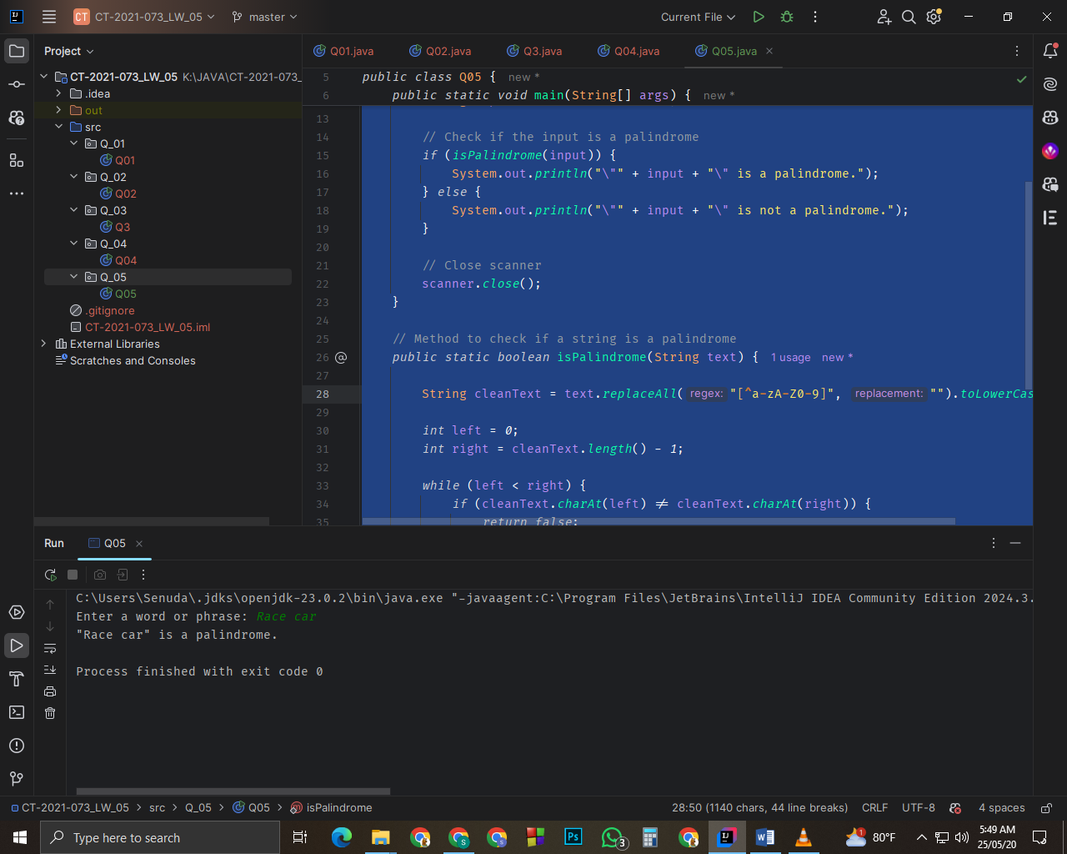

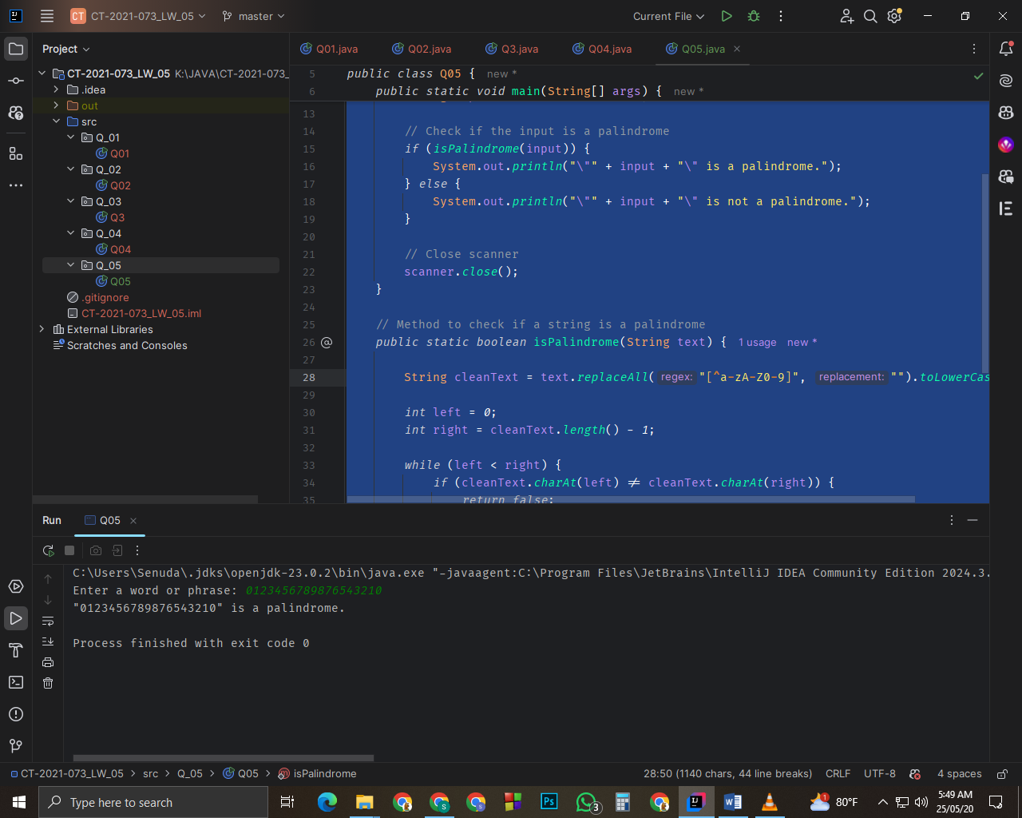

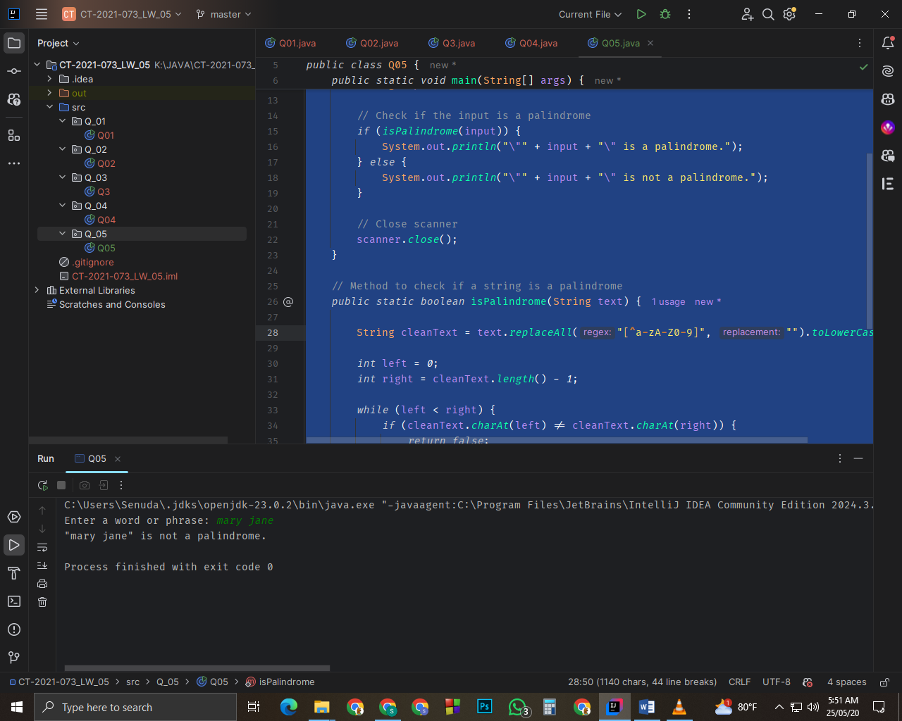

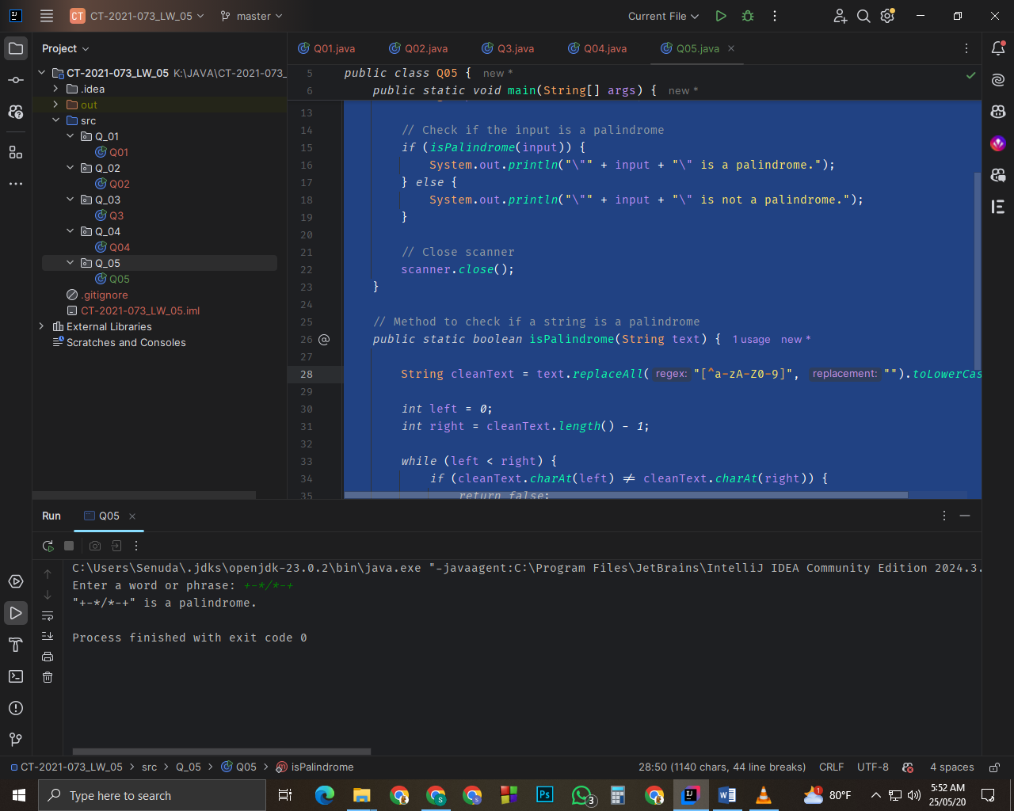

Q6.

Code:

package Q_06;

import java.util.Random;

import java.util.Scanner;

public class Q06 {

public static void main(String[] args) {

// Initialize random number generator

Random random = new Random();

int targetNumber = random.nextInt(100) + 1;

// Create input scanner

Scanner inputScanner = new Scanner(System.in);

int userGuess;

int attemptCount = 0;

System.out.println("Guess the number between 1-100:");

// Main game loop

while (true) {

userGuess = inputScanner.nextInt();

attemptCount++;

if (userGuess < targetNumber) {

System.out.println("Higher! Try again:");

} else if (userGuess > targetNumber) {

System.out.println("Lower! Try again:");

} else {

System.out.printf("Correct! Guessed in %d attempts.%n", attemptCount);

break;

}

}

inputScanner.close();

}

}

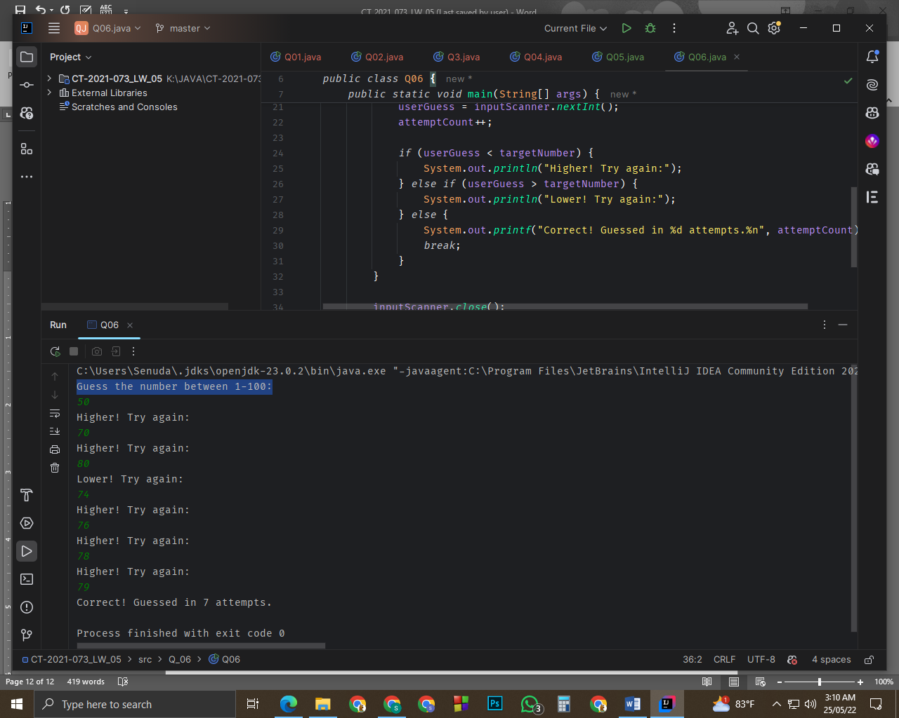

Q7.

Code:

package Q_07;

import java.util.Scanner;

public class Q07 {

public static void main(String[] args) {

Scanner scanner = new Scanner(System.in);

//User sentence input

System.out.println("Enter a sentence:");

String sentence = scanner.nextLine();

//User replacing word input

System.out.println("Enter the word to be replaced:");

String wordToReplace = scanner.next();

//User replacement word input

System.out.println("Enter the replacement word:");

String replacementWord = scanner.next();

//dividing into words - neglect spaces

String[] words = sentence.split(" ");

for (int i = 0; i < words.length; i++) {

if (words[i].equals(wordToReplace)) {

words[i] = replacementWord;

}

}

// Rebuild sentence using StringBuilder

String modifiedSentence = String.join(" ", words);

System.out.println("Modified sentence:");

System.out.println(modifiedSentence);

scanner.close();

}

}

