Q1.

Code:

***Temperature.JAVA*** Class

package Q_01_AND_Q_02;

public class Temperature {

private double celsius;

private double fahrenheit;

//No-Arg Constructor for Temperature

public Temperature() {

}

// Parameterized Constructor for Temperature

public Temperature(double celsius) {

this.celsius = celsius;

}

//getter method for toCelsius

public double toCelsius() {

return celsius;

}

//getter method for toFahrenheit

public double toFahrenheit() {

return fahrenheit;

}

//setter method for setFahrenheit

public void setFahrenheit(double fahrenheit) {

this.fahrenheit = fahrenheit;

}

//setter method for setCelsius

public void setCelsius(double celsius) {

this.celsius = celsius;

}

public double computeFahrenheit(){

double fahrenheit = celsius * 9 / 5 + 32;

return fahrenheit;

}

public double computeCelsius(){

double celsius = (toCelsius() - 32) * 5 / 9;

return celsius;

}

}

***Main1.JAVA*** Class

package Q_01_AND_Q_02;

import java.util.Scanner;

public class Main1 {

public static void main(String[] args) {

//Data member

double celsiusTemperature;

Scanner input = new Scanner(System.in);

//Input for celsiusTemperature

System.out.println("Enter Temperature in Celsius : ");

celsiusTemperature = input.nextDouble();

Temperature fromCelsius = new Temperature(celsiusTemperature);

//compute fahrenheitValue

double fahrenheitValue = fromCelsius.computeFahrenheit();

//Output for fahrenheitValue

System.out.println("Fahrenheit Temperature is " + String.format("%.2f", fahrenheitValue));

}

}

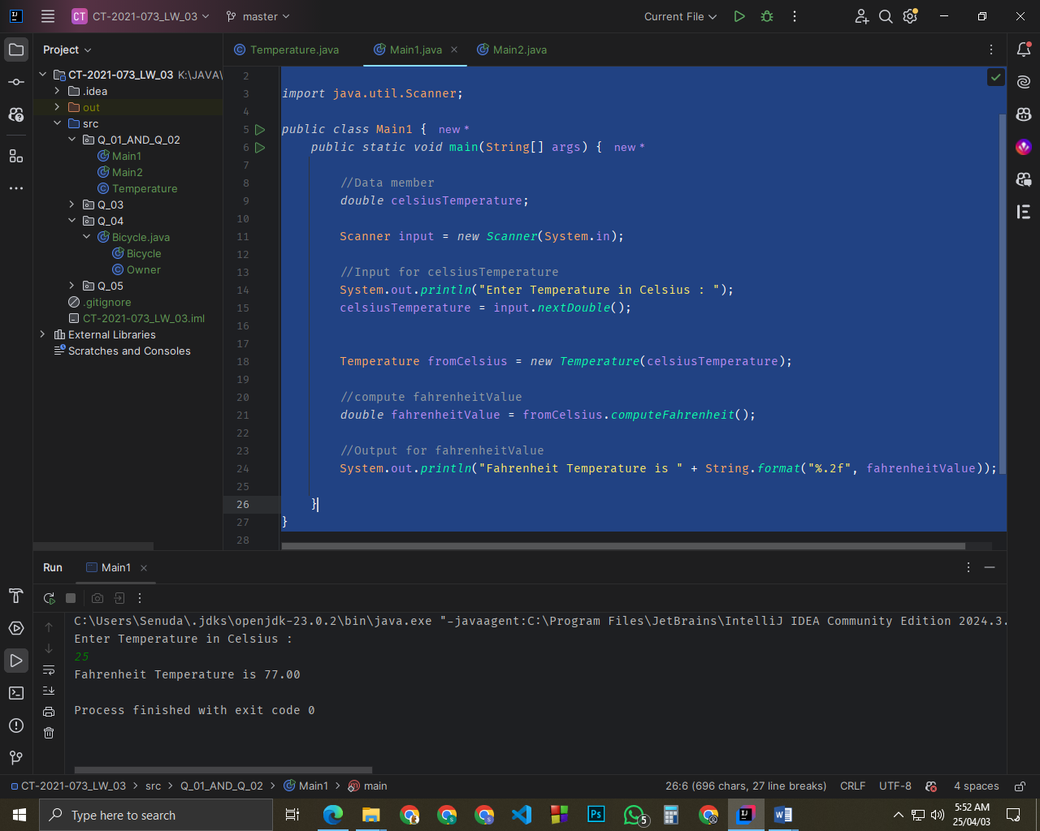

Q2.

Code:

***Main2.JAVA*** Class

package Q_01_AND_Q_02;

import java.util.Scanner;

public class Main2 {

public static void main(String[] args) {

//Data member

double fahrenheitTemperature;

Scanner input = new Scanner(System.in);

//Input for fahrenheitTemperature

System.out.println("Enter Temperature in Fahrenheit : ");

fahrenheitTemperature = input.nextDouble();

Temperature fromFahrenheit = new Temperature(fahrenheitTemperature);

//compute fahrenheitValue

double celsiusValue = fromFahrenheit.computeCelsius();

//Output for fahrenheitValue

System.out.println("Celsius Temperature is " + String.format("%.2f", celsiusValue));

}

}

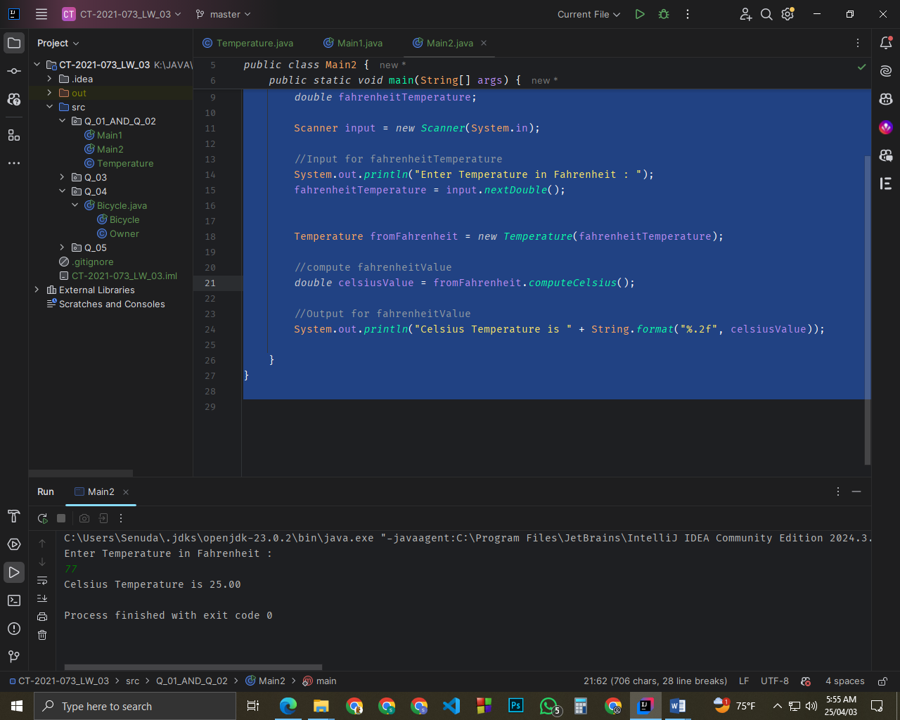

Q3.

Code:

***Circle.JAVA*** Class

package Q_03;

public class Circle {

//Data member

private double radius;

//constructor

public Circle(double radius) {

this.radius = radius;

}

//setter method for setRadius

public void setRadius(double radius) {

this.radius = radius;

}

//getter method for getRadius

public double getRadius() {

return radius;

}

//compute area and return

public double computeArea(){

double area = Math.PI * Math.pow(radius , 2);

return area;

}

//compute circumference and return

public double computeCircumference(){

double circumference = 2 * Math.PI * radius;

return circumference;

}

}

***Main.JAVA*** Class

package Q_03;

import java.util.Scanner;

public class Main {

public static void main(String[] args) {

//Data member

double innerCircleRadius;

double outerCircleRadius;

Scanner input = new Scanner(System.in);

//Input for innerCircleRadius

System.out.println("Enter Inner Circle Radius: ");

innerCircleRadius = input.nextDouble();

//Input for outerCircleRadius

System.out.println("Enter Outer Circle Radius: ");

outerCircleRadius = input.nextDouble();

Circle innerCircle = new Circle(innerCircleRadius);

Circle outerrCircle = new Circle(outerCircleRadius);

//compute shadedArea

double innerCircleArea = innerCircle.computeArea();

double outerCircleArea = outerrCircle.computeArea();

double shadedArea = outerCircleArea - innerCircleArea;

//compute shadedCircumference

double innerCircleCircumference = innerCircle.computeCircumference();

double outerCircleCircumference = outerrCircle.computeCircumference();

double shadedCircumference = outerCircleCircumference - innerCircleCircumference;

//Output for shadedArea and shadedCircumference

System.out.println("Shaded Circle Area is " + String.format("%.2f", shadedArea));

System.out.println("Shaded Circle Circumference is " + String.format("%.2f", shadedCircumference));

}

}

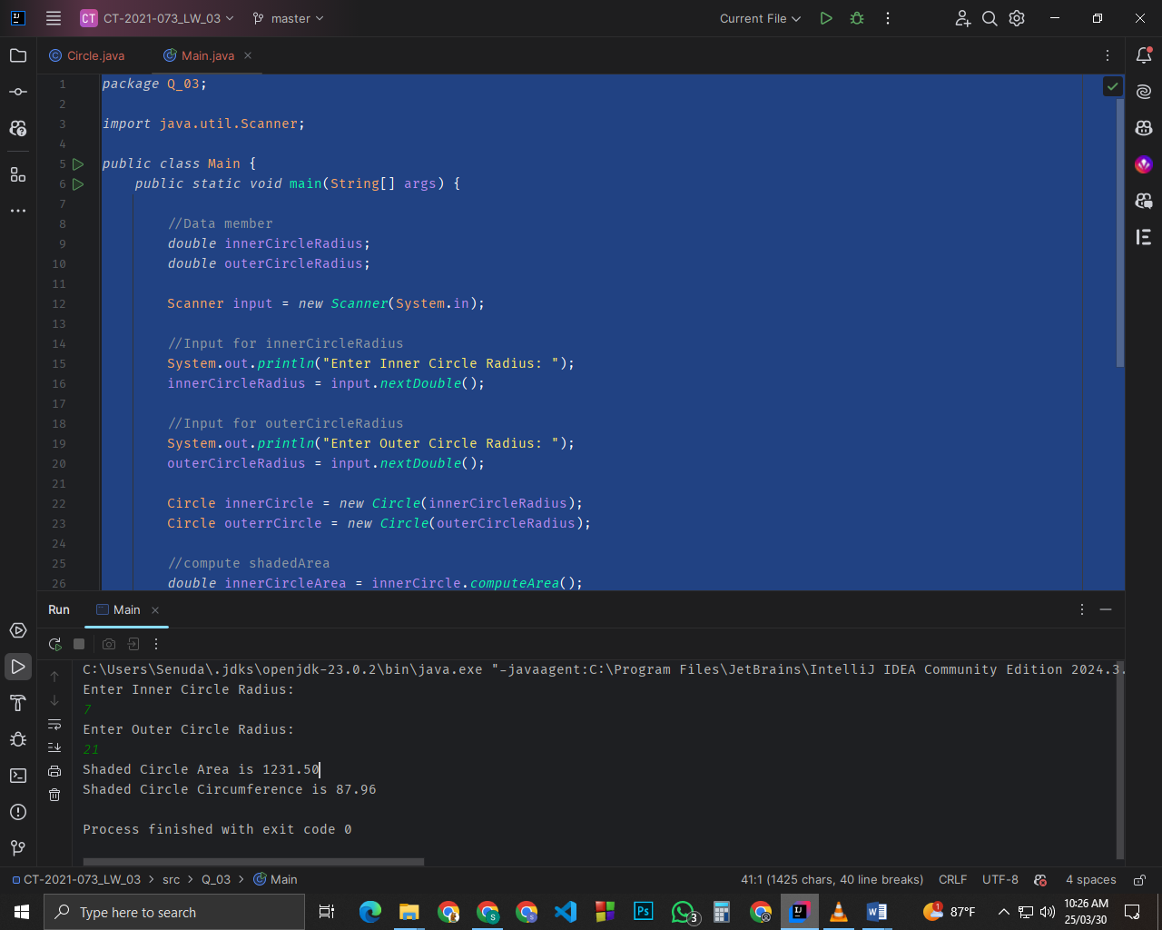

Q4.

Code

***Owner.JAVA*** Class

package Q_04;

class Owner{

// Data Member

private String ownerName;

private String phoneNo;

private String model;

//Constructor:

public Owner(String ownerName, String phoneNo, String model) {

this.ownerName = ownerName;

this.phoneNo = phoneNo;

this.model = model;

}

//Returns the name of this bicycle's owner

public String getOwnerName() {

return ownerName;

}

//Assigns the name of this bicycle's owner

public void setOwnerName(String ownerName) {

this.ownerName = ownerName;

}

//Returns the phoneNo of this bicycle's owner

public String getPhoneNo() {

return phoneNo;

}

//Assigns the name of this bicycle's owner

public void setPhoneNo(String phoneNo) {

this.phoneNo = phoneNo;

}

//Returns the model of this bicycle

public void setModel(String model) {

this.model = model;

}

//Assigns the model of this bicycle

public String getModel() {

return model;

}

}

***Bicycle.JAVA*** Class

public class Bicycle {

public static void main(String[] args) {

//input data

Owner U01 = new Owner("Sammy" , "712345678" , "BMX");

Owner U02 = new Owner("Ann" , "0779876543" , "Singer");

//output data

System.out.println("\nOwner Name is : " + U01.getOwnerName());

System.out.println("Owner Phone is : " + U01.getPhoneNo());

System.out.println("Bicycle Model is : " + U01.getModel());

System.out.println("\nOwner Name is : " + U02.getOwnerName());

System.out.println("Owner Phone is : " + U02.getPhoneNo());

System.out.println("Bicycle Model is : " + U02.getModel());

}

}

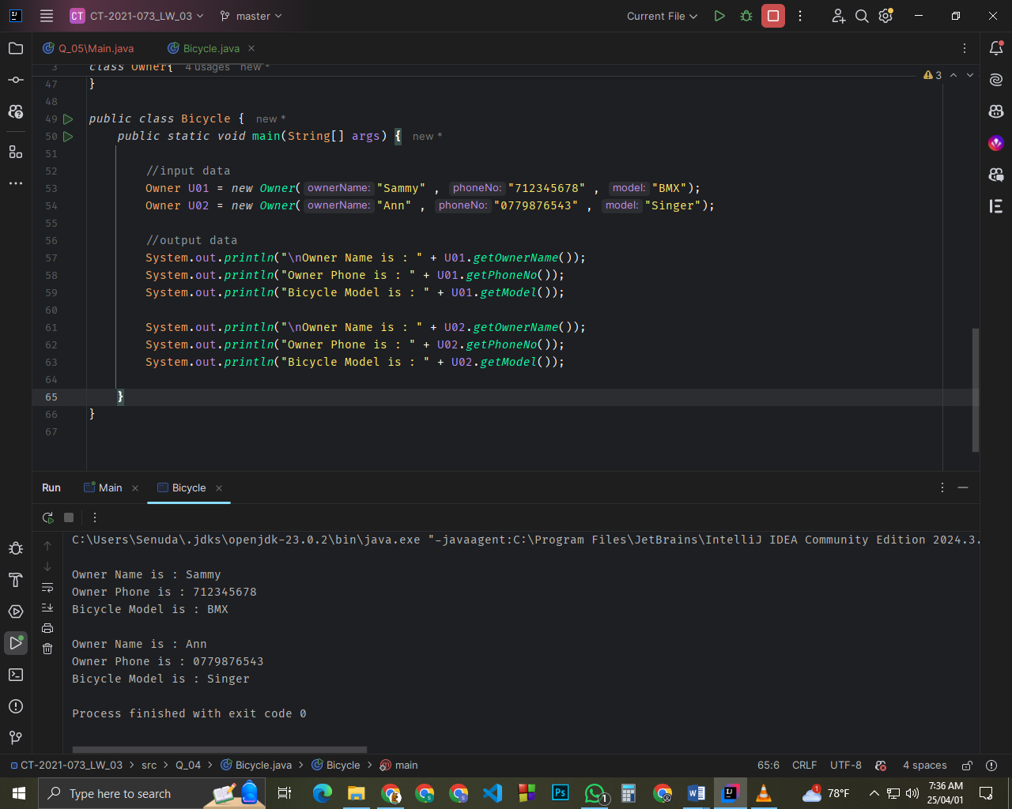

Q5.

Code

***Course.JAVA*** Class

package Q_05;

public class Course {

//Data member

private String courseName;

private String courseCode;

private Lecturer lecturerInCharge;

//constructor

public Course(String courseName, String courseCode, Lecturer lecturer) {

this.courseName = courseName;

this.courseCode = courseCode;

this.lecturerInCharge = lecturer;

}

//getter method for courseName

public String getCourseName() {

return courseName;

}

//setter method for courseName

public void setCourseName(String courseName) {

this.courseName = courseName;

}

//getter method for courseCode

public String getCourseCode() {

return courseCode;

}

//setter method for courseCode

public void setCourseCode(String courseCode) {

this.courseCode = courseCode;

}

//getter method for lecturerInCharge

public Lecturer getLecturerInCharge() {

return lecturerInCharge;

}

//setter method for lecturerInCharge

public void setLecturerInCharge(Lecturer lecturerInCharge) {

this.lecturerInCharge = lecturerInCharge;

}

}

***Lecturer.JAVA*** Class

package Q_05;

public class Lecturer {

//Data member

private String lecturerName;

private String courseTeaching;

//constructor

public Lecturer(String lecturerName, String courseTeaching) {

this.lecturerName = lecturerName;

this.courseTeaching = courseTeaching;

}

//getter method for lecturerName

public String getLecturerName() {

return lecturerName;

}

//setter method for lecturerName

public void setLecturerName(String lecturerName) {

this.lecturerName = lecturerName;

}

//getter method for courseTeaching

public String getCourseTeaching() {

return courseTeaching;

}

//setter method for courseTeaching

public void setCourseTeaching(String courseTeaching) {

this.courseTeaching = courseTeaching;

}

}

***Student.JAVA*** Class

package Q_05;

public class Student {

//Data member

private String studentName;

private String degreeName;

private String courseFollowing;

//constructor

public Student(String studentName, String degreeName, String courseFollowing) {

this.studentName = studentName;

this.degreeName = degreeName;

this.courseFollowing = courseFollowing;

}

//getter method for studentName

public String getStudentName() {

return studentName;

}

//setter method for studentName

public void setStudentName(String studentName) {

this.studentName = studentName;

}

//getter method for degreeName

public String getDegreeName() {

return degreeName;

}

//setter method for degreeName

public void setDegreeName(String degreeName) {

this.degreeName = degreeName;

}

//getter method for courseFollowing

public String getCourseFollowing() {

return courseFollowing;

}

//setter method for courseFollowing

public void setCourseFollowing(String courseFollowing) {

this.courseFollowing = courseFollowing;

}

}

***Main.JAVA*** Class

package Q_05;

public class Main {

public static void main(String[] args) {

//input data

Lecturer lecturer01 = new Lecturer("Dr.Kesavan" , "JAVA");

Course course01 = new Course("JAVA" , "IT01" , lecturer01);

Student student01 = new Student("Silva" , "BICT" , "Gaming development");

Lecturer lecturer02 = new Lecturer("Dr.Carl" , "Software Engineering");

Course course02 = new Course("Networking" , "IT02" , lecturer01);

Student student02 = new Student("Sammy" , "BCS" , "CyberSecurity");

//output data

System.out.println("\nstudent Name is : " + student01.getStudentName());

System.out.println("Student Degree Name is : " + student01.getDegreeName());

System.out.println("Student learning Course Name is : " + student01.getCourseFollowing());

System.out.println("Course Name is : " + course01.getCourseName());

System.out.println("Course Code is : " + course01.getCourseCode());

System.out.println("Lecturer Name is : " + lecturer01.getLecturerName());

System.out.println(lecturer01.getLecturerName() + " Teaching Course is : " + lecturer01.getCourseTeaching());

System.out.println("\nstudent Name is : " + student02.getStudentName());

System.out.println("Student Degree Name is : " + student02.getDegreeName());

System.out.println("Student learning Course Name is : " + student02.getCourseFollowing());

System.out.println("Course Name is : " + course02.getCourseName());

System.out.println("Course Code is : " + course02.getCourseCode());

System.out.println("Lecturer Name is : " + lecturer02.getLecturerName());

System.out.println(lecturer02.getLecturerName() + " Teaching Course is : " + lecturer02.getCourseTeaching());

}

}

