|  |  |
| --- | --- |
| Student ID | IT22179258 |
| Batch | 5.2 |
| Marks |  |
| 1. Code Quality & Organization   (2 Marks) |  |
| 1. Functionality (3 Marks) |  |
| 1. Creativity & User Interface Design (2 Marks) |  |
| 1. Advanced Features & Data Persistence (3 Marks) |  |
| Total: 10 Marks |  |
| Evaluator |  |

**Description:**

Productive Life is the all-in-one productivity app designed to help anyone stay organized, focused, and on track with your goals. Whether they are planning their day, managing tasks, or setting reminders, Productive Life has everything that is needed to optimize time and boost efficiency. **Key features of this app,**

* **Task List Management**: Easily create, organize, and prioritize your tasks. Keep track of your to-do list, check off completed tasks, and stay on top of your daily activities.
* **Set Timers**: Use the built-in timer to stay focused and manage your time effectively.
* **Create Reminders**: Never forget an important task or event again. Set reminders for deadlines, meetings, and personal commitments to ensure you’re always prepared.
* **User-Friendly Interface**: A clean and intuitive interface makes it easy to navigate and manage productivity.

**Screenshots:**

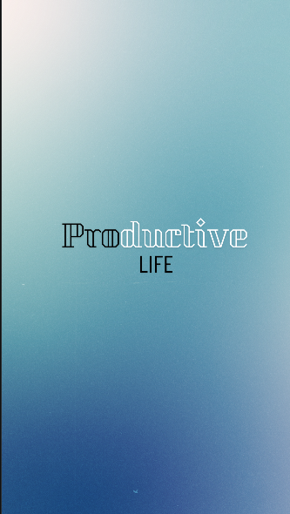 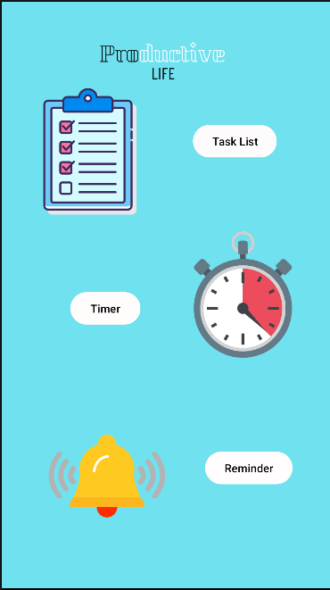

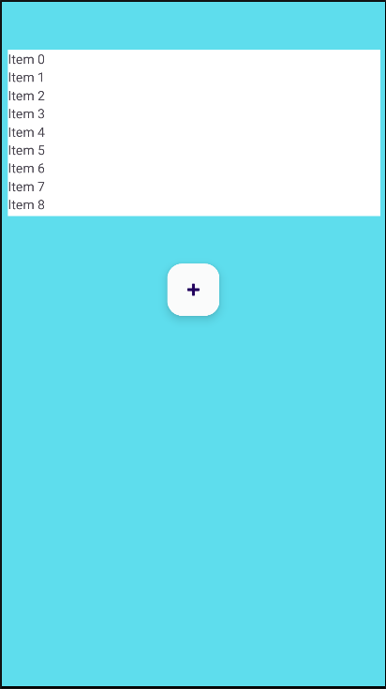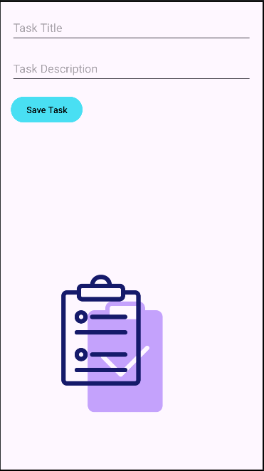

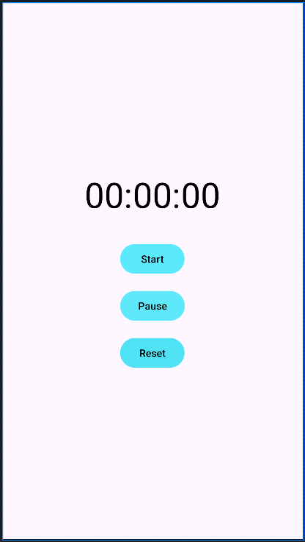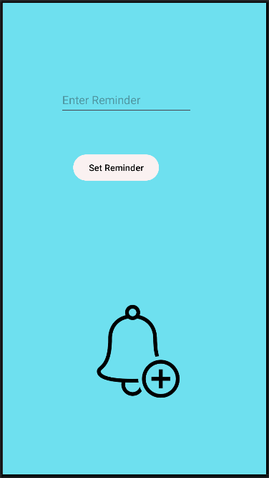

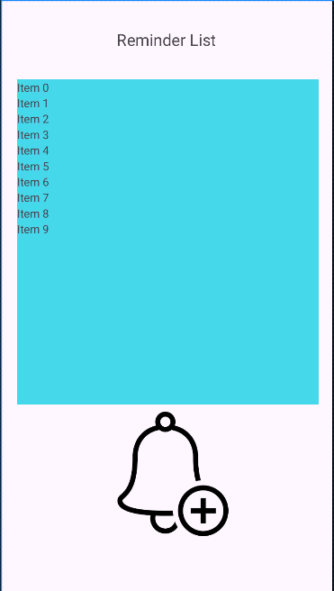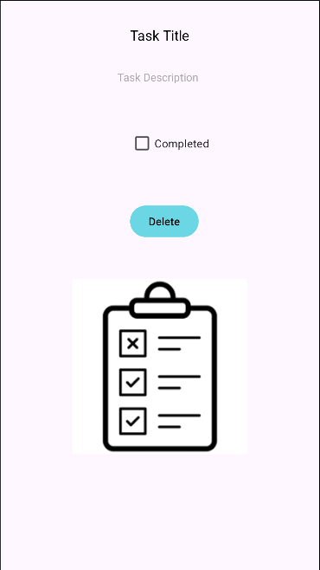

**Content of xml files of Strings and Colors:**

**Strings**

<resources>  
 <string name="app_name">Productive Life</string>  
 <string name="timer">Timer</string>  
 <string name="reminder">Reminder</string>  
 <string name="task_list">Task List</string>  
 <string name="add_new_task">Add new task</string>  
 <string name="enter_reminder">Enter Reminder</string>  
 <string name="set_reminder">Set Reminder</string>  
 <string name="completed">Completed</string>  
 <string name="task_description">Task Description</string>  
 <string name="task_title">Task Title</string>  
 <string name="_00_00_00">00:00:00</string>  
 <string name="start">Start</string>  
 <string name="pause">Pause</string>  
 <string name="reset">Reset</string>  
 <string name="delete">Delete</string>  
 <string name="delete1">Delete</string>  
</resources>

**Colors**

<?xml version="1.0" encoding="utf-8"?>  
<resources>  
 <color name="black">#FF000000</color>  
 <color name="white">#FFFFFFFF</color>  
 <color name="aqua">#49DFF3</color>  
</resources>