
PostNatalCare+ is a comprehensive maternal health platform designed to support mothers throughout their postnatal journey. The service would offer a tiered structure to ensure inclusivity for all users—whether they rely on public healthcare or private coverage.
The platform provides a centralized hub for tracking maternal and child health, managing workflows, and accessing educational resources. It empowers mothers with tools to monitor baby growth, vaccination schedules, and postpartum recovery, while offering personalized reminders and community support.
Through its tiered approach, PostNatalCare+ delivers:
- Tier 1: Free access to essential maternal care features for all users.
- Tier 2: Seamless integration with medical aid for claim management and premium content.
- Tier 3: Advanced public healthcare services, including virtual consultations and partnerships with private providers at reduced rates.
By combining technology, education, and care coordination, PostNatalCare+ aims to bridge gaps in maternal health services, improve outcomes, and make quality care accessible to every mother.

Tier 1: Free Subscribers
Target: General public without medical aid
Features:
- Basic Maternal Care Tracking: Baby’s weight, vaccination status, and milestones.
- Educational Content: Articles and videos on postnatal care, breastfeeding, and nutrition.
- Community Support: Access to public peer-support groups.
- Reminders: Push/email notifications for vaccinations and check-ups.
- Downloadable Basic Reports: For personal records.

Tier 2: Connect Medical Aid
Target: Users with medical aid coverage
Features:
- All Tier 1 Features plus:
- Medical Aid Integration: API or manual verification for claims.
- Premium Dashboard: Advanced maternal health tracking.
- Claim Assistance: Download health reports formatted for medical aid submission.
- Priority Support: Faster response times for queries.

Tier 3: Advanced Public Healthcare & Consultation
Target: Public healthcare users seeking enhanced services (with optional private partnerships)
Features:
- All Tier 1 & 2 Features plus:
- Virtual Consultations: With public health professionals or partnered private providers at reduced rates.
- Advanced Analytics: Personalized care plans based on health data.
- Exclusive Content: Specialized guides for high-risk pregnancies and postnatal complications.
- Discounted Services: Through partnerships with private clinics (e.g., lactation consultants, physiotherapy).
- Integration with Public Health Systems: Sync vaccination and maternal health data with government records.

1. Signup & Onboarding
- Action: Mother registers on the Maternal-Child Health portal.
- Inputs: Name, email/phone, baby’s birth date, optional medical aid details.
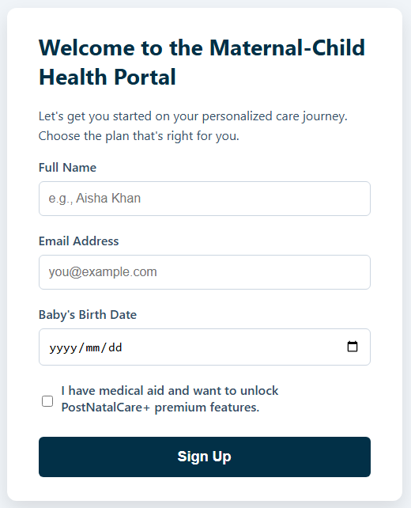
- Experience: Friendly welcome screen explaining benefits of both Free and Premium tiers.
- Option to skip medical aid entry and continue with Free tier.

2. Profile Setup
- Action: User completes health profile.
- Inputs: Basic maternal health info, baby’s details (weight, vaccination status).
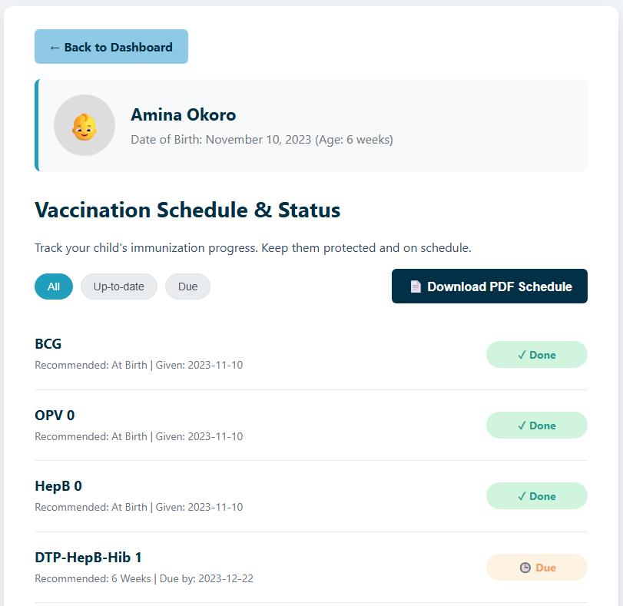
- Experience: Guided form with progress bar.
- Clear messaging: “Complete your profile to unlock personalized care.”

3. Medical Aid Verification
- Action: User enters medical aid membership number or uploads proof.
- System Response: API integration with medical aid provider OR manual verification by admin.
- Status shown as Pending → Verified → Premium Unlocked.
- Experience:
  - Transparent timeline: “Verification usually takes 24–48 hours.”
  - Encouraging message: “While we verify, enjoy free features.”

4. Premium Unlock (PostNatalCare+)
- Action: Once verified, system automatically upgrades user to Premium.
- Experience: Highlights of new features unlocked (consultations, advanced tracking, exclusive content).
- Guided tour of premium dashboard.

5. Ongoing Engagement
- Action: User receives personalized reminders, premium content, and access to consultations.
- Experience:
  - Push/email notifications for milestones.
  - Easy access to premium peer-support groups.
  - Option to download health reports for medical aid claims.

