**CBBA and RPO Planning Analysis**

This document explains how to use the CBBA/RPO planning routines available in the following repository: <https://bitbucket.sdl.usu.edu/projects/SYS/repos/cbba/browse/RPO_dVConstrained>

The main script is named “aa_MainScript_RPO_CBBA.m”. Open this file and modify the set up variables to configure the proper planning. The “Define agents and tasks” section contains the variables a user will most often set up. The number of agents and tasks are specified in this section as identified in . The orbital parameters and randomization routines are found within the “process_agent_task.m” function identified below as well.

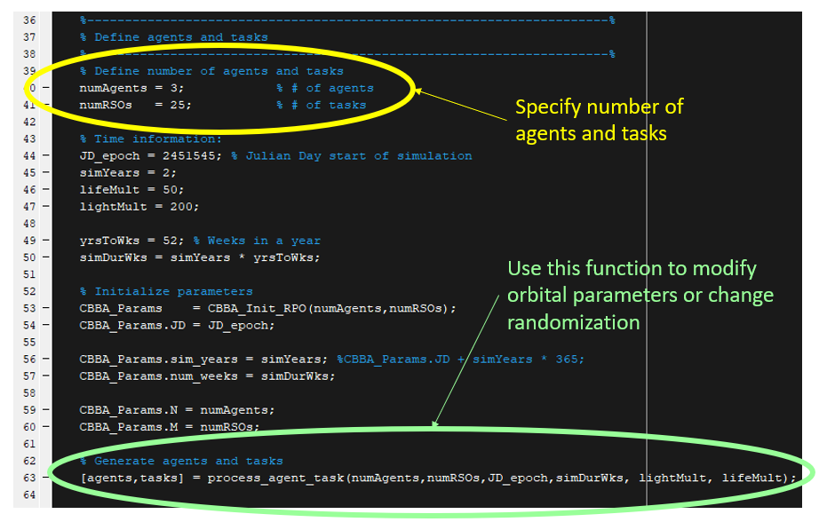

Figure : RPO/CBBA planning script and set-up variables

Note, that each time the script is executed, a new orbital configuration will be generated based on the information specified inside of the “process_agent_task” function. If a set configuration is necessary, I recommend generating the tasks and agents using that function and then saving that set up to a *.mat file and loading it into the script instead of generating a new set of tasks/agents with the “process_agent_task” function each time.