Company Name: SEO CRM
Business Model: My company operates an internal SEO operations platform (SEO CRM) used to plan, organize, and optimize organic search content for websites that we own or operate. We manage multiple sites and content niches inside one CRM (application URL: https://crmpersonal.es). We only use Google Ads API keyword research data to support SEO planning for properties we control. We do not manage Google Ads campaigns for third-party clients, we do not resell Google Ads API access, and we do not offer a public multi-tenant ads management product.
Tool Access/Use: My tool will be used only by employees and authorized contractors inside my company. There is no public self-signup and no external client login to Google Ads API features. Internal users will use the CRM to organize SEO work (projects, niches, pages, keywords, URLs) and to view Keyword Planner metrics such as average monthly search volume, competition, and estimated CPC ranges. Those metrics help our team prioritize topics and content. We may also use Search Console and Analytics data (via separate Google APIs) for organic performance; those integrations are separate from Google Ads API campaign management.
We will also have a scheduled background job (planned weekly) that syncs keyword research metrics from the Google Ads API into our database for the projects we operate. AI assistants inside the CRM may use stored metrics as context for content drafts, but humans always review before any publishing. The tool does not automatically create, edit, pause, or bid on Google Ads campaigns.
Tool Design: For the keyword research aspect of our tool, we will pull Keyword Planner metrics from the Google Ads API into our database (table: ads_keywords). The UI of our tool will read from this database to display keyword volume, competition, and CPC estimates. Users will be able to filter by project and review synced keywords linked to our SEO pages.
Authentication uses OAuth 2.0 with the adwords scope, plus our developer token and customer ID stored only as server-side environment variables (never in the browser). OAuth tokens are stored server-side per project/service. The frontend never calls the Google Ads API directly. Architecture: React frontend, Python FastAPI backend, PostgreSQL database, hosted with custom domain https://crmpersonal.es. Principal place of business: Nigeria. API contact: seo.app2026@gmail.com. Company type: Agency/SEM (internal tooling). Public pages: https://crmpersonal.es/privacy and https://crmpersonal.es/terms.
Requested access level: Basic Access. Requested permissible use: Researching keywords and recommendations. Ads Keyword Planner sync is under implementation and requires Basic Access approval to complete production use. We do not use App Conversion Tracking or Remarketing APIs.
API Services Called:
- Generate keyword ideas and historical metrics via KeywordPlanIdeaService (seed terms / page-related keywords for SEO research).
- Obtain keyword plan metrics (volume, competition, CPC estimates) via KeywordPlanService and related Keyword Plan resources as required by official client library workflows.
- Optional later (read-only only): RecommendationService if we surface keyword recommendations inside the internal UI — not required for initial launch.
API services / capabilities NOT used by this tool:
- Campaign creation or campaign management (no CampaignService write operations).
- Ad creation or ad group ad management (no AdGroupAdService write operations).
- Account creation / user management provisioning.
- Billing, payments, invoices, or budget setup services.
- App Conversion Tracking and Remarketing / Customer Match APIs.
Tool Mockups: Here is a screenshot of what our company’s API tool looks like at https://crmpersonal.es (internal Keywords Ads / Google Ads Keyword Planner screen in SEO CRM):
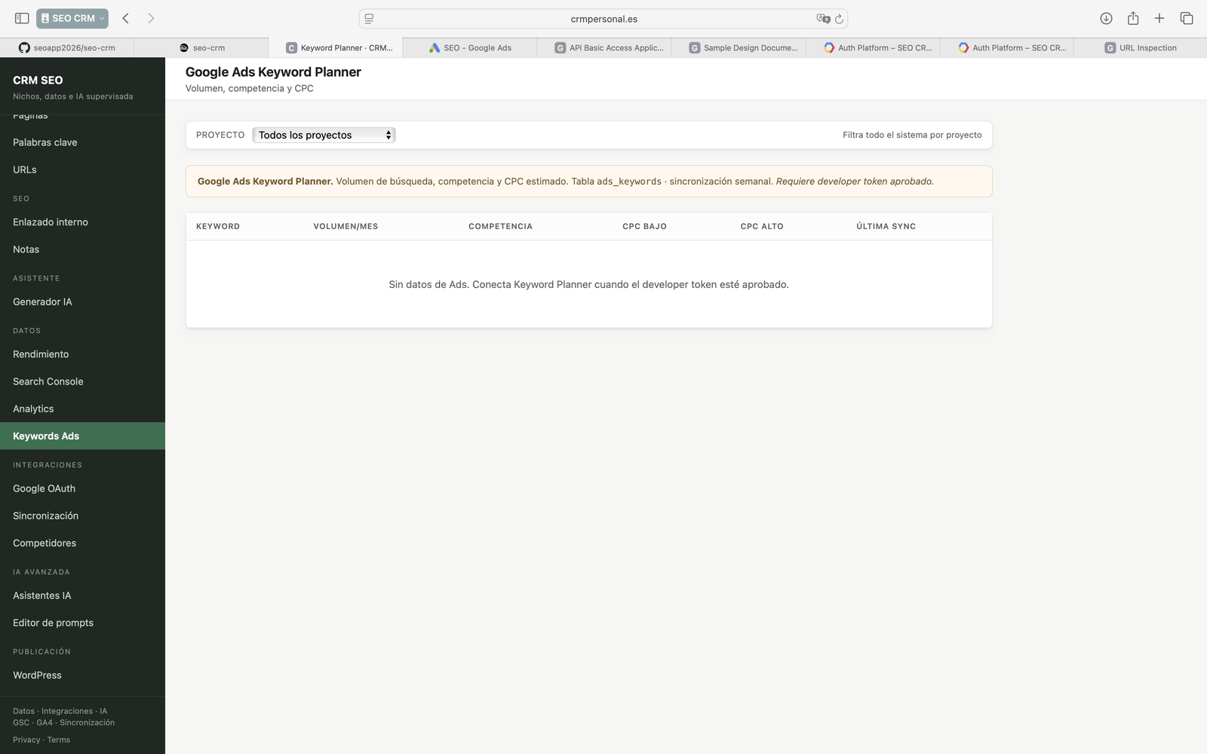
Screenshot description: Live SEO CRM UI at https://crmpersonal.es showing the Google Ads Keyword Planner page with columns Keyword, Volume/month, Competition, CPC low, CPC high, and Last sync (table ads_keywords). Data is displayed from our database after server-side Google Ads API keyword research calls. No campaign edit controls are exposed. Weekly sync; requires approved developer token.
Contact for review: seo.app2026@gmail.com | Tool URL: https://crmpersonal.es | Privacy: https://crmpersonal.es/privacy | Terms: https://crmpersonal.es/terms | Document date: 22 July 2026

