set hive.support.concurrency=true;

set hive.enforce.bucketing=true;

set hive.exec.dynamic.partition.mode=nonstrict;

set hive.txn.manager=org.apache.hadoop.hive.ql.lockmgr.DbTxnManager;

set hive.compactor.initiator.on=true;

set hive.compactor.worker.threads=2;

Evidence for create and import data into camera table

CREATE EXTERNAL TABLE camera(plate string, state_code string, license_type string, summons_number string, issue_date date, summons_image string, violation_time string, violation string, fine_amount float, penalty_amount float, interest_amount float, reduction_amount float, payment_amount float, amount_due float, precinct int, county string, issuing_agency string, violation_status string, judgment_entry_date date) COMMENT 'Open parking external table' ROW FORMAT DELIMITED FIELDS TERMINATED BY ',' STORED AS TEXTFILE LOCATION '/user/nc2325/project_camera' tblproperties ("skip.header.line.count"="1");

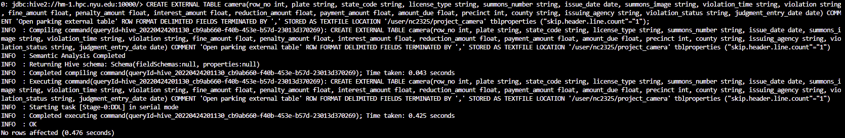See distinct type in county column

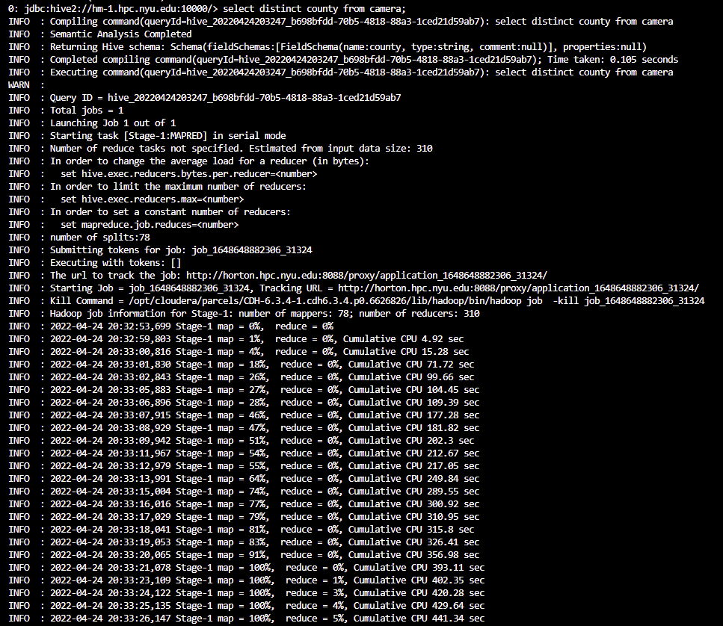

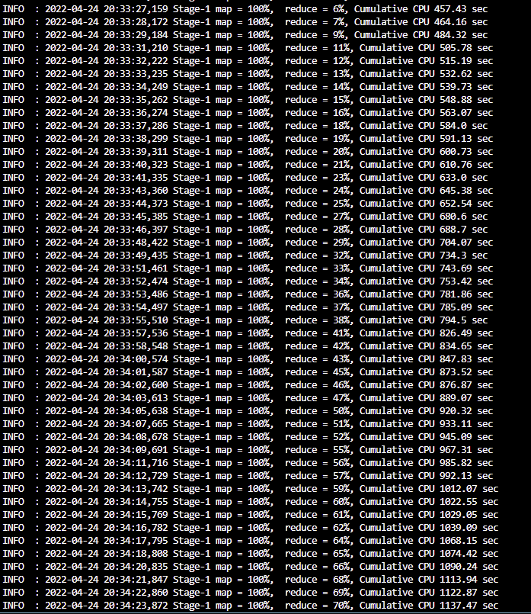

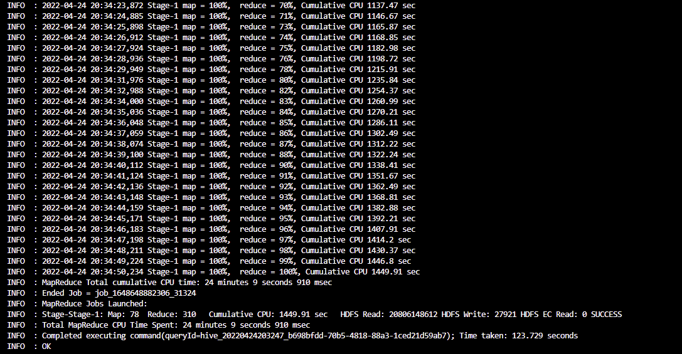

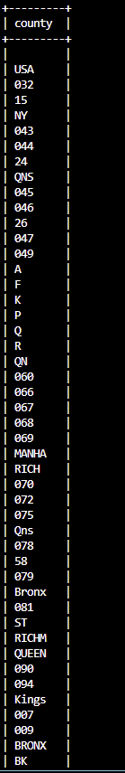

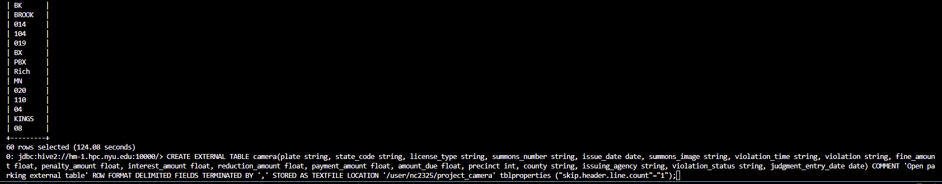

Count of each distinct value in county with our decision on the table

0: jdbc:hive2://hm-1.hpc.nyu.edu:10000/> select county, count(*) from camera group by county;

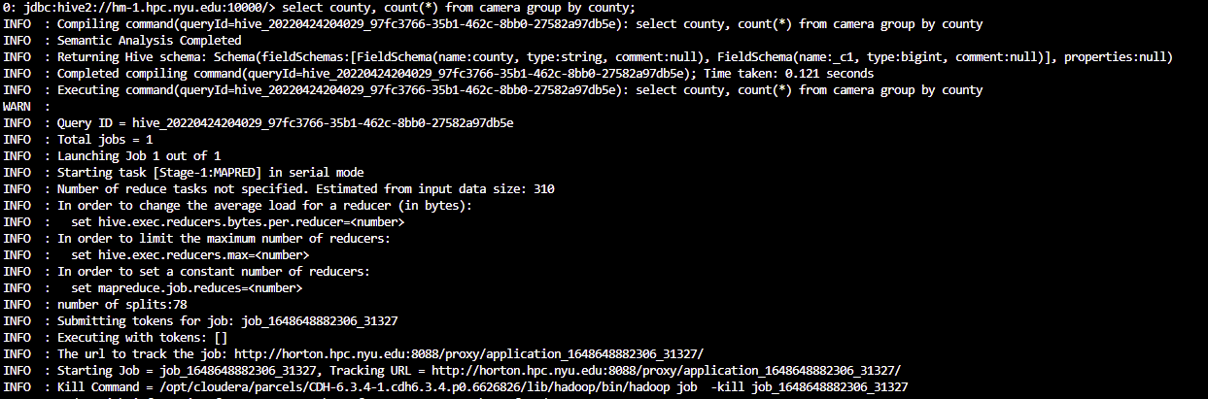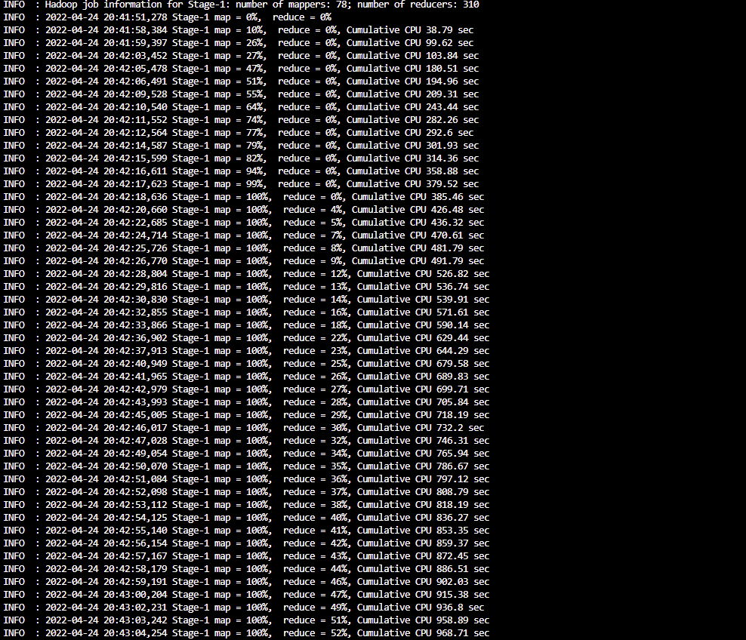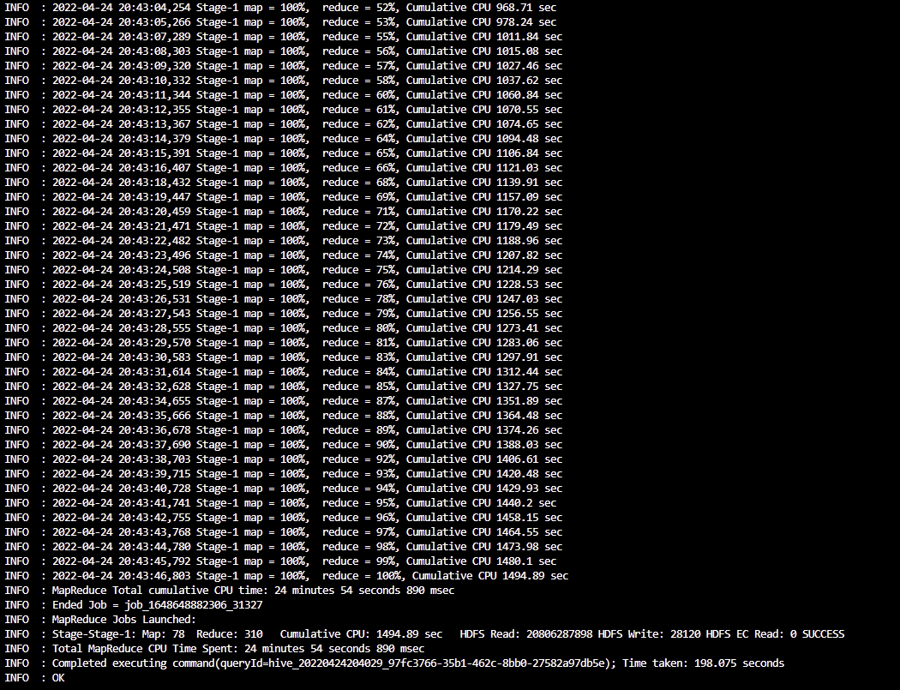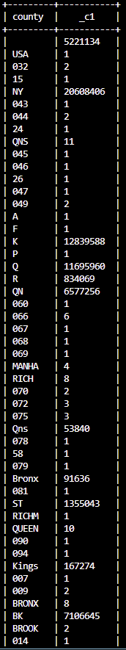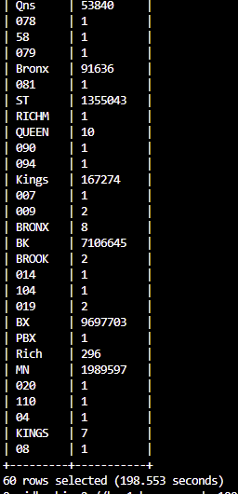

beeline -u jdbc:hive2://hm-1.hpc.nyu.edu:10000/nc2325 -n nc2325 -p PASSWORD --outputformat=csv2 -e "SELECT

county, count(*)

FROM

camera

WHERE

county IN ('NY','K','Q','R','QN','Qns','Bronx','ST','Kings','BK','BX','MN')

GROUP BY

County;" > county_camera.csv

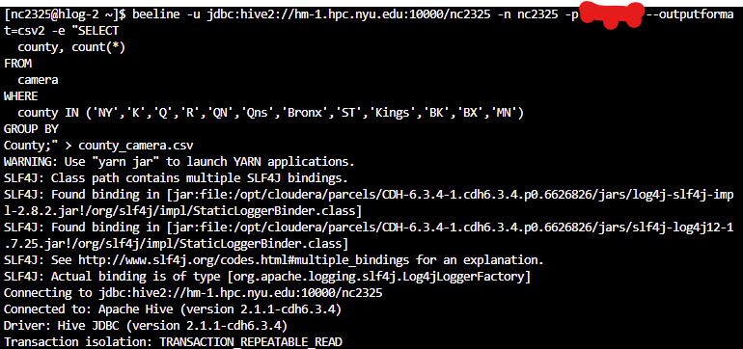

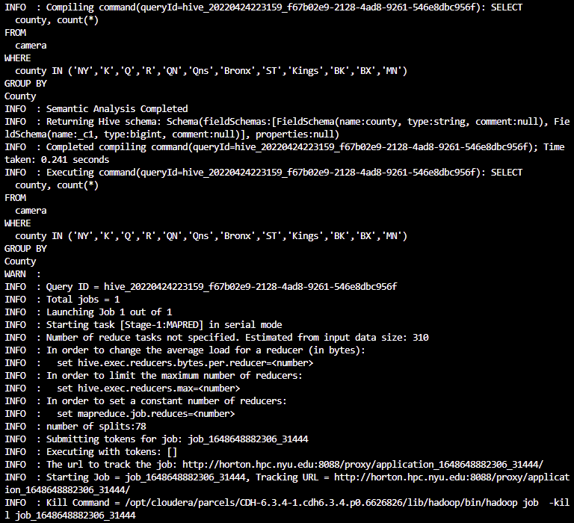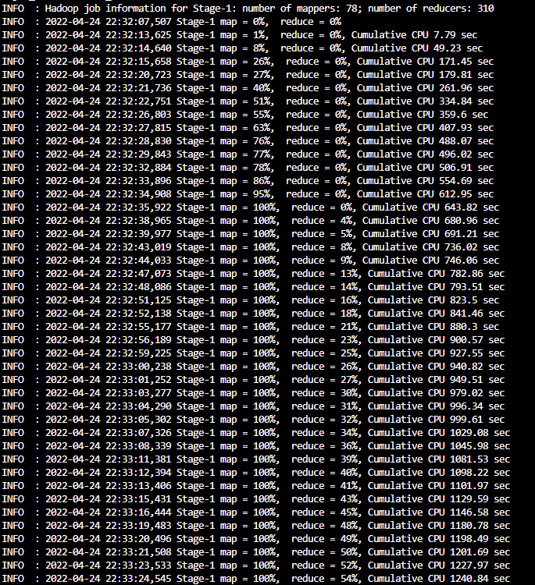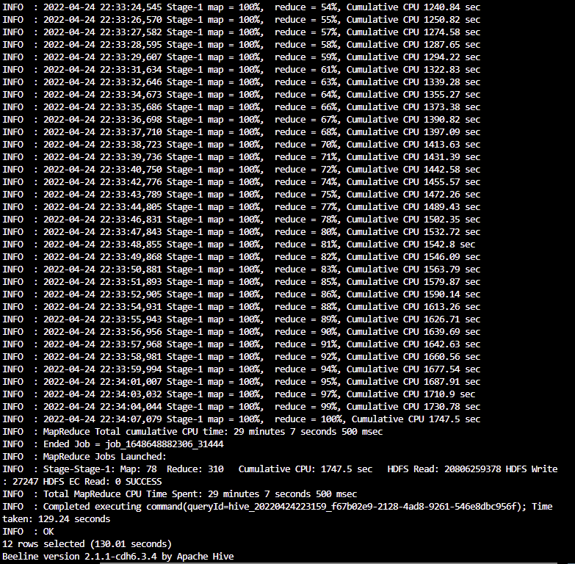

COMPLAINT TABLE

create table crimes(ID string, COMPLAINT_DATE date, COMPLAINT_TIME string, COMPLAINT_PROCESSED_DATE date, COMPLAINT_PROCESSED_TIME string, PRECINCT string, REPORTED_DATE date, OFFENSE_CODE string, OFFENSE_DESC string, INTERNAL_CODE string, PD_DESCRIPTION string, CRIME_ATTEMPT string, LEVEL_OF_OFFENSE string, BOROUGH string, LOCATION string, PREMISE string, JURISDICTION_DESC string, JURISDICTION_CODE string, PARKS string, HADEVELOPT string, HOUSING_PSA string, X_COORD string, Y_COORD string, AGE_GROUP string, SUSP_RACE string, SUSP_SEX string, TRANSIT_DISTRICT string, LATITUDE string, LONGITUDE string, LAT_LONG string, PATROL_BOROUGH string, STATION_NAME string, VIC_AGE string, VIC_RACE string, VIC_SEX string)

COMMENT 'CRIMES'

ROW FORMAT SERDE 'org.apache.hadoop.hive.serde2.OpenCSVSerde'

WITH SERDEPROPERTIES (

"separatorChar" = ",",

"quoteChar"="\"",

"escapeChar"="\\"

)

tblproperties ("skip.header.line.count"="1");

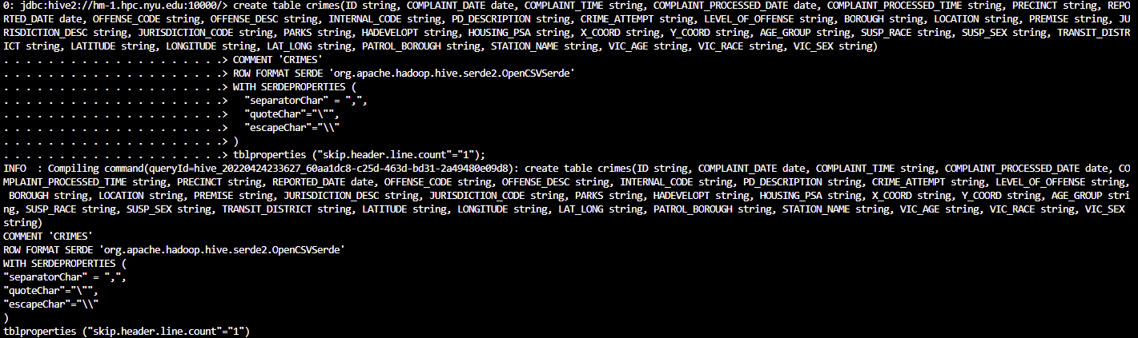

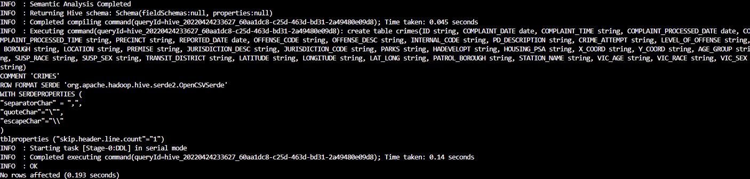

LOAD DATA INPATH '/user/nc2325/project_complaint/NYPD_Complaint_Data_Historic.csv' INTO TABLE crimes;

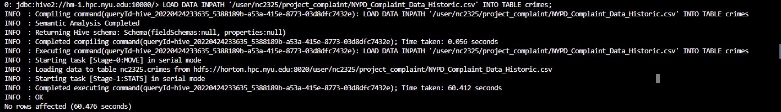

beeline -u jdbc:hive2://hm-1.hpc.nyu.edu:10000/nc2325 -n nc2325 -p PASSWORD --outputformat=csv2 -e "SELECT

BOROUGH, count(*)

FROM

crimes

WHERE

BOROUGH IN ('MANHATTAN','QUEENS', 'STATEN ISLAND', 'BRONX', 'BROOKLYN')

GROUP BY

BOROUGH;" > crimes.csv

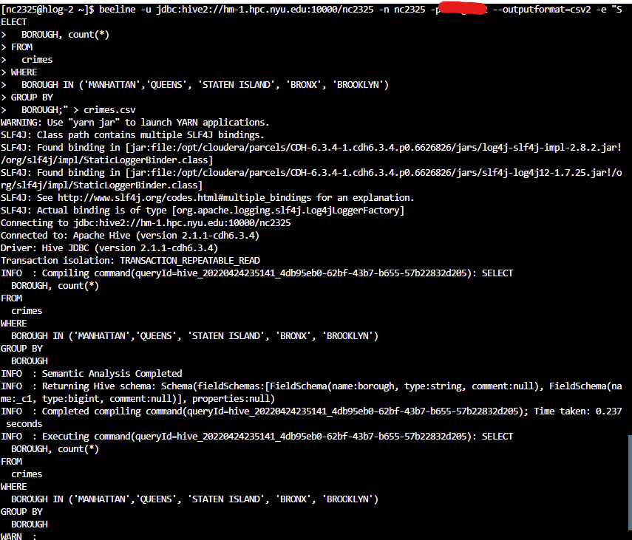

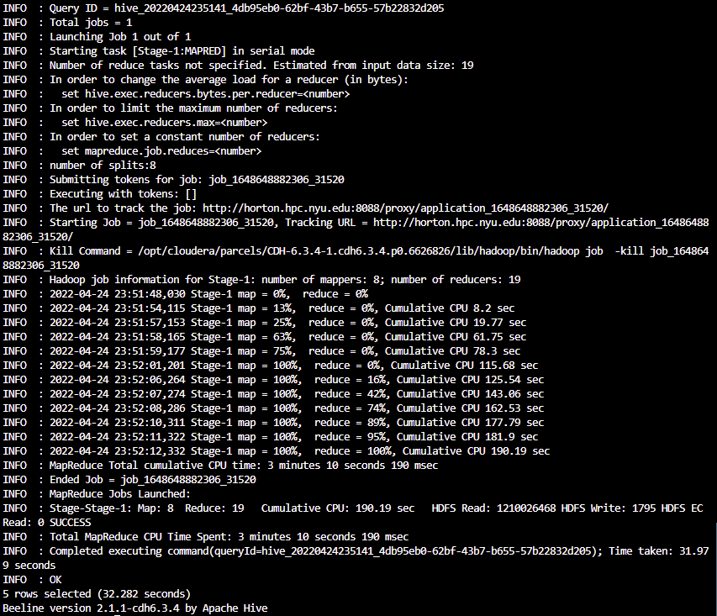

beeline -u jdbc:hive2://hm-1.hpc.nyu.edu:10000/nc2325 -n nc2325 -p PASSWORD --outputformat=csv2 -e ‘SELECT OFFENSE_DESC, LATITUDE, LONGITUDE FROM CRIMES WHERE OFFENSE_DESC = "FORTUNE TELLING";’ > fortune_telling.csv

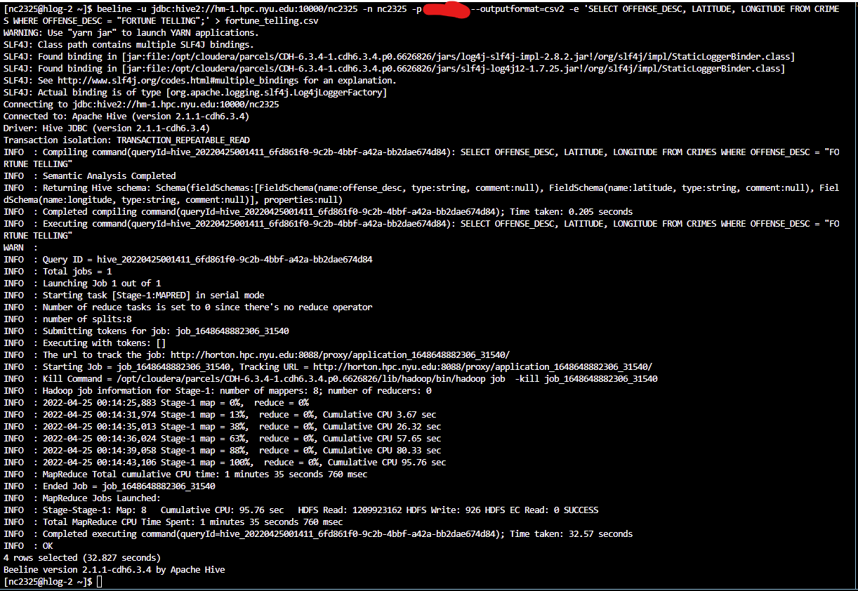

beeline -u jdbc:hive2://hm-1.hpc.nyu.edu:10000/nc2325 -n nc2325 -p PASSWORD --outputformat=csv2 -e ‘SELECT OFFENSE_DESC, LATITUDE, LONGITUDE FROM CRIMES WHERE OFFENSE_DESC = "ARSON";

’ > arson.csv

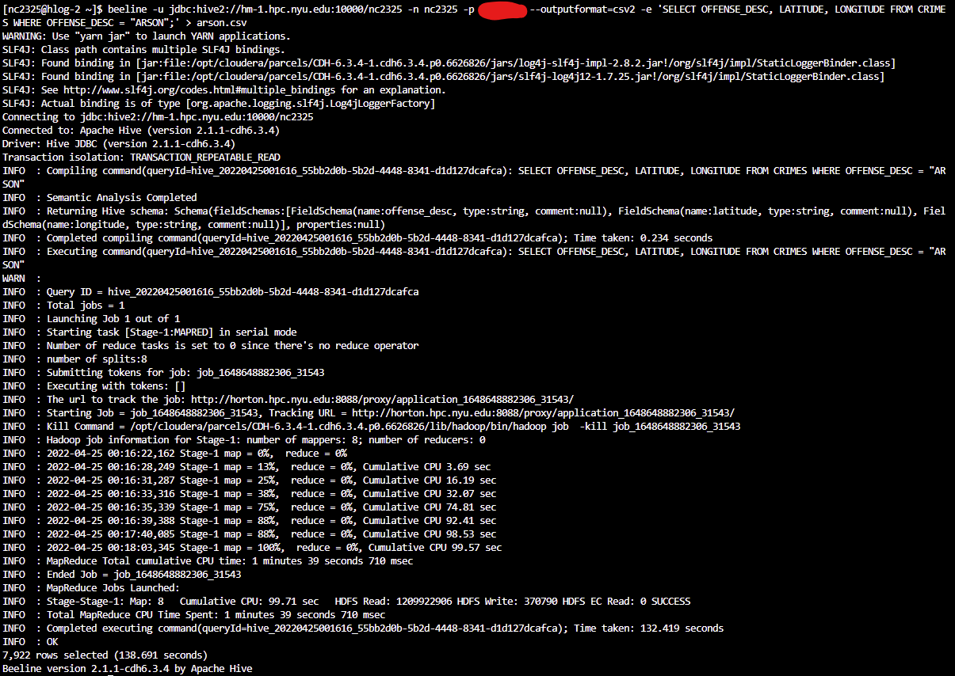

beeline -u jdbc:hive2://hm-1.hpc.nyu.edu:10000/nc2325 -n nc2325 -p PASSWORD --outputformat=csv2 -e ‘SELECT OFFENSE_DESC, LATITUDE, LONGITUDE FROM CRIMES WHERE OFFENSE_DESC = "MURDER & NON-NEGL. MANSLAUGHTER";’ > manslaughter.csv

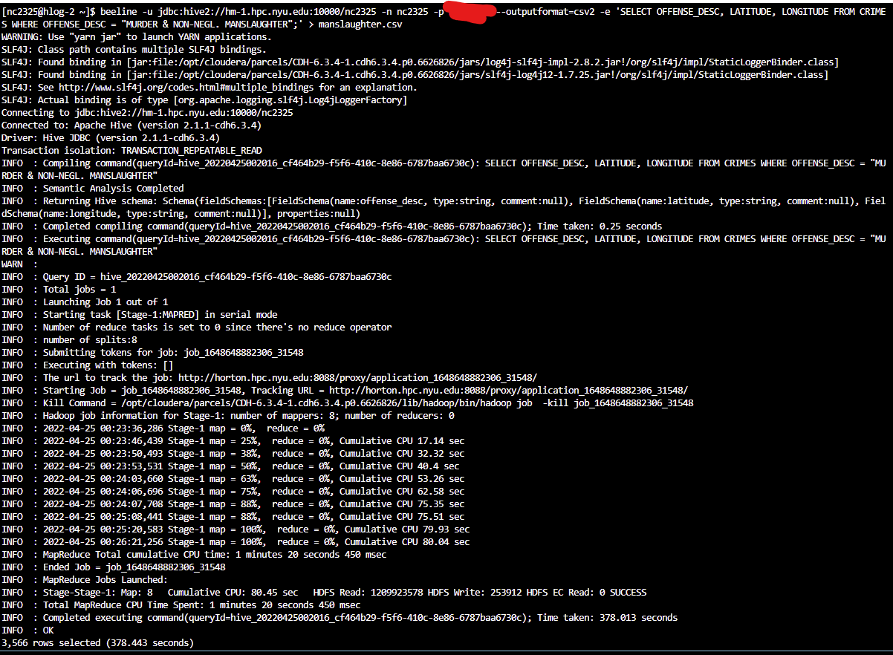

beeline -u jdbc:hive2://hm-1.hpc.nyu.edu:10000/nc2325 -n nc2325 -p PASSWORD --outputformat=csv2 -e ‘SELECT OFFENSE_DESC, LATITUDE, LONGITUDE, LAT_LONG FROM CRIMES WHERE OFFENSE_DESC = "KIDNAPPING & RELATED OFFENSES";’ > kidnapping.csv

