Quasi-Magnetostatics

# Notes:

In equations, bolded values (e.g. ) are vector quantities.

Vectors with hats are unit vectors (e.g. is the azimuthal unit vector). You may assume a hatted vector is in the direction of its parent vector when applicable (e.g. is the unit vector along ).

The magnitude of a vector is denoted by .

# Background:

The wavelength that we’re operating at for 6.5 mT is much larger than the size of our structures, so we can make a quasi-magnetostatic assumption. This allows us to use the Biot-Savart law to analyze coils:

where is along the path C, and is the vector from the wire at point to , the place where the field is being computed.

Others[1] have shown that for a straight thin wire of finite length with constant current:

where .

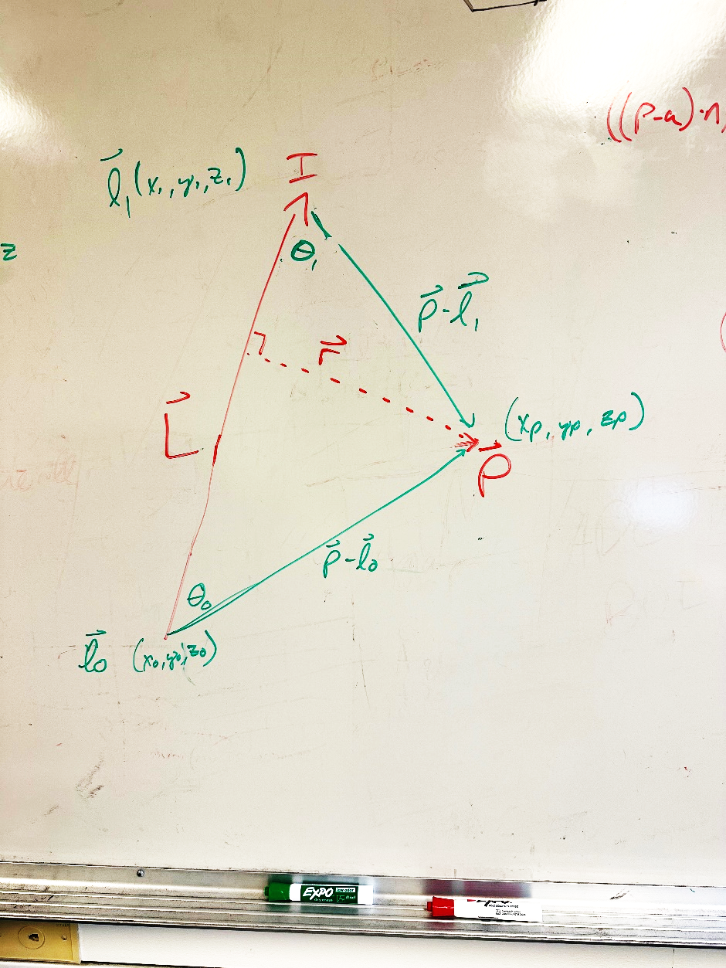

is the shortest vector from the line containing to the observation point .

## Implementation:

To implement this for arbitrary wire orientation, the following expressions are useful:

## Einstein Sum

The easiest way to compute the dot product of each row of A with each row of B is to use the Numpy Einstein Sum function einsum(‘ij,ij->i', A, B).

1. Ulaby, Michielssen, and Ravaioli, “Fundamentals of Applied Electromagnetics” 6th edition, pp. 244-5