# Casual Use Case Specification: UC1

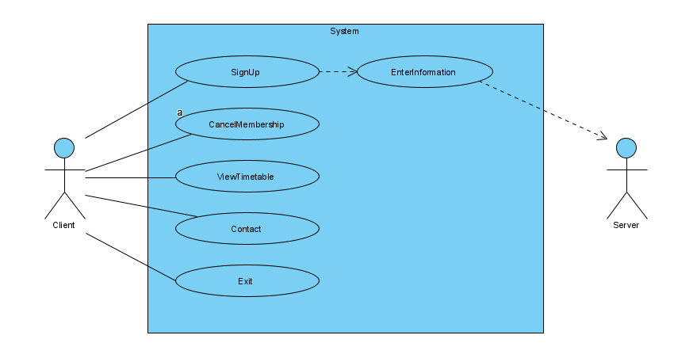

**Use Case Name: Tae kwon do**

**Brief Description:** This Use Case enables Client to sign up their kid to the system

# Section 1: Business Rule(s):

BR 01: Every client must have a unique information.

BR 02: Information must not be deleted, and is allowed to deleted.

BR 03: Only client can sign up.

# Section 2: Scenarios (HD):

**Scenario 1: Signup without errors**

# Preconditions: Client is in the website and the main menu is displayed

| **Step#** | **Actor ( Client )** | **System** | **Data Used** |
| --- | --- | --- | --- |
| 1 | Show main menu | Displays options that can select 'sign up' |  |
| 2 | Selects 'sign up' | Displays information what is needed |  |
| in | Enters Client's information (fist name, last name, street address, city, province) | Data validation:  First name must be entered  Last name must be entered  Street address must be entered  City must be entered  Province must be selected | ClientsInformation  FirstName  LastName  StreetAddress  City  Province |
| in2 | Enters Child's information (name, age group, skill level, time) | Data validation:  Name must be entered  Age group must be selected  Skill Level must be selected  Time must be selected | ChildsInformation  Name  AgeGroup  SkillLevel  Time |
| 5 | Selects to exit | Displays the main menu |  |

**Successful Post-Conditions:** signed up without any errors.