# Casual Use Case Specification: UC1

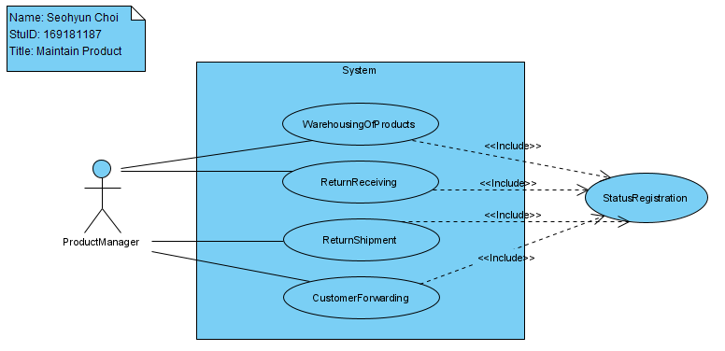

**Use Case Name: Maintain Product**

**Brief Description:** This Use Case enables Product Manager to stock new products to the system when they are imported, receive return when the product has a problem, ship return when the problem has solved, and forward customers. All processes are registered.

# Section 1: Business Rule(s):

BR 01: Every product must have a unique code.

BR 02: Products must not be deleted, product information is allowed to be updated.

BR 03: Only store manager can add products and change products.

# Section 2: Scenarios (HD):

**Scenario 1: Maintain a product without errors**

# Preconditions: Product Manager is logged in and the main menu is displayed

| **Step#** | **Actor ( Product Manager )** | **System** | **Data Used** |
| --- | --- | --- | --- |
| 1 | Show products | Displays options that can select to add a product |  |
| 2 | Selects to add a product | Displays product list | productlist  productCode  productName  productPrice  productDescription  producttypelist |
| 3 | Enters a product code, product name, product price, product description | Data validation:  Product code must be unique  Product name must be entered  Product price must be entered  Product description must be entered  Product type must be selected  Data is valid and saved  Displays the product list | productlist  productCode  productName  productPrice  productDescription  producttypelist |
| 4 | Check and Selects to saves | Prompts to exit or add another product |  |
| 5 | Selects to exit | Displays the main menu |  |

**Successful Post-Conditions:** Product is added to the system

**Scenario 2: The product has been returned**

# Preconditions: Product Manager is logged in and the main menu is displayed

| **Step#** | **Actor ( Product Manager )** | **System** | **Data Used** |
| --- | --- | --- | --- |
| 1 | Show products | Displays options that can select to recieve a product |  |
| 2 | Selects to recieve a product | Displays sold products list | productlist  productCode  productName  productPrice  productDescription  producttypelist |
| 3 | Enters a product code | Data validation:  Product code must be unique  Product name will be displayed  Product price will be displayed  Product description will be displayed  Product type will be displayed  It is stored as returned product | productlist  productCode  productName  productPrice  productDescription  producttypelist |
| 4 | Check and Selects to saves | Prompts to exit |  |
| 5 | Selects to exit | Displays the main menu |  |

**Successful Post-Conditions:** The system indicates that the product has been returned

# Casual Use Case Specification: UC2

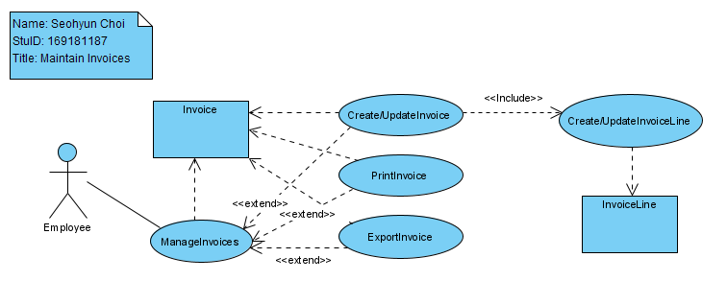

**Use Case Name: Maintain Invoices**

**Brief Description:** This Use Case enables Employee to manage invoices includes create, update, print and export invoices. All processes are recorded in Invoice line.

# Section 1: Business Rule(s):

BR 01: Invoice must not be deleted when it be recorded.

BR 02: Only employee can access on invoice system.

BR 03: Every invoices must have a unique code.

# Section 2: Scenarios (HD):

**Scenario 1: Maintain an invoice without errors**

# Preconditions: Employee is logged in and the main menu is displayed

| **Step#** | **Actor ( Employee )** | **System** | **Data Used** |
| --- | --- | --- | --- |
| 1 | Show invoices | Displays options that can select to create invoices |  |
| 2 | Selects to create an invoice | Displays invoice list | Invoicelist  InvoiceCode  InvoiceName  InvoiceDetails  InvoiceDescription  Invoicetypelist |
| in | Enters invoice code, invoice name, invoice details, invoice description and invoice type | Data validation:  Invoice code must be unique  Invoice name must be entered  Invoice details must be entered  Invoice description must be entered  Invoice type must be selected  Data is valid and saved  Displays the Invoice list | Invoicelist  InvoiceCode  InvoiceName  InvoiceDetails  InvoiceDescription  Invoicetypelist |
| 4 | Check and Selects to saves | Prompts to exit or add another invoice |  |
| 5 | Selects to exit | Displays the main menu |  |

**Successful Post-Conditions:** Invoice is created to the system

**Scenario 2: Update an invoice without errors**

# Preconditions: Employee is logged in and the main menu is displayed

| **Step#** | **Actor ( Employee )** | **System** | **Data Used** |
| --- | --- | --- | --- |
| 1 | Show current invoices | Displays options that can select to update invoices |  |
| 2 | Selects to update an invoice | Displays current invoice list | Invoicelist  InvoiceCode  InvoiceName  InvoiceDetails  InvoiceDescription  Invoicetypelist |
| in | Enters new invoice code, invoice name, invoice details, invoice description and invoice type | Data validation:  Invoice code must be unique  Invoice name must be entered and can be same  Invoice details must be entered and can be same  Invoice description must be entered and can be same  Invoice type must be selected and can be same  Data is valid and saved and can be same  Displays the Invoice list | Invoicelist  InvoiceCode  InvoiceName  InvoiceDetails  InvoiceDescription  Invoicetypelist |
| 4 | Check and Selects to saves | Prompts to exit or update another invoice |  |
| 5 | Selects to exit | Displays the main menu |  |

**Successful Post-Conditions:** Invoice is updated to the system