[EE838] Feature Extraction and 3D Reconstruction

20164332 Kwanggun Seo/서광균

Assignment 08 Camera Calibration

‘init_intrinsic_param.m’

initialize lense distortion and camera center as given (if not 0 for both). Then computing the vanishing point get the focal length of the camera.

‘go_calib_optim.m’

by finding the Jacobian matrix we optimize the intrinsic parameter.

**Results**

* Given Data Set

*Calibration parameters after initialization:*

*Focal Length: fc = [ 670.65491 670.65491 ]*

*Principal point: cc = [ 319.50000 239.50000 ]*

*Skew: alpha_c = [ 0.00000 ] => angle of pixel = 90.00000 degrees*

*Distortion: kc = [ 0.00000 0.00000 0.00000 0.00000 0.00000 ]*

*Main calibration optimization procedure - Number of images: 20*

*Gradient descent iterations: 1...2...3...4...5...6...7...8...9...10...11...12...13...14...15...16...17...18...19...20...21...22...23...24...done*

*Estimation of uncertainties...done*

*Calibration results after optimization (with uncertainties):*

*Focal Length: fc = [ 662.49528 664.67741 ] +/- [ 1.43402 1.54263 ]*

*Principal point: cc = [ 306.51277 241.75102 ] +/- [ 2.83486 2.60831 ]*

*Skew: alpha_c = [ 0.00000 ] +/- [ 0.00000 ] => angle of pixel axes = 90.00000 +/- 0.00000 degrees*

*Distortion: kc = [ -0.27907 0.32025 0.00050 0.00028 0.00000 ] +/- [ 0.01144 0.04729 0.00064 0.00067 0.00000 ]*

*Pixel error: err = [ 0.59063 0.42184 ]*

*Note: The numerical errors are approximately three times the standard deviations (for reference).*

*Pixel error: err = [0.59063 0.42184] (all active images)*

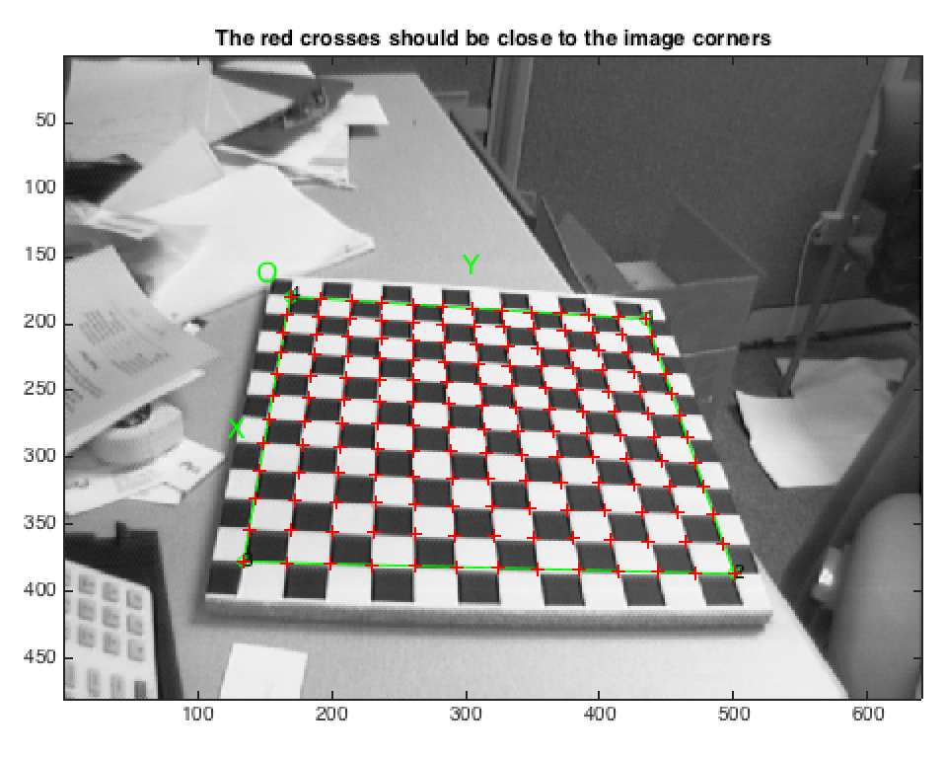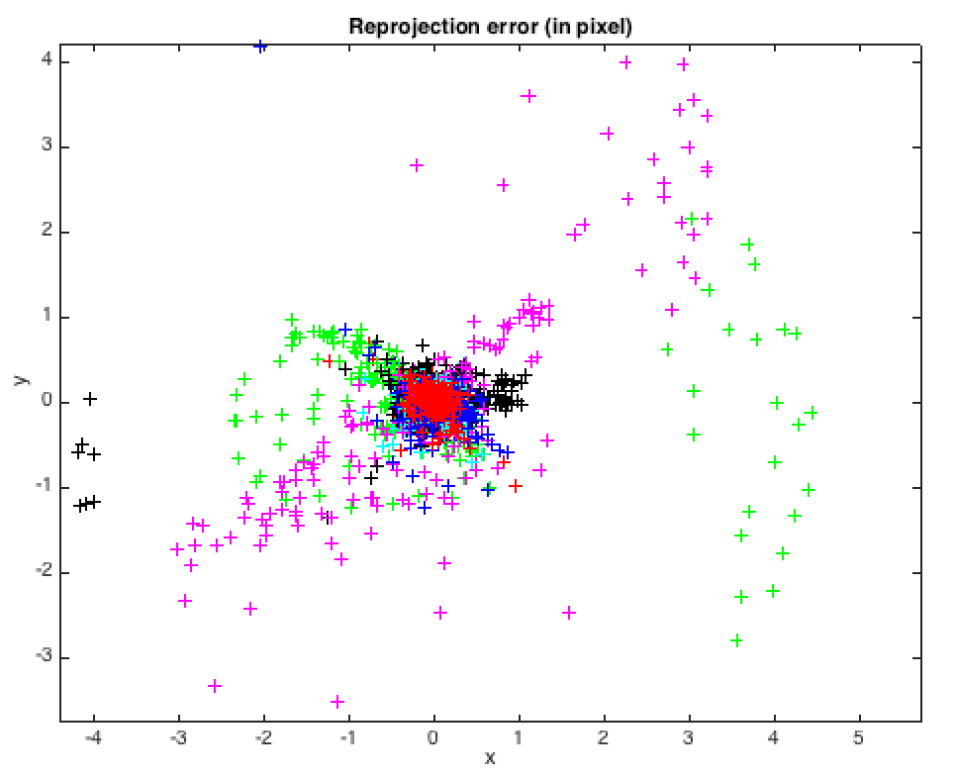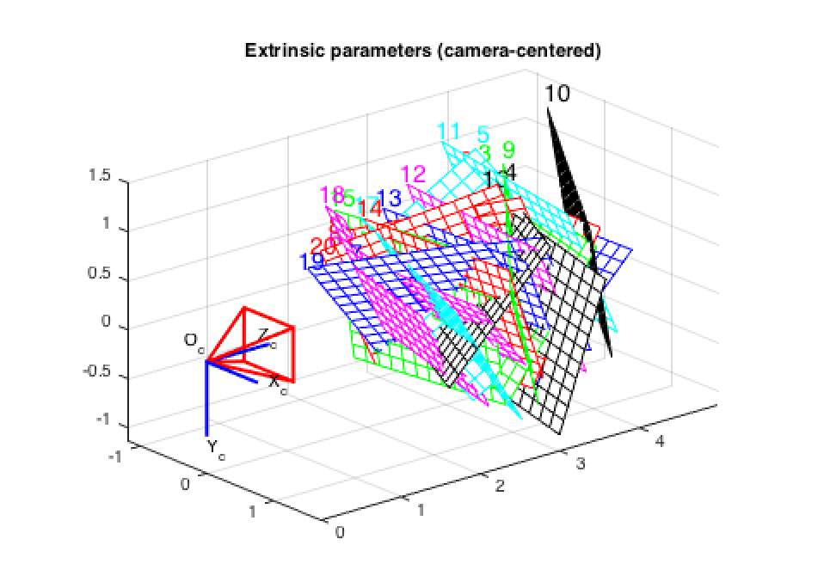

* **Own Data Set**

Aspect ratio optimized (est_aspect_ratio = 1) -> both components of fc are estimated (DEFAULT).

Principal point optimized (center_optim=1) - (DEFAULT). To reject principal point, set center_optim=0

Skew not optimized (est_alpha=0) - (DEFAULT)

Distortion not fully estimated (defined by the variable est_dist):

Sixth order distortion not estimated (est_dist(5)=0) - (DEFAULT) .

Initialization of the principal point at the center of the image.

Initialization of the intrinsic parameters using the vanishing points of planar patterns.

Initialization of the intrinsic parameters - Number of images: 25

Calibration parameters after initialization:

Focal Length: fc = [ 11150.02668 11150.02668 ]

Principal point: cc = [ 2807.50000 1871.50000 ]

Skew: alpha_c = [ 0.00000 ] => angle of pixel = 90.00000 degrees

Distortion: kc = [ 0.00000 0.00000 0.00000 0.00000 0.00000 ]

Main calibration optimization procedure - Number of images: 25

Gradient descent iterations: 1...2...3...4...5...Warning: it appears that the principal point cannot be estimated. Setting center_optim = 0

6...7...8...9...10...11...12...13...14...15...16...17...18...19...done

Estimation of uncertainties...done

Calibration results after optimization (with uncertainties):

Focal Length: fc = [ 11944.05609 12392.23170 ] +/- [ 151.79308 187.61667 ]

Principal point: cc = [ 2952.61994 -341.72992 ] +/- [ 0.00000 0.00000 ]

Skew: alpha_c = [ 0.00000 ] +/- [ 0.00000 ] => angle of pixel axes = 90.00000 +/- 0.00000 degrees

Distortion: kc = [ 0.34422 -0.40179 -0.10323 0.00594 0.00000 ] +/- [ 0.10863 0.62208 0.01467 0.00215 0.00000 ]

Pixel error: err = [ 3.28597 2.74973 ]

Note: The numerical errors are approximately three times the standard deviations (for reference).

Pixel error: err = [ 3.28597 2.74973] (all active images)

* Reprojection error is quite large due to blurry image and not enough sufficient position of the image.

