[EE838] Feature Extraction and 3D Reconstruction

20164332 서광균

Assignment 10: Robust Estimation: 2-View 3D Reconstruction

In this assignment, out goal was to reconstruct 3D points from 2D point using two images. By computing the fundamental matrix from the previous assignment, we can find the essential matrix using $E={K'}^{T}FK$. Using the essential matrix found, we can derive four possible solutions for camera motion. The camera with point in front is the true solution we want to find. Using the camera rotation and translation matrix we can triangulate the 3D points from the two corresponding image points. The following are the results of the computed 3D points from the point correspondences using iteration number 1000, threshold , and SIFT feature extraction and matching.

If seen closely, the data is kind of noisy which might be due to non-optimization process. Using bundle adjustment or aligning data points to the epipolar plane would make the 3D points more accurate.

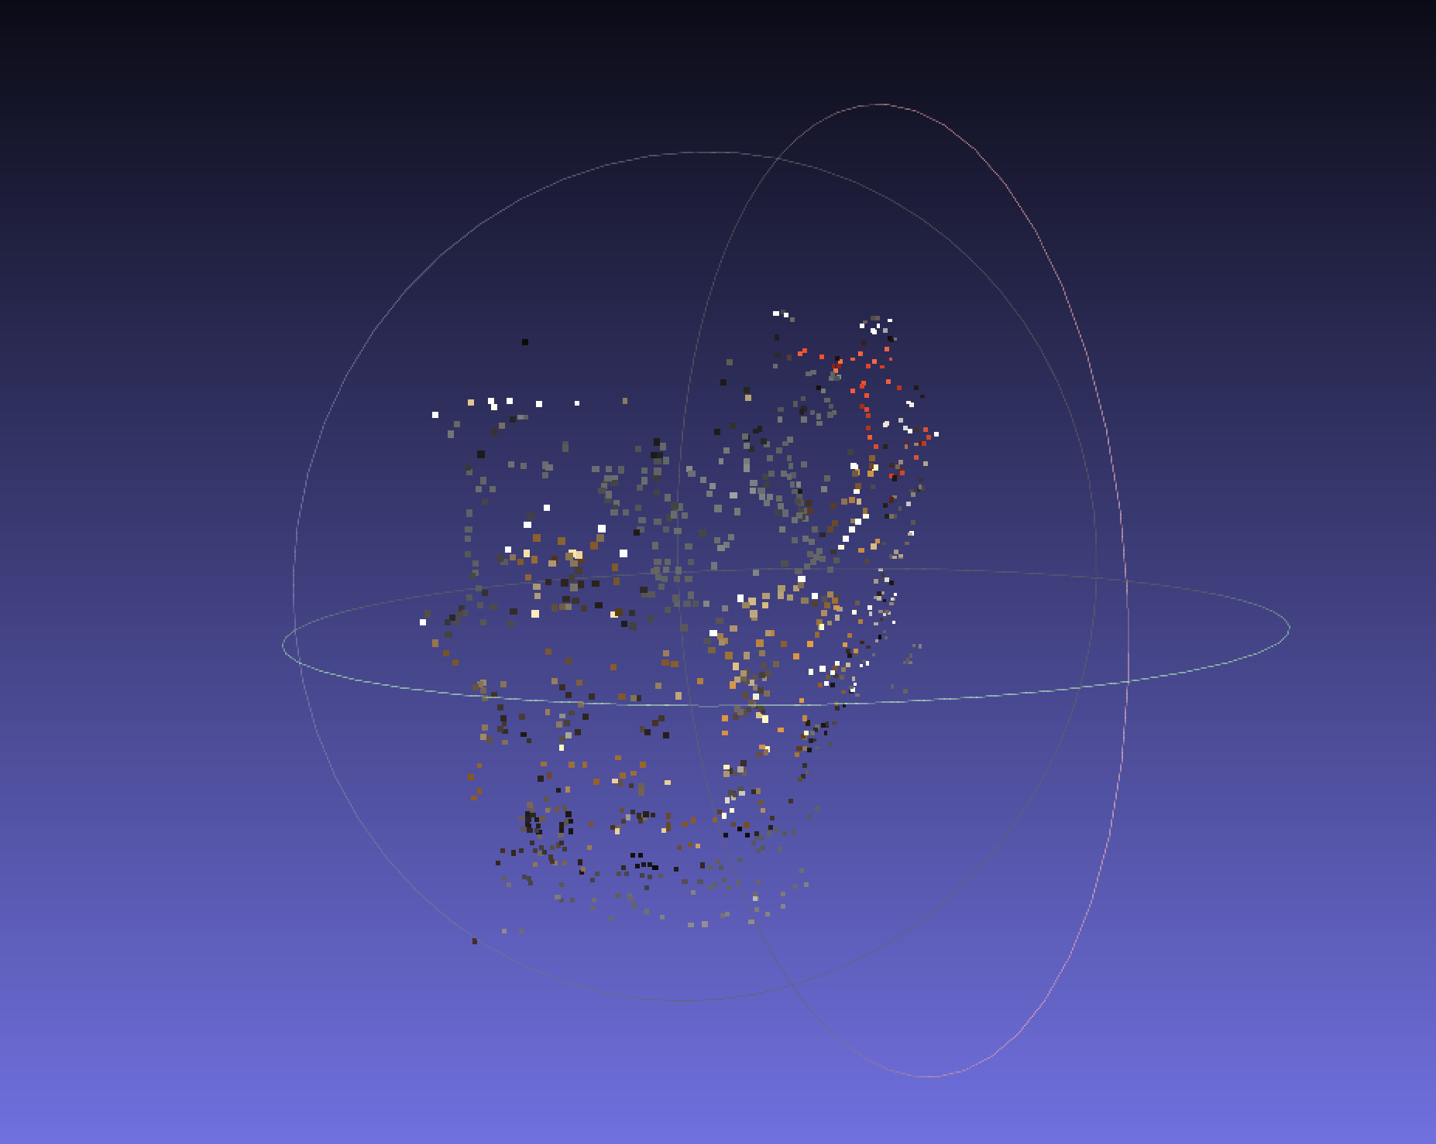

Figure 1. 2 view 3D reconstructed result

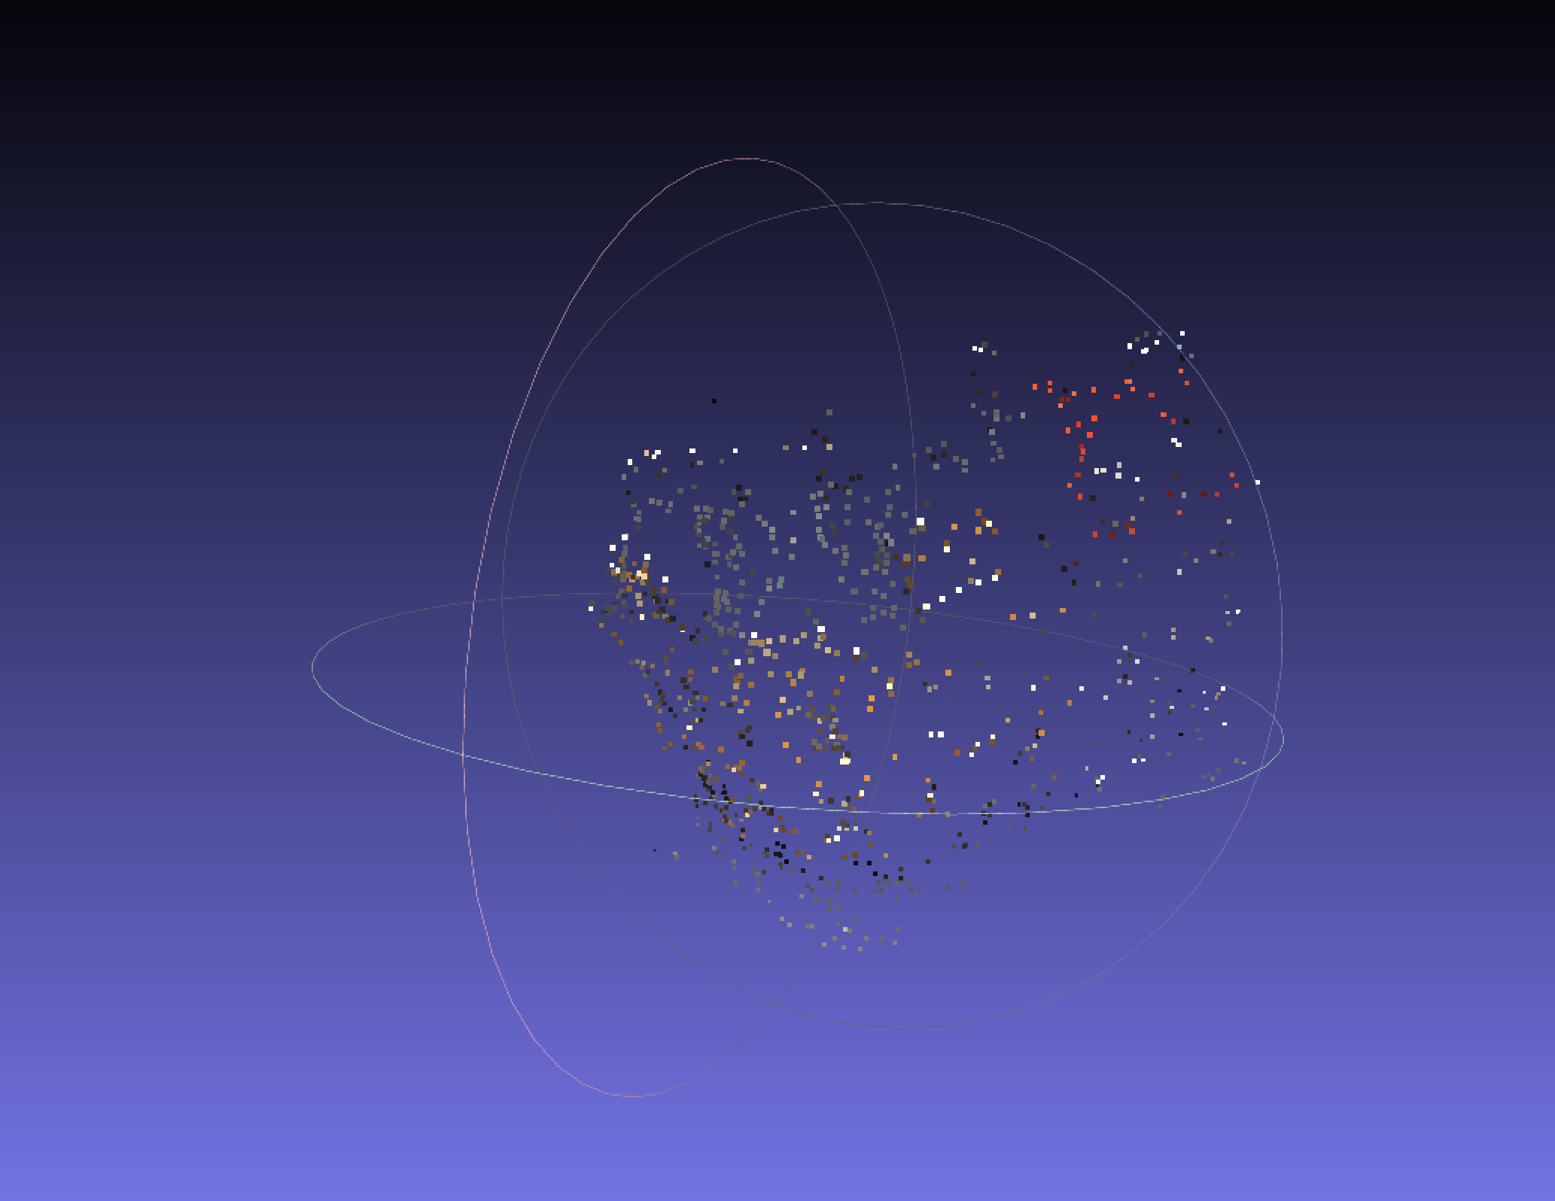

Figure 2. 2 view 3D reconstructed result from different angle

Using different iteration number does not change that much of the result. However changing the threshold value for the inlier distance the number of inlier points decreases as we set the threshold to a lower value.

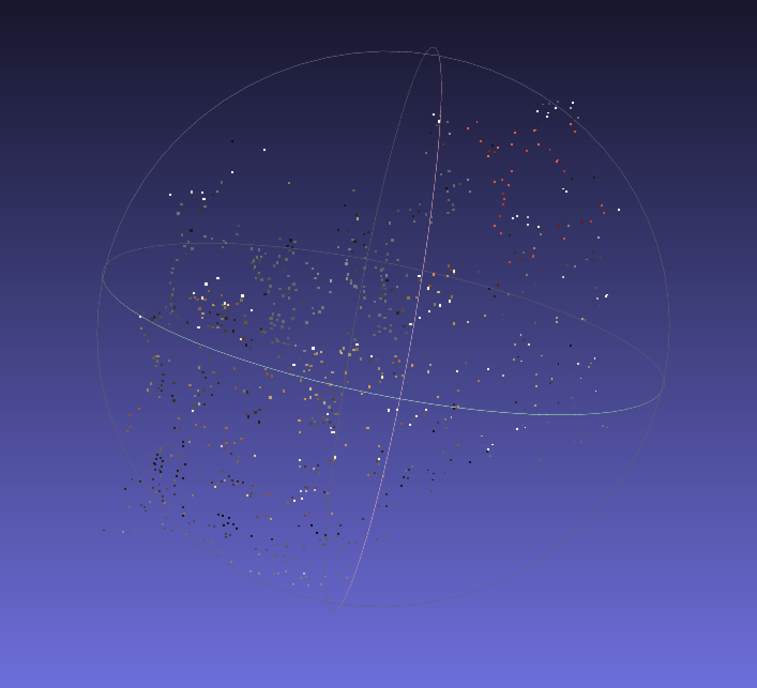

Figure 3. iteration 500 with inlier threshold 5

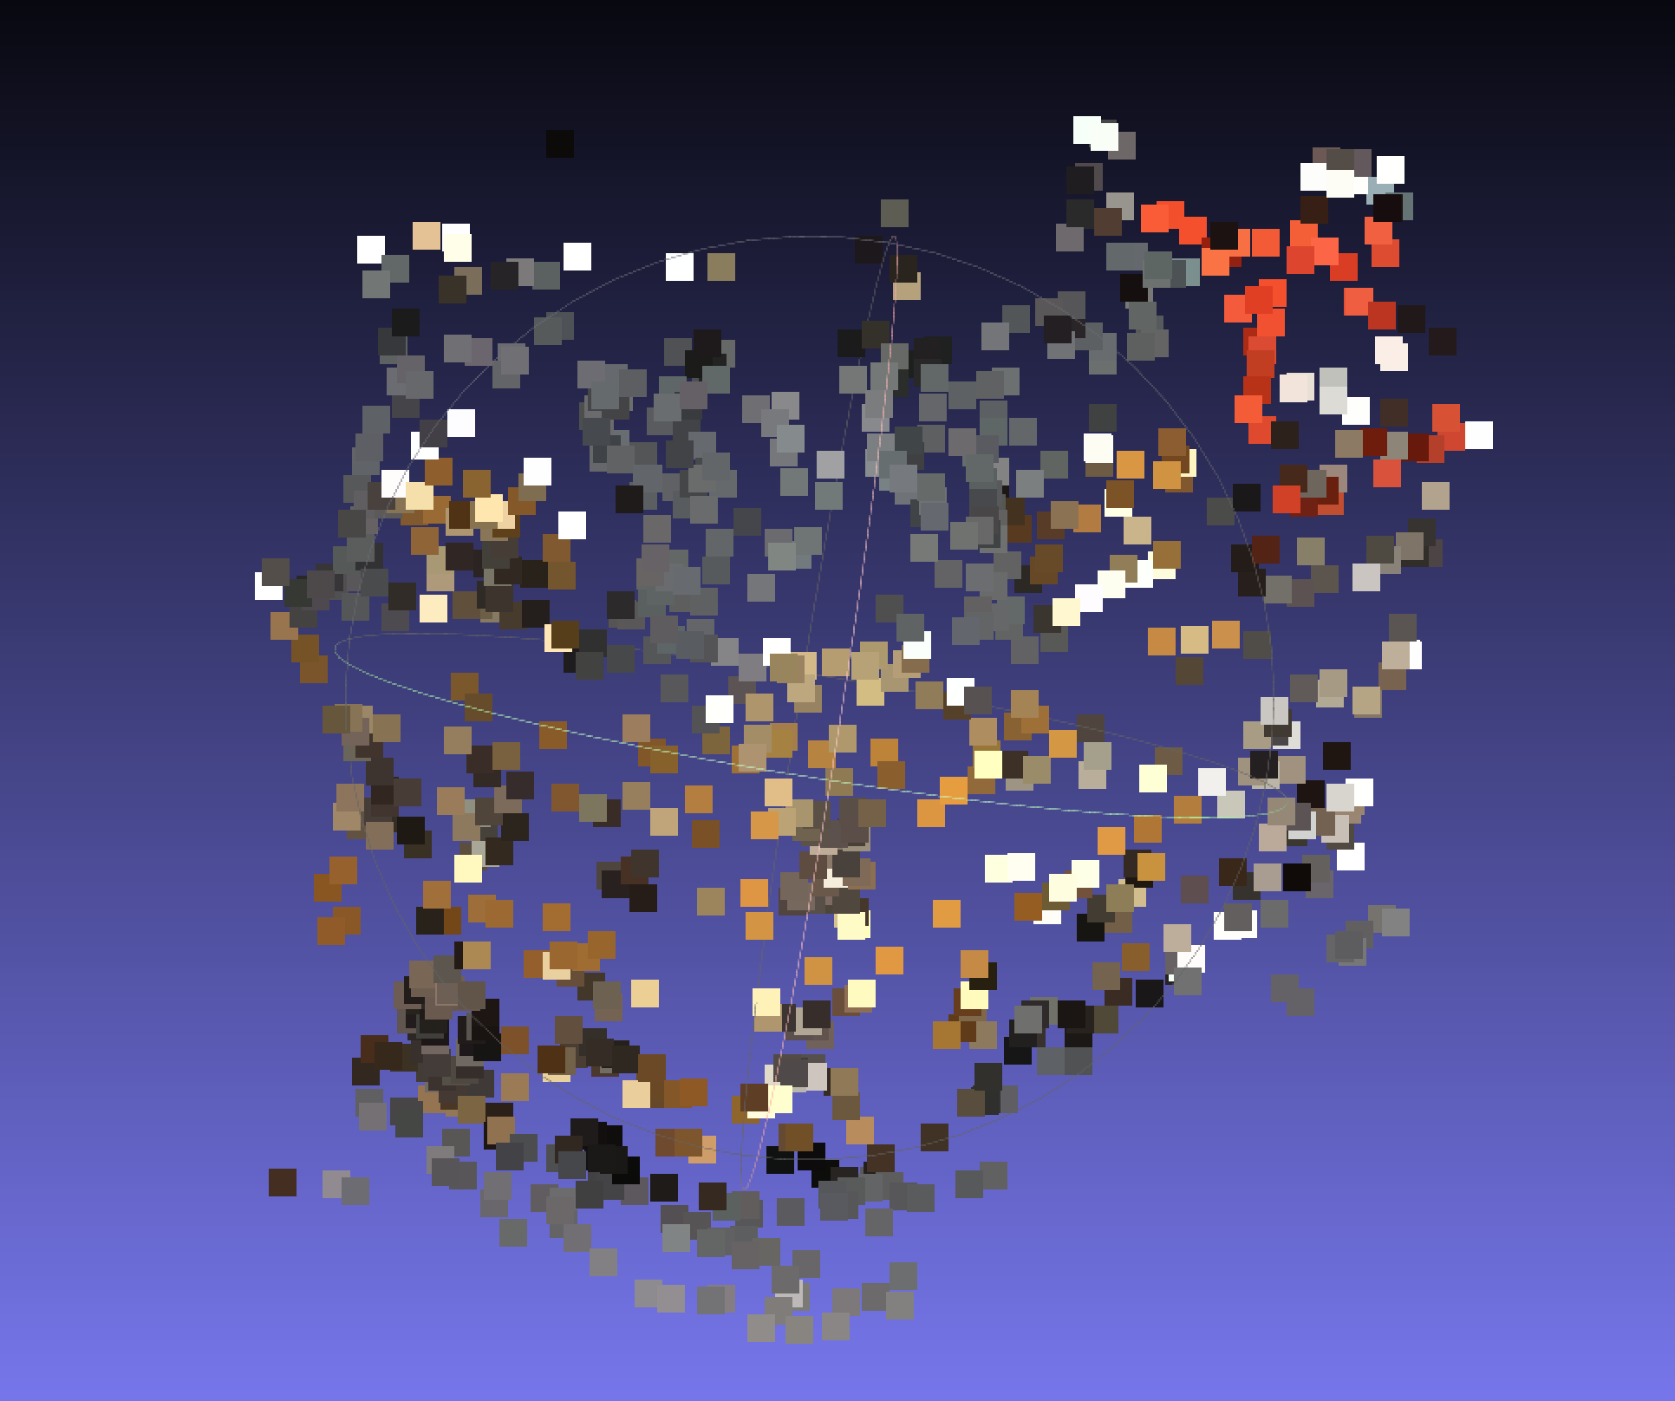

Figure 4. iteration 100 with inlier threshold 5

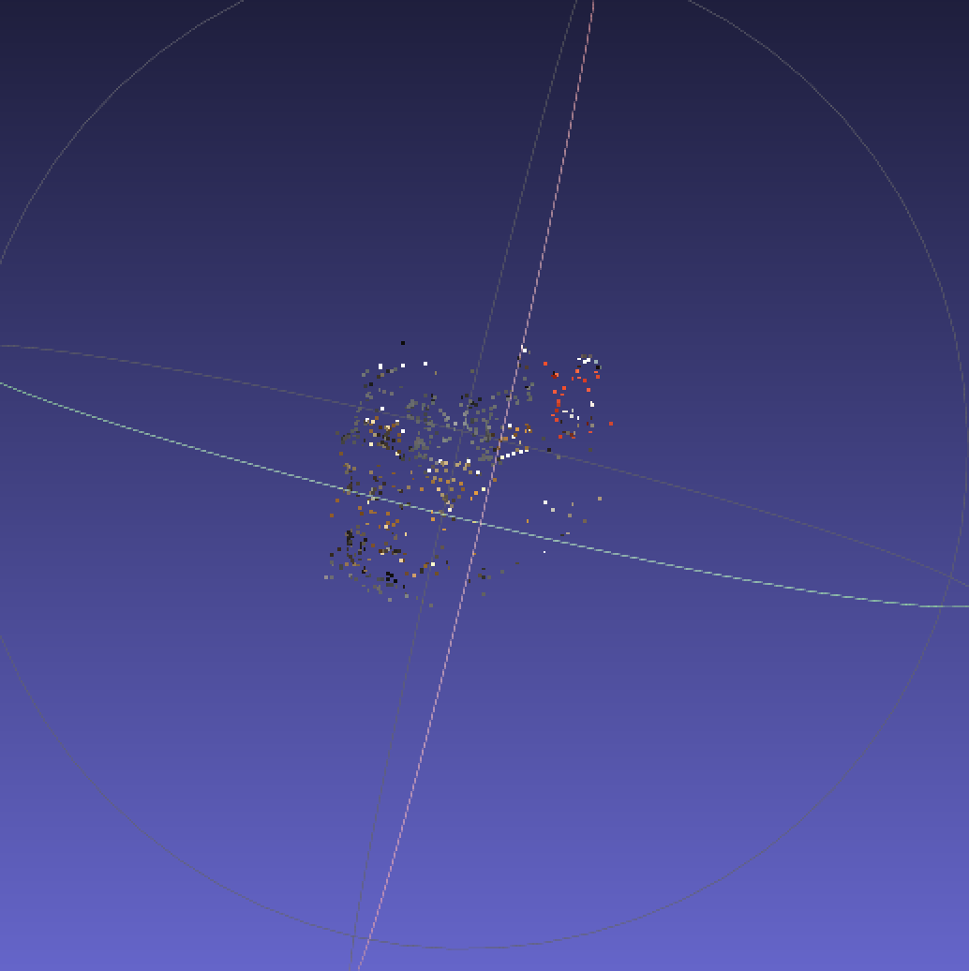

Figure 5. iteration 500 with inlier threshold 1

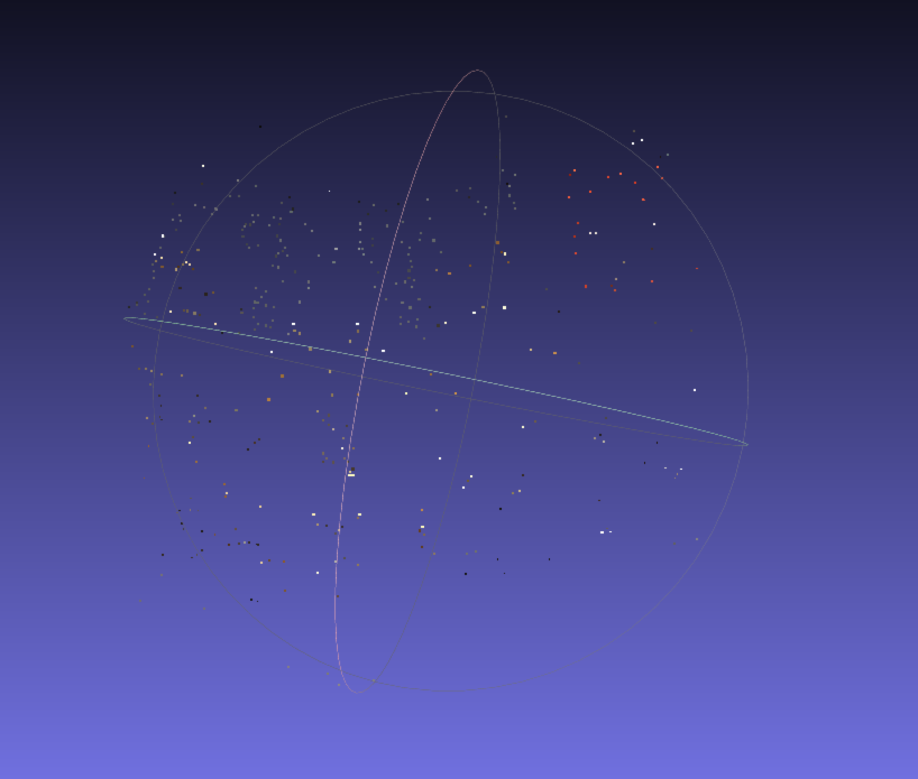

Figure 6. iteration 500 with inlier threshold 0.1

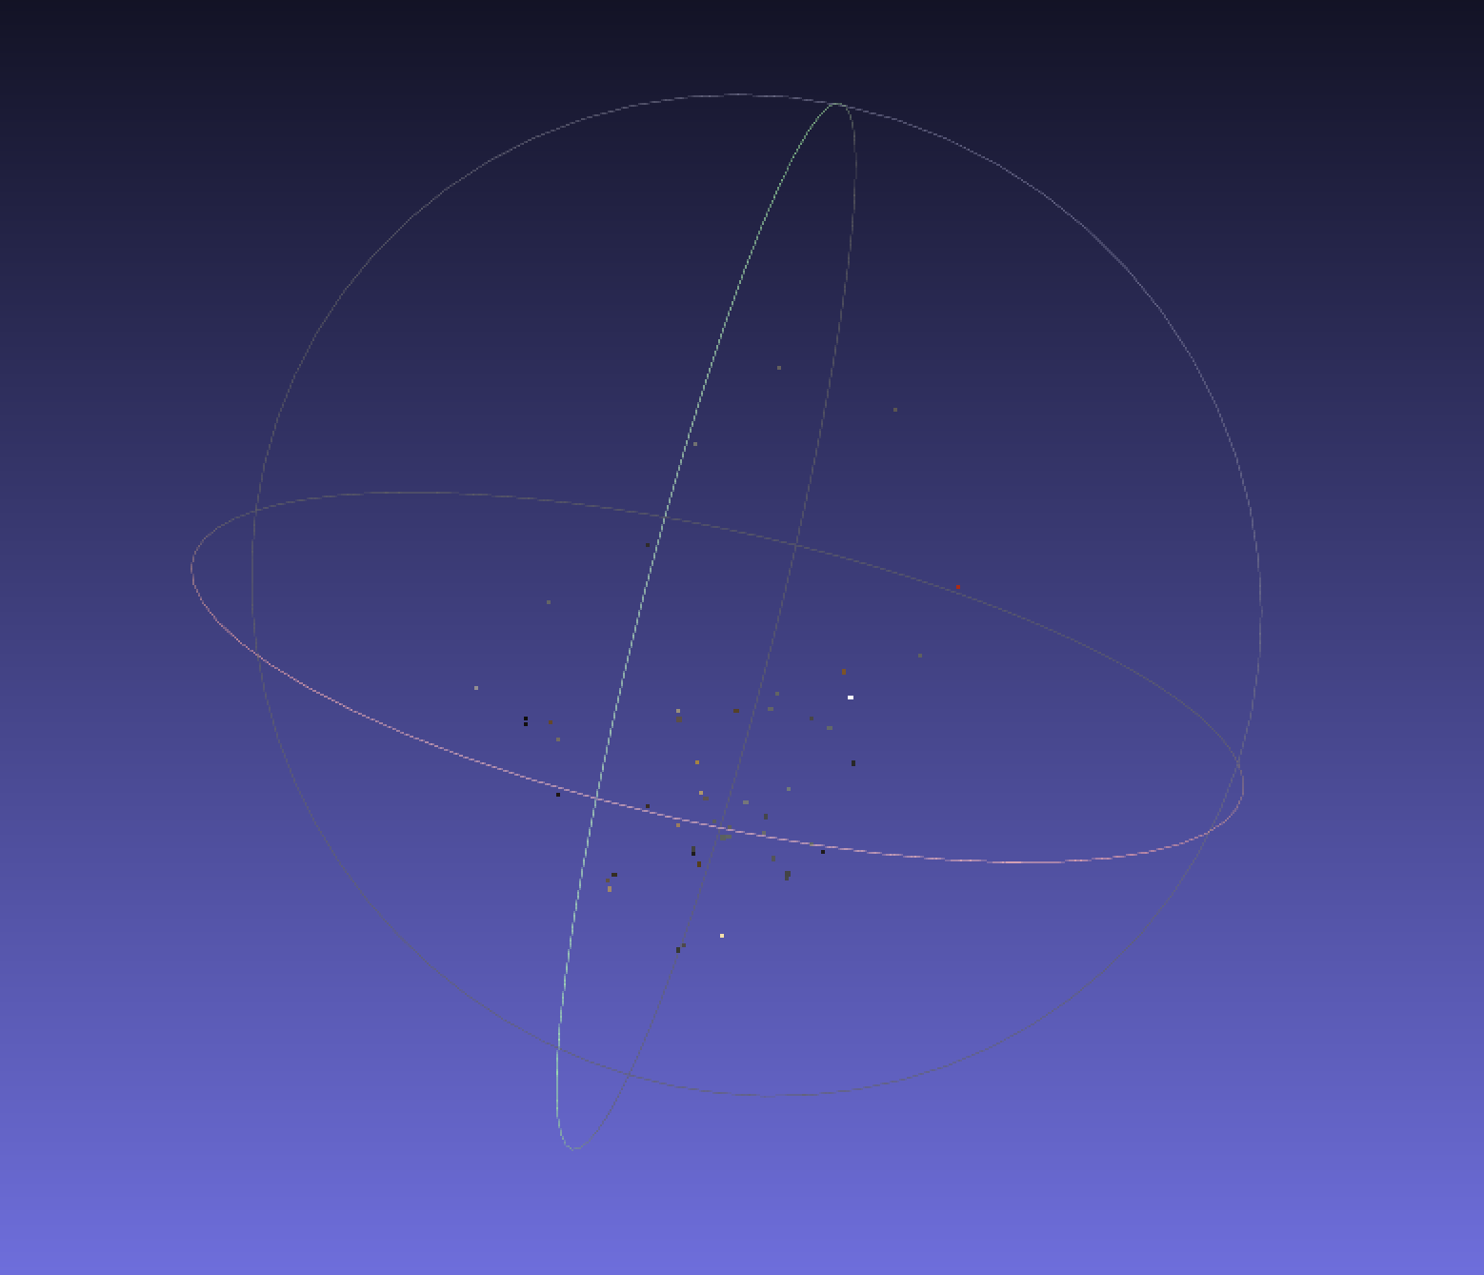

Figure 7. iteration 500 with inlier threshold 0.001