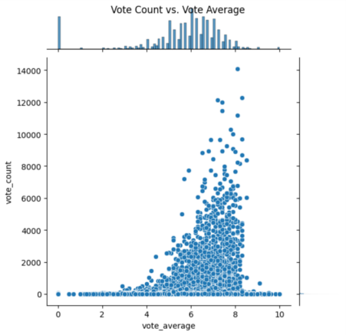import matplotlib.pyplot as plt

import seaborn as sns

movies_df = pd.read_csv("movies_metadata.csv")

vote_count = movies_df['vote_count']

vote_average = movies_df['vote_average']

heatmap_data = pd.DataFrame({'Vote Count': vote_count, 'Vote Average': vote_average})

plt.figure(figsize=(10, 8))

sns.heatmap(heatmap_data.corr(), annot=True, cmap='coolwarm')

plt.title('Vote Count vs. Vote Average Heatmap')

plt.show()

plt.figure(figsize=(10, 8))

sns.jointplot(x='vote_count', y='vote_average', data=movies_df)

plt.title('Vote Count vs. Vote Average')

plt.show(

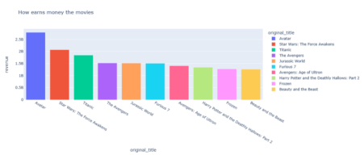import plotly.express as px

import seaborn as sns

import pandas as pd

import numpy as np

movie = pd.read_csv("movies_metadata.csv")

top_list = movie[['original_title','revenue']]

top_revenue = top_list.sort_values(by=['revenue'], ascending = False).dropna().head(10) px.bar(top_revenue, x='original_title', y = 'revenue', color='original_title', title = "How earns money the movies")

어려운점

1. 주제정하기

2. 데이터 열 때 딕셔너리 내의 리스트 내의 딕셔너리 형태로 되어 있던 것