Supporting Information

Sinuosity–Inundation Trade-Offs in Urban Drainage Networks:
A Scale-Proportional Gibbs’ Model Analysis of Seoul

Minsoo Seok, Changmin Park, and Yongwon Seo*
Department of Civil Engineering, Yeungnam University, Gyeongsan, Republic of Korea
*Corresponding author: Yongwon Seo (yongwon.seo@yu.ac.kr)

Supplementary figure descriptions
Figure S1 illustrates why the storage layout used for the drainage-direction matrix affects computational efficiency. A nested vector<vector<T>> stores its rows in separately allocated memory blocks, so repeated access to neighboring cells can require additional pointer indirection and cache-line loads. PLENA instead stores matrix elements in a single row-major vector<T>. Adjacent elements are therefore more likely to be loaded together, improving cache locality during repeated neighborhood operations. The schematic is illustrative; the realized performance gain depends on the access pattern, compiler, and hardware.
Figure S2 shows a PLENA run using automatic thread selection together with the corresponding processor utilization. The captured execution reports 24 worker threads on Computer B, which used an Intel Core i7-13700HX processor with 16 cores (8 performance cores and 8 efficient cores) and 24 threads. PLENA distributes independent β-class and replicate tasks across worker threads, whereas updates within each stochastic realization remain sequential. Figure S3 shows that the resulting implementation required less generation time than the benchmarked MATLAB implementation across all tested network sizes.
Figure S3 compares generation times for the MATLAB-based Gibbs-model implementation and PLENA on Computer A (Intel Core i5-7500, 4 cores and 4 threads), Computer B (Intel Core i7-13700HX, 16 cores and 24 threads), and Computer C (Intel Core i5-1340P, 12 cores and 16 threads). PLENA required less generation time across all tested network sizes, with the largest absolute time differences observed for the largest networks. Computer B showed the shortest PLENA generation times for the larger networks. This pattern is consistent with, but does not by itself establish, a benefit from its greater thread availability, because processor architecture, clock behaviour, and memory configuration also differed among the computers.
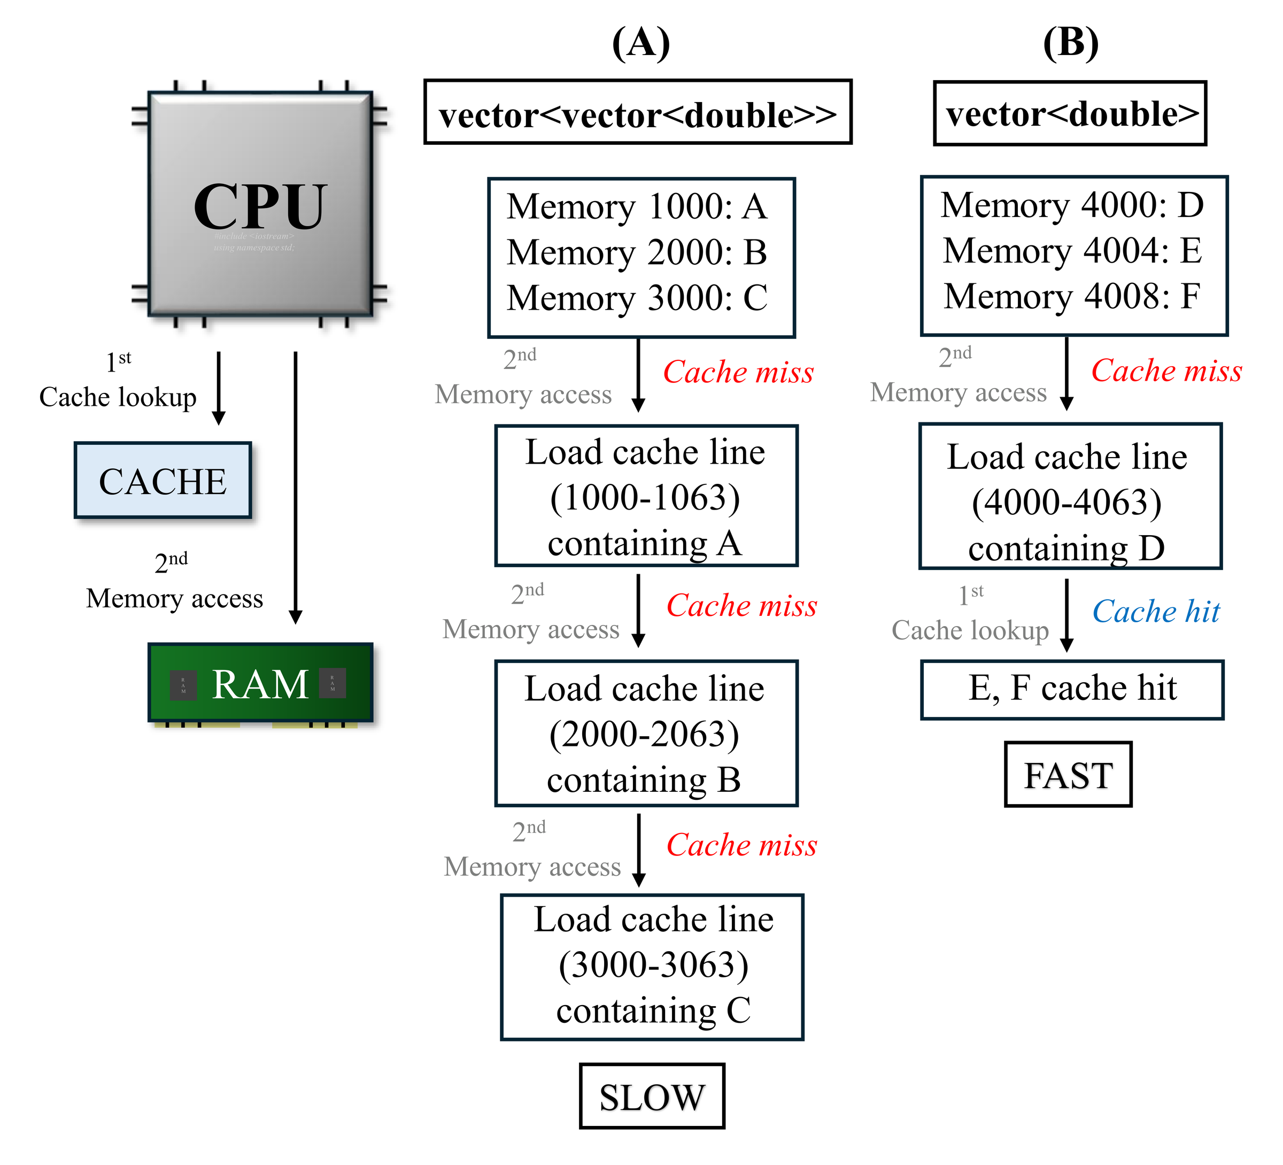
Figure S1. Schematic comparison of nested and contiguous memory layouts. Row-major contiguous storage places adjacent cell values together and improves cache locality during repeated neighborhood access. Types and addresses are schematic examples; the PLENA Matrix implementation stores vector<int>.

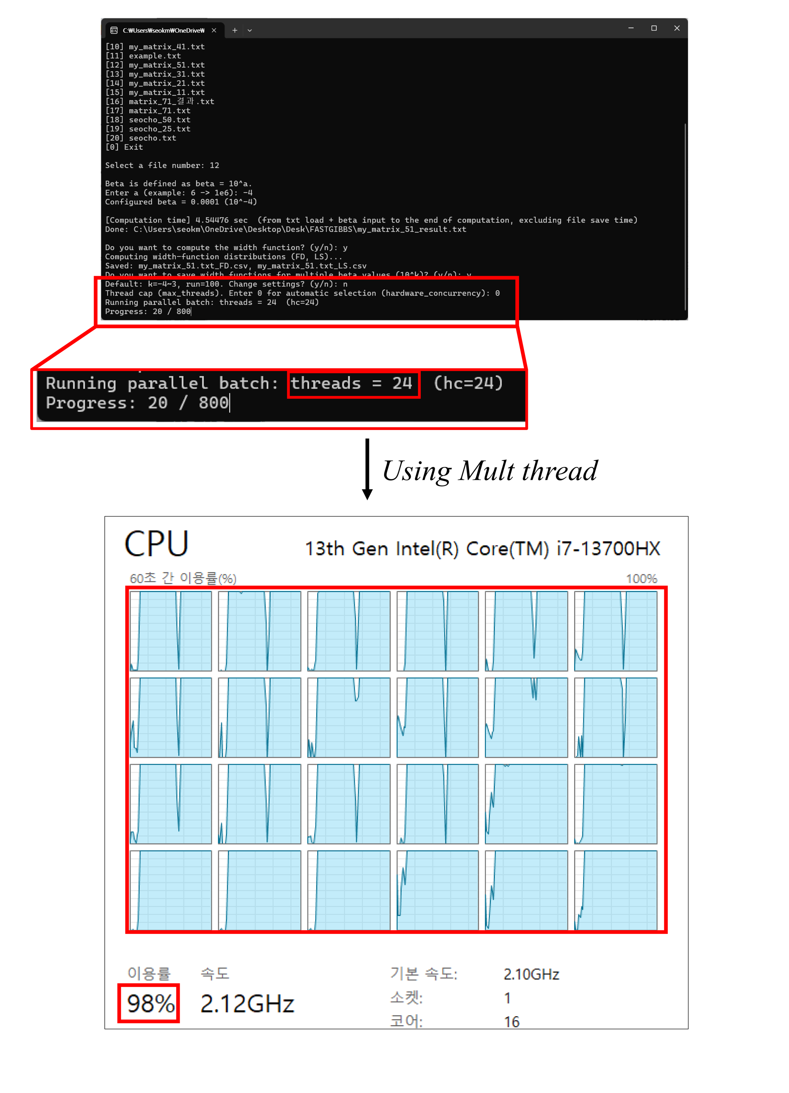
Figure S2. PLENA console output and processor utilization during parallel width-function estimation. The captured run reports automatic use of 24 worker threads. Parallel execution is applied across independent β-class and replicate tasks; utilization varies with hardware and workload.

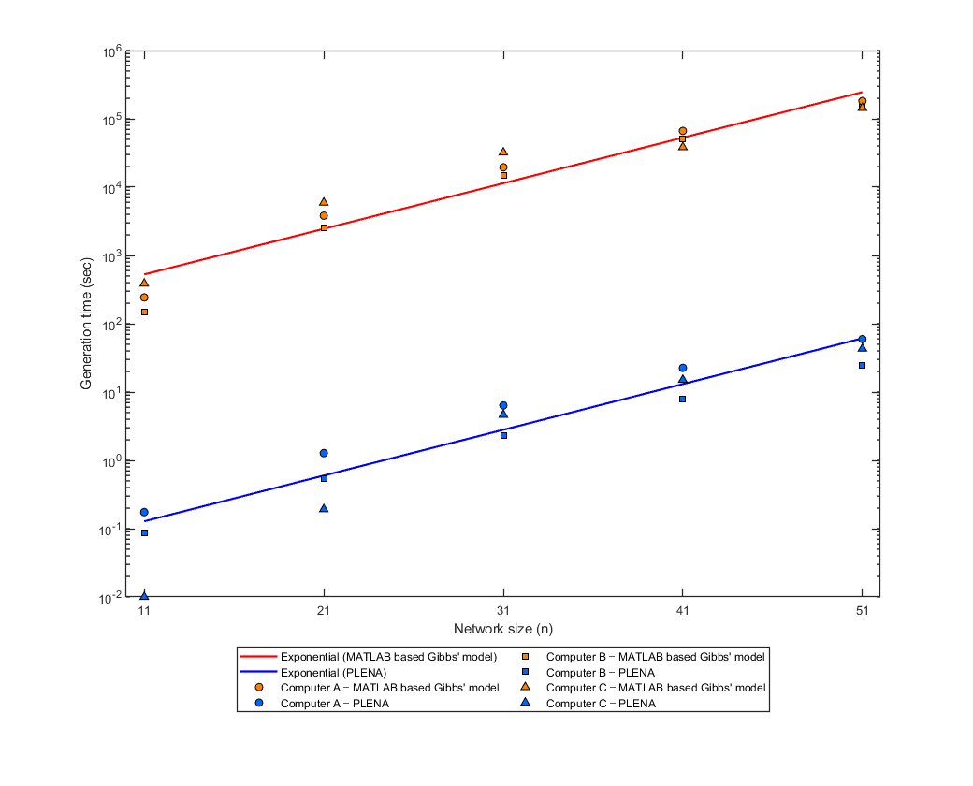
Figure S3. Generation-time comparison between the MATLAB-based Gibbs-model implementation and PLENA across the tested network sizes. The y-axis is logarithmic; values represent the tested configurations and computing environment.
Benchmark computers: A, Intel Core i5-7500; B, Intel Core i7-13700HX; and C, Intel Core i5-1340P. The same operating system, MATLAB release, and C++ compiler release were used across the three computers. PLENA used automatic thread selection (thread cap = 0); the run shown in Figure S2 selected 24 worker threads on Computer B.

