Velocity, Injury Risk, and Franchise Value
An exploratory LA Dodgers pitching and financial analysis
Analysis edition — generated from processed data

1. Executive summary
This project combines 184 pitcher-season observations (106 unique pitchers) with team financial data and a six-team comparison panel.
- A 1 mph velocity increase is associated with 4.24 in IL_days (p=<0.001).
- A 1 mph velocity increase is associated with 0.0015 in WAR_per_IP (p=<0.001).
- A 1 mph velocity increase is associated with 0.0080 in Postseason_WAR_proxy (p=0.075).
- Results are observational associations. They do not establish that velocity or the superstar strategy caused the outcomes.

2. Data and design
Pitcher-level models use player-clustered standard errors and exclude rows flagged for fewer than five innings. A sensitivity model controls for the prior observed season's IL days.
The financial analysis compares LAD with NYY, BOS, NYM, CHC, and SFG using team and season fixed effects. Post equals one from 2024 onward.
Important caveats: only six team clusters are available, pre-trends are imperfect, external financial values are estimates, and 2026 values are preliminary.

3. Velocity trade-off
Velocity bucket | Pitcher-seasons | Mean IL days | Mean WAR/IP
<92 mph | 36 | 21.8 | 0.0086
92-94 mph | 46 | 21.4 | 0.0083
94-96 mph | 65 | 26.2 | 0.0089
96+ mph | 37 | 45.9 | 0.0127
Bucket counts and means above are computed from the processed pitcher dataset when this report is built.
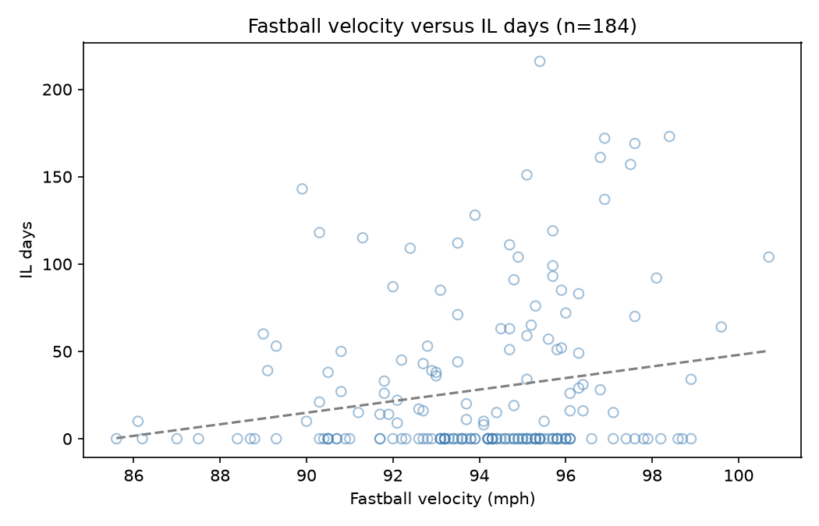
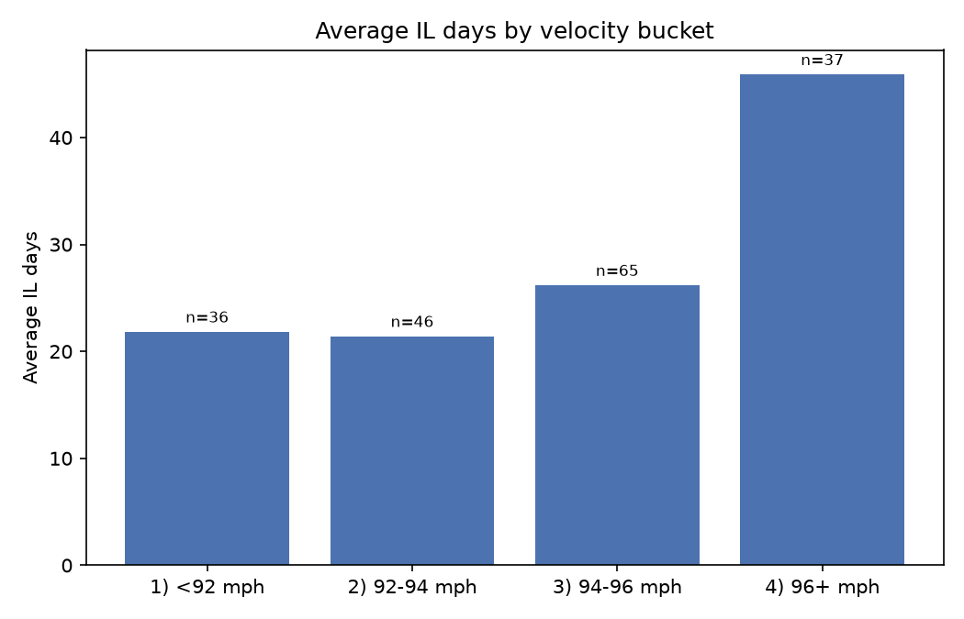

4. Team financial comparison
Metric | Before 2024 mean | 2024+ mean | Change
Revenue | $535.8M | $650.5M | +$114.7M
Operating income | $38.0M | $23.5M | -$14.5M
Team value | $3.60B | $6.15B | +$2.55B
CBT tax | $18.4M | $136.2M | +$117.8M
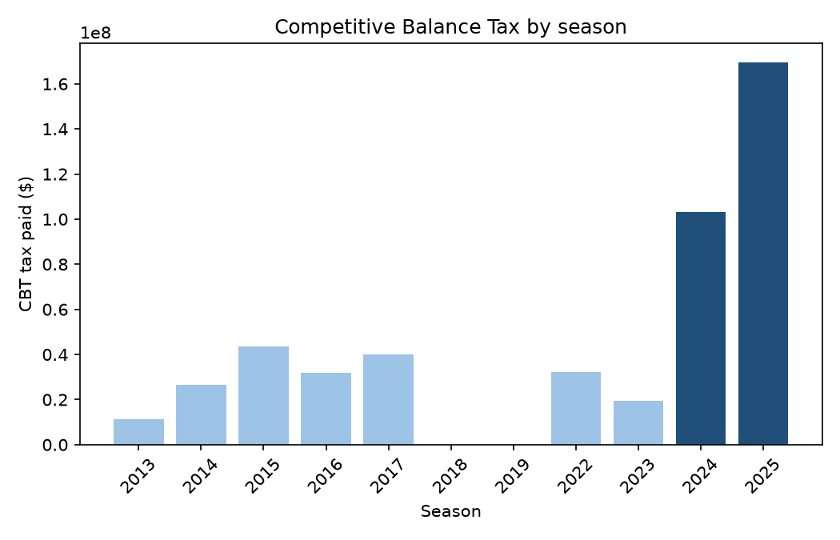

4.1 Difference-in-Differences
Outcome | Full-sample effect | p-value | Excl. 2020-21
Revenue | +$97.4M | <0.001 | +$89.8M (p=<0.001)
Team_Value | +$1.66B | <0.001 | +$1.62B (p=<0.001)
Operating_Income | -$2.8M | 0.955 | +$35.0M (p=0.469)
OI_Margin_Pct | -13.17 pp | 0.199 | 9.12 pp (p=0.365)
OI_Margin_Pct is stored as a proportion. Its coefficients are multiplied by 100 and reported above in percentage points (pp).
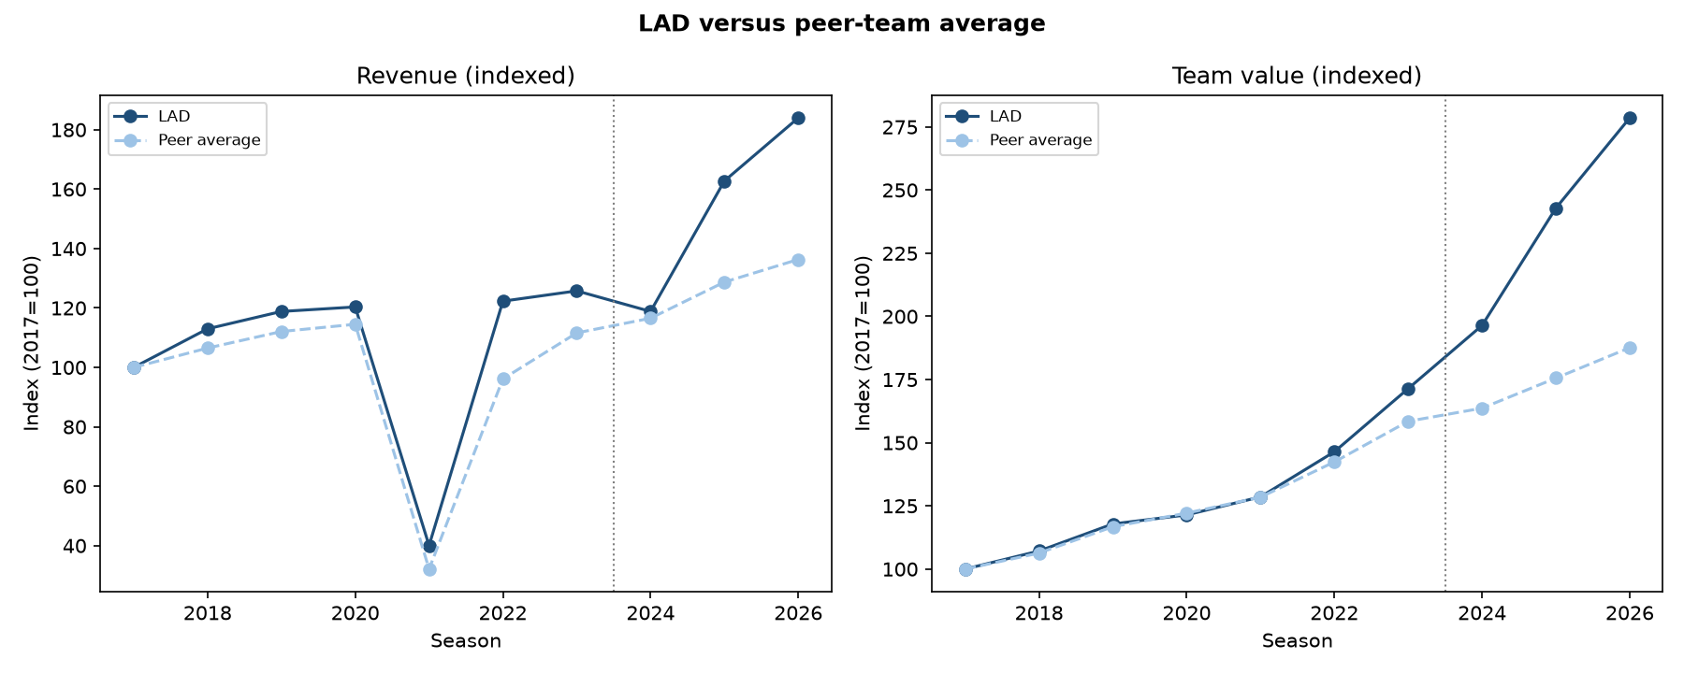
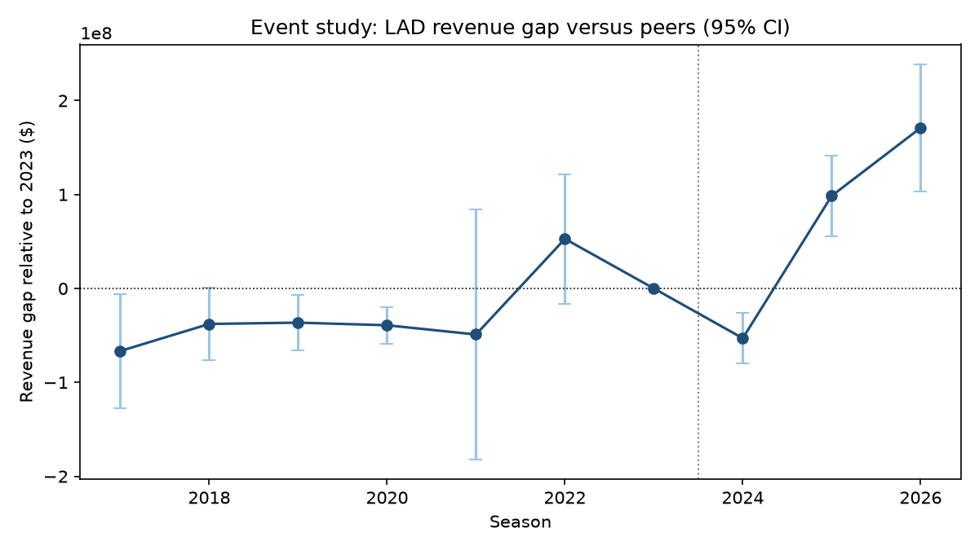

5. Interpretation and limitations
- Higher velocity is associated with both greater injury burden and higher WAR efficiency.
- Revenue and team-value estimates rise relative to the selected peer group, while operating-income effects are not statistically distinguishable from zero.
- The DiD estimates are exploratory: six clusters limit conventional cluster-robust inference, and the parallel-trends assumption is not fully supported.
- The published IL snapshot can understate unresolved or unmatched stints; the live collection utility now right-censors open stints for future refreshes.
The repository includes the processed datasets, scripts, workbook, figures, and documentation needed to inspect and rerun the analysis.

