Product design guide for
RF regulatory certification

▶ CONTENTS
1. Scope 3
2. Block Diagram 3
3. Pin Map Overview 4
4. Test Mode Overview 5
5. How to use common tools 5
6. Product Design Guide for Sigfox RF Certification 8
7. Product Design Guide for WIFI RF Certification 8
7. Product Design Guide for BLE RF Certification 11
8. Product Design Guide for GPS RF Certification 12
9. Product Design Guide for NFC RF Certification 13

1. Scope
SFM20R is a module that supports Quad mode.(Sigfox, WIFI, BLE, GPS, NFC)
This document describes what should be considered when designing the product for RF regulatory certification of each RF block.

2. Block Diagram
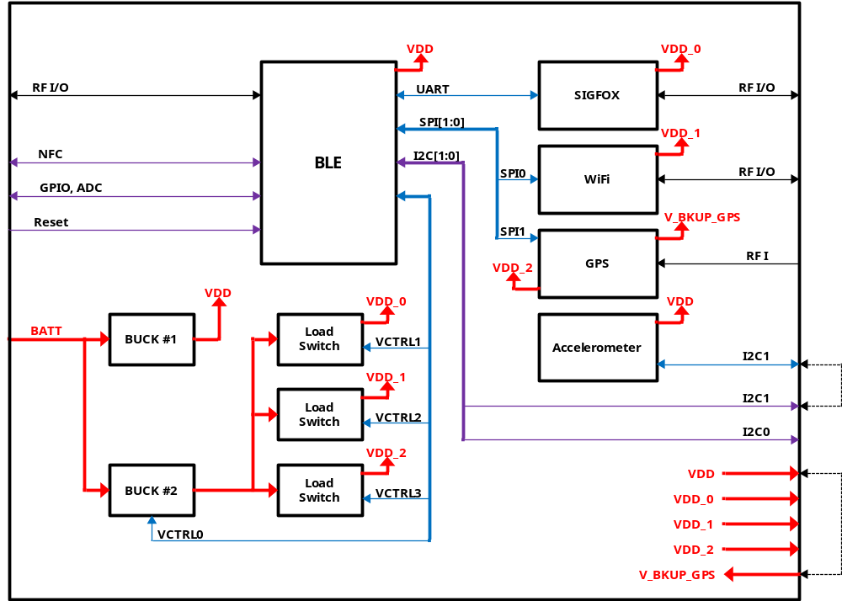
< Block diagram of SFM20R model>
BLE chip (nRf52832/ARM Cortex M4) is host MCU.
For RF regulatory certification, each RF block must be set to Test mode.
In case of WIFI, WIFI UART and WIFI download enable pin should be connected to the outside.
(UART0_TX_WIFI, UART0_RX_WIFI, DL_EN/INT_WIFI)

3. Pin Map Overview
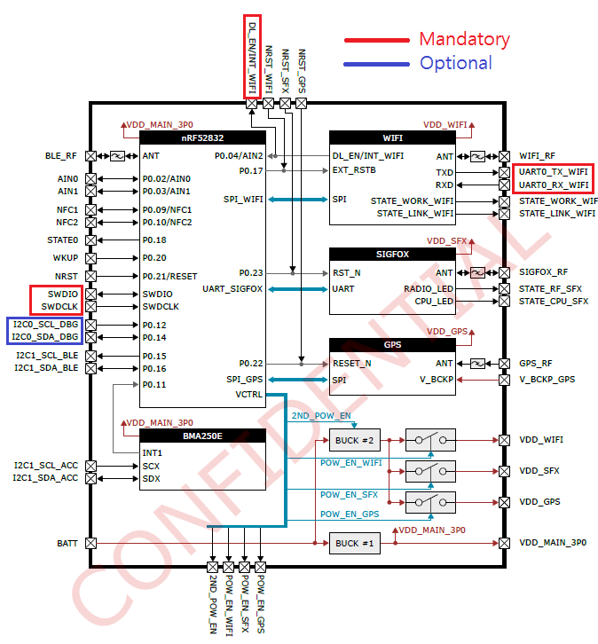
* External connection pin.
Mandatory : 5 pins (Test conducted with J-Link equipment)
. SWD (2 pins : SWDCLK, SWDIO) : use J-Link connect
. WIFI UART(2 pins : UART0_TX_WIFI, UART0_RX_WIFI) : WIFI RF Test, download for WIFI firmware
. DL_EN/INT_WIFI : boot for WIFI firmware download mode (Active Low)
* SWD(use RTT) : BLE, Sigfox, GPS, Dedicated UART : WIFI
Optional : 2 pins (Can be tested with UART when using, "USB to UART converter" required)
. I2C_DBG (I2C0_SCL_DBG, I2C0_SDA_DBG) : Used as UART in "RF regulatory certification" test

4. Test Mode Overview
. Kind of boot mode
Normal mode : 0 (default, The mode setting is possible with SWD)
Sigfox test mode : 6 (via SWD), 7(via UART)
WIFI test mode : 1 (via WIFI UART), *WIFI download mode -> DL_EN/INT_WIFI to GND
BLE test mode : 3 (via SWD and via UART)
GPS test mode : 4 (via SWD and via UART)
* How to setting test mode : SEND "CMx" to RTT in Normal mode. ("x" is boot mode)
* How to go back to normal mode : SEND "CF" (0x4346) to RTT, it is initialized to normal mode.

. RF Testable Interface
 | Interface pins
 | SWD pins  (Use RTT) | WIFI_UART pins | Use I2C_DBG pins as uart  (I2C0_SCL_DBG <- TXD,  I2C0_SDA_DBG -> RXD)
SIGFOX | O (mode:6) | X | O (mode:7)
SIGFOX | O (mode:6) | X | Baud rate : 9600
WIFI | X | O (mode:1) | X
BLE | O (mode:3) | X | O (mode:3)
BLE | O (mode:3) | X | Baud rate : 19200
GPS | O (mode:4) | X | O (mode:4)
GPS | O (mode:4) | X | Baud rate : 9600
 | j-Link | USB to Uart | USB to Uart

5. How to use common tools
. Use RTT tools
Tools for RTT communication with J-link equipment via SWD
https://www.nordicsemi.com/eng/nordic/Products/nRF51822/nRF5x-Command-Line-Tools-Win32/33444
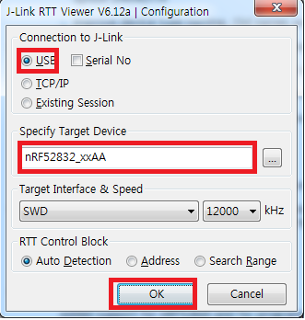
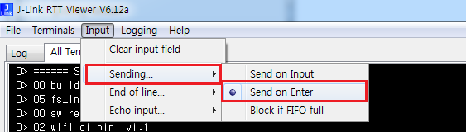
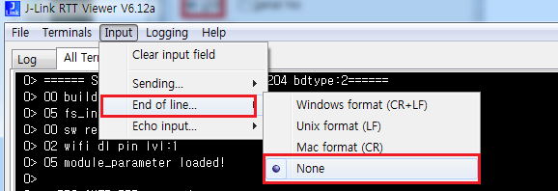
. Setting Boot Mode with RTT Viewer (Applies after rebooting)
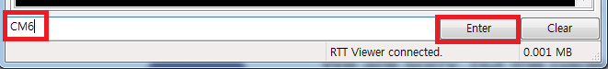
*6 is boot bode value (sigfox), ref. boot mode value
. Setting Boot Mode to Normal mode with RTT Viewer
. Connect RTT by Terminal tool (eg. Tera Teram)
1) Run RTT Viewer (It acts as a telnet server)
2) Connect terminal tool
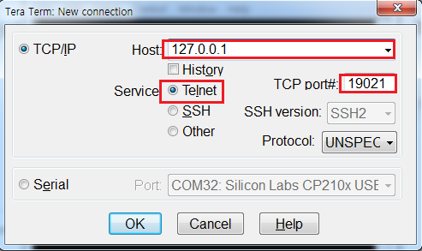
. How to create a virtual com port via RTT (For tools that use the com port)
1) Run RTT Viewer (It acts as a telnet server)
2) Run VSPE (http://www.eterlogic.com/Products.VSPE.html)
3) Create Connector (Set to unused com port)
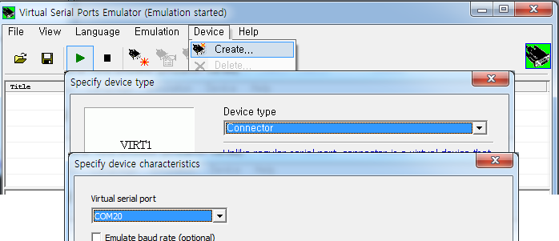
4) Create TCP Client. (Set the speed(baud rate) baud rate for your tool)
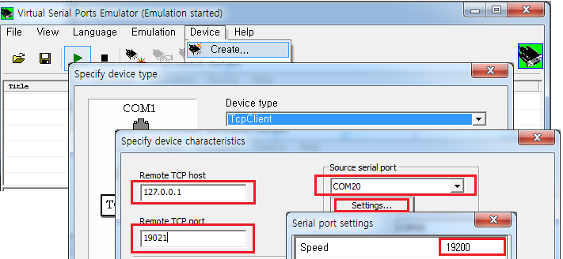
4) Com port is available

6. Product Design Guide for Sigfox RF Certification
"Sigfox RF Certification" available with UART or SWD
Set the test mode to 6(RTT) or 7(UART).
You must provide "J-Link" when using "SWD" or provide "USB to serial converter board" when using "UART".
In case of RF Certification, it is recommended to use a shielded cable because there is a possibility of problems due to noise emitted through the cable.

[set test mode]
RTT
UART

[test tool]
Test with AT command using terminal tools (RTT or UART)

[Serial Config]
Baud rate : 9600, Data bits : 8, parity : None, Stop bits : 1

[Test Cmd]
AT$CW=868130000,1,15<CR><LF> CwEuON
AT$CW=868130000,0,15<CR><LF> CwEuOFF
AT$CW=902200000,1,24<CR><LF> CwUsON
AT$CW=902200000,0,24<CR><LF> CwUsOFF
AT$CW=920800000,1,24<CR><LF> CwRcz4ON
AT$CW=902200000,0,24<CR><LF> CwRcz4OFF
ref. https://www.onsemi.com/pub/Collateral/AX-SIGFOX-D.PDF

7. Product Design Guide for WIFI RF Certification
When WIFI RF Certification test, it must be able to control the DL_EN / INT_WIFI pin and the WIFI UART (UART0_TX_WIFI, UART0_RX_WIFI) pins.
To conduct WiFi Certification, It use Test Binary, which is provided for separate Certification.
Because of this, WIFI downloads may be required. (WIFI download mode -> DL_EN/INT_WIFI to low)
Set the test mode to 1 and using the WIFI UART port.
You must provide "USB to serial convertor board" when using "UART".
In case of RF Certification, it is recommended to use a shielded cable because there is a possibility of problems due to noise emitted through the cable.

[set test mode]

[test tool]
using terminal tools (UART)

[Serial Config]
Baud rate : 115200, Data bits : 8, parity : None, Stop bits : 1

[ Test firmwares]
* WIFI download mode -> DL_EN/INT_WIFI to low and booting

. FCC
Tx Command : ESP8285_RF_TEST_20171018.bin

. CE
Tx and Rx Command : ESP8285_RF_TEST_20171018.bin
Adaptivity Test : ESP8285_CE_Adaptivity_20171018.bin

. TELEC
Tx and Rx Command : ESP8285_RF_TEST_20171018.bin
Occupied Bandwidth and Spread-spectrum Bandwidth / Factor(14Channel) : ESP8266_TELEC_20171018.bin
**Using EMC mode for Tx/Rx Command
**Using SRRC mode for TELEC Occupied Bandwidth and Spread-spectrum Bandwidth / Factor(14Channel)

[how to write firmware]
Booting for WIFI download mode (DL_EN/INT_WIFI to low)
. ESP8285_RF_TEST_20171018.bin
run development\sigfox_cfg2\tools\wifitools\Certification_Test_write_RF_TEST.cmd
. ESP8285_CE_Adaptivity_20171018.bin
run development\sigfox_cfg2\tools\wifitools\Certification_Test_write_CE_Adaptivity.cmd
. ESP8266_TELEC_20171018.bin
run development\sigfox_cfg2\tools\wifitools\Certification_Test_write_TELEC.cmd

[CE : Adaptivity Test]
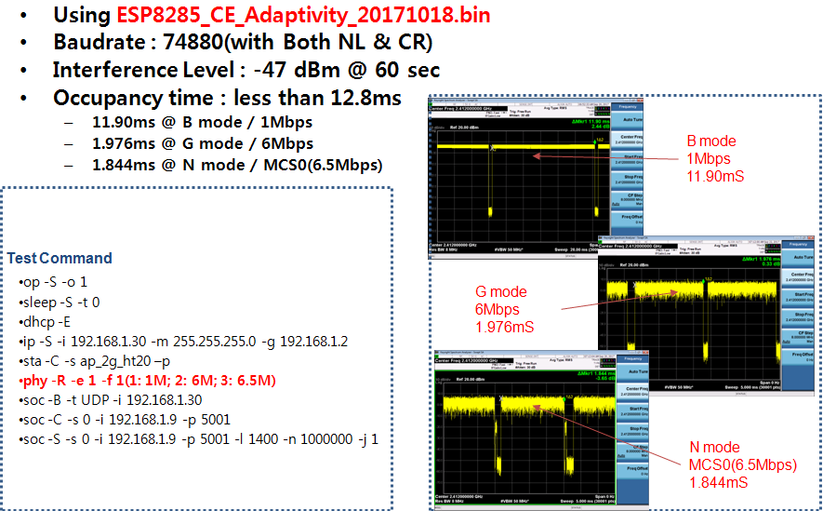

[TELEC : Occupied Bandwidth and Spread-spectrum Bandwidth / Factor(14Channel)]
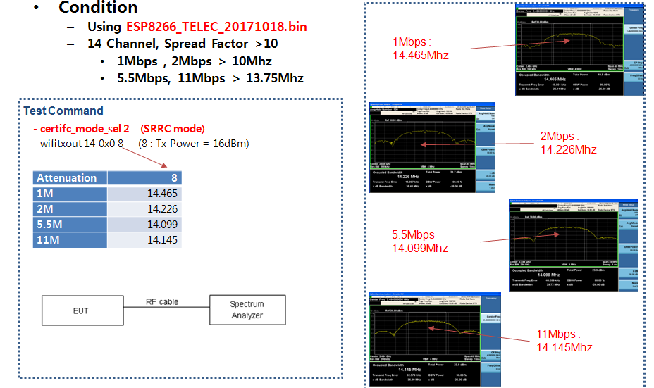
[Test Command : Tx]
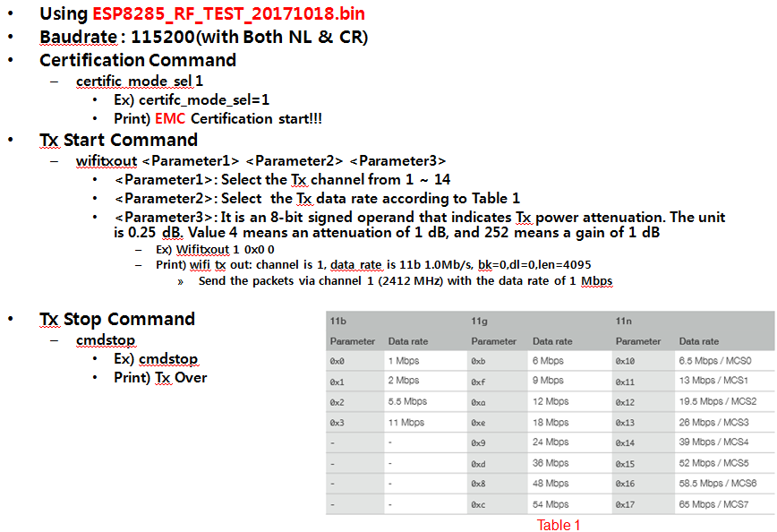

[Test Command : Rx]
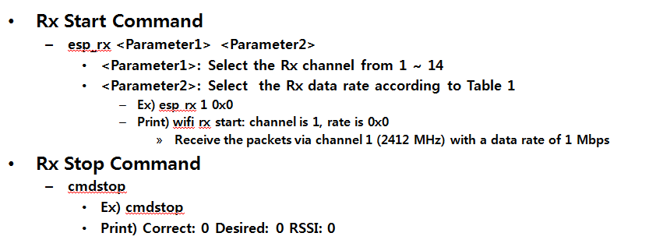

7. Product Design Guide for BLE RF Certification
" BLE RF Certification" available with UART or SWD
You must provide "J-Link" when using "SWD" or provide "USB to serial convertor board" when using "UART".
In case of RF Certification, it is recommended to use a shielded cable because there is a possibility of problems due to noise emitted through the cable.
[set test mode]

[Serial Config]
Baud rate : 19200, Data bits : 8, parity : None, Stop bits : 1

[test tool]
nRFgo Studio : https://www.nordicsemi.com/kor/nordic/Products/nRFgo-Studio/nRFgo-Studio-Win64/14964
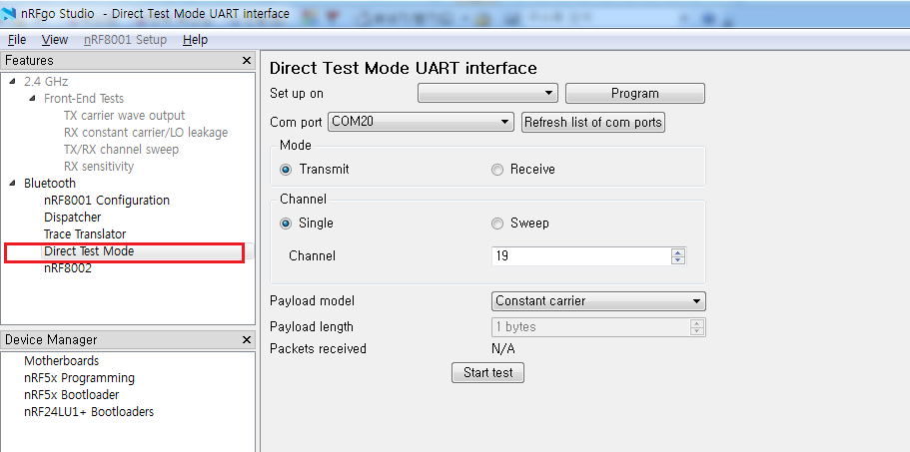
* Other tools using the com port are also available.

8. Product Design Guide for GPS RF Certification
" GPS Certification" available with UART or SWD
You must provide "J-Link" when using "SWD" or provide "USB to serial convertor board" when using "UART".
In case of RF Certification, it is recommended to use a shielded cable because there is a possibility of problems due to noise emitted through the cable.

[set test mode]

[Serial Config]
Baud rate : 9600, Data bits : 8, parity : None, Stop bits : 1

[Use test tool]
u-center : http://www.u-blox.com/en/u-center-download-windows
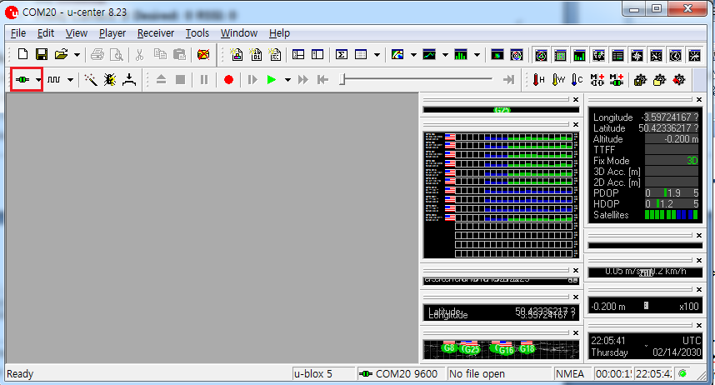

9. Product Design Guide for NFC RF Certification
CE (RED) certification must also proceed with NFC certification.
Certification should be carried out at the product end including the NFC antenna.

