**Open Software Project**

**경영학과 1517034 정성원**

**Assignment 1.**

**1. rotation.cpp**

**1) Idea**

-NN interpolation과 bilinear interpolation을 이용해 주어진 이미지를

**2) Code**

# include <opencv2/opencv.hpp>

# include <iostream>

using namespace cv;

using namespace std;

template <typename T>

Mat myrotate(const Mat input, float angle, const char* opt);

int nearest(float a);

int bilinear(const Mat input, float x, float y, int ch);

int main() {

Mat input, rotated;

//Read each image

input = imread("lena.jpg");

//Check for invalid input

if (!input.data) {

cout << "Could not open or find the image" << endl;

return -1;

}

//original image

imshow("image", input);

//rotated = myrotate<Vec3b>(input, 45, "nearest");

rotated = myrotate<Vec3b>(input, 45, "bilinear");

//rorated image

imshow("rotated", rotated);

waitKey(0);

return 0;

}

template <typename T>

Mat myrotate(const Mat input, float angle, const char*opt) {

int row = input.rows;

int col = input.cols;

float radian = angle * CV_PI / 180;

float sq_row = ceil(row * sin(radian) + col * cos(radian));

float sq_col = ceil(col * sin(radian) + row * cos(radian));

Mat output = Mat::zeros(sq_row, sq_col, input.type());

for (int i = 0; i < sq_row ; i++) {

for (int j = 0; j < sq_col ; j++) {

float x = (j - sq_col / 2) * cos(radian) - (i - sq_row / 2) * sin(radian) + col / 2;

float y = (j - sq_col / 2) * sin(radian) + (i - sq_row / 2) * cos(radian) + row / 2;

if ((y >= 0) && (y <= (row - 1)) && (x >= 0) && (x <= (col - 1))){

if (!strcmp(opt, "nearest")) {

//nearest method

output.at<Vec3b>(i, j)[0] += input.at<Vec3b>(nearest(y), nearest(x))[0];

output.at<Vec3b>(i, j)[1] += input.at<Vec3b>(nearest(y), nearest(x))[1];

output.at<Vec3b>(i, j)[2] += input.at<Vec3b>(nearest(y), nearest(x))[2];

}

else if (!strcmp(opt, "bilinear")) {

//bilinear method

output.at<Vec3b>(i, j)[0] += bilinear(input, y, x, 0);

output.at<Vec3b>(i, j)[1] += bilinear(input, y, x, 1);

output.at<Vec3b>(i, j)[2] += bilinear(input, y, x, 2);

}

}

}

}

return output;

}

int nearest(float a) {

/*return nearest integer*/

if (abs(a - (int)a) <= (abs(a + 1 - (int(a)))))

return int(a);

return int(a) + 1;

}

int bilinear(const Mat input, float x, float y, int ch) {

/*return intensity of floating point using bilinear interpolation*/

int x1 = int(x); int x2 = int(x) + 1;

int y1 = int(y); int y2 = int(y) + 1;

int temp1 = (x2 - x)*input.at<Vec3b>(x1, y2)[ch] + (x - x1)*input.at<Vec3b>(x1, y1)[ch];

int temp2 = (x2 - x)*input.at<Vec3b>(x2, y2)[ch] + (x - x1)*input.at<Vec3b>(x2, y1)[ch];

return (x2 - x) * temp2 + (x - x1) * temp1;

}

**3) Result**

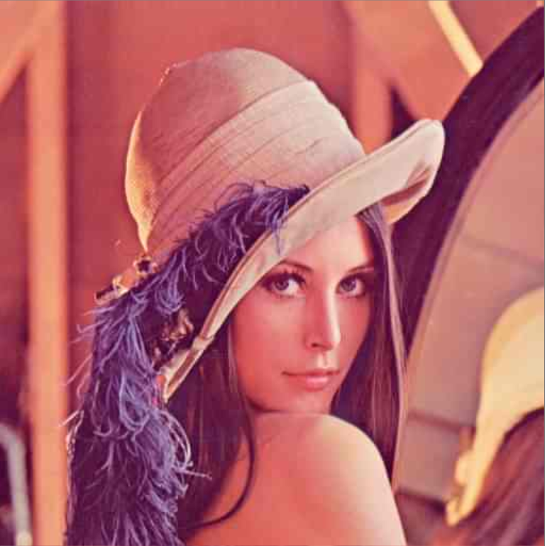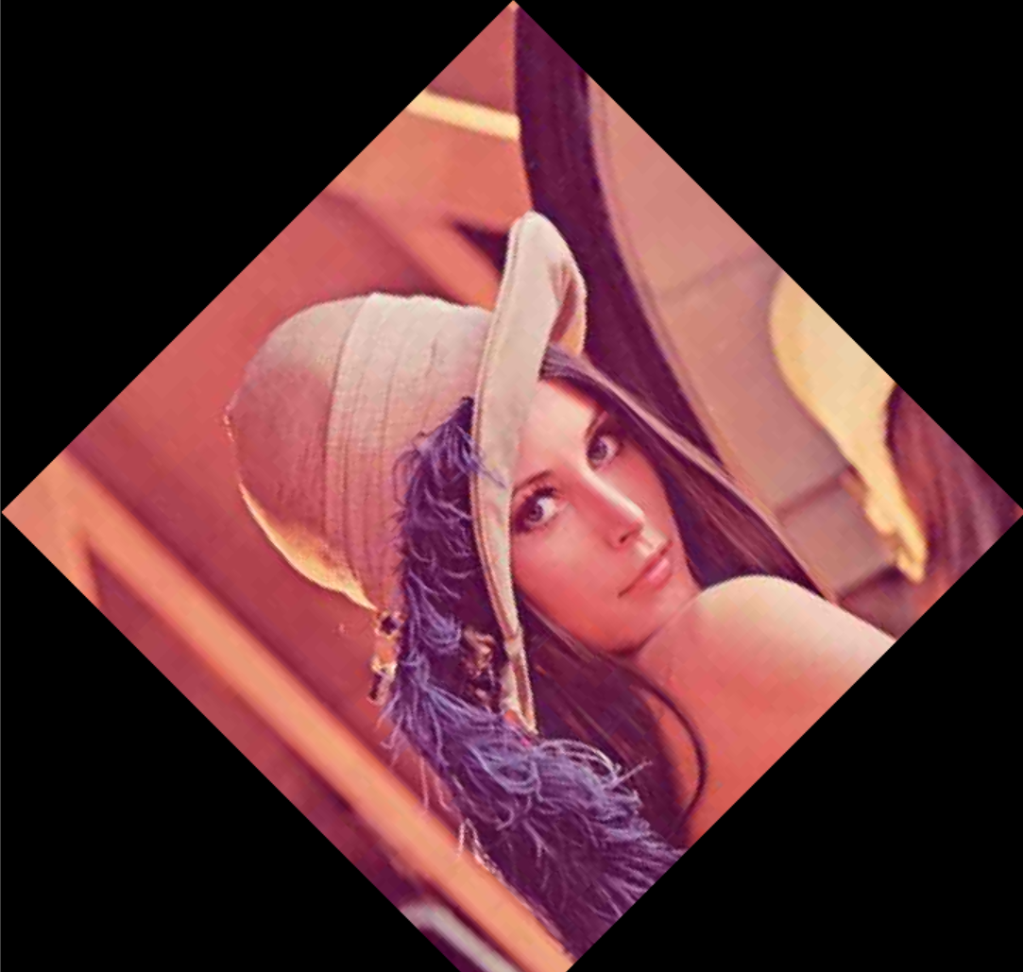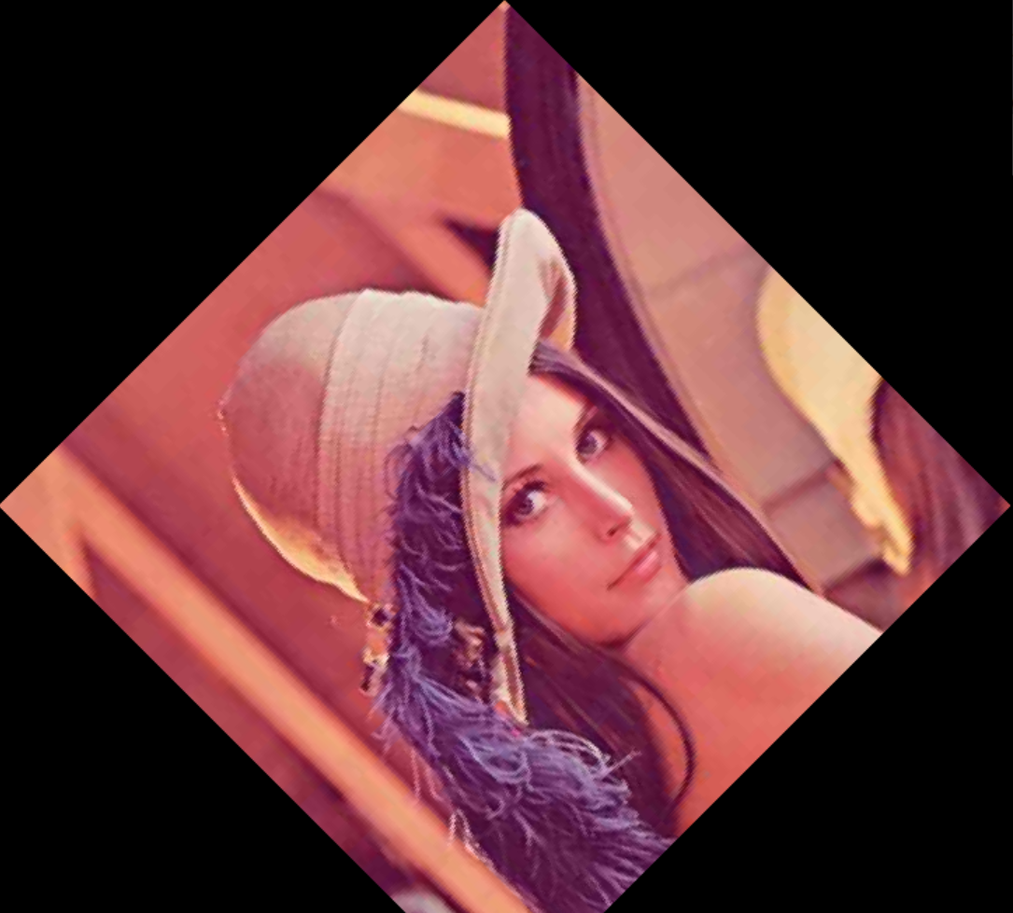

**2. stitching.cpp**

**1) Idea**

-Affine transformation을 이용한 image stitching

**2) Code**

**A. Code for calculate affine**

template <typename T>

Mat cal_affine(int ptl_x[], int ptl_y[], int ptr_x[], int ptr_y[], int number_of_points) {

Mat M(2 * number_of_points, 6, CV_32F, Scalar(0));

Mat b(2 * number_of_points, 1, CV_32F);

Mat M_trans, temp, affineM;

// initialize matrix

for (int i = 0; i < number_of_points; i++) {

// initialize M

M.at<float>(i * 2, 0) = M.at<float>(i * 2 + 1, 3) = ptl_x[i];

M.at<float>(i * 2, 1) = M.at<float>(i * 2 + 1, 4) = ptl_y[i];

M.at<float>(i * 2, 2) = M.at<float>(i * 2 + 1, 5) = 1;

b.at<float>(i * 2, 0) = ptr_x[i];

b.at<float>(i * 2 + 1, 0) = ptr_y[i];

}

// (M^T * M)^(−1) * M^T * b ( * : Matrix multiplication)

//cout << "M" << M << endl;

//cout << "M.size()" << M.size() << endl;

M_trans = M.t();

//cout << M << endl;

affineM = (M_trans * M).inv() * M_trans * b;

//cout << affineM << endl;

return affineM;

}

**B. Code for Merge two images**

// initialize merged image

Mat I_f(bound_b - bound_u + 1, bound_r - bound_l + 1, CV_32FC3, Scalar(0));

// inverse warping with bilinear interplolation

for (int i = -diff_x_; i < I_f.rows - diff_x_; i++) {

for (int j = -diff_y_; j < I_f.cols - diff_y_; j++) {

float x = A12.at<float>(0) * i + A12.at<float>(1) * j + A12.at<float>(2) + diff_x_;

float y = A12.at<float>(3) * i + A12.at<float>(4) * j + A12.at<float>(5) + diff_y_;

int y1 = floor(y);

int y2 = ceil(y);

int x1 = floor(x);

int x2 = ceil(x);

float mu = y - y1;

float lambda = x - x1;

if (x1 >= 0 && x2 < I2_row && y1 >= 0 && y2 < I2_col){

for (int k = 0; k < 3; k++) {

float f1 = mu * I2.at<Vec3f>(x1, y2)[k] + (1 - mu) * I2.at<Vec3f>(x1, y1)[k];

float f2 = mu * I2.at<Vec3f>(x2, y2)[k] + (1 - mu) * I2.at<Vec3f>(x2, y1)[k];

I_f.at<Vec3f>(i + diff_x_, j + diff_y_)[k] += lambda * f2 + (1 - lambda) * f1;

}

}

}

}

**3) Result**

