SEOSAW Coarse Woody Debris Protocol
If you use this protocol, please cite the manual as:
SEOSAW partnership. (2021). A network to understand the changing socio‐ecology of the southern African woodlands (SEOSAW): Challenges, benefits, and methods. Plants, People, Planet, 3(3), 249-267. doi: 10.1002/ppp3.10168.

Casey M. Ryan, Nicholas Berry, Stephen Syampungani, Francisco Maiato Gonçalves, Steve Makungwa, Benjamin Wigley, Manfred Finckh, Nicola Stevens, Caroline Lehmann, Mat Williams, Mylor Ngoy Shutcha , Jonathan Ilunga Muledi, Sally Archibald, Wayne Twine, Isla Grundy, Carla Staver, Anderson Muchawona, Benard Guedes, Adeline Fayolle, Josiah Katani, Nicholas Berry, Edward Mitchard, Kyle Dexter, Iain McNicol, Rose Pritchard, Emily Woollen, Thom Brade, Ellie Wood, Sam Bowers, John L. Godlee, Geoff Wells, David Bauman , Oliver Phillips, Penny Mograbi, Lorena Benitez.

Acknowledgements
The production of this field manual was supported by the NERC funded SEOSAW project. The woody debris (based on Waddell, 2002) was developed as part of the ESPA-funded (DFID/ESRC/NERC) ACES project. The work was also supported by a GCRF Impact Accelerator Grant. Translation was funded by the NERC-funded SECO project.

Version control
- V 1.0 11 May 2022 Separated from main protocol and updated to match transect design of small stems and herbaceous biomass protocols by LB. Incorporated comments from JG from fieldwork in Angola.

Coarse woody debris
Coarse woody debris is defined as dead tree stems, large limbs, and other large wood pieces either lying on the ground or elevated off the ground, but not rooted in the ground. It does not include live material, standing dead trees still rooted in the ground (included in the stem inventory), stumps (which have their own protocol), dead foliage, separated bark, non-woody pieces, roots, or the part of the tree stem below the root collar.

Coarse woody debris should be measured along perpendicular transect lines forming four intersections across the plot to avoid piece-orientation bias. We recommend that each transect should be 100m and originate at 20 and 80 m on the X and Y axes (Figure 1). Shrubs and small stems can also be sampled along these transect lines {see small stems and shrub protocol}.

Transect design can be flexible, but you should avoid parallel transects. If diagonal transects are used, make sure to record your transect length.

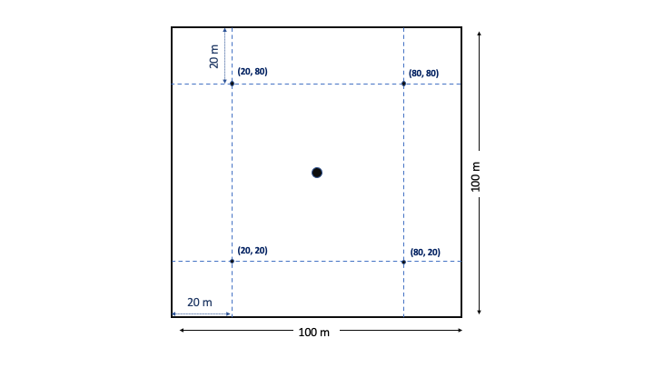
Figure 1: Suggested layout for line transects in a 1 ha plot.

A piece of debris is measured if:
- the central longitudinal axis of the piece intersects the transect
- the diameter at the point of intersection is ≥ 5 cm, and the piece length is > 0.5 m
- the piece is not decayed to the point of having no structural integrity (i.e. can be measured).
- Other rules include:
- When a piece of wood is forked or has a very large branch attached to the main bole—and both segments intersect the transect—they are tallied as two separate pieces, if each meets the required minimum dimensions
  - Measure the entire length of the piece when encountering the first branch
  - For subsequent branches, measure to the lowest fork not yet recorded
- A piece is tallied twice if it intersects two different transects or if it is nonlinear and intersects the same transect in two locations
Measurements taken on each piece are:
- Diameter at the point of intersection (cm). This can be estimated if you cannot pass the tape around the piece. Callipers are very useful for smaller items; a diameter tape will be needed for larger items
- Piece length (m)
- Species of the piece, if possible.
- Tag id of the stem, if an associated tag is found or can be inferred from XY coordinates
Using the equations set out in (Waddell, 2002) you can thereby estimate total coarse woody debris density (logs/ha), volume (m3/ha), and biomass (t/ha) in the plot.

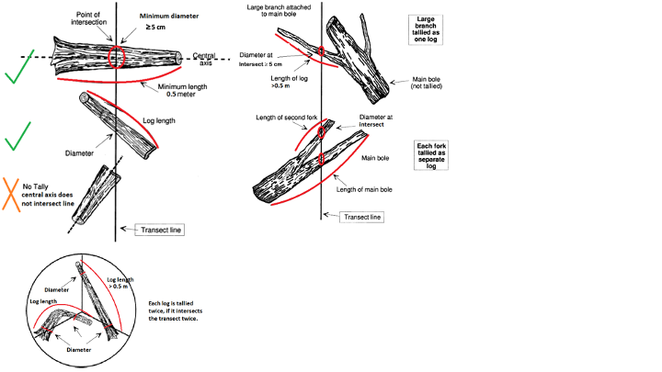
≥ 5 cm
≥ 5 cm
Figure 2: Coarse woody debris sampling diagrams, adapted from (Waddell, 2002).

Bibliography

Waddell, K. (2002). Sampling coarse woody debris for multiple attributes in extensive resource inventories,. Ecological Indicators, 1(3), 139-153.

