SEOSAW Plot Data Sheet
Plot name:  Plot code:  State, Country, Continent:  Census date: | Project PI(s):  Inventory leader:  Botanist(s):  Assistants:  People to be acknowledged:  Funding project:
Plot Dimensions
 | What is the shape of the plot? | Area (ha) | Length or Radius (m)
 |  |  | X | Y
Plot | Rectangle Circle
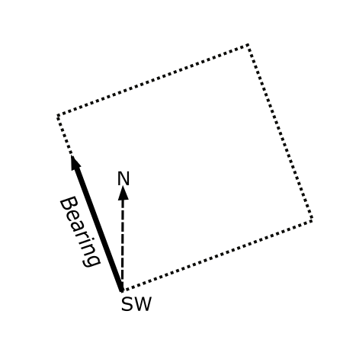 Bearing (°):
Plot Location
 | Longitude (Dec. °) | Latitude (Dec. °) | GPS Accuracy (m)
Corner 1
Corner 2
Corner 3
Corner 4
Center
Corners marked with permanent posts: True False

Elevation (m): Slope (0-90 Dec. °): Aspect (0-365 Dec. °):

Catenal position: 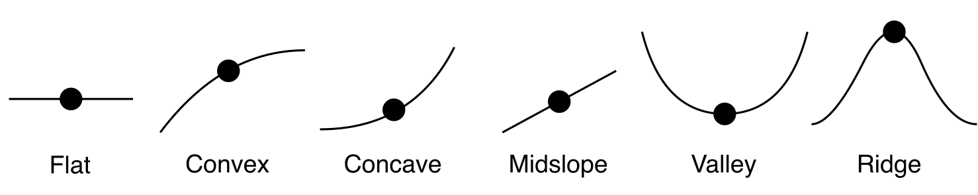

Sampling
Minimum stem diameter on main plot (cm):
Minimum stem height on main plot (cm):

If subdivided...
Area of subplots (ha): Number of subplots:

Additional Measurements
 | True/False | Notes
Tree height
Lianas
Dead stems
Stumps
Sapling count
Understory
Coarse Woody Debris
Canopy Cover
Stems tagged

Comments
e.g. nested plots (levels, minimum diameter), transects, description of corner stakes, tagging method

