herbaceous biomass sampling protocol

Penny Mograbi, John Godlee, Casey Ryan, Sally Archibald, Robert Ang'ila, Lorena Benitez, Sitta Malulu Buluma, Elisha Elifuraha, Vivian Kathambi, Josephat Kalugasha, Naftal Mahewa Lissu, Eunice W. Maina, Buster Mogonong, Edwin Nyamugadza

Link to other protocols:
For a full estimation of biomass on a SEOSAW plot, this protocol has been designed to maximise compatibility with:
- SEOSAW Coarse woody debris protocol
- SEOSAW Shrub protocol
- SEOSAW Tree protocol (including small stems protocol)
For a deeper understanding of the floristic composition of the ground layer, this protocol can be combined with the GGG protocol, which allows for exploring community composition, phylogeny and taxonomy, and functional traits. For more information on the GGG, please contact them at: https://globalgrassygroup.github.io/contact/

Acknowledgements
This herbaceous protocol draws heavily from extensive consultation with the Global Grassy Group (GGG) (https://globalgrassygroup.github.io/) and the approaches contained in their herbaceous protocol: Lehmann et al. (2022) Global Grassy Group Guide to functional and taxonomic composition of ground layer plants, data management, guidelines on database contribution, collaboration and authorship. https://doi.org/10.21203/rs.3.pex-1905/v1.

Version control
V0.0. 17 Jan 2022 Initial outline by JG and PM
V1.0. 21 Mar 2022 Major revision by PM, CR, LB and SA during field testing at Morogoro, Tanzania
V1.1. 31 Mar 2022 Editorial revision by JG
V1.2 7 April 2022 Minor clarifications by LB
V1.3. 11 April 2022 Minor clarifications by SA
V1.4. 5 May 2022 Incorporated comments from SEOSAW SC Members: JG, Kyle Dexter, Natasha Ribeiro

Introduction
This protocol covers how to sample biomass in grasses and other plants, litter, and smaller woody stems and debris. The purpose of this protocol is to estimate biomass and carbon stocks within the different herbaceous layer components, quantify fire fuel loads and, with the addition of the GGG protocol, diversity in the ground layer of SEOSAW plots. It also demonstrates how to collect herbaceous biomass with or without the use of the GGG herbaceous composition protocol. This protocol has been harmonized with the SEOSAW tree (including small stems), coarse woody debris, and shrub protocols. When all these protocols are combined you will be able to estimate biomass and diversity, in all plants in a consistent way in savannas, shrublands, woodlands, and dry forest. The protocols are designed to avoid double counting of organisms and minimise sampling effort by using the same sampling infrastructure where possible.

When to sample?
Ideally, for biomass sampling, aim to sample at peak biomass productivity early in the dry season when senescence has started in the grass layer. For full community composition, use the GGG’s guidelines to capture peak biodiversity.

How to use the GGG protocol to measuring ground layer diversity in SEOSAW plots
To assess ground layer diversity, use the GGG protocol (Lehmann et al. 2022). The GGG protocol is based on a 50 x 50 m (0.25 ha) plot where herbaceous composition (species presence/absence) and cover (%) is sampled using 21 x 1 m diameter circular subplots arranged along four 25 m transects originating from the centre of the plot in a cross pattern. When using the GGG protocol in 1 ha SEOSAW plots (100 x 100 m), it is recommended to replicate the GGG cross layout in the four quadrats of the plot (Figure 1b) to capture fine scale variation of the herbaceous layer across the plot. If the plot’s herbaceous component is homogeneous, place one 0.25 ha GGG plot in the centre of the SEOSAW plot (Figure 1a). If the SEOSAW plot is smaller than 50 x 50 m, it is still recommended to use the full size in the GGG protocol, even if some of the 21 subplots fall outside the SEOSAW plot boundaries (Figure 1c). Other plot sizes will require judgement by the researcher to gauge whether greater sampling is required to capture the heterogeneity of herbaceous vegetation diversity.
When using the GGG protocol in SEOSAW plots, record all species with the circular subplots that are <1.3 m in height. This avoids double counting when analysing data in conjunction with data from the stems and small stems protocols.
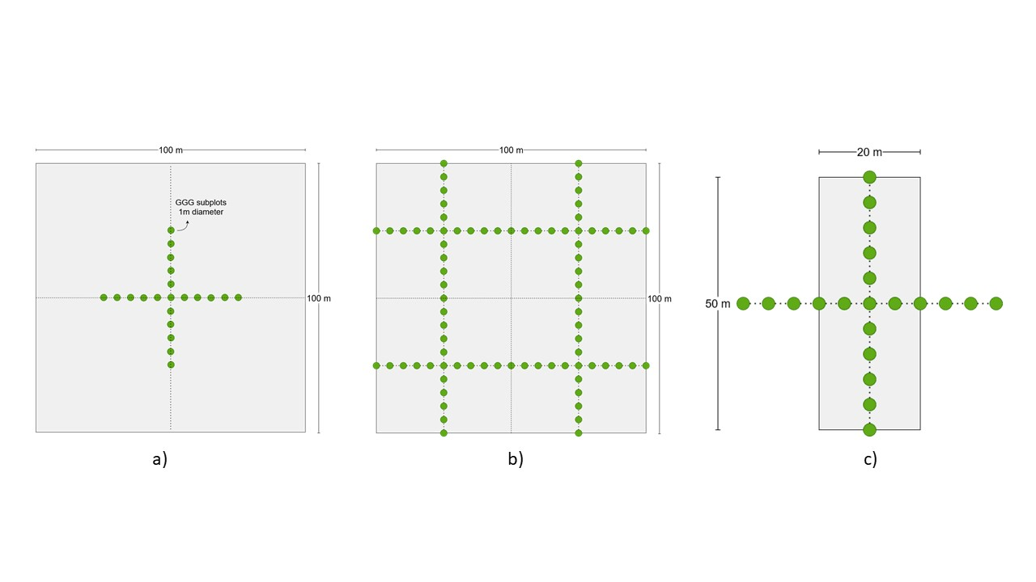
Figure 1. Alternative sampling strategies for a) a 1 ha plot with one set of 25 m GGG transects, b) a 1 ha plot with four sets of 25 m GGG transects centred on the four quadrats of the plot, and b) a small 0.1 ha plot, showing how the transects extend beyond the plot boundaries.

Ground layer biomass

4.1. Biomass clipping sampling locations
Herbaceous biomass clipping sample locations occur along two of the same transect points as the small stem belt transects (see small stems protocol) at the 20 and 80 m transects, and along one arm of the coarse woody debris transects (see coarse woody debris protocol).
For a 1 ha plot, biomass harvesting should be conducted in clusters of three 50 x 50 cm (0.25 m²) randomly distributed quadrats at 6 locations along the 20 and 80 m transects. These clusters of three randomly distributed quadrats should be collected at the intersections of the 20, 50 and 80 m transects (Figure 2a).
If herbaceous diversity data are being collected using the GGG protocol, for ease of sampling biomass can be clipped in four clusters of three randomly distributed 50 x 50cm (0.25 m²) quadrats from the centre of each quarter between transects (see GGG protocol) (Figure 2b).
At each point, the sampling location is determined ‘randomly’ by throwing the quadrat over your shoulder (see video). Quadrats are distributed randomly to avoid repeatedly clipping the same locations in the plots during subsequent remeasurement. If throwing your quadrat proves difficult, you can instead throw a brightly coloured marker and use it as a proxy for the centre of your quadrat.
If the thrown quadrat does not land flat, note the centre point of the quadrat relative to the ground, and reposition the quadrat flat on the ground, disassembling and reassembling it as needed (see video). Maintain the position of the random location by aligning the centre point of the quadrat with the original thrown centre point. Do not change the location of the quadrat even if it lands on bare ground or rock.
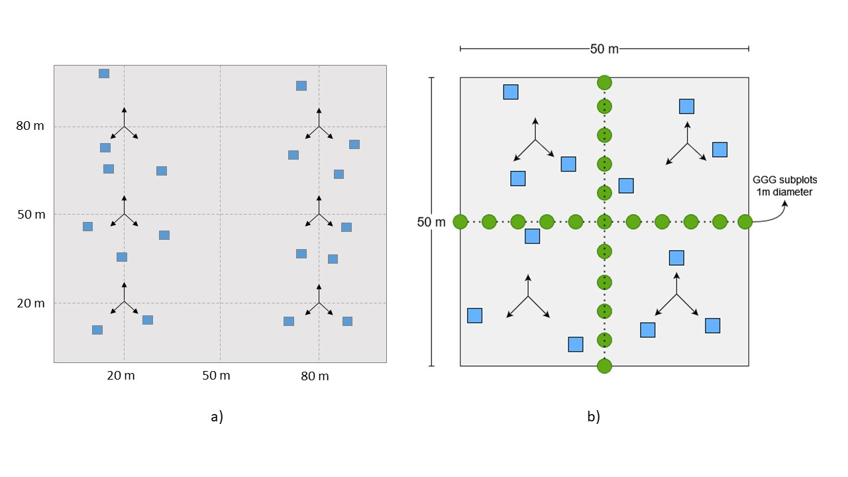
Figure 2. Biomass sampling locations in a) 1 ha SEOSAW plot without GGG herbaceous diversity sampling, with 18 biomass clipping quadrats distributed in clusters of three quadrats randomly distributed from the 20, 50 and 80 m transect intersections, and b) in a plot using GGG diversity sampling, with 12 biomass clipping quadrats distributed in clusters of three quadrats randomly distributed from the centre of each GGG quadrat.

4.2. Biomass data collection and clipping
Within each random quadrat, first record the following information (averaged across the entire quadrat area):
- Average height of the herbaceous plant leaves (excluding the inflorescences) to 1cm accuracy using a tape measure or a marked pole (termed “leaf table height”).
- Average litter depth to 1 cm accuracy
- Presence/absence of dung and species, if known (only if individual pieces are larger than your fist e.g. elephant, cattle)
- Whether the quadrat has evidence of fire (e.g. ash, charcoal, char marks)
- Whether the quadrat is under a tree canopy
- Areal cover of bare soil and rock and stone, combined to the nearest 10%
- Optional: a photo of each quadrat before clipping, record the photo ID on the datasheet (these can be used to explain potential errors in the clipped data)
Then ground layer biomass should be clipped 1 cm above the base (to avoid killing grasses) and the wet mass recorded in the following sequence:
- Grass and sedges – dead and alive, attached to the base of the plant (see video)
- Other plant material
  - Forbs: dead/alive, stalks and leaves
  - Non-spinescent, woody shrubs <30 cm height: strip attached leaves and include green stalks geophyte leaves. (All of small spinescent shrubs go in 3 to speed things along)
- Woody material (see video and video)
  - Woody stems (<30 cm height) stripped of leaves
  - Coarse woody debris (< 5 cm average diameter) clipped to the extent of the quadrat
  - Bark
  - Large woody seeds (e.g. Kigelia africana, Strychnos sp.)
  - Whole spinescent woody shrubs <30 cm height
- Litter
  - Dead, detached, grass and leaves
  - Twigs (<2 mm)
  - Small seeds
- Optional: succulents – if abundant (left to the discretion of the researcher) on the plot, otherwise, ignore (i.e. do not include in 1).
Only plants that are rooted within the 0.25m² quadrat should be clipped. i.e. If part of a plant rooted within the quadrat falls outside the quadrat, include that plant’s material in the clipping and weighing. If a plant is rooted outside of the quadrat and part of it’s material falls within the quadrat, exclude that material from the clipping and weighing.
The entirety of non-woody plants >30 cm in height should be clipped. Woody shrubs >30 cm are included in the shrub protocol {in development}.
If the grass layer is tall and dense, it may be easier to clip everything and sort the components on a tarpaulin in the shade to minimise (human and plant) water loss.
Once all categories have been clipped and their wet mass has been recorded, the sampling location should only contain bare ground, dung, woody plants >30cm height, and maybe succulents.

Weighing biomass samples

Wet biomass
Clipped wet biomass should be weighed immediately in a field weigh station (Box 1) to prevent water loss. Make sure the mass balance is level, positioned securely on a stable base, and sheltered from wind to prevent sample material blowing out of the basin. Samples should be placed directly into a wide, plastic basin that can be placed on top of the mass balance. Record the mass of all biomass categories from 18 (or 12 if using in conjunction with the GGG protocol) quadrats within the plot, separately. Discard all biomass material once it has been weighed (see video).
Box 1. Field weigh station
A field weigh station can be set up by placing a mass balance accurate to 1 g (e.g. a small, digital, kitchen scale) into a hard briefcase, pelican case or other suitable container that provides a firm, stable base as well as a windshield (the lid of the case). A spirit level should be glued onto the mass balance to ensure the weigh station is level. Zero the scale including the weight of a wide plastic basin that can hold the wet biomass samples.
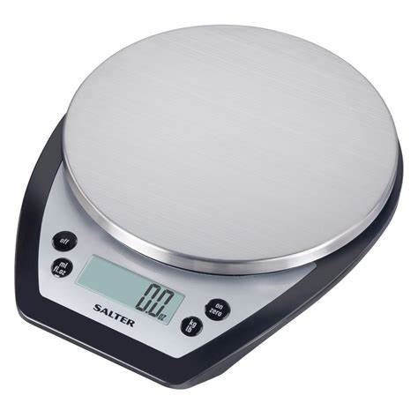

Dry biomass – grab samples
Once all biomass clipping quadrats have been weighed, and disposed of, perform a ‘grab’ sample of each of the four biomass categories above.
A grab sample is 4-5 handfuls (~100 g) of each category that is representative of the wet material in the plot into separately labelled paper bags (Box 2). Only one bag is collected per biomass category per plot, so in total you will have 18 (or 12) bags per plot. Collect material and weigh immediately to minimise moisture loss. Remember to maintain the 1cm above the ground clipping distance to represent the full wet-fuel load of the canopy. Samples should be weighed in the field without the paper bag and then placed in the bag. Record the wet mass on the bag. These grab samples will then be dried and their wet::dry mass ratio will be used as a calibration for the total wet to dry mass conversion of the clipped quadrat measures.
[If a field weigh station is not available, keep all clipped wet biomass for all quadrats (section 4.1.1.) in labelled paper bags and air or oven dry in a laboratory. If keeping all samples, it becomes very bulky to transport, and time consuming to process in the laboratory.]
After collection, ensure the bags are packed loosely to prevent the material rotting (any decomposition affects the biomass estimation), and keep them sheltered from wind and rain. Depending on the climate, it may be possible to air dry material (at least a week will be needed). Air drying samples involves keeping the bags open and allowing the samples to dry out passively in a well-ventilated room to the ambient humidity. Air dried samples will only dry down to the relative humidity of the room, so if this method is used, also record the relative humidity and air temperature before the final dry weighing. Otherwise, weigh the use a drying oven at ~60 °C for at least 72 hours or until the mass of the material does not change.
Measure the mass of the dried material using a mass balance with a precision of at least 1 g, recording each biomass category separately. Either sample out of the bag (preferable) or minus the weight of the bag in the field.
Box 2. Bag label
Researcher name: _Joe Soap
Date: 5 July 2022
Plot name: MGR_1
Location: 20,20 [X Y coordinates]
Wet mass: 105 g
Sample Contents: Grass & sedges

Equipment
General
- 4 x 100 m measuring tapes to site the transects correctly
- 4 measuring tapes or strings to lay along the transects
- Notebook / datasheets / tablet
- Pens / pencils
Biomass clipping
- 50 x 50 cm quadrat (see section 6 quadrat construction)
- Clippers / secateurs / box cutter / shears may be useful in very grassy systems
- Gardening gloves
Grab samples
- Paper bags: ideally, 196 x 115 x 385 mm dimensions, flat bottomed, ~6 per 1 ha plot for grab samples, ~6 x 3 x 18 = 324 per 1 ha plot without a field weigh station
- Permanent marker
Field weigh station
- Small, digital, kitchen scale accurate to 1 g or better
- Hard briefcase, pelican case or other suitable container with a stable base and a lid as a windbreak
- Spirit level
- Wide, plastic basin

Constructing quadrats
A 0.25 m² square quadrat is best made from lengths of rigid PVC pipe, commonly used for in-home electrical wire conduits. Cut four lengths of pipe to 55 cm and make a square using 4 right-angle connector pieces. Cut down the pipe further if needed until the interior of the quadrat is 50x50 cm.
Useful size class reference marks can be marked on the edge of the quadrat for 2 mm and 5 cm wood diameter size class thresholds.

Other useful tips
- if dead wood within the quadrat is stuck in the ground and difficult to remove, replace it with another piece of wood of approximately the same size
- if there is something within the quadrat that cannot be broken or cut, and you can’t find a similar piece elsewhere, apply the following: if more than half of it is in the quadrat, weigh the whole item; if less than half is contained in the quadrat, ignore it.
- if the edge of the quadrat lies on a grass tussock, if possible divide the tussock keeping that part that is rooted within the quadrat.
- plants that have strong stems (e.g. biennials) should be treated as woody plants. E.g. Jasminium sp., Abrus sp., Senna obtusifolia.

References
Wigley, B. J., Charles-Dominique, T., Hempson, G. P., Stevens, N., Tebeest, M., Archibald, S., Bond, W. J., Bunney, K., Coetsee, C., Donaldson, J., Fidelis, A., Gao, X., Gignoux, J., Lehmann, C., Massad, T. J., Midgley, J. J., Millan, M., Schwilk, D., Siebert, F., … Kruger, L. M. (2020). A handbook for the standardised sampling of plant functional traits in disturbance-prone ecosystems, with a focus on open ecosystems. In Australian Journal of Botany (Vol. 68, Issue 8, pp. 473–531). CSIRO. https://doi.org/10.1071/BT20048

