SEOSAW ground layer biomass sampling protocol

Penny Mograbi, John Godlee, Casey Ryan, Sally Archibald, Robert Ang'ila, Lorena Benitez, Sitta Malulu Buluma, Elisha Elifuraha, Vivian Kathambi, Josephat Kalugasha, Naftal Mahewa Lissu, Eunice W. Maina, Buster Mogonong, Edwin Nyamugadza, Kyle Dexter, Vera de Cauwer, Natasha Ribeiro

Acknowledgements
This ground layer protocol draws heavily from consultation with the Global Grassy Group (GGG) (https://globalgrassygroup.github.io/) and the approaches contained in their ground layer protocol: Lehmann et al. (2022) Global Grassy Group guide to understanding and measuring the functional and taxonomic composition of ground layer plants. https://doi.org/10.21203/rs.3.pex-1905/v1.

Version control
V0.0. 17 Jan 2022 Initial outline by JG and PM
V1.0. 21 Mar 2022 Major revision by PM, CR, LB and SA during field testing at Morogoro, Tanzania
V1.1. 31 Mar 2022 Editorial revision by JG
V1.2 7 April 2022 Minor clarifications by LB
V1.3. 11 April 2022 Minor clarifications by SA
V1.4. 5 May 2022 Incorporated comments from SEOSAW SC Members: JG, KD, NR
V1.5. 11 Nov 2022 Editorial revision and clarifications by JG, PM
V1.6. 6 December 2023 Incorporated comments from JG’s, VdC’s & KD’s fieldwork at Ongava
V1.7. 7 February 2024 Updated field sample description, minor clarifications: PM
V1.8. 16 May 2025 Minor edits - PM

Introduction
This protocol covers how to sample the biodiversity and biomass of grasses and other plants, litter and debris existing in the ground layer. The protocol is in two parts. The first part (Section 3) describes how to use the GGG (Global Grassy Group) ground layer protocol (https://doi.org/10.21203/rs.3.pex-1905/v1) in SEOSAW plots to measure taxonomic and functional diversity. For more information on the GGG, please contact them at: https://globalgrassygroup.github.io/contact/. The second part (Section 4) focuses on estimating the biomass and fuel load of different ground layer components.
This protocol has been harmonized with the SEOSAW tree, coarse woody debris, and small stems and shrubs protocols. When all these protocols are combined you will be able to estimate biomass and diversity of all plants in a consistent way. The protocols are designed to avoid double counting of organisms and minimise sampling effort by using the same sampling infrastructure where possible.

When to sample?
Ideally, for biomass sampling, aim to sample at peak biomass early in the dry season when senescence has started in the grass layer. For full community composition, use the GGG protocol guidelines to capture peak biodiversity.

Estimating ground layer diversity with the GGG protocol
To assess ground layer functional and taxonomic diversity, use the GGG protocol (Lehmann et al. 2022). The GGG protocol is based on a 50 x 50 m (0.25 ha) plot where ground layer composition (species presence/absence) and cover (%) is sampled using 21 x 1 m diameter circular subplots arranged along four 25 m transects originating from the centre of the plot in a cross pattern. When using the GGG protocol in 1 ha SEOSAW plots (100 x 100 m), it is recommended to replicate the GGG cross layout in the four quadrats of the plot (Figure 1b) to capture fine scale variation of the ground layer across the plot. If the plot’s ground layer component is homogeneous, place one 0.25 ha GGG plot in the centre of the SEOSAW plot (Figure 1a). If the SEOSAW plot is smaller than 50 x 50 m, it is still recommended to use the full size in the GGG protocol, even if some of the 21 subplots fall outside the SEOSAW plot boundaries (Figure 1c). Other plot sizes will require judgement by the researcher to gauge whether greater sampling is required to capture the heterogeneity of ground layer vegetation diversity.
When using the GGG protocol in SEOSAW plots, record all woody species within the circular subplots that are <30 cm in height. This avoids double counting when analysing data in conjunction with data from the small stems and shrubs protocols. Record all non-woody plants regardless of height.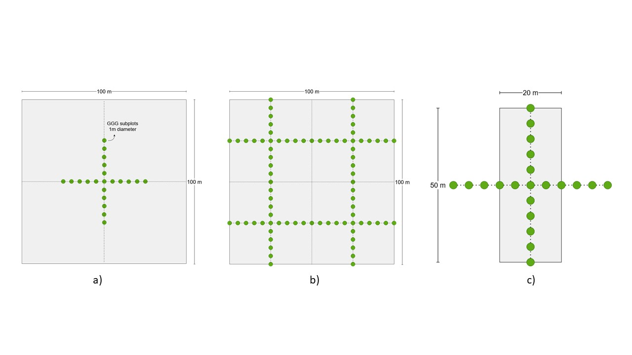
Figure 1. Alternative sampling strategies for a) a 1 ha plot with one set of 25 m GGG transects, b) a 1 ha plot with four sets of 25 m GGG transects centred on the four quadrats of the plot, and b) a small 0.1 ha plot, showing how the transects extend beyond the plot boundaries.

Estimating ground layer biomass

4.1. Biomass clipping sampling locations
Ground layer biomass clipping sample locations occur along two of the same transect points as the small stem and shrubs belt transects (see small stems and shrubs protocol) at the 20 and 80 m transects, which may also correspond to two of the four coarse woody debris transects (see coarse woody debris protocol).
For a 1 ha plot, biomass harvesting should be conducted in clusters of three 50x50 cm (0.25 m²) randomly distributed quadrats at six locations along the 20 and 80 m transects (thus 18 total quadrats sampled). These clusters of three randomly distributed quadrats should be located at the intersections of the 20, 50 and 80 m transects (Figure 2a).
If ground layer diversity data are being collected using the GGG protocol, for ease of sampling biomass can be clipped in four clusters of three randomly distributed 50x50cm (0.25 m²) quadrats from the centre of each quarter between GGG transects (see GGG protocol) (Figure 2b).
At each point, the sampling location is determined ‘randomly’ by throwing the quadrat over your shoulder (see video). Quadrats are distributed randomly to avoid repeatedly clipping the same locations in the plots during subsequent remeasurements. If throwing your quadrat proves difficult, you can instead throw a brightly coloured marker and use it as a proxy for the centre of your quadrat.
If the thrown quadrat does not land flat, note the centre point of the quadrat relative to the ground, and reposition the quadrat flat on the ground, disassembling and reassembling it as needed (see video). Maintain the position of the random location by aligning the centre point of the quadrat with the original thrown centre point. Do not change the location of the quadrat even if it lands on bare ground or rock. If the quadrat lands on a tree or shrub that does not accommodate the quadrat easily (e.g. basal area of the tree is larger than the quadrat, or small stems prevent the quadrat from lying flat), move the quadrat just to the side so the quadrat is touching the tree or shrub and record this location.
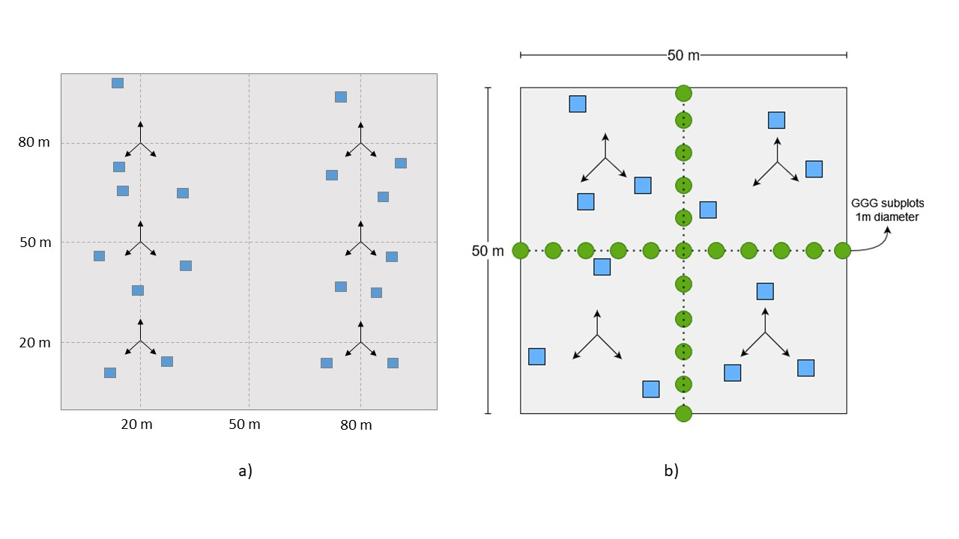
Figure 2. Biomass sampling locations in: a) 1 ha SEOSAW plot without GGG ground layer diversity sampling, with 18 biomass clipping quadrats distributed in clusters of three quadrats randomly distributed from six locations along the 20, 50 and 80 m transect intersections along the 20 and 80 m transect lines; and b) in a plot using GGG diversity sampling, with a total of 12 biomass clipping quadrats distributed in clusters of three clipping quadrats randomly distributed from the centre of each of the four GGG quadrats. Each biomass clipping quadrat is 50 cm x 50 cm.

4.2. Biomass data collection and clipping
Within each quadrat, first record the following information (averaged across the entire quadrat area):
- Average height of the ground layer plant leaves (excluding the inflorescences) to 1 cm accuracy using a tape measure or a marked pole. The average height contains about 80% of the aerial biomass. This metric was developed to account for the fact that many plants have a few tall flowering stems, and maximum plant height is not a useful measure of the height at which leaf material is concentrated, or their ecological role in the ecosystem (in particular, capacity to shade out other plants, flammability, and grazing potential). Average height includes all plants listed under section 4.2.1. What to clip?
- Average litter depth to 1 cm accuracy
- Presence/absence of dung and species, if known (only if individual pieces are larger than your fist, e.g. elephant, cattle)
- Whether the quadrat has evidence of fire (e.g. ash, charcoal, char marks)
- Whether the quadrat is under a tree canopy
- Areal cover of bare ground, including bare soil, rock and stone, to the nearest 10%
- Optional: a photo of each quadrat before clipping, record the photo ID on the datasheet (these can be used to explain potential errors in the clipped data)

4.2.1. What to clip?
Ground layer biomass should be clipped to 1 cm above the base (to avoid killing the graminoids) and the wet mass recorded in the following sequence:
- Graminoids (i.e. grass, sedges and rushes) – dead and alive, attached to the base of the plant (see video)
- Other plant material
  - Forbs: dead (attached to base of plant)/alive, stalks and leaves
  - Non-spinescent, woody shrubs <30 cm height: strip attached leaves, green stalks and geophyte leaves. (All of small spinescent shrubs go in 3 to speed things along)
- Woody material (see video and video)
  - Woody stems (<30 cm height) stripped of leaves. Plants that have strong stems (e.g. biennials) should be treated as woody plants. E.g. Jasminium sp., Abrus sp., Senna obtusifolia.
  - Woody debris (2 mm ≤ average diameter < 5 cm) clipped to the extent of the quadrat. If dead wood within the quadrat is stuck in the ground and difficult to remove, replace it with another piece of wood of approximately the same size.
  - Bark
  - Large woody fruits (e.g. Kigelia africana, Strychnos spp.)
  - Whole spinescent woody shrubs <30 cm height
- Litter
  - Dead, detached graminoids and leaves
  - Twigs (<2 mm average diameter)
  - Small seeds and fruits
- Dung
- Optional: succulents – if abundant (left to the discretion of the researcher) on the plot, otherwise, ignore (i.e. do not include in 1 or 2).
Only plants that are rooted within the 0.25 m² quadrat should be clipped. If part of a plant rooted within the quadrat falls outside the quadrat, include that plant’s material in the clipping and weighing. If a plant is rooted outside of the quadrat and part of its material falls within the quadrat, exclude that material from the clipping and weighing. if the edge of the quadrat lies on a grass tussock, if possible divide the tussock keeping that part that is rooted within the quadrat. If there is something (e.g., a piece of wood) within the quadrat that cannot be broken or cut, and you can’t find a similar piece elsewhere, apply the following: if more than half of it is in the quadrat, weigh the whole item; if less than half is contained in the quadrat, ignore it.

The entirety of non-woody plants >30 cm in height should be clipped. Woody plants >30 cm do not need to be clipped as they are included in the SEOSAW small stems and shrubs protocol or SEOSAW trees protocol (depending on height and diameter).
If the graminoid layer is tall and dense, it may be easier to clip everything and sort the components on a tarpaulin in the shade to minimise (human and plant) water loss.
Once all categories have been clipped and their wet mass has been recorded, the sampling location should only contain bare ground and woody plants >30 cm height, and maybe succulents.

Weighing biomass samples
The method below describes a field weigh station which has the advantages of saving time and transporting less biomass back to laboratories than conventional drying methods. The principle is to calculate the wet mass of a large volume of material in the field using a weighing scale (Box 1), and then take a small ‘grab sample’ (~100 g sample) (section 4.3.2.) back to the laboratory for drying. The wet:dry ratio from these grab samples is then used to estimate the dry mass of the quadrat clippings. If a field weigh station is not available, keep all clipped wet biomass from all quadrats (section 4.2.1.) in labelled paper bags and air or oven dry in a laboratory.

Wet biomass – field sample
Make sure the field station (Box 1) is level, positioned securely on a stable base, and sheltered from wind to prevent sample material blowing out of the basin. Clipped wet biomass should be weighed immediately in a field weigh station (Box 1) to prevent water loss. Place the clipped wet biomass directly into a wide, plastic basin that can be placed on top of the mass balance. Record the mass of all biomass categories from 18 (or 12 if using in conjunction with the GGG protocol) Figure 2) quadrats within the plot, separately. For each sampling location (of the 4 or 6), keep about a handful (~20 g) of each category (Section 4.2.1. What to clip?) for the grab samples (section 4.3.2. below). Discard all remaining material (see video).

Dry biomass – grab samples for the lab
A grab sample is ~100 g of each category (grass, other herbs, wood, litter, dung) that is representative of the wet material in the plot. Grab samples can be harvested by taking a small handful of each category from each quadrat, weighing it immediately to minimise water loss, and adding to a labelled paper bag containing handfuls from all quadrats (Box 2). Record the wet mass of each addition to the grab sample separately on the bag.
Using grab samples means you only need to transport 5 or 6 bags back to the laboratory, rather than about 72 full bags (more if the ground layer biomass is high).
Box 1. Field weigh station
A field weigh station can be set up by placing a mass balance accurate to 1 g (e.g. a small, digital, kitchen scale) into a hard briefcase, pelican case or other suitable container that provides a firm, stable base as well as a windshield (the lid of the case). A spirit level should be glued onto the mass balance to ensure the weigh station is level. Zero the scale including the weight of a wide plastic basin that can hold the wet biomass samples.
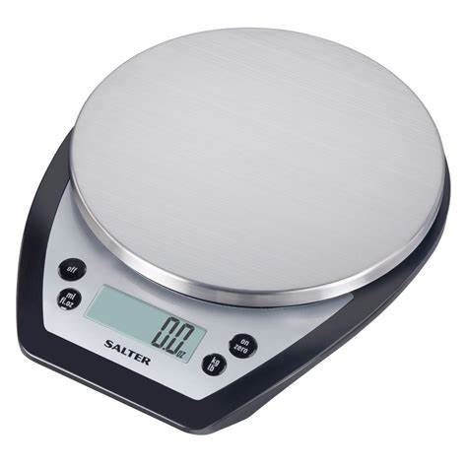
These grab samples will be dried and their wet:dry mass ratio will be used as a calibration to estimate the dry mass of the clipped quadrat samples.
After collection, ensure the bags are packed loosely to prevent the material rotting (any decomposition affects the biomass estimation), and keep them sheltered from wind and rain. Depending on the climate, it may be possible to air dry material (at least a week will be needed). To air dry samples, leave the bags open and allow the samples to dry passively in a well-ventilated room to the ambient humidity. Air dried samples will only dry to the relative humidity of the room, so if this method is used, also record the relative humidity and air temperature before the final dry weighing. Otherwise, place the samples in a drying oven at ~60 °C for at least 72 hours or until the mass of the material does not change.
Measure the mass of the dried material using a mass balance with a precision of at least 1 g, recording each biomass category separately. Either weigh the sample out of the bag (preferable) or subtract the weight of the bag.
Box 2. Bag label
Researcher name: Joe Soap
Date: 5 July 2022
Plot name: ABC_1
Grab mass 1:
Grab mass 2:
Grab mass 3:
Grab mass 4:
Grab mass 5:
Grab mass 6:
Grab mass 7:
Grab mass 8:
Grab mass 9:
Total Wet mass: xx g
Sample Contents: Graminoids
Grab mass 10:
Grab mass 11:
Grab mass 12:
Grab mass 13:
Grab mass 14:
Grab mass 15:
Grab mass 16:
Grab mass 17:
Grab mass 18:

Equipment
General
- 4x 100 m measuring tapes to site the transects correctly
- 4 measuring tapes or strings to lay along the transects (optional)
- Notebook / datasheets / tablet computer
- Pens / pencils
Biomass clipping
- 50 x 50 cm quadrat (see section 6 quadrat construction)
- Clippers / secateurs / box cutter / shears may be useful in very grassy systems
- Gardening gloves
Grab samples
- Paper bags: 196 x 115 x 385 mm dimensions, flat bottomed,
  - ideally, with a field weigh station: ~10 bags per 1 ha plot for grab samples (includes extras);
  - with no field weight station: to transport all clipped material back to the lab ~6 (locations) x 3 (quadrats) x 5 (biomass categories) x 3 (bags for large amounts of bulky biomass) = 270 per 1 ha plot
- Permanent marker
Field weigh station
- Small, digital, kitchen scale (mass balance) accurate to 1 g or better
- Hard briefcase, pelican case or other suitable container with a stable base and a lid as a windbreak
- Spirit level
- Wide, plastic basin

Constructing quadrats
A 0.25 m² (50x50 cm) square quadrat is best made from lengths of rigid PVC pipe, commonly used for in-home electrical wire conduits. Cut four lengths of pipe to 55 cm and make a square using 4 right-angle connector pieces. Cut down the pipe further if needed until the interior of the quadrat is 50x50 cm.
Useful size class reference marks can be marked on the edge of the quadrat for 2 mm and 5 cm wood diameter size class thresholds.

