SEOSAW small stems and shrubs sampling protocol

Vera De Cauwer, Penny Mograbi, Buster Mogonong, Sally Archibald, Casey Ryan, Robert Ang'ila, Lorena Benitez, Sitta Malulu Buluma, Elisha Elifuraha, Vivian Kathambi, Josephat Kalugasha, Naftal Mahewa Lissu, Eunice W. Maina, Edwin Nyamugadza, John Godlee, Justice Muvengwi, Kyle Dexter, Hermane Diesse,

Version control
V0.0. 13 Apr 2022 Initial outline by BM and PM.
V0.1. 14 Apr 2022 PM incorporated revisions from LB, CR, BM.
V1.0. 14 Jun 2022 PM incorporated major revisions from SA, added feedback from JG after Angola field test.
V2.0 6 Dec 2023 incorporated revisions from SA, PM, JG, KD, JM, HD and VDC.
V2.1 7 Feb 2024 modified Conti figure, minor editing - PM
V2.2. 16 May 2025 minor edits - PM

Introduction
The purpose of this protocol is to estimate the biomass and species composition of shrubs, small trees and tree saplings, collectively referred to hereafter as ‘small stems and shrubs’.
The protocol consists of two components: (1) measuring biodiversity and tree regeneration, and (2) measuring aboveground biomass. These data can be used for a variety of research questions, such as floristic research, regeneration studies, carbon sequestration, fuel load and fodder contents.
This protocol has been harmonized with the SEOSAW tree, coarse woody debris, and ground layer protocols to avoid double counting of organisms and to minimise sampling effort by using the same sampling infrastructure where possible. Used together, these protocols capture the full suite of biodiversity and biomass of vegetation ecosystem components (trees, shrubs, and herbaceous plants).
Even if you are working in an ecosystem that does not contain a lot of shrubs we strongly encourage you to use the protocol to record the few shrubs that are present. ‘Zero’ data points are quick to capture and invaluable for the studies of the biogeography of shrubs.

When to sample?
Small stems and shrubs can be measured at any time during the year, but species ID may easier when flowers and fruit, or at least leaves, are present.

What to sample?
As standard, the SEOSAW ground layer protocol samples woody stems <30 cm height, and the SEOSAW tree protocol samples woody stems >5 cm diameter at 1.3 m height. The SEOSAW small stems and shrubs protocol therefore samples woody stems >30 cm height, and less then <5 cm diameter at 1.3 m height. This way, the three protocols sample all woody vegetation in the plot, without double counting any individuals.
Height and diameter thresholds are dependent on both research question and ecosystem structure. If you need to change the diameter or height thresholds for any of the protocols, make sure to adjust the thresholds in the other protocols accordingly, so no individuals are double counted or missed.
If your research aims only require species counts of small stems and shrubs, and you do not need aboveground biomass, use section 5 only.

Sample design
Small stems and shrubs are sampled in three 2 m x 100 m belt transects per 1 ha plot, located at the 20 m, 50 m and 80 m transect lines (Figure 1). The 20 and 80 m transects are also used for the coarse woody debris and ground layer biomass collection protocols. For plots smaller than one hectare, we recommend sampling two 50 m belt transects for every 0.25 hectare of plot area.
Only sample individuals that are rooted inside the belt transect.
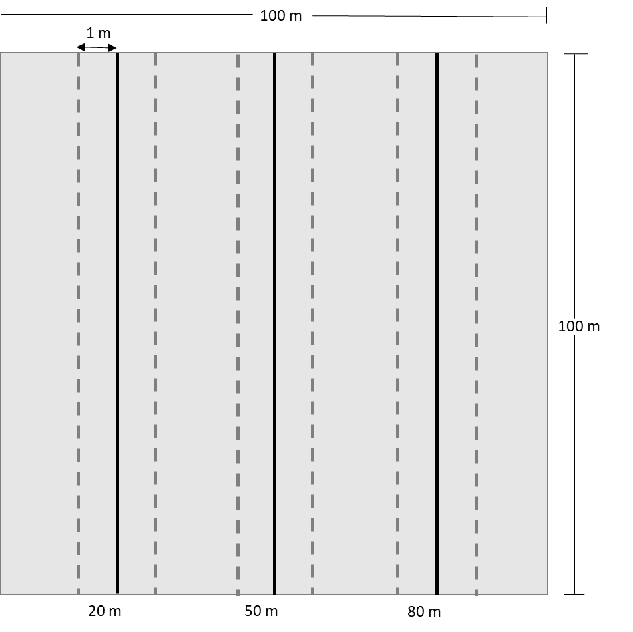
Figure 1: Layout of the belt transect to survey small stems and shrubs.

Option 1: Estimating diversity and tree regeneration
To estimate the biodiversity of small stems and shrubs, count the number of individuals and their species within each belt transect (Figure 1), noting how many individuals of each species are topkilled or alive. Note that multistemmed shrubs that are joined at the base are treated as one organism. Species counts are useful for floristic questions even without biomass measurements.
If the survey only aims to assess tree regeneration, you can leave out the shrubs in your tally.

Option 2: Estimating biomass and biodiversity
This section describes how to estimate aboveground biomass of small stems and shrubs by recording the stem diameter and canopy dimensions of all individuals rooted within the belt transects (Figure 1) using Conti et al.’s (2019) approach.
To record stem diameter and canopy dimensions, the following parameters should be measured and recorded on the datasheet:
- For tree-like individuals where crown branching begins above 1.3m height, where all stems on the organism are <5cm DBH (Figure 2a):
  - diameter at breast height (DBH at the 1.3 m POM). The POM is measured along the stem in a straight line, not vertically from the ground. For detailed descriptions of how to measure at the POM, refer to the tree protocol.
  - Height (H) (optional - to increase allometric model accuracy): from the bottom of the woody plant to average canopy height. When the individual is in leaf, only consider the live leaves and stems for the canopy.
- For tree-like individuals where crown branching begins below 1.3 m height (Figure 2b):
  - Basal diameter (BD) measured at 10 cm stem height.
  - Mean crown diameter (CD): take two perpendicular measurements of the canopy and calculate the mean.
  - Height (H) (optional - to increase allometric model accuracy): from the bottom of the woody plant to average canopy height. When the individual is in leaf, only consider the live leaves and stems for the canopy.
- For woody plants with many small stems originating at or below ground level, resembling a shrub (Figure 2c):
  - Mean crown diameter (CD): take two perpendicular measurements of the canopy and calculate the mean.
  - Height (H): from the bottom of the woody plant to average canopy height. When the woody plant is in leaf, only consider the live leaves and stems for the canopy.
- Other notes: topkill, new/resprouting stem, phenology (leaves, flower or fruits present)

These measurements allow you to calculate biomass using the Conti et al. (2019) framework (see section 8, Figure 2).
Note: Accuracy should be to the nearest 5 cm for canopy diameter and height measurements and 1 mm for diameter measurements.

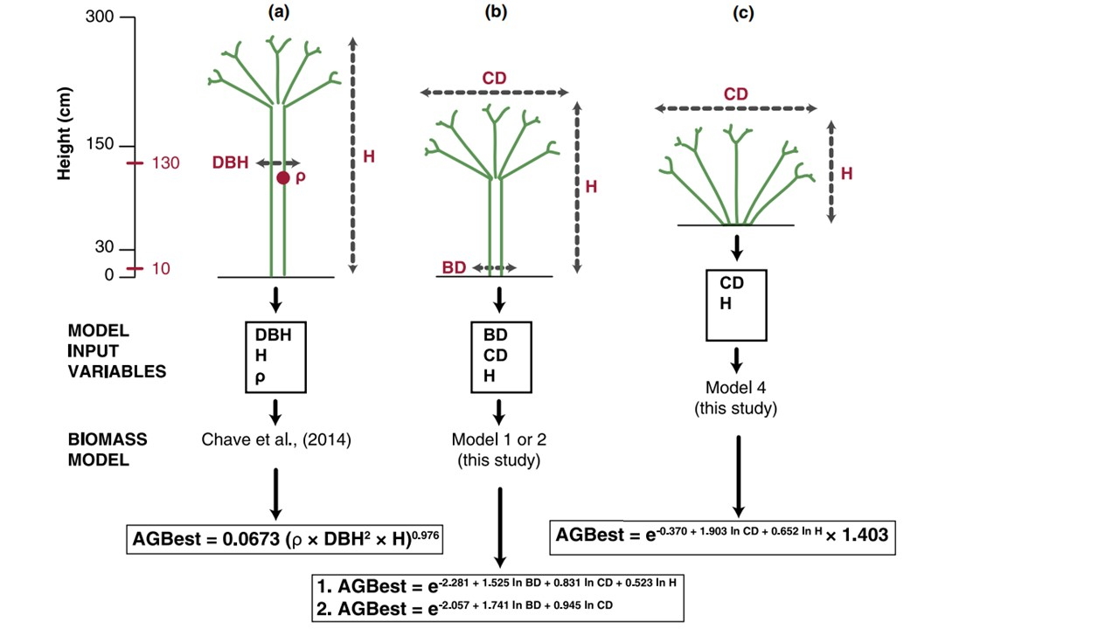
Figure 2. Conti et al (2019) framework for selecting aboveground biomass (AGB) allometric models for woody plants with different physiognomy, and the required field measurements to estimate biomass (a)-(c). DBH = diameter (cm) at 1.3 m POM; BD = basal diameter (cm) measured at 0.1 m POM; CD = mean crown diameter (m); H = height (m); ρ = wood density (g cm⁻³); AGBest = estimated AGB dry biomass (kg).

Average canopy height is best measured using a marked stick with 5 cm increments for short plants. For tall plants (> 3m in height), clinometers, laser range finders (e.g. Nikon Forestry Pro) and ultrasound devices (e.g. Haglöf Vertex Hypsometer) can all be used to produce accurate estimates of tree height. The additional cost of more sophisticated devices generally provides quicker or easier measurements rather than improved accuracy.
If required, the distinction between shrubs and trees can be made post-field during data analysis. As there are many definitions for shrubs, it is up to the involved researchers to choose one that is relevant for their purposes. For example, a shrub can be defined floristically as a woody species that produces most of its flowers and seeds within the disturbance zone (Hermann et al. 2012, Hoffmann & Solbrig 2003, Zizka et al. 2014). The disturbance zone, from ground level to 3 m, is the zone where fire and elephants are major causes of natural disturbance. Foresters often define a shrub species as a multi-stemmed woody plant species that rarely exceeds a certain height or basal diameter threshold.

Equipment
- General field consumables: clipboard, notebook, datasheets, pencils
- Marked measuring stick
- DBH tape
- Calipers (easier to measure diameter of small stems)
- Marked stick (5 cm increments), or a clinometer / laser range finder / ultrasound device to measure height
- 3 tape measures (100 m long)

References
Chave, J., Réjou‐Méchain, M., Búrquez, A., Chidumayo, E., Colgan, M. S., Delitti, W. B., ... & Vieilledent, G. (2014). Improved allometric models to estimate the aboveground biomass of tropical trees. Global Change Biology, 20(10), 3177-3190. https://doi.org/10.1111/gcb.12629
Conti, G., Gorné, L. D., Zeballos, S. R., Lipoma, M. L., Gatica, G., Kowaljow, E., Whitworth-Hulse, J. I., Cuchietti, A., Poca, M., Pestoni, S., & Fernandes, P. M. (2019). Developing allometric models to predict the individual aboveground biomass of shrubs worldwide. Global Ecology and Biogeography, 28(7), 961-975. https://doi.org/10.1111/geb.12907
Hermann, J. M., Haug, S., DePatta Pillar, V., & Pfadenhauer, J. (2012). Shrubs versus “gullivers”: Woody species coping with disturbance in grasslands. Plant Ecology, 213(11), 1757–1768. https://doi.org/10.1007/s11258-012-0131-4
Hoffmann, W. A., & Solbrig, O. T. (2003). The role of topkill in the differential response of savanna woody species to fire. Forest Ecology and Management, 180(1–3), 273–286. https://doi.org/10.1016/S0378-1127(02)00566-2
Zizka, A., Govender, N., & Higgins, S. I. (2014). How to tell a shrub from a tree: A life-history perspective from a South African savanna. Austral Ecology, 39(7), 767–778. https://doi.org/10.1111/aec.12142

Other useful reference material:
Drummond, R. B. (1975). A list of trees, shrubs and woody climbers indigenous or naturalised in Rhodesia. Kirkia, 10(1), 229-285.
Donaldson, L., Nanayakkara, B., & Harrington, J. (2016). Plant physiology and Development. in Thomas, B., Murray, B. G., & Murphy, D. J. Encyclopedia of Applied Plant Sciences, second edition. Academic Press: Oxford, U.K.
Thorne, M. S., Skinner, Q. D., Smith, M. A., Rodgers, J. D., Laycock, W. A., & Cerekci, S. A. (2002). Evaluation of a technique for measuring canopy volume of shrubs. Rangeland Ecology & Management/Journal of Range Management Archives, 55(3), 235-241.

