SECO soil sampling protocol

version 1.8 (Dec 2023)

Authors: Timothy Baker, Kyle Dexter, Casey Ryan, Oliver Phillips, Mathew Williams

Context

The aim of this protocol is to obtain comparable metrics of the soil nutrient content and concentrations of forests, woodlands and savannas in dry pan-tropical biomes. The protocol also aims to be sufficiently similar to previous work in moist and dry tropical biomes, to enable pantropical, within- and cross-biome comparisons by combining new and existing datasets.

The questions that the protocol aims to allow us to address include:

1. To what extent do soil properties control dry tropics’ ecosystem structure, dynamics and composition, compared to other environmental variables and disturbance history?

2. What are the carbon and nutrient stocks of the different ecosystems of the dry tropics?

3. How does the role of soil properties as a control on i) tree dynamics and composition and ii) grass biomass and composition vary between the moist and dry tropics?

The protocol draws on previous work in the RAINFOR (both the ‘fast’ + ‘intensive’ soils sampling protocols), NERC Biome switching project, SEOSAW and TROBIT protocols. The protocol covers the full pipeline of data supply, from field data collection to data management and storage.

Approach

The overall aim is to obtain a single value for each parameter for each plot where we are measuring tree dynamics and grass, for the surface soil (0 - 30 cm), similar to the protocol for TROBIT and SEOSAW. Our overall approach is to take multiple samples across each plot and bulk and air-dry the samples. Apart from measurement of bulk density, soil analyses will be carried out in the School of Geography, Leeds for lab analysis, apart from cases where export is not possible.

Parameters to measure

In field:
Soil colour (Munsell)
Soil texture (useful check for subsequent lab data)
Bulk density

In lab:
Particle size
Total N
Total C
Total P (total, using acid digestion)
pH
Available Mg, Ca, Na, Al, K

Equipment
- Mallet (wood, plastic, or metal)
- Wood block to place on top of the core
- Steel corer: 40-50 cm long, diameter 6-10 cm - this can be cut from steel tubing, with the edge slightly sharpened at one end, and a small hole (1 cm) drilled through a diameter at the other end. Take spares, as the cores are easily deformed by hitting a stone.
- Steel rod, <1 cm diameter, 60 cm long
- 2 mm sieve
- Resealable plastic bags
- Balance (precision to 1g, maximum weight 3 kg)
- Field notebook
- Pencil
- Spade
- Trowel
- Knife or machete
- Duct tape (for marking depth on core)
- Metal file (for re-sharpening cores in the field - optional)
- Oven for drying samples for measuring bulk density (optional)

Field sampling: site selection

At least five samples should be taken per plot, and bulked to give a single sample for analysis for each plot. For a standard square plot, one sampling location is at the centre of the plot, and four are located in each corner, 10 m from plot edges (Fig. 1).

However, the optimum distribution and number of sampling points may vary according to the shape of the plot or the nature of the landscape. The principle is to obtain a single bulked sample that reflects the heterogeneity within the plot.

Figure 1. Soil field sampling protocol. A typical square 100 x 100 m forest plot should be sampled in five locations; at each sampling location, show with black circles, one core, 0-30 cm depth, should be taken.

For “transect-plots” (e.g. 10 x 1000 m), it is recommended to sample at regular intervals (e.g. every 200m). For plots with other dimensions (e.g. 20 x 500 m), it is advised to sample in a “zigzag-pattern”, every 100 m. Sampling should avoid any trails that pass through plots.

If there are very strong environmental gradients within a plot (e.g. seasonally flooded and upland areas), independent samples should be taken in each vegetation type, and the subplots that these vegetation types relate to should be recorded.

Soils should be sampled in the [late] dry season, if low-lying areas (e.g. dambos) are seasonally inundated.

Field sampling

At each sampling point, two soil cores are collected. One soil core is used for taking the soil sample that is used for further analysis and bulk density; the second core is used for field measurements of soil colour and texture.

Core 1: sample for lab analysis and bulk density

- At each sampling location, clear litter from an area of 40 x 40 cm, without disturbing the soil.

- Drive the core into the ground to 30 cm depth, using the mallet. Place a strong piece of wood on top of the core to help spread the weight of the mallet, and minimise damage to the top of the core. Ensure the metal rod is placed through the core holes during this process. If the core stops descending into the soil and cannot reach the full depth (e.g. hitting hardpan), stop sampling and record the depth to which the core was taken. Check for compression by measuring the height of the soil inside the core. Use the steel rod to rotate and extract the core. Some digging with spade or trowel may be required to remove the deeper core. Be careful to ensure that the removed core is filled with soil. Use a knife to trim of soil adhering to the sample below the core.

- At each sampling location, collect the soil from the core in one Ziploc, plastic bag. Label each bag with the plot code, sample number and date.

- Note: if >30% by weight of the sample is comprised of fragments >2 mm (gauge by eye), resample elsewhere within the plot, recording this fact. If the entire site is dominated by coarse fragments (>30% in samples) then take another sample at each sampling location, and combine.

- Calculate the total core volume for each sample and record. The core volume should be calculated based on the depth of penetration and the cross-sectional area of the core

- Dry the soil either in the sun (protected from dust), or in a low temperature oven (ideally 40 ºC; max. 60ºC). Drying time will depend on the initial moisture content, but one week is typical in a plastic bag. Break up large aggregates by hand to speed drying. You should repeatedly weigh a small number of representative bags across the plots (e.g. 3) until the weight of the sample remains constant to indicate drying is completed. Be sure to record the weighs and date and time of weighing.

- Pass the dry sample through a 2 mm sieve to remove stones and woody debris (e.g. roots). You may need to break up clumps of soil so they pass through the sieve. Weigh both fine (<2 mm) and coarse mineral fractions; only the fine fraction is used to determine bulk density and for further analysis. Also weigh and record woody debris mass.

- Calculate the bulk density of the fine fraction (BD, g cm⁻³) as (dry weight of fine fraction, g)/(core volume, cm³). If >30% of the core is coarse fragments, calculate bulk density using the dry weight of all the soil, including coarse fragments.

- Reduce each core (e.g. to 1/8th original volume) before combining all the samples of fine mineral (<2 mm) fraction of soil from each plot together and then split this sample into two halves. Ensure the sample is well-mixed before sub-sampling: don’t just take the top half of the sample in the bag, as this will have different texture to the bottom half. This can be done using either a riffle splitter (Figure 2, a box containing a number of slotted paths which the soil is passed through, producing two equally divided subsamples in the boxes below), or coning and halving (Figure 3, pouring the sample so that it takes on a conical shape and then flattening it out and dividing). Make sure to clean the splitter between plots.

- Retain 100g soil for analysis from each half of the sample. For each soil sample from each plot, one of the duplicates is sent to Leeds for analysis; the other is archived. Archived soils should be placed in a plastic bag in dry storage, and preferably chilled or frozen, to provide a replacement sample if needed for analysis.
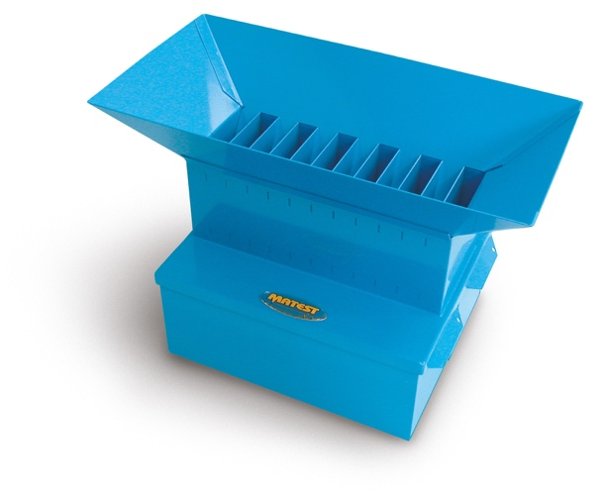
Figure 2. Example of a riffle splitter, used to homogenise and reduce samples.

Figure 3. Instructions for coning and halving to homogenise and reduce samples.

Core 2: sample for recording colour and texture in the field

Soil samples for recording colour and texture do not need to be brought to the lab. A second core can be used to take the samples for these observations.

- At each sampling location, alongside the first core, clear litter from an area of 40 x 40 cm, without disturbing the soil.

- Drive the core into the ground to 30 cm depth, using the mallet. Place a strong piece of wood on top of the core to help spread the weight of the mallet, and minimise damage to the top of the core. Ensure the metal rod is placed through the core holes during this process. If the core stops descending into the soil and cannot reach the full depth (e.g. hitting hardpan), stop sampling and record the depth to which the core was taken. Use the steel rod to rotate and extract the core. Some digging with spade or trowel may be required to remove the deeper core. Be careful to ensure that the removed core is filled with soil. Use a knife to trim of soil adhering to the sample below the core.

- Collect the soil from the core in one plastic bag and mix until the soil is a uniform colour.

- For each sample, note the soil colour of the mineral soil using a Munsell colour chart, and provide a description of texture. See Appendix 1 for approaching soil texture classification.

- Once you have determined the colour and texture of the soil, you may dispose of this sample.

Alternative approach without soil corer

If a soil corer is not available, an alternative approach to the soil sampling is as follows. This method has been used in all plots in South America to date.

      - Dig a small pit to 30 cm depth, and use the excavated soil to take the sample for laboratory analysis, and for assessing soil colour and texture. Follow the procedure above for drying, sieving and storing this sample.

      - For measuring bulk density, drive metal rings into one side of the pit at 10-20 cm and 20-30 cm depth. Collect the soil from both depths in one plastic bag. Label each bag with the plot code, sample number and date.

      - Calculate the total volume sampled and record. The volume is calculated based on the depth of penetration and the cross-sectional area of both metal rings. Follow the protocol above for drying, sieving and weighing the soil, and calculating the bulk density of the fine fraction, based on the samples from both depths.

Recorded data summary for each sample location:

- Date of sample collection
- Researcher
- Plot ID
- Sample number
- Soil colour
- Soil texture
- Total core dry mass
- Fine material dry mass
- Coarse material dry mass
- Woody material dry mass
- Diameter of the core
- Depth of penetration
- Core volume
- Bulk density

Laboratory analysis

Samples should be packaged in such a way as to ensure they remain intact for the duration of the journey, using triple containment.

The use of sealed plastic containers fastened with cable ties is advised. To ensure sample traceability in the laboratory, each sample should be clearly labelled with the sample ID, country of origin and date of collection.

All consignments must be accompanied by the Letter of Authority. This letter must be contained within the package and displayed on the outside to prevent the package being opened at customs. Contact Tim Baker (t.r.baker@leeds.ac.uk) for this document. The address to send samples to is:

Rachel Gasior
Laboratories (Soil held under PHL)
5.52k Goods Inwards/Field Store
Level 5 Roger Stevens Building
School of Geography
University of Leeds
Leeds
West Yorkshire
LS2 9JT
United Kingdom
Laboratory analysis and data management

Rachel Gasior will manage receipt of all samples and pass to lab technician Holly Armitage for analysis.

All lab data will be checked by Holly Armitage, and then by the person in the project responsible for soils analysis, before being passed to the ForestPlots.net staff (Karina Lisboa Melgaco Ladvocat) for upload to ForestPlots.net.

All lab data will also be supplied by the person responsible for the soils data, directly to the team that collected the sample prior to upload to ForestPlots.net.

Appropriate R code for summarising and compiling data from a soil data plot download for SECO plots will be made available to all project partners by the researchers on the project.

Costs

Over the course of the project, we estimate SECO will collect 400 new soil samples for analysis. All costs of laboratory analysis, data management and data supply, as well as soil import licences to the UK are paid for by Leeds as part of SECO.

Field costs for obtaining appropriate collection and export permits, collecting and sending the samples from partners to Leeds are covered by the fieldwork budgets with partners.

Bibliography

SEOSAW protocol

McNicol, I. M., C. M. Ryan, and M. Williams (2015), How resilient are African woodlands to disturbance from shifting cultivation?, Ecological Applications, 25, 2320-2336.

Williams, M., C. M. Ryan, R. M. Rees, E. Sambane, J. Fernando, and J. Grace (2008), Carbon sequestration and biodiversity of re-growing miombo woodlands in Mozambique, Forest Ecology and Management, 254, 145-155.

RAINFOR protocol

Quesada, C.A., Phillips, O.L., Schwarz, M., Czimczik, C.I., Baker, T.R., Patiño, S., Fyllas, N.M., Hodnett, M.G., Herrera, R., Almeida, S. et al. (2012), Basin-wide variations in Amazon forest structure and function are mediated by both soils and climate. Biogeosciences, 9, 2203-2246.

TROBIT protocol

Saiz, G., Bird, M.I., Domingues, T., Schrodt, F., Schwarz, M., Feldpausch, T.R., Veenendaal, E., Djagbletey, G., Hien, F., Compaore, H. and Diallo, A., (2012), Variation in soil carbon stocks and their determinants across a precipitation gradient in West Africa. Global Change Biology, 18, 1670-1683.

Appendix 1 Classifying soil texture
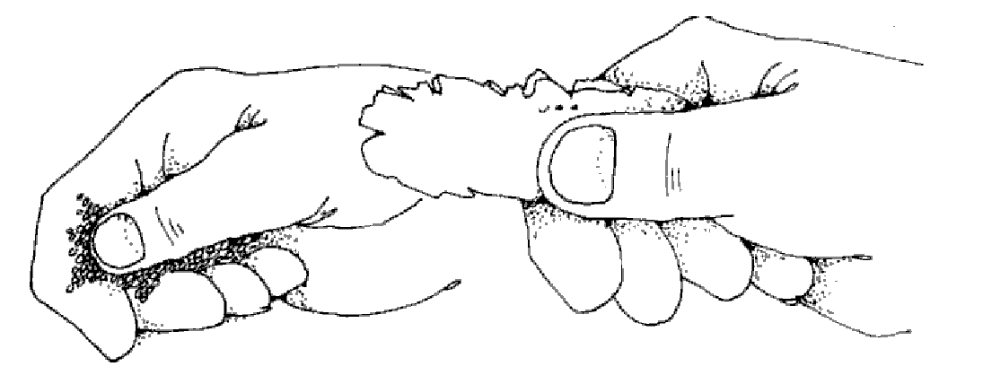
Figure 4: Illustration depicting how to form a ribbon by pushing the soil sample with thumb and forefinger.

