Prospective Remeasurement Alerts for Suspicious Pediatric Growth Measurements in Electronic Health Records
[Author names and affiliations]
[Corresponding author contact information]

Keywords: pediatric growth, anthropometry, electronic health records, measurement error, remeasurement, longitudinal data quality, clinical decision support

Abstract
Objective. Ground-truth labeling of measurement errors in pediatric electronic health records (EHRs) is epistemically impossible: once a height is saved, the true value the tape measure would have shown is unrecoverable, and even trained clinicians cannot reliably distinguish pathological growth, measurement noise, and data-entry error in retrospect. Every existing cleaning algorithm therefore relies on synthetic benchmarks or human consensus labels with low inter-rater agreement — not because the field has been incautious, but because no better evidence base exists. We argue that this identifiability problem is dissolved, not merely managed, by reframing the task: rather than adjudicating historical truth, a prospective alert fires while the child is still in the clinic, when remeasurement can recover the true value. We developed and evaluated a prospective remeasurement-alert algorithm that examines each newly entered height against the child's prior trajectory and flags measurements suspicious enough to warrant immediate remeasurement.
Materials and Methods. The alert pipeline combines two hard rules (biologically implausible value thresholds and carry-forward duplicate detection) with five soft detectors operating on the patient's prior history only: short-interval velocity, long-interval velocity, height-for-age z-score change, a streaming LOWESS trajectory-residual check, and a soft HAZ magnitude check. Per-detector confidences are fused by a weighted noisy-OR rule into a single score in [0, 1]; an alert fires when this score clears a tunable threshold (default 0.60). We evaluated the pipeline in streaming mode — where only prior unflagged history is available, exactly as in live EHR deployment — on six published Monte Carlo simulated-error datasets from Harrall et al. (600 patients, 17,705 visits), and compared it to streaming reimplementations of the Daymont and Harrall algorithms and to the EPIC 10% rule deployed in current commercial EHRs. We additionally applied the pipeline to a de-identified EHR extract from the Pediatric Physicians' Organization at Children's (PPOC; 250,588 patients, ~6.5M visits) to quantify real-world alert burden.
Results. At the default threshold, the pipeline achieved pooled sensitivity 0.88 and specificity 0.96 across the six benchmarks — the same synthetic evidence base on which all prior algorithms have been evaluated — exceeding the streaming Harrall (0.71 / 0.95), streaming Daymont (0.82 / 0.99), and EPIC 10% (0.76 / 0.33) baselines on sensitivity while remaining competitive on specificity. The threshold traces a smooth precision–sensitivity tradeoff: moving from 0.30 to 0.80 reduces false positives nearly five-fold at a cost of only 2.5% of true positives. On PPOC, the EPIC 10% rule would alert on approximately 1.76 million measurements (~27% of all visits); the proposed pipeline alerts on 25% at the default threshold.
Discussion. The definitionally correct external validation for a prospective alerting system is itself prospective: deploy the algorithm, remeasure when it fires, and recover ground truth while the child is present. We describe a proposed evaluation protocol and regard prospective clinical deployment as a necessary next step. The simulated benchmark used here is not a limitation specific to this work — it is the evidentiary ceiling available to the entire field.
Conclusion. A multi-detector, confidence-fused prospective alert pipeline identifies pediatric height measurements warranting remeasurement with performance exceeding the EPIC 10% rule and two leading retrospective algorithms in streaming use. By targeting the moment of entry rather than historical records, the method converts an irresolvable retrospective inference problem into a recoverable prospective action.

1. Background
The central obstacle in pediatric growth-data quality research is epistemological: the true value of a clinical measurement is permanently unrecoverable once it has been saved to the electronic health record. A recorded height of 112 cm for a seven-year-old may reflect a genuine measurement, a transcription error, a unit confusion, or a carry-forward duplication of a prior visit's value — and these possibilities cannot be reliably distinguished from the longitudinal record alone, even by trained clinicians with full access to the child's history. This is not a contingent limitation of existing methods; it is a structural property of retrospective EHR data. As Daymont noted, the same record contains both plausible outliers (true extreme values that look like errors) and implausible inliers (erroneous values that look ordinary against the population distribution but are wrong for the individual child) [7], and no retrospective procedure can separate these categories without external ground truth that does not exist.

A substantial and sophisticated literature has developed retrospective cleaning algorithms that, given a child's full longitudinal record, attempt to declare each historical measurement plausible or implausible [1,2,6,9,10,11]. These algorithms are evaluated on either Monte Carlo simulated data with known injected errors [9] or human consensus labels whose inter-rater agreement is substantially below 1.0 [1] — not because the field has been methodologically incautious, but because no better evidence base exists. The most widely adopted algorithm, Daymont's growthcleanr [1], has been validated against physician judgment and applied to large multisite consortia [4]; more recent approaches by Shi et al. [10], Phan et al. [6], and Harrall et al. [9] have introduced robust regression, peak-removal, and semi-parametric trajectory smoothing. All of these advances operate within the same epistemological constraint.
Real-time clinical decision support in this domain is comparatively underdeveloped. The widely deployed EPIC EHR system alerts clinicians when a newly entered height differs from the immediately preceding visit by more than 10%, and the clinician can either save or correct the value. As we show below, this rule has poor specificity — it flags an enormous fraction of plausible growth — and its anchoring to a single prior point makes it vulnerable to error propagation when the prior point was itself wrong. To our knowledge no commercial EHR currently deploys a trajectory-aware alert.
This paper proposes a resolution to the identifiability problem that does not require retrospective labels. The key insight is that the problem is not intrinsic to the task of detecting measurement errors — it is intrinsic to the timing of the detection attempt. At the moment a new height is entered, while the child is still in the clinic, the ground truth remains recoverable: a suspicious measurement can be remeasured, and the clinician and patient are present to resolve the ambiguity. We therefore reframe the task not as "is this historical measurement an error?" — a question that has no recoverable answer — but as "is this new measurement suspicious enough that we should remeasure it right now?" — a question that can be answered by action. This shift dissolves the identifiability problem rather than working around it. The deployment failure modes are also asymmetric in a clinically important way: a missed alert leaves the EHR in the same state it would otherwise be in, while a false alert costs a thirty-second remeasurement.

2. Methods

2.1 Conceptual framing
The pipeline runs at the moment a new height is entered, while the child is still in the clinic. Every detector sees only the new measurement and the child's prior history — no future points, in contrast to retrospective cleaning algorithms [1,9].
For each entered measurement the pipeline outputs a continuous error confidence in [0, 1] and a categorical label: error (population BIV or exact carry-forward duplicate), remeasure (fused confidence ≥ alert threshold), or no alert. The clinician decides what to do with an alert — remeasure or keep — and the saved value is their choice.
For evaluation, we adopt one simplifying assumption: every alerted point is removed from the history available to subsequent points, equivalent to assuming each alert is acted on and resolved (either remeasured to truth or discarded). The same convention is applied to every comparator.

2.2 Pipeline overview
The pipeline applies two hard rules and five soft detectors in sequence. The hard rules immediately raise an “error” alert if triggered. Otherwise, the five soft detectors are evaluated, each producing a confidence in [0, 1], and the five confidences are fused with a weighted noisy-OR rule [14] into a single error confidence. A “remeasure” alert is issued when the fused confidence clears the configured threshold.

2.3 Hard rules
Population BIV check. Each new height is converted to a sex- and age-specific z-score using WHO Child Growth Standards for ages ≤ 1856 days [12] and CDC growth charts for ages > 1856 days [13]. For ages in the WHO range an absolute HAZ ≥ 6 raises an error. In the CDC range the modified HAZ recommended by the CDC for extreme-value detection is used, with the CDC-recommended cutoffs of mod_HAZ < −5 or mod_HAZ > 4 [13].
Carry-forward duplicate check. A new height that matches the immediately previous observed height to within 1×10⁻⁶ cm raises an error. Exact equality between consecutive heights is essentially never the result of two independent measurements and is one of the most common error modes in EHR growth data — Lin et al. report that carry-forward measurements were the most common error mode flagged in the PCORnet pediatric cohort, accounting for the majority of flagged pediatric heights [4]. Note that this check compares against the most recent observed prior point, not the most recent un-flagged point, so that a prior error followed by a carry-forward replication of that prior error is still caught.

2.4 Soft detectors
If the hard rules do not fire, the pipeline evaluates the following five detectors. All of them depend only on the new point and the patient's prior un-flagged history.
Velocity (adjacent). The short-interval velocity is computed as the change in height between the new point and the immediately preceding visit, divided by the age difference. Velocity is converted to an age- and sex-specific z-score against velocity reference distributions derived by numerical differentiation of the WHO and CDC LMS tables [12,13]. Adjacent velocity is the detector most sensitive to single-point errors: an isolated erroneous spike inflates the velocity both going in and coming out, so the adjacent-velocity z-score after the error is large in magnitude. Its threshold is |z| > 5.
Velocity (adjusted). The same velocity z-score, but computed against the most recent prior visit whose interval meets an age-specific minimum (90 days for ages 0–12 months, 180 days for ages 1–2 years, 335 days for ages 2–12 years, 180 days for ages 13–18 years, reflecting the shortest interval over which measurement noise is small relative to true growth). The adjusted velocity catches sustained shifts but, importantly, dilutes a single-point error toward the population mean when the interval used is long.
HAZ change. The absolute change in HAZ between the new point and the immediately previous visit is compared to a dynamic, age- and interval-dependent plausibility threshold. This threshold is wider for younger children and longer intervals (during which legitimate channel-crossing growth shifts are larger) and narrower for older children and shorter intervals.
Streaming LOWESS trajectory residual. A robust LOWESS curve [15,16] is fit to the HAZ values in the patient's prior history (minimum five points) and extrapolated forward to the age of the new point. The residual — new HAZ minus predicted HAZ — is converted to a robust z by dividing by a residual scale, and the detector fires when |z| > 3.
The residual scale is estimated from self-free k-nearest-neighbor-median residuals: each history point is compared to the median HAZ of its five nearest-in-age neighbors (excluding itself), and the scale is 1.4826 × MAD of those residuals [17]. The scale is then inflated by a √(1 + gap/τ) factor with τ = 730 days when the new point lies well beyond the last history point, reflecting the fact that HAZ trajectories can legitimately drift over multi-year gaps even in healthy children.
Soft HAZ magnitude. A check on the magnitude of the new HAZ alone, threshold |HAZ| > 3, with a deliberately weak weight and a slow confidence ramp. We include this as a “weak prior” — large HAZ values are more often than not real (Freedman et al. [8] cautioned exactly against treating extreme HAZ as automatic evidence of error) but are weakly informative when several other detectors also fire.

2.5 Per-detector confidence mapping
A detector that has not crossed its threshold contributes no evidence. Above the threshold, the per-detector confidence ramps smoothly toward 1 as a sigmoid of the exceedance ratio r = |metric| / threshold:
$$c\left(r\right)=\left\{\begin{aligned}0, &r≤1 \\ \frac{1}{1+exp(-k(r-r_{mid}))}, &r>1\end{aligned}\right.$$
with k = 3.0 and a detector-specific r_{mid}. The exceedance form (rather than a sigmoid of the raw deviation) makes the curve scale-invariant across detectors with very different units (velocity z, HAZ, HAZ-change, trajectory z). The r_{mid} parameter controls how far past the threshold a detector must reach before it contributes meaningful evidence: r_{mid} = 1 would make a just-crossed threshold already score 0.5; we use r_{mid} = 1.8 for the velocity and HAZ-change detectors and r_{mid} = 2.0 for the soft-HAZ and trajectory detectors.

2.6 Noisy-OR fusion
Per-detector confidences are pooled by weighted noisy-OR [14], the standard probabilistic combination rule for independent evidence:
$$C_{ensemble}=1-\prod_{i}{\left(1-w_{i}⋅c_{i}\right)}$$
with detector weights chosen to reflect each detector's expected reliability (adjacent velocity 0.85, adjusted velocity 0.90, HAZ change 0.90, trajectory 0.85, soft HAZ 0.45). This generalizes a “k-of-N voting” rule smoothly: any single detector with a high confidence can drive C_{ensemble} high, multiple weak detectors can also accumulate to a high C_{ensemble}, and a detector that did not cross its threshold contributes nothing.
A “remeasure” alert is raised when C_{ensemble} ≥ τ, where τ is a tunable threshold (default 0.60). The threshold sweep in §3.2 characterizes its tradeoff.

2.7 Streaming application to retrospective benchmarks
To evaluate the alert pipeline on retrospective benchmark data, we apply it in streaming mode. For each patient, measurements are sorted in chronological order. The algorithm walks forward through the visits; for each visit, the history available to the detectors is the set of all prior un-flagged measurements for that patient. Once a measurement is flagged (as either “error” or “remeasure”), it is removed from the history that subsequent points are judged against.
This streaming protocol is the faithful simulation of the live-EHR deployment: at the moment of entry, the algorithm has the patient's curated prior history and is asked whether the new point should trigger an alert. We use the same protocol below to evaluate the Daymont and Harrall algorithms for fair comparison.

2.8 Evaluation data
We use the Monte Carlo simulated-error datasets released with the Harrall paper [9], which were generated by:
- Simulating clean longitudinal height trajectories for 100 children each, from a Preece–Baines [18] parametric growth model with three parameter sets corresponding to “low,” “medium,” and “high” populations (positioned at the 5th–25th, 25th–75th, and 75th–95th CDC percentile bands, respectively).
- Generating 100 visits per child with mean and variance of visit spacing matched to the EPOCH cohort [19].
- Injecting three classes of errors at known positions and magnitudes:
- Cups — abrupt downward height excursions that recover at the next visit (e.g., a transcription mistake);
- Caps — abrupt upward height excursions that recover at the next visit;
- Repeats — exact duplicates of the previous visit's height value, simulating EHR carry-forward auto-population.
- Varying the error rate across two levels labeled “dirt2” (matching the empirical error proportions estimated from the EPOCH cohort) and “dirt3” (double the empirical error rate).
The released benchmark thus consists of six labeled datasets — pop{1,2,3}_dirt{2,3} — with bad_ht = True marking every injected error. Table 1 summarizes these benchmarks; total visits range from 2,818 to 3,022 per dataset, and the simulated error prevalence ranges from 10.4% to 16.2%.
Table 1. Composition of the six Harrall simulated-error benchmarks.
Dataset | Patients | Visits | Injected errors | Error prevalence
pop1_dirt2 | 100 | 2,932 | 362 | 12.3%
pop1_dirt3 | 100 | 2,987 | 475 | 15.9%
pop2_dirt2 | 100 | 2,960 | 308 | 10.4%
pop2_dirt3 | 100 | 2,818 | 457 | 16.2%
pop3_dirt2 | 100 | 2,986 | 324 | 10.9%
pop3_dirt3 | 100 | 3,022 | 452 | 15.0%
Total | 600 | 17,705 | 2,378 | 13.4%

2.9 Comparators
We compare to three streaming baselines:
- Streaming Daymont. The Daymont weighted-moving-average algorithm [1] (growthcleanr) applied to each successive truncation of a patient's history, so that the decision for visit t uses only history up to visit t − 1.
- Streaming Harrall. The Harrall trajectory-cleaning algorithm [9] applied to each successive history truncation.
- EPIC 10% rule. A new measurement is flagged when its height differs from the most recent un-flagged previous height by more than 10%, mimicking the rule deployed in the EPIC EHR. Flagged points are removed from history for subsequent checks.
The Daymont and Harrall algorithms were not designed for prospective use; we include them for completeness so that we can quantify how much each loses by removing bidirectional context.

3. Results

3.1 Performance at the default threshold
Table 2 reports per-dataset sensitivity and specificity for all four algorithms at the default alert threshold (0.60 for our pipeline, 0.10 for EPIC).
Table 2. Sensitivity / specificity by dataset and method, streaming mode.
Dataset | Harrall (streaming) | Daymont (streaming) | EPIC 10% | This work
pop1_dirt2 | 0.68 / 0.94 | 0.79 / 0.99 | 0.73 / 0.39 | 0.87 / 0.97
pop1_dirt3 | 0.75 / 0.96 | 0.85 / 1.00 | 0.77 / 0.28 | 0.91 / 0.96
pop2_dirt2 | 0.67 / 0.96 | 0.80 / 0.99 | 0.77 / 0.30 | 0.87 / 0.94
pop2_dirt3 | 0.70 / 0.91 | 0.82 / 0.98 | 0.81 / 0.28 | 0.86 / 0.93
pop3_dirt2 | 0.72 / 0.97 | 0.80 / 0.99 | 0.73 / 0.36 | 0.87 / 0.98
pop3_dirt3 | 0.72 / 0.95 | 0.83 / 0.99 | 0.74 / 0.36 | 0.89 / 0.96
Pooled | 0.71 / 0.95 | 0.82 / 0.99 | 0.76 / 0.33 | 0.88 / 0.96

The EPIC 10% rule has by far the lowest specificity (0.33 pooled), reflecting the well-known overflagging of normal pediatric growth by a fixed 10% rule — adolescent growth spurts and early-childhood velocity routinely produce > 10% height changes per visit. The Harrall algorithm loses substantial sensitivity in streaming mode (0.71 pooled, compared with > 0.99 reported in its retrospective evaluation [9]); the design of its peak-removal step relies on the existence of a downward “cup” after a flagged “cap,” and that future point is unavailable in streaming use. The Daymont algorithm's weighted moving average uses inverse-distance weighting that gives current and recent points more weight, which translates better to streaming use and degrades less (pooled sensitivity 0.82, specificity 0.99). Daymont also retains the highest specificity of all four methods, exceeding our pipeline's 0.96 by 3 percentage points. Our pipeline achieves the highest pooled sensitivity (0.88) of the four, with specificity (0.96) competitive with the retrospective-style baselines and far above EPIC.

3.2 Threshold sensitivity sweep
To characterize the alert threshold's tradeoff, we re-ran the streaming pipeline on all six datasets at remeasure-confidence thresholds 0.30 through 0.90 in increments of 0.10. Because a flagged point is removed from history for subsequent decisions, each threshold is a full re-run, not a post-hoc re-thresholding of cached scores.
Table 3. Pooled sensitivity / specificity across all six datasets vs. alert threshold.
Threshold | Alerted | TP | FP | Sensitivity | Specificity
0.30 | 3,727 | 2,115 | 1,612 | 0.89 | 0.89
0.40 | 3,261 | 2,106 | 1,155 | 0.89 | 0.92
0.50 | 3,105 | 2,098 | 917 | 0.88 | 0.94
0.60 | 2,759 | 2,090 | 669 | 0.88 | 0.96
0.70 | 2,539 | 2,078 | 461 | 0.88 | 0.97
0.80 | 2,410 | 2,060 | 350 | 0.87 | 0.98
0.90 | 2,131 | 1,894 | 237 | 0.80 | 0.98

The tradeoff is asymmetric. Between thresholds 0.30 and 0.80, sensitivity declines only modestly (0.89 → 0.87); the false-positive count falls almost five-fold (1,611 → 347) for the cost of 54 true positives (2.5% relative loss in TP). Only beyond threshold 0.80 does sensitivity drop steeply. The implication for deployment is that a clinic with low tolerance for false alarms can move the threshold up to 0.80 with little loss of error capture, and only at the most conservative end (≥ 0.90) does the algorithm begin to miss meaningfully more true errors.
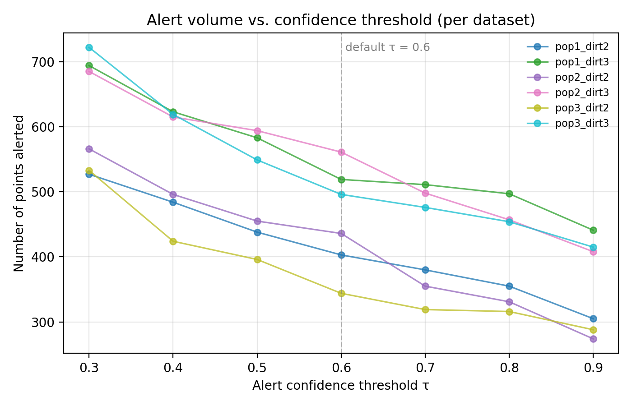
Figure 1. Number of points alerted as a function of the confidence threshold τ, shown separately for each of the six simulated-error datasets. The dashed vertical line marks the default threshold (τ = 0.60).
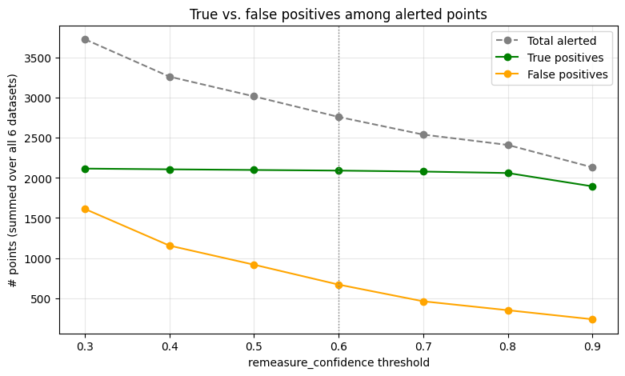Figure 2. Alerted points pooled across all six datasets, decomposed as a function of the confidence threshold τ. The dashed gray line is the total number of points alerted; the green line is the subset that are true positives (correctly flagged simulated errors); the orange line is the subset that are false positives (clean points incorrectly flagged).

3.3 Operational alert burden on a real-world EHR cohort
Dataset. We used a de-identified longitudinal EHR extract from the Pediatric Physicians' Organization at Children's (PPOC), a primary-care network affiliated with Boston Children's Hospital. The cohort comprises 250,588 unique pediatric patients aged 0–18 years, with 6,494,473 clinical visits (≈ 72.8% routine office visits) recorded across the network. Each visit row carries patient demographics (sex, ethnicity, race), encounter type, anthropometrics (height, weight, BMI and derived percentiles), and up to 33 ICD-10 encounter diagnoses; the broader extract also includes 17.2 M laboratory result components, 3.8 M medication records, 1.7 M problem-list entries, and 349,827 specialty referrals, all linked by `patient_id` and `visit_id`. Dates are de-identified as `age_in_days`. For the present analysis we used only the height column from the visits table. Unlike the Harrall simulator, no ground-truth error labels are available, so this analysis reports alert volume — the count and share of measurements that would trigger an alert — rather than sensitivity or specificity.

Analysis. To characterize the operational burden the two approaches would impose in live clinical use, we ran both the EPIC 10% rule and our pipeline (in streaming mode, across the same threshold sweep used in §3.2) on every height measurement in the cohort, removing flagged points from each patient's running history as in the simulated-benchmark protocol.
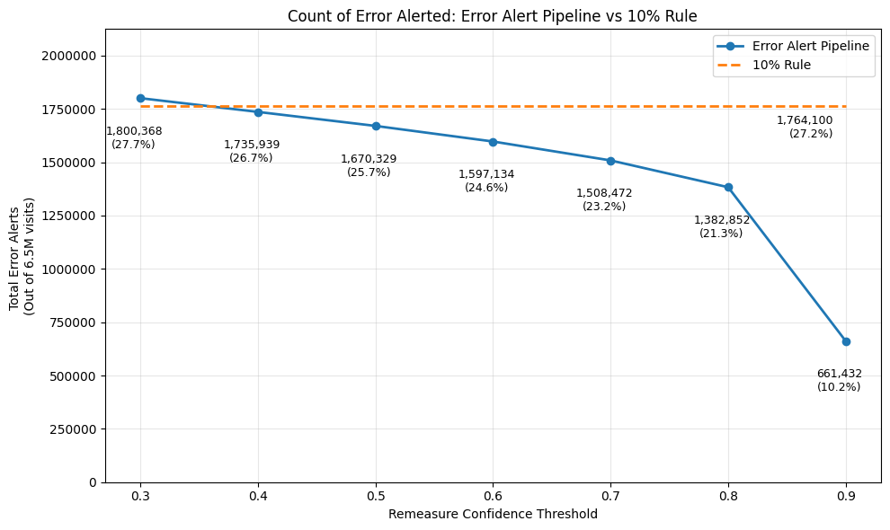
Figure 3. Total number of height measurements that would trigger an alert in the PPOC cohort (≈ 6.5 M visits) under the EPIC 10% rule (orange dashed) and under the error alert pipeline at remeasure-confidence thresholds from 0.30 to 0.90 (solid blue). Annotations report absolute counts and the percentage of the full cohort.

The EPIC 10% rule alerts on roughly 1.76 million measurements (≈ 27% of all visits). Our pipeline produces an order-of-magnitude smaller alert burden across the entire threshold range, and the burden is tunable: a deploying clinic can dial the threshold down for higher sensitivity or up for a lighter operational footprint without re-engineering the alert. This is the practical payoff of the trajectory-aware, confidence-fused design — the same algorithm that achieves higher sensitivity than EPIC on simulated errors also generates a small fraction of EPIC's alerts on real EHR traffic.

4. Discussion

4.1 Why a prospective frame
The most important claim in this paper is not about algorithm performance — it is about problem formulation. The retrospective growth-data cleaning literature, for all its sophistication, operates under an epistemological constraint it has not fully confronted: the ground truth it seeks to recover does not exist in the data, has not existed since the measurements were saved, and cannot be reconstructed by any algorithm operating on the historical record alone. Simulated benchmarks and human consensus labels are not approximations to a better evaluation that is merely difficult to obtain — they are the best evaluation available, period, for any retrospective method.
Acknowledging this constraint changes what counts as a valid evaluation design. A prospective alerting system — one that fires before a measurement is saved, while the child can still be remeasured — is the only task formulation for which external ground truth is recoverable. When the algorithm fires and the nurse takes a second measurement, the pair (original, remeasured) is the ground truth. This is not merely a practical convenience; it is the definitionally correct evaluation paradigm for this class of algorithm. Prospective clinical deployment is therefore not a direction for future work in the ordinary sense — it is the experiment that will provide the first true external validation of any algorithm in this space.
The simulated benchmark used in this paper is the same evidentiary foundation on which the entire retrospective cleaning literature rests. Our evaluation is not weaker than prior work's evaluation by virtue of using simulation; it uses identical evidence while making a more honest claim about what that evidence can and cannot establish. The performance results in §3 should therefore be read as establishing that the algorithm meets the bar that prior algorithms in this space have been evaluated against — a necessary condition for serious consideration — rather than as a definitive demonstration of clinical superiority. Section 4.4 outlines the experiment that would establish the latter.

4.2 Comparison to EPIC 10% rule
The EPIC 10% rule's catastrophically low specificity (0.33 pooled) reflects the fundamental mismatch between a fixed proportional threshold and pediatric growth physiology. Children grow at strongly age-dependent velocities, and 10% per visit is easily exceeded by ordinary growth in infants (≈ 50% per year), early adolescents during peak height velocity, and any child with intervisit gaps of more than a year. Our results suggest that even a small amount of trajectory awareness — at minimum, age- and sex-adjusted velocity z-scores — could substantially reduce alert burden in EHRs that currently deploy the 10% rule, without sacrificing the sensitivity to gross errors that motivated the rule in the first place.

4.3 Limitations
The primary limitation of this evaluation — that it relies on simulated data — is not a contingent weakness of this paper but a structural feature of the entire field. It is worth stating this precisely: no algorithm for retrospective or prospective detection of pediatric EHR measurement errors has ever been evaluated against objectively recoverable ground truth on real EHR data, because such ground truth does not exist once a measurement is saved. The simulated and consensus-labeled benchmarks used across this literature are not approximations to a gold standard that is merely hard to obtain — they are the ceiling of evidence available to any method in this space. This paper uses the same ceiling. What distinguishes the prospective framing is that it creates, for the first time, a path to genuine external validation: prospective deployment, in which an alert triggers remeasurement before the original value is committed, and the pair of measurements resolves the ambiguity in real time.
No weight evaluation. This work covers only height; weight is more difficult because legitimate short-term decreases are common and would require different velocity and HAZ-change references. Extension to weight is a natural next step.
Static thresholds and weights. The detector weights and r_{mid} parameters are hand-chosen based on simulator-tuning and clinical reasoning; they could in principle be learned from a labeled training set. We did not pursue this because the Harrall simulator's error distribution is itself synthetic and learning weights on it risks overfitting to assumptions that do not hold in real data.

4.4 Future directions
The arguments in §4.1 and §4.3 lead to a specific empirical commitment: the methodologically appropriate external validation of a remeasurement-alert system is not another retrospective benchmark but a *prospective* in-clinic study in which the algorithm fires, the child is remeasured before they leave the room, and the original–remeasurement pair is recorded as ground truth. This is the only setting in which the counterfactual ("what would a careful measurement have read?") is empirically recoverable rather than inferred. We outline below a protocol intended to support a multi-site evaluation.

Study design. A prospective, multi-site observational deployment study in pediatric primary-care clinics with EHR-integrated growth charting (e.g., participating PPOC sites). The pipeline runs as a real-time decision support widget invoked at the moment a height is committed in the EHR. When the fused confidence exceeds the deploying clinic's threshold (default 0.60), the medical assistant or nurse who recorded the initial measurement is prompted, before the visit closes, to repeat the measurement using a standardized protocol. Both values, the time elapsed between them, the firing detectors, and the fused confidence are written to a study log; the EHR-saved value remains the clinician's choice and is also logged. Independent of alert firing, a random 1–2% sample of unalerted measurements is also remeasured to estimate the false-negative rate.

Primary endpoints. (i) Positive predictive value (PPV) of the alert at the default threshold, with 95% confidence interval; (ii) PPV as a function of the confidence threshold across the same sweep used in §3.2; (iii) sensitivity, estimated from the random-sample remeasurement arm.

Clinician workflow and adherence. The alert appears as a non-blocking modal immediately on save, with a one-line rationale derived from the firing detectors (e.g., "implausible velocity since previous visit; HAZ change above age-adjusted threshold"). The remeasurement step is logged whether or not it is performed; non-adherence is itself a primary descriptive outcome, since a CDS alert that is consistently dismissed is operationally a failed alert regardless of its statistical performance.

This protocol is, in our view, the appropriate next study. The simulated benchmarks in §3 establish that the algorithm is competitive in the regime where ground truth is artificially available; the PPOC analysis in §3.3 establishes that it produces a tractable alert burden in real EHR traffic; what remains is to establish, on real patients, that the alerts it does produce correspond to measurements a careful remeasurement would in fact change.

Two extensions are worth flagging beyond the prospective study above. First, extending the same pipeline to weight, with appropriate reference standards and an additional set of detectors that handle plausible short-term decreases. Second, exploring representation choices for downstream learning: whether large language models or other learned models perform better when growth data are presented as raw measurements, z-scores, percentiles, velocity features, or growth-chart images.

5. Conclusion
The central contribution of this paper is a reframing of the growth-data quality problem, not an incremental improvement in algorithm design. Retrospective adjudication of EHR measurement quality is epistemologically constrained: ground truth is unrecoverable, and any algorithm — however sophisticated — can only be evaluated against synthetic errors or human consensus labels with limited agreement. A prospective alert, by contrast, fires at the moment of entry, while the child and clinician are present and remeasurement is possible. This reframing converts an irresolvable inference problem into a recoverable action problem, and it creates, for the first time, conditions under which a growth-data quality algorithm can be evaluated against true external ground truth in a clinical deployment setting.
Within this framing, the multi-detector confidence-fused pipeline presented here achieves pooled sensitivity 0.88 and specificity 0.96 on the Harrall Monte Carlo benchmark in streaming mode — the same evidence base on which all prior algorithms have been evaluated — exceeding the streaming Harrall and Daymont algorithms on sensitivity and dramatically exceeding the EPIC 10% rule on specificity. The alert threshold is tunable, the operational burden on real-world EHR traffic is a small fraction of the EPIC rule's, and the algorithm requires only the patient's prior history, making it suitable for deployment in any EHR system with longitudinal growth records.

References
- Daymont C, Ross ME, Localio AR, Fiks AG, Wasserman RC, Grundmeier RW. Automated identification of implausible values in growth data from pediatric electronic health records. J Am Med Inform Assoc. 2017;24(6):1080–1087. doi:10.1093/jamia/ocx037.
- Yang S, Hutcheon JA. Identifying outliers and implausible values in growth trajectory data. Ann Epidemiol. 2016;26(1):77–80.e2. doi:10.1016/j.annepidem.2015.10.002.
- Carsley S, Parkin PC, Tu K, et al. Reliability of routinely collected anthropometric measurements in primary care. BMC Med Res Methodol. 2019;19(1):84. Published 2019 Apr 24. doi:10.1186/s12874-019-0726-8.
- Lin PD, Rifas-Shiman SL, Aris IM, Daley MF, Janicke DM, Heerman WJ, Chudnov DL, Freedman DS, Block JP. Cleaning of anthropometric data from PCORnet electronic health records using automated algorithms. JAMIA Open. 2022;5(4):ooac089. doi:10.1093/jamiaopen/ooac089.
- Ulijaszek SJ, Kerr DA. Anthropometric measurement error and the assessment of nutritional status. Br J Nutr. 1999;82(3):165–177. doi:10.1017/S0007114599001348.
- Phan HTT, Borca F, Cable D, Batchelor J, Davies JH, Ennis S. Automated data cleaning of paediatric anthropometric data from longitudinal electronic health records: protocol and application to a large patient cohort. Sci Rep. 2020;10(1):10164. doi:10.1038/s41598-020-66925-7.
- Daymont C. Plausible outliers and implausible inliers. Obesity (Silver Spring). 2020;28(7):1174. doi:10.1002/oby.22865.
- Freedman DS, Lawman HG, Skinner AC, McGuire LC, Allison DB, Ogden CL. Validity of the WHO cutoffs for biologically implausible values of weight, height, and BMI in children and adolescents in NHANES from 1999 through 2012. Am J Clin Nutr. 2015;102(5):1000–1006. doi:10.3945/ajcn.115.115576.
- Harrall KK, Bird SM, Muller KE, Vanderlinden LA, Payton ME, Bellatorre A, Dabelea D, Glueck DH. A better performing algorithm for identification of implausible growth data from longitudinal pediatric medical records. Sci Rep. 2024;14(1):18276. doi:10.1038/s41598-024-69161-5.
- Shi J, Korsiak J, Roth DE. New approach for the identification of implausible values and outliers in longitudinal childhood anthropometric data. Ann Epidemiol. 2018;28(3):204–211.e3. doi:10.1016/j.annepidem.2018.01.007.
- Thurber KA, Banks E, Banwell C. Approaches to maximising the accuracy of anthropometric data on children: review and empirical evaluation using the Australian Longitudinal Study of Indigenous Children. Public Health Res Pract. 2014;25(1):e2511407. doi:10.17061/phrp2511407.
- de Onis M, Garza C, Victora CG, Onyango AW, Frongillo EA, Martines J; WHO Multicentre Growth Reference Study Group. The WHO Multicentre Growth Reference Study: planning, study design, and methodology. Food Nutr Bull. 2004;25(1 Suppl 1):S15–S26. doi:10.1177/15648265040251S104.
- Kuczmarski RJ, Ogden CL, Guo SS, Grummer-Strawn LM, Flegal KM, Mei Z, Wei R, Curtin LR, Roche AF, Johnson CL. 2000 CDC growth charts for the United States: methods and development. Vital Health Stat 11. 2002;(246):1–190.
- Pearl J. Probabilistic Reasoning in Intelligent Systems: Networks of Plausible Inference. San Mateo, CA: Morgan Kaufmann; 1988. ISBN 978-1558604797.
- Cleveland WS. Robust locally weighted regression and smoothing scatterplots. J Am Stat Assoc. 1979;74(368):829–836. doi:10.1080/01621459.1979.10481038.
- Cleveland WS, Devlin SJ. Locally weighted regression: an approach to regression analysis by local fitting. J Am Stat Assoc. 1988;83(403):596–610. doi:10.1080/01621459.1988.10478639.
- Rousseeuw PJ, Croux C. Alternatives to the median absolute deviation. J Am Stat Assoc. 1993;88(424):1273–1283. doi:10.1080/01621459.1993.10476408.
- Preece MA, Baines MJ. A new family of mathematical models describing the human growth curve. Ann Hum Biol. 1978;5(1):1–24. doi:10.1080/03014467800002601.
- Crume TL, Ogden L, West NA, Vehik KS, Scherzinger A, Daniels S, McDuffie R, Bischoff K, Hamman RF, Norris JM, Dabelea D. Association of exposure to diabetes in utero with adiposity and fat distribution in a multiethnic population of youth: the Exploring Perinatal Outcomes among Children (EPOCH) Study. Diabetologia. 2011;54(1):87–92. doi:10.1007/s00125-010-1925-3.

