Prospective Remeasurement Alerts for Suspicious Pediatric Growth Measurements in Electronic Health Records
[Author names and affiliations]
[Corresponding author contact information]
Keywords: pediatric growth, anthropometry, electronic health records, measurement error, remeasurement, longitudinal data quality, clinical decision support

Abstract
Objective. To develop and evaluate a real-time electronic health record (EHR) alert flagging potentially erroneous pediatric height measurements that warrant repeating.
Materials and Methods. We built a multi-detector, confidence-fused pipeline that uses only prior unflagged patient history at the time of height entry and returns a remeasurement alert confidence score between 0 and 1. An alert is issued when this score reaches a tunable alert-confidence threshold (default 0.60). Performance was evaluated in streaming mode on six published Monte Carlo simulated-error benchmarks (Harrall et al.; 600 patients, 17,705 visits; 2,378 injected simulated errors), against streaming reimplementations of the Daymont and Harrall algorithms and the incumbent static rules-based 10% prior-height-change rule (“10% rule”) currently in in use in our local electronic health record. Operational burden, in terms of the volume of remeasurement alerts the system would generate in clinical use, was estimated in a de-identified outpatient pediatric EHR extract from the Pediatric Physicians’ Organization at Children’s (PPOC; 250,588 patients, 6,494,473 visits).
Results. At the default alert-confidence threshold (0.60), the pipeline detected 2,090 of 2,378 injected simulated errors and generated 669 false alerts among 15,327 non-injected visits (sensitivity 0.88, specificity 0.96), compared with streaming Harrall (0.71 / 0.95), streaming Daymont (0.82 / 0.99), and the 10% rule (0.76 / 0.33). Raising the alert-confidence threshold to 0.70 left simulated sensitivity at 0.88 and increased specificity to 0.97 (2,078 true positives; 461 false positives). In the PPOC extract, the 10% rule would have generated 1,764,100 alerts (27.2% of visits). The pipeline’s estimated alert burden was threshold dependent: 1,597,134 alerts (24.6%) at the default threshold, 1,508,472 (23.2%) at threshold 0.70, and 661,432 (10.2%) at threshold 0.90.
Conclusion. In simulated streaming evaluation, a trajectory-aware remeasurement-alert pipeline achieved higher sensitivity than streaming comparator implementations and the 10% rule, with lower specificity than Daymont. A fundamental constraint shared by retrospective growth data cleaning method is that no real-world benchmark of confirmed pediatric height error exists. Once a value is saved, its validity cannot be recovered from the record. This is what motivates the prospective reframing: real-error accuracy can be established only by remeasuring flagged children at the point of care. Because the real-world EHR cohort has no ground-truth error labels, this analysis could only characterize the operational alert volume the pipeline would generate under different alert-confidence thresholds. These findings support real-time clinical validation of outpatient pediatric anthropometric measurements and issuing of remeasurement alerts as a practical strategy for obtaining contemporaneous reference measurements. Workflow impact and clinical utility remain to be determined.

Background

The surveillance of growth is a cornerstone in providing high quality and effective pediatric care. Longitudinal growth measurements inform growth-chart interpretation, BMI classification, health surveillance, referral decisions, and evaluation for endocrine, nutritional, gastrointestinal, and other conditions. Routinely collected anthropometric measurements are nevertheless vulnerable to measurement, recording, and transcription error [3,5].
A central obstacle is that the validity of an anthropometric measurement is usually lacking when it has been saved to the electronic health record. A recorded height of 112 cm for a seven-year-old may reflect a genuine measurement, a transcription error, a unit confusion, a measurement error, or a carry-forward duplication of a prior visit’s value — and these possibilities cannot be reliably distinguished from the longitudinal record alone, even by trained clinicians with full access to the child’s history. Retrospective EHR data simply do not contain enough reference information to resolve the question. As Daymont noted, the same record contains both plausible outliers (true extreme values that look like errors) and implausible inliers (erroneous values that look ordinary against the population distribution but are wrong for the individual child) [7], and retrospective procedures have limited ability to separate these categories without an external reference measurement.
A substantial literature has developed retrospective data cleaning algorithms that, given a child’s full longitudinal record, attempt to declare each historical measurement plausible or implausible [1,2,6,9,10,11]. Population-based biologically implausible value cutoffs identify extreme values but may also remove true extremes [8]; longitudinal methods add within-child information through weighted moving averages, robust regression, local trajectory rules, peak-removal heuristics, or semi-parametric trajectory smoothing [1,6,9,10]. These algorithms are evaluated on either Monte Carlo simulated data with known injected errors [9] or human consensus labels whose interrater agreement is substantially below 1.0 [1]. The unresolved gap is not whether longitudinal context is useful; it is how to use prior-history-only information at the point of care to decide whether a new value should be remeasured.
Real-time clinical decision support for anthropometric data quality is comparatively underdeveloped. Prior EHR alerting work has used a simple fixed-change rule in which a newly entered height or weight triggers a pop-up when it varies by at least 10% from the most recent comparable value, allowing the user to delete, correct, or save the value [21]. The comparator available in our local EHR (Epic) uses the same fixed-change concept for height, flagging entries that differ from the immediately preceding visit by a configurable percentage (default 10%); we refer to this comparator as the “10% rule” throughout the paper. As we show below, this rule has poor specificity in pediatric height data — it flags an enormous fraction of plausible growth — and its anchoring to a single prior point makes it vulnerable to error propagation when the prior point was itself wrong. Because these low-specificity warnings fire so frequently on normal growth, clinicians may learn to disregard them -- alert fatigue that blunts the safeguard. What remains missing is a trajectory-aware, prior-history-only, human-in-the-loop alert designed for prospective remeasurement rather than retrospective deletion.
We propose here a prospective task formulation that addresses a practical limitation of retrospective labels. At the moment a new height is entered, while the child is still in the clinic, the original measurement uncertainty can often still be reduced: a suspicious measurement can be repeated, and the clinician and patient are present to act on the result. We therefore reframe the task not as "is this historical measurement an error?" — a question that retrospective records often cannot answer definitively — but as "is this new measurement suspicious enough that we should remeasure it right now?"
The present study is a preclinical evaluation of streaming alert performance plus a retrospective analysis of operational alert burden. The operational consequences are also asymmetric: a missed alert leaves the EHR no worse than before, while a false alert imposes workflow burden that must be measured, tuned, and monitored. We therefore developed a trajectory-aware, prior-history-only pediatric height remeasurement alert and evaluated its streaming performance against published simulated-error benchmarks and comparator algorithms, then estimated operational alert burden in a large pediatric primary-care EHR cohort.

Methods

Conceptual framing
The pipeline runs through all data up to and including the time a new height is entered. That is, while the child is still in the clinic. Every detector sees only the new measurement and the child’s prior history — no future points, in contrast to retrospective cleaning algorithms [1,9].
For each entered measurement the pipeline outputs a continuous error confidence and a categorical label indicating whether to alert error. The clinician decides what to do with an alert — remeasure or keep — and the saved value is their choice.
For evaluation, we adopt one simplifying assumption: every alerted point (i.e, points which have been flagged for remeasurement) is removed from the history available to subsequent points, equivalent to assuming each alert is acted on and resolved (either remeasured to truth or discarded). The same convention is applied to every comparator.

Pipeline overview
The pipeline applies two hard rules and five soft detectors in sequence. The hard rules check for unambiguous problems and immediately raise an “error” alert if triggered. Otherwise, the five soft detectors are evaluated, each producing a confidence estimate (CE) between 0 and 1, and the five CE’s are fused with a weighted noisy-OR rule [14] into a single CE. A “remeasure” alert is issued when the fused confidence clears the predetermined threshold.

Hard rules
Population biologically implausible value check. This flags heights too extreme for a child of an age and sex. Each new height is converted to a sex- and age-specific height-for-age z-score (HAZ) using WHO Child Growth Standards for ages ≤ 1856 days [12] and CDC growth charts for ages > 1856 days [13]. For ages in the WHO range an absolute HAZ ≥ 6 raises an error. In the CDC range the modified HAZ (mod_HAZ) recommended by the CDC for extreme-value detection is used, with the CDC-recommended cutoffs of mod_HAZ < −5 or mod_HAZ > 4 [13].
Carry-forward duplicate check. A new height that is identical to the previous one (matching to within 1×10⁻⁶ cm) is flagged. Exact equality between consecutive heights is essentially never the result of two independent measurements and almost always means the previous value was copied forward rather than remeasured; Lin et al. found carry-forward measurements to be the most common error mode flagged in the PCORnet pediatric cohort [4]. Note that this check compares against the most recent observed prior point, not the most recent un-flagged point, so that a prior error followed by a carry-forward replication of that prior error is still caught.

Soft detectors
If the hard rules do not fire, the pipeline evaluates the following five detectors. All of them depend only on the new point and the patient’s prior un-flagged history.
Velocity (adjacent). This computes the change in height between the new point and the immediately preceding visit, divided by the age difference. The growth rate is converted to an age- and sex-specific z-score against velocity reference distributions derived by numerical differentiation of the WHO and CDC LMS tables [12,13]. Adjacent velocity is the detector most sensitive to single-point errors: an erroneous spike inflates the velocity both on the visit with the error and on the following visit. Its threshold is |z| > 5.
Velocity (adjusted). The same velocity z-score, but computed against the most recent prior visit whose interval meets an age-specific minimum (90 days for ages 0–12 months, 180 days for ages 1–2 years, 335 days for ages 2–12 years, 180 days for ages 13–18 years), preventing computing velocity over short span that measurement noise, divided by tiny age difference, dominate true growth. The adjusted velocity catches sustained shifts but dilutes a single-point error toward a normal velocity when the interval used is long.
HAZ change. This looks at how far a patient’s height-for-age position changed from the previous visit. The absolute change in HAZ between the new point and the immediately previous visit is compared to a dynamic, age- and interval-dependent plausibility threshold. This threshold is wider for younger children and longer intervals (during which legitimate channel-crossing growth shifts are larger) and narrower for older children and shorter intervals.
Streaming trajectory residual. Fits a smooth curve through the child’s prior HAZ values (using robust Locally Weighted Scatterplot Smoothing (LOWESS) [15,16]) and extrapolate forward to predict the HAZ expected at the the age of the new point. The residual — observed HAZ minus predicted HAZ — is converted to a z score by dividing by a residual scale, and the detector fires when |z| > 3.
The residual scale is estimated from self-free k-nearest-neighbor-median residuals: each history point is compared to the median HAZ of its five nearest-in-age neighbors (excluding itself), and the scale is 1.4826 × MAD of those residuals [17]. The scale is then inflated by a √(1 + gap/τ) factor with τ = 730 days when the new point lies well beyond the last history point, reflecting the fact that HAZ trajectories can legitimately drift over multi-year gaps even in healthy children.
Soft HAZ magnitude. A check on the magnitude of the new HAZ alone, threshold |HAZ| > 3, with a deliberately weak weight and a slow confidence ramp. We include this as a “weak prior” — large HAZ values usually reflects genuine biological variation rather than measurement error (Freedman et al. [8] cautioned against treating extreme HAZ as automatic evidence of error) but are weakly informative when several other detectors also fire.

Per-detector confidence mapping
Each detector reports a raw metric and has its own firing threshold. Each raw metric is turned into a confidence between 0 and 1. A detector that has not crossed its threshold contributes no evidence (confidence 0). Above the threshold, the per-detector confidence ramps smoothly toward 1 along a sigmoid curve drive by the exceedance ratio r = |metric| / threshold – how many times over its own threshold the detector is:
$$c\left(r\right)=\left\{\begin{aligned}0, &r≤1 \\ \frac{1}{1+exp(-k(r-r_{mid}))}, &r>1\end{aligned}\right.$$
with k = 3.0 and a detector-specific r_{mid}. We used r_{mid} = 1.8 for the velocity and HAZ-change detectors and r_{mid} = 2.0 for the soft-HAZ and trajectory detectors.

Noisy-OR fusion
Per-detector confidences are combined into a single ensemble confidence using a weighted noisy-OR rule [14], a standard probabilistic combination rule for independent evidence:
$$C_{ensemble}=1-\prod_{i}{\left(1-w_{i}⋅c_{i}\right)}$$
with detector weights chosen to reflect each detector's expected reliability (adjacent velocity 0.85, adjusted velocity 0.90, HAZ change 0.90, trajectory 0.85, soft HAZ 0.45). Any single detector with a high confidence can drive C_{ensemble} high, multiple weak detectors can also accumulate to a high C_{ensemble}, and a detector that did not cross its threshold contributes nothing.
A “remeasure” alert is raised when C_{ensemble} ≥ τ, where τ is a tunable threshold (default 0.60). The threshold sweep in Section 3.2 characterizes its tradeoff.

Streaming application to retrospective benchmarks
To evaluate the alert pipeline on retrospective benchmark data, we apply it in streaming mode. For each patient, measurements are sorted in chronological order. The algorithm walks forward through the visits; for each visit, the history available to the detectors is the set of all prior un-flagged measurements for that patient. Once a measurement is flagged (as either “error” or “remeasure”), it is removed from the history that subsequent points are judged against.
This streaming protocol mirrors live-EHR deployment: when a new height is entered, the algorithm has the patient's prior history and is asked whether the new point should trigger an alert. We use the same protocol below to evaluate the Daymont and Harrall algorithms for fair comparison.

Evaluation data
We use the Monte Carlo simulated-error datasets released with the Harrall paper [9], which were generated by:
- Simulating clean longitudinal height trajectories for 100 children each, from a Preece–Baines [18] parametric growth model with three parameter sets corresponding to “low,” “medium,” and “high” populations (positioned at the 5th–25th, 25th–75th, and 75th–95th CDC percentile bands, respectively).
- Generating 100 visits per child with mean and variance of visit spacing matched to the EPOCH cohort [19].
- Injecting three classes of errors at known positions and magnitudes:
- Cups — abrupt downward height excursions that recover at the next visit (e.g., a transcription mistake);
- Caps — abrupt upward height excursions that recover at the next visit;
- Repeats — exact duplicates of the previous visit's height value, simulating EHR carry-forward auto-population.
- Varying the error rate across two levels labeled “dirt2” (matching the empirical error proportions estimated from the EPOCH cohort) and “dirt3” (double the empirical error rate).
The released benchmark thus consists of six labeled datasets — pop{1,2,3}_dirt{2,3} — with bad_ht = True marking every injected error. Table 1 summarizes these benchmarks; total visits range from 2,818 to 3,022 per dataset, and the simulated error prevalence ranges from 10.4% to 16.2%.
Table 1. Composition of the six Harrall simulated-error benchmarks.
Dataset | Patients | Visits | Injected errors | Error prevalence
pop1_dirt2 | 100 | 2,932 | 362 | 12.3%
pop1_dirt3 | 100 | 2,987 | 475 | 15.9%
pop2_dirt2 | 100 | 2,960 | 308 | 10.4%
pop2_dirt3 | 100 | 2,818 | 457 | 16.2%
pop3_dirt2 | 100 | 2,986 | 324 | 10.9%
pop3_dirt3 | 100 | 3,022 | 452 | 15.0%
Total | 600 | 17,705 | 2,378 | 13.4%

Comparators
We compare to three streaming baselines:
- Streaming Daymont. The Daymont weighted-moving-average algorithm [1] (growthcleanr) applied to each successive truncation of a patient's history, so that the decision for visit t uses only history up to visit t − 1.
- Streaming Harrall. The Harrall trajectory-cleaning algorithm [9] applied to each successive history truncation.
- The 10% rule. A new measurement is flagged when its height differs from the most recent un-flagged previous height by more than 10%, mimicking the fixed-change rule running by default in our local EHR comparator implementation. Flagged points are removed from history for subsequent checks.
The Daymont and Harrall algorithms were not designed for prospective use; we include them for completeness so that we can quantify how much each loses by removing bidirectional context.

Results

Performance at the default threshold
Table 2 reports per-dataset sensitivity and specificity for all four algorithms at the default alert threshold (0.60 for our pipeline, 0.10 for the 10% rule).
Table 2. Sensitivity / specificity by dataset and method, streaming mode.
Dataset | Harrall (streaming) | Daymont (streaming) | 10% RULE | Alert pipeline  (This work)
pop1_dirt2 | 0.68 / 0.94 | 0.79 / 0.99 | 0.73 / 0.39 | 0.87 / 0.97
pop1_dirt3 | 0.75 / 0.96 | 0.85 / 1.00 | 0.77 / 0.28 | 0.91 / 0.96
pop2_dirt2 | 0.67 / 0.96 | 0.80 / 0.99 | 0.77 / 0.30 | 0.87 / 0.94
pop2_dirt3 | 0.70 / 0.91 | 0.82 / 0.98 | 0.81 / 0.28 | 0.86 / 0.93
pop3_dirt2 | 0.72 / 0.97 | 0.80 / 0.99 | 0.73 / 0.36 | 0.87 / 0.98
pop3_dirt3 | 0.72 / 0.95 | 0.83 / 0.99 | 0.74 / 0.36 | 0.89 / 0.96
Pooled | 0.71 / 0.95 | 0.82 / 0.99 | 0.76 / 0.33 | 0.88 / 0.96

The 10% rule has by far the lowest specificity (0.33 pooled), reflecting the well-known overflagging of normal pediatric growth by a fixed 10% rule — adolescent growth spurts and early-childhood velocity routinely produce > 10% height changes per visit. The Harrall algorithm loses substantial sensitivity in streaming mode (0.71 pooled, compared with > 0.99 reported in its retrospective evaluation [9]); the design of its peak-removal step relies on the existence of a downward “cup” after a flagged “cap,” and that future point is unavailable in streaming use. The Daymont algorithm’s weighted moving average uses inverse-distance weighting that gives current and recent points more weight, which translates better to streaming use and degrades less (pooled sensitivity 0.82, specificity 0.99). Daymont also retains the highest specificity of all four methods, exceeding our pipeline’s 0.96 by 3 percentage points. Our pipeline achieves the highest pooled sensitivity (0.88) of the four, with specificity (0.96) competitive with the retrospective-style baselines and far above the 10% rule.

Threshold sensitivity sweep
To characterize the alert threshold’s tradeoff, we re-ran the streaming pipeline on all six datasets at remeasure-confidence thresholds 0.30 through 0.90 in increments of 0.10. Because a flagged point is removed from history for subsequent decisions, each threshold is a full re-run, not a post-hoc re-thresholding of cached scores.
Table 3. Pooled sensitivity / specificity across all six datasets vs. alert threshold.
Threshold | Alerted | TP | FP | Sensitivity | Specificity
0.30 | 3,727 | 2,115 | 1,612 | 0.89 | 0.89
0.40 | 3,261 | 2,106 | 1,155 | 0.89 | 0.92
0.50 | 3,105 | 2,098 | 917 | 0.88 | 0.94
0.60 | 2,759 | 2,090 | 669 | 0.88 | 0.96
0.70 | 2,539 | 2,078 | 461 | 0.88 | 0.97
0.80 | 2,410 | 2,060 | 350 | 0.87 | 0.98
0.90 | 2,131 | 1,894 | 237 | 0.80 | 0.98

The tradeoff is asymmetric. Between thresholds 0.30 and 0.80, sensitivity declines only modestly (0.89 -> 0.87); the false-positive count falls almost five-fold (1,612 -> 350) for the cost of 55 true positives (2.6% relative loss in TP). Only beyond threshold 0.80 does sensitivity drop steeply. The operational implication is that a clinic with low tolerance for false alarms could move the threshold up to 0.80 with little loss of simulated-error capture, and only at the most conservative end (≥ 0.90) does the algorithm begin to miss meaningfully more injected errors. The same tradeoff is shown as an ROC curve in Figure 2b: the points for τ between 0.30 and 0.80 trace a nearly flat segment in the upper-left region, and only at τ = 0.90 does the curve turn sharply downward as sensitivity collapses.
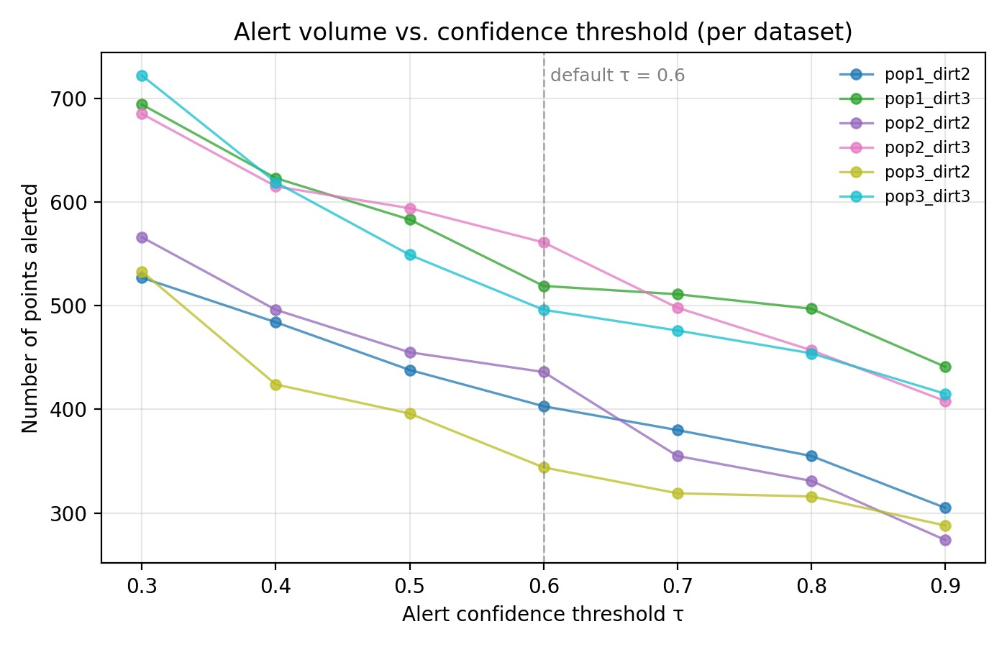
Figure 1: Number of points alerted as a function of the confidence threshold τ, shown separately for each of the six simulated-error datasets. The dashed vertical line marks the default threshold (τ = 0.60).
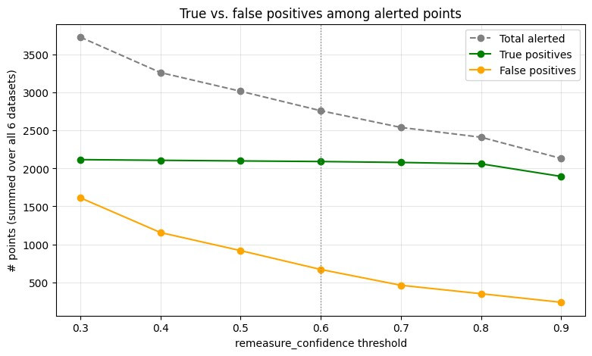
Figure 2a: Alerted points pooled across all six datasets, decomposed as a function of the confidence threshold τ. The dashed gray line is the total number of points alerted; the green line is the subset that are true positives (correctly flagged simulated errors); the orange line is the subset that are false positives (clean points incorrectly flagged).
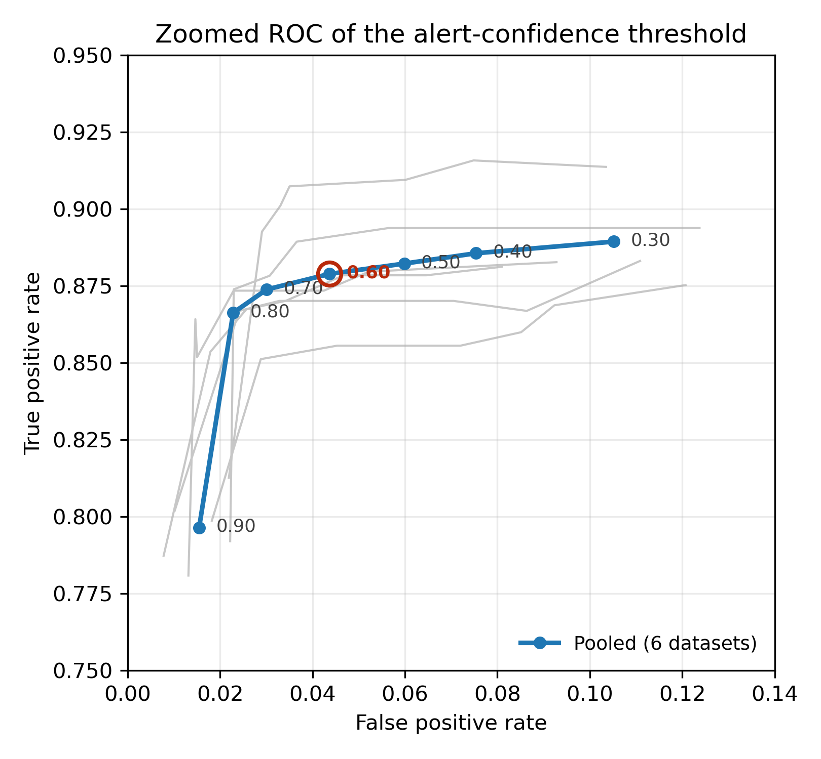
Figure 2b: Zoomed ROC curve of the streaming pipeline across the alert-confidence threshold. The blue curve is pooled across all six simulated-error datasets, with each point labeled by its confidence threshold τ; the default threshold (τ = 0.60) is circled. Gray lines show the six individual datasets.

Operational alert burden on a real-world EHR cohort
Dataset. We used a de-identified longitudinal EHR extract from the Pediatric Physicians’ Organization at Children’s (PPOC), a primary-care network affiliated with Boston Children’s Hospital. The cohort comprises 250,588 unique pediatric patients aged 0–18 years, with 6,494,473 clinical visits (≈ 72.8% routine office visits) recorded across the network. Each visit row carries patient demographics (sex, ethnicity, race), encounter type, anthropometrics (height, weight, BMI and derived percentiles), and up to 33 ICD-10 encounter diagnoses; the broader extract also includes 17.2 M laboratory result components, 3.8 M medication records, 1.7 M problem-list entries, and 349,827 specialty referrals, all linked by patient_id and visit_id. Dates are de-identified as age_in_days. For the present analysis we used only the height column from the visits table. Unlike the Harrall simulator, no ground-truth error labels are available, so this analysis reports alert volume — the count and share of measurements that would trigger an alert — rather than sensitivity or specificity.
Analysis. To characterize the operational burden the two approaches would impose in live clinical use, we ran both the 10% rule and our pipeline (in streaming mode, across the same threshold sweep used in Section 3.2) on every height measurement in the cohort, removing flagged points from each patient’s running history as in the simulated-benchmark protocol.
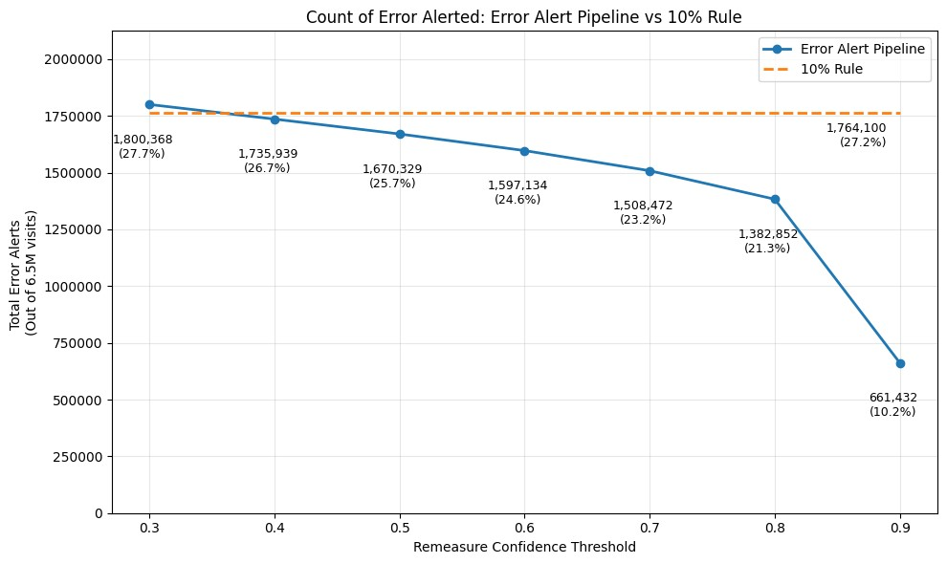
Figure 3: Total number of height measurements that would trigger an alert in the PPOC cohort (≈ 6.5 M visits) under the 10% rule (orange dashed) and under the error alert pipeline at remeasure-confidence thresholds from 0.30 to 0.90 (solid blue). Annotations report absolute counts and the percentage of the full cohort.
The 10% rule alerts on roughly 1.76 million measurements (1,764,100; ≈ 27.2% of all visits). At the most permissive threshold tested (0.30), the pipeline alerted slightly more often than the 10% rule (1,800,368; 27.7%), but its alert volume fell below the 10% rule at threshold 0.40 (1,735,939; 26.7%) and declined steadily thereafter — to 1,597,134 (24.6%) at the default threshold of 0.60 and 661,432 (10.2%) at threshold 0.90. The threshold sweep thus quantifies the tradeoff between simulated-error sensitivity and expected remeasurement burden. These results suggest that trajectory-aware alerting could reduce alert volume relative to the 10% rule, but prospective deployment is needed to measure adherence, PPV, false negatives, and workflow impact in practice.

Discussion

Central claim and scope
We reframe pediatric growth-data quality as a prospective detection problem rather than a retrospective cleaning problem. Retrospective cleaning methods are valuable, but not applicable to real time, prospective error detection required for deployment in clinic. The current standard for prospective measurement error detection used in our local EHR, which uses a static rule-based logic like the 10% rule, also leaves room for improvement.

The present evaluation supports only that bounded claim. The simulated benchmark is useful for comparing methods under controlled error assumptions, and the PPOC EHR analysis estimates the operational burden such alerts would create in real traffic. Together, these analyses test whether a prospective remeasurement strategy is technically and operationally plausible. They do not establish clinical superiority, predictive value in deployed use, or workflow acceptability. Section 4.4 outlines the prospective study required to establish those claims.

Comparison to the 10% rule
The 10% rule’s low specificity in the Harrall simulated-error benchmark (0.33 pooled) reflects a mismatch between a fixed proportional threshold and pediatric growth physiology. Children grow at strongly age-dependent velocities, and 10% per visit is easily exceeded by ordinary growth in infants (≈ 50% per year), early adolescents during peak height velocity, and any child with intervisit gaps of more than a year. Our results suggest that even a small amount of trajectory awareness — at minimum, age- and sex-adjusted velocity z-scores — could substantially reduce alert burden in EHRs that currently use the 10% rule, without sacrificing the simulated sensitivity to gross errors that motivated the rule in the first place.

Limitations
The primary limitation of this evaluation follows directly from its scope: it is a preclinical streaming evaluation, not a deployed clinical validation study. Once a measurement has been saved, whether it was an error is effectively unknowable retrospectively since the original clinical measurement cannot be repeated under the same circumstances. Retrospective studies must rely on imperfect proxies like simulated errors or human consensus labels whose interrater agreement on individual values are low because even clinicians with full access to a child’s history frequently disagree on whether a given value is an error. Our reliance on the Harrall simulated benchmark inherits this constraint directly, and it cannot be remedied retrospectively. The prospective framing is valuable because it could collect contemporaneous repeat measurements when an alert fires, allowing future studies to estimate predictive value, adherence, and workflow impact directly in clinical use; sensitivity would require additional repeat measurement of a sample of unalerted visits, as outlined below.
No weight evaluation. This work covers only height; weight is more difficult because legitimate short-term decreases are common and would require different velocity and HAZ-change references. Extension to weight is a natural next step.
Static thresholds and weights. The detector weights and r_{mid} parameters are hand-chosen based on simulator-tuning and clinical reasoning; they could in principle be learned from a labeled training set. We did not pursue this because the Harrall simulator’s error distribution is itself synthetic and learning weights on it risks overfitting to assumptions that do not hold in real data.

Future directions
The arguments in Section 4.1 and Section 4.3 motivate a prospective in-clinic study in which the algorithm fires, the child is remeasured before they leave the room, and the original–remeasurement pair is recorded for evaluation. This design would estimate PPV, sensitivity, adherence, and workflow burden using contemporaneous repeat measurements rather than retrospective labels alone. We outline below a protocol intended to support a multi-site evaluation.
Study design. A prospective, multi-site observational deployment study in pediatric primary-care clinics with EHR-integrated growth charting (e.g., participating PPOC sites). The pipeline runs as a real-time decision support widget invoked at the moment a height is committed in the EHR. When the fused confidence exceeds the deploying clinic’s threshold (default 0.60), the medical assistant or nurse who recorded the initial measurement is prompted, before the visit closes, to repeat the measurement using a standardized protocol. Both values, the time elapsed between them, the firing detectors, and the fused confidence are written to a study log; the EHR-saved value remains the clinician’s choice and is also logged. Independent of alert firing, a random 1–2% sample of unalerted measurements is also remeasured to estimate the false-negative rate.
Primary endpoints. (i) Positive predictive value (PPV) of the alert at the default threshold, with 95% confidence interval; (ii) PPV as a function of the confidence threshold across the same sweep used in Section 3.2; (iii) sensitivity, estimated from the random-sample remeasurement arm.
Clinician workflow and adherence. The alert appears as a non-blocking modal immediately on save, with a one-line rationale derived from the firing detectors (e.g., "implausible velocity since previous visit; HAZ change above age-adjusted threshold"). The remeasurement step is logged whether or not it is performed; non-adherence is itself a primary descriptive outcome, since a CDS alert that is consistently dismissed is operationally a failed alert regardless of its statistical performance.
This protocol is, in our view, the appropriate next study. The simulated benchmarks in Section 3 establish that the algorithm is competitive in the regime where ground truth is artificially available; the PPOC analysis in Section 3.3 establishes that it produces a tractable alert burden in real EHR traffic; what remains is to establish, on real patients, that the alerts it does produce correspond to measurements a careful remeasurement would in fact change.
Two extensions are worth flagging beyond the prospective study above. First, extending the same pipeline to weight, with appropriate reference standards and an additional set of detectors that handle plausible short-term decreases. Second, exploring representation choices for downstream learning: whether large language models or other learned models perform better when growth data are presented as raw measurements, z-scores, percentiles, velocity features, or growth-chart images.

Conclusion
The central contribution of this paper is a prospective framing of the growth-data quality problem. Retrospective adjudication is constrained because the original clinical measurement usually cannot be repeated after the fact, leaving simulated errors and human consensus labels as imperfect but useful references. A prospective alert, by contrast, fires at the moment of entry, while the child and clinician are present and remeasurement is possible. It converts uncertain retrospective judgments into opportunities for repeat measurement.
Within this bounded claim, the multi-detector confidence-fused pipeline presented here achieved pooled sensitivity 0.88 and specificity 0.96 on the Harrall Monte Carlo benchmark in streaming mode, with higher sensitivity than streaming Harrall and Daymont implementations, lower specificity than Daymont, and much higher specificity than the 10% rule. In the PPOC EHR extract, the pipeline produced fewer alerts than the 10% rule at its default threshold and progressively fewer at more conservative thresholds, though at the most permissive threshold tested it slightly exceeded the 10% rule’s volume. These findings support prospective evaluation of trajectory-aware remeasurement alerts, but do not by themselves establish clinical effectiveness, workflow acceptability, or generalizability across EHR implementations.

References
- Daymont C, Ross ME, Localio AR, Fiks AG, Wasserman RC, Grundmeier RW. Automatedidentification of implausible values in growth data from pediatric electronic health records. _{J} Am Med Inform Assoc. 2017;24(6):1080–1087. doi:10.1093/jamia/ocx037.
- Yang S, Hutcheon JA. Identifying outliers and implausible values in growth trajectory data.Ann Epidemiol. 2016;26(1):77–80.e2. doi:10.1016/j.annepidem.2015.10.002.
- Carsley S, Parkin PC, Tu K, et al. Reliability of routinely collected anthropometric measurements in primary care. _{BMC Med Res Methodol}. 2019;19(1):84. Published 2019 Apr 24. doi:10.1186/s12874-019-0726-8.
- Lin PD, Rifas-Shiman SL, Aris IM, Daley MF, Janicke DM, Heerman WJ, Chudnov DL,Freedman DS, Block JP. Cleaning of anthropometric data from PCORnet electronic health records using automated algorithms. _{JAMIA Open.} 2022;5(4):ooac089. doi:10.1093/jamiaopen/ooac089.
- Ulijaszek SJ, Kerr DA. Anthropometric measurement error and the assessment of nutritionalstatus. _{Br J Nutr.} 1999;82(3):165–177. doi:10.1017/S0007114599001348.
- Phan HTT, Borca F, Cable D, Batchelor J, Davies JH, Ennis S. Automated data cleaningof paediatric anthropometric data from longitudinal electronic health records: protocol and application to a large patient cohort. _{Sci Rep.} 2020;10(1):10164. doi:10.1038/s41598-02066925-7.
- Daymont C. Plausible outliers and implausible inliers. _{Obesity (Silver Spring).} 2020;28(7):1174. doi:10.1002/oby.22865.
- Freedman DS, Lawman HG, Skinner AC, McGuire LC, Allison DB, Ogden CL. Validity of theWHO cutoffs for biologically implausible values of weight, height, and BMI in children and adolescents in NHANES from 1999 through 2012. _{Am J Clin Nutr.} 2015;102(5):1000–1006. doi:10.3945/ajcn.115.115576.
- Harrall KK, Bird SM, Muller KE, Vanderlinden LA, Payton ME, Bellatorre A, Dabelea D,Glueck DH. A better performing algorithm for identification of implausible growth data from longitudinal pediatric medical records. _{Sci Rep.} 2024;14(1):18276. doi:10.1038/s41598-02469161-5.
- Shi J, Korsiak J, Roth DE. New approach for the identification of implausible values and outliers in longitudinal childhood anthropometric data. _{Ann Epidemiol.} 2018;28(3):204–211.e3. doi:10.1016/j.annepidem.2018.01.007.
- Thurber KA, Banks E, Banwell C. Approaches to maximising the accuracy of anthropometricdata on children: review and empirical evaluation using the Australian Longitudinal Study of Indigenous Children. _{Public Health Res Pract.} 2014;25(1):e2511407. doi:10.17061/phrp2511407.
- de Onis M, Garza C, Victora CG, Onyango AW, Frongillo EA, Martines J; WHO Multicentre Growth Reference Study Group. The WHO Multicentre Growth Reference Study: planning, study design, and methodology. _{Food Nutr Bull.} 2004;25(1 Suppl 1):S15–S26. doi:10.1177/15648265040251S104.
- Kuczmarski RJ, Ogden CL, Guo SS, Grummer-Strawn LM, Flegal KM, Mei Z, Wei R, CurtinLR, Roche AF, Johnson CL. 2000 CDC growth charts for the United States: methods and development. Vital Health Stat 11. 2002;(246):1–190.
- Pearl J. Probabilistic Reasoning in Intelligent Systems: Networks of Plausible Inference. San Mateo, CA: Morgan Kaufmann; 1988. ISBN 978-1558604797.
- Cleveland WS. Robust locally weighted regression and smoothing scatterplots. _{J Am Stat} Assoc. 1979;74(368):829–836. doi:10.1080/01621459.1979.10481038.
- Cleveland WS, Devlin SJ. Locally weighted regression: an approach to regression analysis bylocal fitting. _{J Am Stat Assoc.} 1988;83(403):596–610. doi:10.1080/01621459.1988.10478639.
- Rousseeuw PJ, Croux C. Alternatives to the median absolute deviation. _{J Am Stat Assoc.} 1993;88(424):1273–1283. doi:10.1080/01621459.1993.10476408.
- Preece MA, Baines MJ. A new family of mathematical models describing the human growthcurve. _{Ann Hum Biol.} 1978;5(1):1–24. doi:10.1080/03014467800002601.
- Crume TL, Ogden L, West NA, Vehik KS, Scherzinger A, Daniels S, McDuffie R, Bischoff K,Hamman RF, Norris JM, Dabelea D. Association of exposure to diabetes in utero with adiposity and fat distribution in a multiethnic population of youth: the Exploring Perinatal Outcomes among Children (EPOCH) Study. _{Diabetologia.} 2011;54(1):87–92. doi:10.1007/s00125010-1925-3.
- Saari A, Harju S, Makitie O, Saha MT, Dunkel L, Sankilampi U. Systematic growth monitoring for the early detection of celiac disease in children. _{JAMA Pediatr.} 2015;169(3):e1525. doi:10.1001/jamapediatrics.2015.25.
- Haerian K, McKeeby J, DiPatrizio G, Cimino JJ. Use of clinical alerting to improve thecollection of clinical research data. _{AMIA Annu Symp Proc.} 2009;2009:218–222.

