RETAILPULSE AI

Retail Revenue & Customer
Intelligence System
AICTE | IBM SkillsBuild Data Analytics with AI Internship 2026
Student Project
Sepal Sagar
B.Tech CSE
Bengal College of Engineering and Technology

2. Abstract
RetailPulse AI converts 1,067,371 UCI Online Retail II transaction rows into validated KPIs, product and market analysis, RFM profiles, descriptive K-Means segments, a transparent rule-based risk indicator, and evidence-based opportunities. A four-page Streamlit dashboard presents the results for business review. It supports decision-making but does not predict churn or establish causal effects.

3. Introduction
Transaction records alone do not explain performance, its drivers, customer inactivity, or management choices. The project makes a traceable analytical path from operational records to business action.
DATA → INFORMATION → INSIGHTS → DECISION → ACTION

4. Problem Statement
A retail business has a large volume of historical transaction data but needs a unified intelligence system to understand revenue performance, customer value, customer inactivity, product performance, market performance, risks, and opportunities. The system should help management move from descriptive metrics toward actionable decisions.

5. Business Objectives
- Measure business performance with defined KPIs and trends.
- Identify important products, markets, and revenue concentration.
- Segment identified customers using RFM behavior.
- Prioritize valuable customers with elevated rule-based risk scores.
- Identify evidence-backed product, market, and customer opportunities.
- Translate findings into recommended actions through an interactive dashboard.

6. Dataset
Source: UCI Machine Learning Repository, Online Retail II (dataset 502), credited to Chen (2012). The source workbook has 1,067,371 rows and eight fields: Invoice, StockCode, Description, Quantity, InvoiceDate, Price, Customer ID, and Country. It covers 2009-12-01 to 2011-12-09. The approximately 43.5 MB workbook has two overlapping sheets combined using actual invoice dates. Currency is pound sterling (GBP).

7. Data Quality
Invoice, StockCode, Quantity, InvoiceDate, Price, and Country have no missing values. Description is missing on 4,382 rows; Customer ID is missing on 243,007 rows. There are 39,516 eligible invoices, 5,852 identified customers, 4,890 products, and 43 countries. Before deduplication, 3,457 negative-quantity lines have no C prefix and all are zero-priced; 2,745 positive-quantity zero-price lines represent 252,259 units. Five negative-price bad-debt adjustments and one C-prefixed nonnegative-quantity anomaly were found.

8. Data Cleaning

Duplicate handling
Within-sheet duplicate checks and cross-sheet 64-bit row fingerprints found 34,335 repeated full-row occurrences across 32,907 patterns. One copy was retained in aggregates; the source workbook was unchanged. This removed 33,663 eligible sale lines, 214,609 units, and £466,309.43 gross sales (2.4% of final gross). The lines affected 5,079 invoices, but no eligible invoice was removed. The treatment materially affects revenue and is disclosed.

Transaction classification
- Sale: numeric invoice, no C prefix, merchandise classification, positive quantity and price, and not an exact duplicate.
- Defined merchandise return: C-prefixed invoice, negative quantity, positive price, merchandise classification, and not duplicate. Its signed value is negative and reported separately.
- Postage/carriage services and their qualifying reversals are reported separately. Gift vouchers, accounting entries, discounts, tests, commissions, and adjustments are not merchandise sales or returns.
- Zero-price rows are excluded from paid sales; positive-quantity zero-price lines (2,745) and negative-quantity zero-price signals (3,457) remain separate. The five negative-price bad-debt rows total £-158,676.14 before deduplication.
- Missing Customer IDs remain in business-wide aggregates but are excluded from customer-level analysis. Missing product descriptions receive a fallback label.

9. KPI Framework
Headline sales are merchandise-only; service charges and reversals are reported separately.
KPI | Baseline | Definition
Gross Sales | £19,640,817.62 | Eligible positive Quantity × Price merchandise lines after deduplication.
Return value | £-716,394.37 | Signed value of defined C-prefixed merchandise returns.
Net Sales | £18,924,423.25 | Gross Sales plus signed defined returns.
Orders | 39,516 | Distinct invoices with eligible sale lines.
Identified Customers | 5,852 | Distinct nonmissing IDs on eligible sales.
Paid Units | 11,187,743 | Eligible positive-quantity, positive-price merchandise units.
AOV | £497.03 | Gross Sales divided by eligible orders.
Repeat Customer Rate | 72.35% | Identified customers with >1 eligible orders divided by identified customers.
Return Line Rate | 1.785% | Defined return lines divided by eligible sale lines.
Comparable Growth | 2.98% | Jan–Nov 2011 gross divided by Jan–Nov 2010 gross, minus one.

Service charges are £452,006.55; service reversals are £-15,620.22.

10. Exploratory Analysis
Comparable Jan–Nov sales rose from £8,598,370.57 to £8,854,813.06, or 2.98%. December is excluded because 2011 ends on December 9. The top 10 identified customers contribute 16.14% of identified revenue; the top 10 products contribute 8.02% of merchandise sales. Defined merchandise returns are 17,910 lines, 467,731 units, and £-716,394.37 signed value.

11. Customer Intelligence
RFM uses identified customers and eligible merchandise sales. Recency is days since last eligible purchase, Frequency is distinct eligible invoices, and Monetary is eligible gross merchandise sales. The reference date is 2011-12-10, one day after the latest valid sale. 824,364 source rows have Customer ID and 243,007 do not. Identified customers represent 86.9% (£17,065,908.67) of eligible merchandise revenue.

12. Customer Segmentation
RFM features are log1p transformed and standardized before K-Means. K=2–6 were assessed with sampled silhouette (up to 2,500 customers) and adjusted Rand seed stability. K=2 has the highest silhouette, but K=4 was selected for actionable profile separation and strong stability. These are behavioral segments, not supervised predictions.
K | Sampled silhouette | Seed stability ARI
2 | 0.441 | 0.999
3 | 0.351 | 0.988
4 | 0.366 | 0.997
5 | 0.343 | 0.946
6 | 0.340 | 0.999

Segment | Customers | Avg monetary | Avg orders | Avg recency | Revenue share
Low-Value Inactive | 1,954 | £315.97 | 1.38 | 395 days | 3.6%
Recent Developing | 1,260 | £837.37 | 3.02 | 29 days | 6.2%
Valuable At Risk | 1,448 | £1,967.90 | 5.06 | 229 days | 16.7%
High-Value Active | 1,190 | £10,541.10 | 19.14 | 28 days | 73.5%

The four profiles are Low-Value Inactive, Recent Developing, Valuable At Risk, and High-Value Active. Names were assigned after profile review.

13. Customer Risk
The Customer Risk Indicator is a rule-based risk indicator, not a churn prediction model. Score = 100 × (0.50 × recency percentile + 0.30 × six-month activity decline + 0.20 × defined return-value ratio). Activity compares Jun–Nov 2011 spend with Dec 2010–May 2011. Bands: Low ≤50, Moderate >50–75, High >75. High-value at-risk status requires top-quartile monetary value and score ≥60.
154 customers meet the high-value at-risk rule, with £1,018,708.34 historical eligible sales. This is a prioritization signal, not predicted customer loss.

14. Product Intelligence
Product | Gross sales | Revenue share | Orders | Return line rate
REGENCY CAKESTAND 3 TIER (22423) | £330,590.32 | 1.68% | 3,918 | 8.63%
WHITE HANGING HEART T-LIGHT HOLDER (85123A) | £257,724.71 | 1.31% | 5,365 | 2.43%
JUMBO BAG RED RETROSPOT (85099B) | £180,569.34 | 0.92% | 3,989 | 2.08%
PAPER CRAFT , LITTLE BIRDIE (23843) | £168,469.60 | 0.86% | 1 | 100.00%
PARTY BUNTING (47566) | £148,318.28 | 0.76% | 2,674 | 0.85%

Examples of qualifying product opportunities from the implemented engine:
- Stock code 47566: Jan-Nov revenue growth 101.6%; eligible revenue 148,318.28; 960 orders in Jan-Nov 2010 and 1609 in Jan-Nov 2011.
- Stock code 79321: Jan-Nov revenue growth 81.9%; eligible revenue 80,540.88; 422 orders in Jan-Nov 2010 and 550 in Jan-Nov 2011.
- Stock code 22197: Jan-Nov revenue growth 60.4%; eligible revenue 79,520.20; 880 orders in Jan-Nov 2010 and 1207 in Jan-Nov 2011.
An unusual-volume example is product 23843 (PAPER CRAFT , LITTLE BIRDIE): 80,995 units in one order and an equal defined return quantity. The pattern warrants review and is not treated as repeatable demand.
The largest absolute product return value is for code 23843: £-168,469.60. Return causes are not inferred from transaction data.

15. Market Intelligence
Market | Gross sales | Business share | Customers | Jan–Nov growth
United Kingdom | £16,798,048.47 | 85.5% | 5,334 | 1.3%
EIRE | £623,360.96 | 3.2% | 3 | -23.9%
Netherlands | £549,773.41 | 2.8% | 22 | 5.0%
Germany | £383,289.00 | 2.0% | 107 | 9.4%
France | £311,090.29 | 1.6% | 93 | 40.3%

The UK contributes 85.5% of merchandise sales. This is exposure to the largest market, not evidence it is inherently undesirable. France grew 40.3% with 203 and 345 orders in the comparable windows, satisfying the 100-order support rule.

16. Risks
- 154 high-value customers meet the rule-based risk threshold.
- Defined merchandise reversals total £-716,394.37; unpriced signals are separate.
- The UK represents 85.5% of eligible merchandise sales.
- 13.1% of eligible revenue has no Customer ID.
- Exact duplicate handling changes gross sales by £466,309.43.
- Historical transactions do not establish causation or current conditions; the risk score is not churn prediction.

17. Opportunities

High-value at-risk customers
Evidence: 154 customers are in the top monetary quartile and have risk score >= 60; their eligible historical sales total 1,018,708.34.
Interpretation: A meaningful pool of previously valuable customers may need retention attention.
Business impact: historical evidence identifies a review or test opportunity; realized impact is not measured.
Recommended action: Prioritize personalized service outreach and test a relevant replenishment or feedback message.

Growing market
Evidence: France: Jan-Nov eligible revenue growth 40.3%; 203 orders in Jan-Nov 2010 and 345 in Jan-Nov 2011.
Interpretation: The market shows positive growth with enough order volume in both comparison windows to warrant attention.
Business impact: historical evidence identifies a review or test opportunity; realized impact is not measured.
Recommended action: Review capacity and customer acquisition options for France; validate margin and repeat behavior before expanding spend.

Strong growing product
Evidence: Stock code 47566: Jan-Nov revenue growth 101.6%; eligible revenue 148,318.28; 960 orders in Jan-Nov 2010 and 1609 in Jan-Nov 2011.
Interpretation: A product with repeated order presence and comparable-period sales growth may merit supply and placement review.
Business impact: historical evidence identifies a review or test opportunity; realized impact is not measured.
Recommended action: Check stock availability and product presentation for 47566; monitor margin and return rate before increasing inventory.

Strong growing product
Evidence: Stock code 79321: Jan-Nov revenue growth 81.9%; eligible revenue 80,540.88; 422 orders in Jan-Nov 2010 and 550 in Jan-Nov 2011.
Interpretation: A product with repeated order presence and comparable-period sales growth may merit supply and placement review.
Business impact: historical evidence identifies a review or test opportunity; realized impact is not measured.
Recommended action: Check stock availability and product presentation for 79321; monitor margin and return rate before increasing inventory.

Strong growing product
Evidence: Stock code 22197: Jan-Nov revenue growth 60.4%; eligible revenue 79,520.20; 880 orders in Jan-Nov 2010 and 1207 in Jan-Nov 2011.
Interpretation: A product with repeated order presence and comparable-period sales growth may merit supply and placement review.
Business impact: historical evidence identifies a review or test opportunity; realized impact is not measured.
Recommended action: Check stock availability and product presentation for 22197; monitor margin and return rate before increasing inventory.

Strong growing product
Evidence: Stock code 21137: Jan-Nov revenue growth 29.7%; eligible revenue 65,189.29; 231 orders in Jan-Nov 2010 and 313 in Jan-Nov 2011.
Interpretation: A product with repeated order presence and comparable-period sales growth may merit supply and placement review.
Business impact: historical evidence identifies a review or test opportunity; realized impact is not measured.
Recommended action: Check stock availability and product presentation for 21137; monitor margin and return rate before increasing inventory.

Strong growing product
Evidence: Stock code 22502: Jan-Nov revenue growth 430.9%; eligible revenue 60,880.30; 461 orders in Jan-Nov 2010 and 411 in Jan-Nov 2011.
Interpretation: A product with repeated order presence and comparable-period sales growth may merit supply and placement review.
Business impact: historical evidence identifies a review or test opportunity; realized impact is not measured.
Recommended action: Check stock availability and product presentation for 22502; monitor margin and return rate before increasing inventory.

Strong growing product
Evidence: Stock code 82484: Jan-Nov revenue growth 28.9%; eligible revenue 56,745.73; 491 orders in Jan-Nov 2010 and 593 in Jan-Nov 2011.
Interpretation: A product with repeated order presence and comparable-period sales growth may merit supply and placement review.
Business impact: historical evidence identifies a review or test opportunity; realized impact is not measured.
Recommended action: Check stock availability and product presentation for 82484; monitor margin and return rate before increasing inventory.

Strong growing product
Evidence: Stock code 22178: Jan-Nov revenue growth 62.5%; eligible revenue 52,382.82; 721 orders in Jan-Nov 2010 and 926 in Jan-Nov 2011.
Interpretation: A product with repeated order presence and comparable-period sales growth may merit supply and placement review.
Business impact: historical evidence identifies a review or test opportunity; realized impact is not measured.
Recommended action: Check stock availability and product presentation for 22178; monitor margin and return rate before increasing inventory.

Strong growing product
Evidence: Stock code 22469: Jan-Nov revenue growth 68.7%; eligible revenue 48,935.11; 950 orders in Jan-Nov 2010 and 1028 in Jan-Nov 2011.
Interpretation: A product with repeated order presence and comparable-period sales growth may merit supply and placement review.
Business impact: historical evidence identifies a review or test opportunity; realized impact is not measured.
Recommended action: Check stock availability and product presentation for 22469; monitor margin and return rate before increasing inventory.

Strong growing product
Evidence: Stock code 22138: Jan-Nov revenue growth 23.5%; eligible revenue 45,882.01; 824 orders in Jan-Nov 2010 and 887 in Jan-Nov 2011.
Interpretation: A product with repeated order presence and comparable-period sales growth may merit supply and placement review.
Business impact: historical evidence identifies a review or test opportunity; realized impact is not measured.
Recommended action: Check stock availability and product presentation for 22138; monitor margin and return rate before increasing inventory.

Strong growing product
Evidence: Stock code 48185: Jan-Nov revenue growth 20.5%; eligible revenue 45,723.84; 553 orders in Jan-Nov 2010 and 330 in Jan-Nov 2011.
Interpretation: A product with repeated order presence and comparable-period sales growth may merit supply and placement review.
Business impact: historical evidence identifies a review or test opportunity; realized impact is not measured.
Recommended action: Check stock availability and product presentation for 48185; monitor margin and return rate before increasing inventory.

Market revenue concentration
Evidence: United Kingdom contributes 85.5% of eligible gross sales.
Interpretation: The business has substantial exposure to activity in its largest market.
Business impact: historical evidence identifies a review or test opportunity; realized impact is not measured.
Recommended action: Protect service and retention in United Kingdom while validating a measured expansion test in adequately sized secondary markets.

18. Business Recommendations

High priority — Valuable At Risk
1448 customers; average value 1,967.90, frequency 5.06 orders, recency 229.2 days. Above-median value with relatively long average recency. This segment represents 2,849,512.81 in identified eligible sales.
Next action: Test a tailored win-back message and measure recovered orders against a holdout.

Medium priority — Low-Value Inactive
1954 customers; average value 315.97, frequency 1.38 orders, recency 395.3 days. The profile has lower purchase frequency or value than the portfolio center. This segment represents 617,408.36 in identified eligible sales.
Next action: Use low-cost onboarding or product discovery and monitor second-order conversion.

Medium priority — Recent Developing
1260 customers; average value 837.37, frequency 3.02 orders, recency 29.1 days. The profile has lower purchase frequency or value than the portfolio center. This segment represents 1,055,080.14 in identified eligible sales.
Next action: Use low-cost onboarding or product discovery and monitor second-order conversion.

Medium priority — High-Value Active
1190 customers; average value 10,541.10, frequency 19.14 orders, recency 28.4 days. Average order frequency is in the upper customer quartile. This segment represents 12,543,907.36 in identified eligible sales.
Next action: Protect the repeat-purchase experience and test relevant complementary offers.
Prioritize a measured retention test for the valuable at-risk group, protect active customer experience, and validate stock, margin, returns, and customer repeat behavior before expansion. The project does not estimate realized uplift.

19. System Architecture
UCI Online Retail II → sheet-wise cleaning and classification → validated Parquet/JSON tables → KPI and trend analysis → RFM and K-Means → rule-based risk and opportunity engine → Streamlit dashboard → business decisions.
The implementation does not use a database, external API, cloud infrastructure, or LLM.

20. Technology Stack
- Python, pandas, NumPy, and openpyxl for analysis and workbook access.
- scikit-learn for scaling, K-Means, silhouette evaluation, and adjusted Rand stability.
- PyArrow for Parquet output; Streamlit and Plotly for the dashboard and charts.
- python-docx for report generation.

21. Dashboard Screenshots
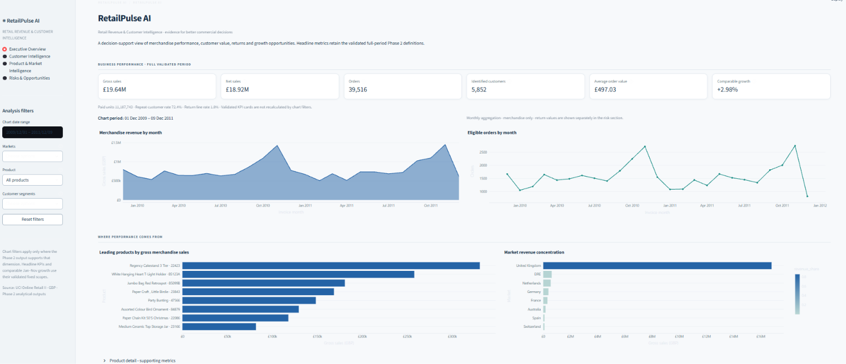
Figure 1. RetailPulse AI — Executive Overview.

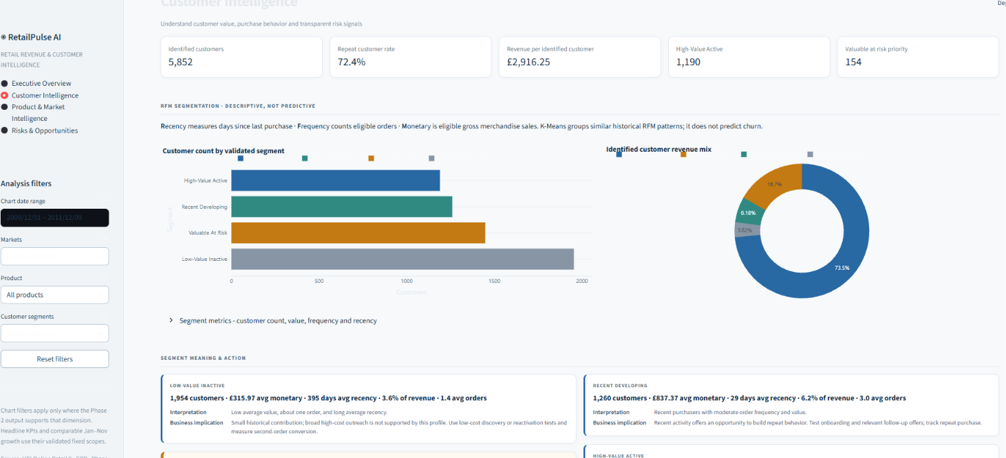
Figure 2. RetailPulse AI — Customer Intelligence.

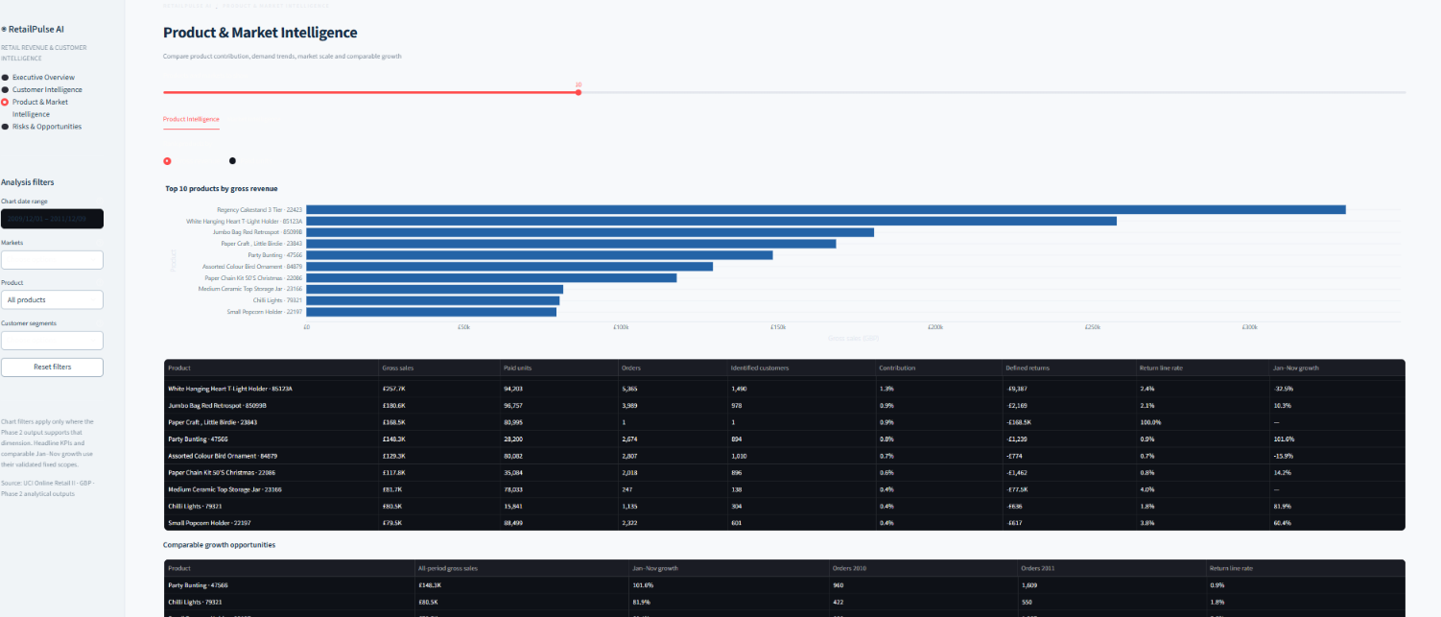
Figure 3. RetailPulse AI — Product & Market Intelligence.

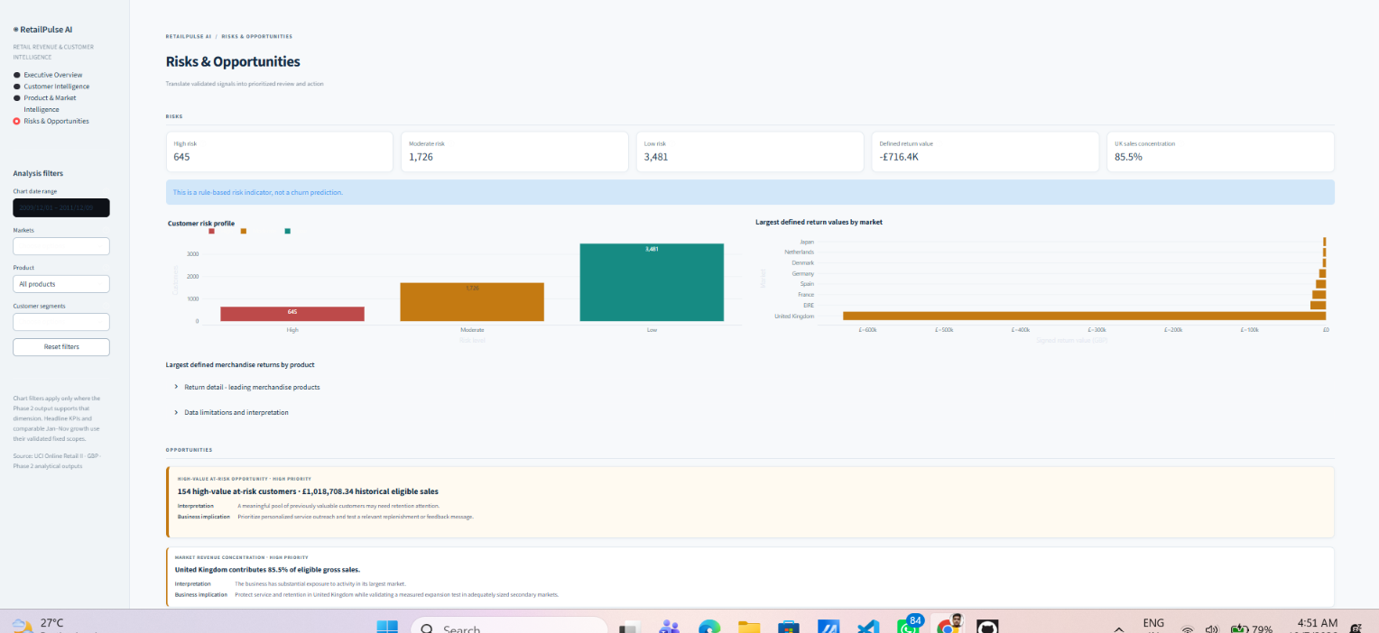
Figure 4. RetailPulse AI — Risks & Opportunities.

22. Key Results
Measure | Validated result
Gross merchandise sales | £19,640,817.62
Net merchandise sales | £18,924,423.25
Orders | 39,516
Identified customers | 5,852
Average order value | £497.03
Repeat customer rate | 72.35%
Comparable Jan–Nov growth | 2.98%
UK revenue share | 85.5%
Valuable At Risk customers | 1,448
High-value at-risk opportunity | 154 customers / £1,018,708.34

23. Limitations
- 243,007 source rows lack Customer ID; customer analysis covers identified transactions (86.9% of eligible revenue).
- Historical analysis is descriptive, does not establish causation, and may not represent current conditions.
- The risk indicator is rule-based, not churn prediction; clustering describes observed behavior.
- Duplicate treatment materially affects gross sales; unpriced quantity events do not support monetary return calculations.
- No margin, campaign exposure, or verified churn labels are available; opportunity values are historical, not forecast uplift.

24. Future Scope
- Real-time ingestion and alerts.
- Predictive churn analysis only if reliable labeled outcomes become available.
- Demand forecasting and additional customer features.
- Database-backed architecture, cloud deployment, and a governed natural-language analytics assistant.
These are future possibilities, not implemented features.

25. Conclusion
RetailPulse AI converts 1,067,371 historical transaction rows into validated KPIs, trends, drivers, risk priorities, opportunities, and recommended actions: KPI → Trend → Driver → Risk → Opportunity → Action. It provides an auditable basis for management review without claims of prediction or causation.

26. References
- Chen, D. (2012). Online Retail II [Dataset]. UCI Machine Learning Repository. https://doi.org/10.24432/C5CG6D
- UCI Online Retail II dataset page: https://archive.ics.uci.edu/dataset/502/online%2Bretail%2Bii
- Streamlit documentation: https://docs.streamlit.io/
- scikit-learn documentation: https://scikit-learn.org/stable/
- Plotly Python documentation: https://plotly.com/python/
- pandas documentation: https://pandas.pydata.org/docs/
- AICTE | IBM SkillsBuild Data Analytics with AI Internship 2026 project context supplied for this project.

