What we want to do?  
Use Dynamic Programming techniques to enhance 2D images in elastography. Use DP to reduce decorrelation noise caused by tissue deformations, enhancing the quality of imaging results.

What is static elastography?

It involves applying controlled, slow mechanical compression or stress to the tissue under examination. This compression is done in a controlled and gradual manner, enabling the tissue to reach a relatively stable deformed state.

While the tissue undergoes this controlled compression, imaging modalities such as ultrasound capture the tissue's behavior and deformation in real-time. This imaging process helps to track and understand how the tissue responds to the applied compression.

Through analysis of the imaging data, a map of tissue displacement is generated. This map provides a visual representation of how different parts of the tissue move or change position during compression.

Problem?

One major challenge involves signal decorrelation between the pre-compression and post-compression images, resulting in significant noise in the obtained displacement map, which is a key limiting factor in elastography.

Related work:  
The RF data is first upsampled by a factor of four in the axial direction. The image is then subdivided into four parts and a coarse displacement map is calculated for each part iteratively. Each part is subsequently divided into four parts and the displacement of each part is calculated by the same iterative technique using the displacement of the parent grid as an initial guess. The method is shown to generate accurate low noise displacement fields. However, the computation time is reported to be more than 1 min for a strain image that is less than half of the number of pixels in the strain images generated in this paper. Hence, the method is not immediately suitable for real time elastography.

Steps:  
1D strain estimation & 1-D smoothness regularization

2D strain estimation & 2-D smoothness regularization

DP steps:

1) Breaking the total optimization cost into a sum of individual costs, such that each cost corresponds to a discrete

decision. The decisions should follow each other sequentially and the cost corresponding to each decision should

only depend on the previous and not the future decisions

(causality).

2) Determining what decisions are possible at each stage.

3) Writing a recursion on the optimal cost from the first stage

to the final stage.

1-D strain estimation:

evaluating how tissue deforms under stress or external force, usually using ultrasound or other imaging modalities. Strain is the change in dimension relative to the original dimension of the tissue. In a 1-D context, this relates to changes along a single axis or direction.

1-D smoothness regularization:  
To enhance the accuracy of strain estimation, a regularization technique is applied. This method imposes constraints on the strain profile, promoting smoothness by penalizing abrupt changes. It helps in reducing noise and errors in the estimated strain field. The concept of smoothness regularization aids in reducing noise and enhancing the reliability of estimated strain profiles in elastography.

echo signals:

The "echo signal" in elastography refers to the ultrasound echoes received from tissue structures during an ultrasound examination, which are utilized to assess tissue stiffness or elasticity.

smoothness of the displacements:

gradual variation of displacement values rather than sudden or erratic shifts.

1-D steps:  
1- consider 2 lines (before & after )

2-

Difference of each pixel

3- dmin < d < dmax

4- normalization:  
both precompression and postcompression ultrasound images are divided by the maximum value of one of the images.

4-Smoothing displacement:  
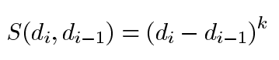

5- cost function:  
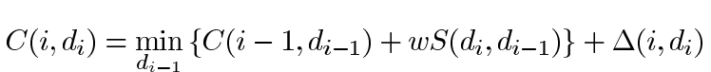

W : is a regularization weight which governs smoothness.

6- store c for each pixel:  
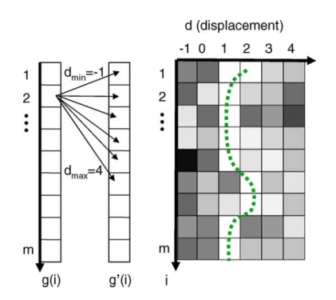

7-since the strain value is low in elastography, it is expected and desired that at each sample of RF data, the change between the displacement of a sample and its previous sample is not more than 1. Therefore, the search range of optimum value for is limited to the three values of di-1 ,di and di+1, which results in a significant gain in speed

8- Memoizing:

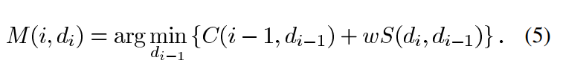

9-using *Hierarchical Search and Subpixel Displacement Estimation*  
should be read again!

10-expriment 1D:  
 1- data: RF data was acquired from an Antares Siemens system (Issaquah, WA) with a 7.27-MHz linear array at a sampling rate of 40 MHz

a breast elastography phantom (CIRS, Norfolk, VA) with a lesion of 10 mm diameter and three times stiffer than the background was palpated freehand.

2-For the purposes of comparison, strain images were also calculated using a standard cross correlation method with a 3-mm window size and 80% overlap and a three point parabolic interpolation to find the subsample location of the correlation peak

3-Linear regression with a 5-sample window is performed on the displacement field to calculate strain.

4-Normalization

5-The unitless performance metric signal-to-noise ratio (SNR) and contrast-to-noise ratio (CNR) were calculated

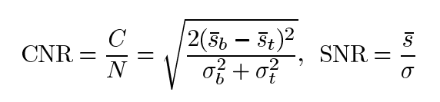

6- implement and test cross correlation method

7- implement and test cross correlation method with median filter

8-implement 1d dp

9-experiment on a CIRS elasticity QA phantom with the Young’s modulus of 33 kPa was compressed in 24 steps, each step 0.005 in

10-expriment 2D:

1-Assuming that ultrasound images consist of A-lines, the distance between the pre and postcompression signals is

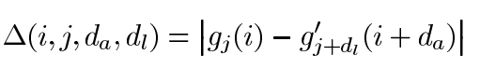

2- smoothness:  
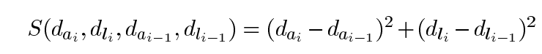

3-cost function:  
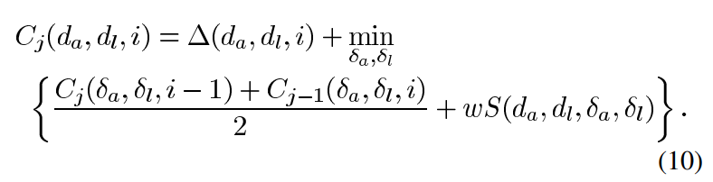

4-memoizing:  
For memoization, and values that minimize the cost function are stored for all , and values

5-The specific form of the cost function allows the calculation of the displacement of each A-line using the cost values of the previous A-line.

6-expriment:  
 data :on the breast phantom

Validation: CNR is calculated between the shown target window and the four background windows on top, right, bottom, and left of the lesion



TASKS:  
1- reading paper

2-reading code

3- data – almost done

4- write code

5- report

Problems:

1. 1D
2. Method for calculate strain image.
3. 2D

Expected Outputs:

1. Displacement map for 1D
2. Displacement map for 1D + Median filter
3. Strain Image for 1D + cross correlation
4. Strain Image for 1D + cross correlation + Median filter
5. Strain Image for 1D + 1D DP
6. CNR of each image
7. SNR of each image
8. All of above for 2D

Coding Tasks:

Functions:

1. 1D delta function – Shabnam
2. 2D delta function - Shabnam
3. 1D Smooth function - Ala
4. 2D Smooth function - Ala
5. Body of the code for 1D - Sepehr
6. Body of the code for 2D - Sepehr
7. Strain Calculator (correlation method) – Ala =>image = (Img1, displacemap)
8. Strain Calculator (for 1D DP) - shabnam=>image = (Img1, displacemap)
9. Strain Calculator (for 2D DP) - shabnam=>image = (Img1, displacemap)
10. CNR Calculator for 2D Image – Ala =>number = (ImgOutpu, hyper parameter)
11. SNR Calculator for 2D Image - shabnam=>vector = (ImgOutpu, hyper parameter)

Report Tasks: