تکلیف 12

سپهر مقیسه

9831103

1-

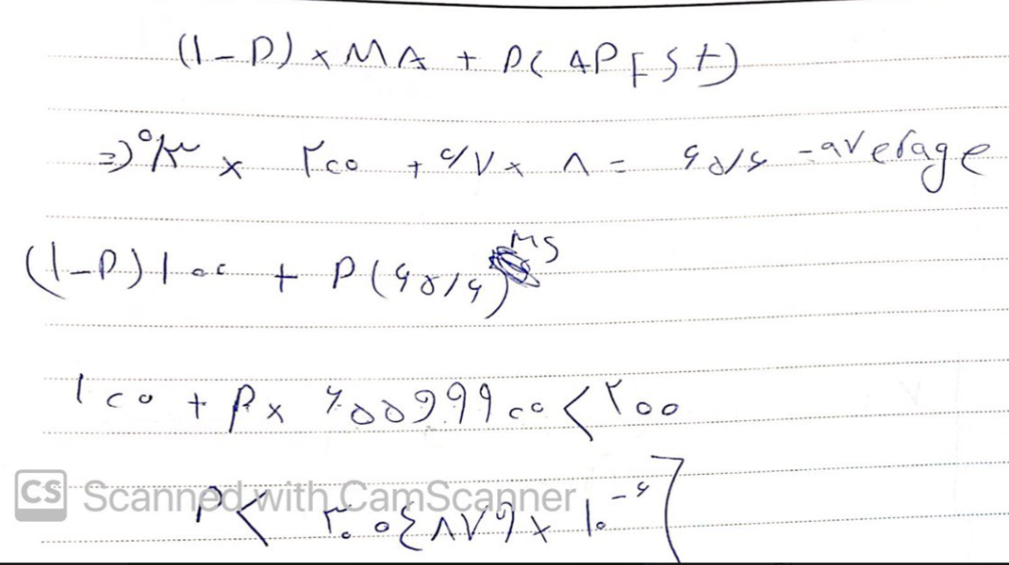

2-

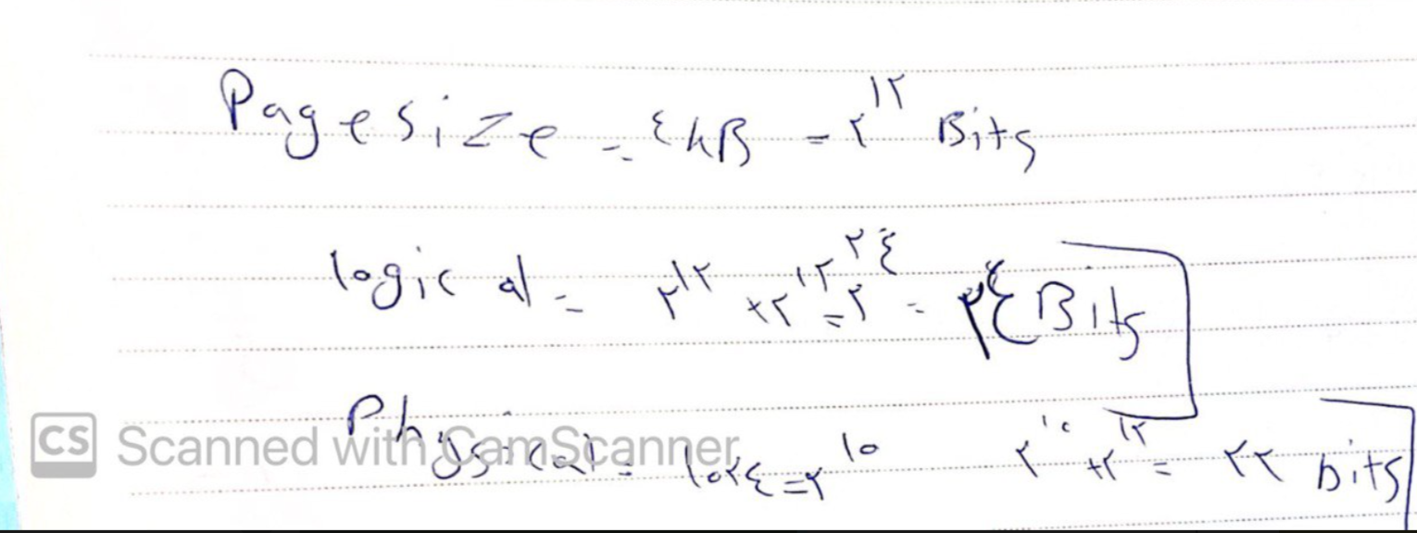

3-fifo الف) :

|  |  |  |  |  |  |  |  |  |  |  |  |  |  |  |  |  |  |  |  |
| --- | --- | --- | --- | --- | --- | --- | --- | --- | --- | --- | --- | --- | --- | --- | --- | --- | --- | --- | --- |
| 9 | 6 | 8 | 3 | 5 | 2 | 2 | 7 | 4 | 3 | 6 | 6 | 2 | 9 | 3 | 3 | 3 | 3 | 3 | 3 |
| 0 | 9 | 6 | 8 | 3 | 5 | 5 | 2 | 7 | 4 | 3 | 3 | 6 | 2 | 9 | 9 | 9 | 9 | 9 | - |
| 8 | 0 | 9 | 6 | 8 | 3 | 3 | 5 | 2 | 7 | 4 | 4 | 3 | 6 | 2 | 2 | 2 | 2 | - | - |

75%

LRU:

|  |  |  |  |  |  |  |  |  |  |  |  |  |  |  |  |  |  |  |  |
| --- | --- | --- | --- | --- | --- | --- | --- | --- | --- | --- | --- | --- | --- | --- | --- | --- | --- | --- | --- |
| 9 | 9 | 9 | 2 | 2 | 2 | 2 | 2 | 2 | 3 | 3 | 3 | 3 | 3 | 3 | 3 | 3 | 3 | 3 | 3 |
| 0 | 0 | 8 | 8 | 8 | 5 | 5 | 5 | 4 | 4 | 4 | 4 | 9 | 9 | 9 | 9 | 9 | 9 | 9 | - |
| 8 | 6 | 6 | 6 | 3 | 3 | 3 | 7 | 7 | 7 | 6 | 6 | 6 | 6 | 2 | 2 | 2 | 2 | - | - |

70%

Optimal:

|  |  |  |  |  |  |  |  |  |  |  |  |  |  |  |  |  |  |  |  |
| --- | --- | --- | --- | --- | --- | --- | --- | --- | --- | --- | --- | --- | --- | --- | --- | --- | --- | --- | --- |
| 8 | 8 | 8 | 8 | 8 | 3 | 3 | 3 | 3 | 3 | 3 | 3 | 3 | 3 | 3 | 3 | 3 | 3 | 3 | 3 |
| 9 | 9 | 9 | 5 | 5 | 5 | 5 | 5 | 7 | 7 | 4 | 4 | 6 | 6 | 9 | 9 | 9 | 9 | 9 | - |
| 0 | 0 | 6 | 6 | 2 | 2 | 2 | 2 | 2 | 2 | 2 | 2 | 2 | 2 | 2 | 2 | 2 | 2 | - | - |

55%

ب)

Fifu :

|  |  |  |  |  |  |  |  |  |  |  |  |  |  |  |  |  |  |  |  |
| --- | --- | --- | --- | --- | --- | --- | --- | --- | --- | --- | --- | --- | --- | --- | --- | --- | --- | --- | --- |
| 4 | 2 | 0 | 6 | 5 | 9 | 7 | 3 | 5 | 5 | 8 | 8 | 8 | 6 | 6 | 1 | 7 | 4 | 4 | 4 |
| 3 | 4 | 2 | 0 | 6 | 5 | 9 | 7 | 3 | 3 | 5 | 5 | 5 | 8 | 8 | 6 | 1 | 7 | 7 | - |
| 5 | 3 | 4 | 2 | 0 | 6 | 5 | 9 | 7 | 7 | 3 | 3 | 3 | 5 | 5 | 8 | 6 | 1 | - | - |

80%

Lru:

|  |  |  |  |  |  |  |  |  |  |  |  |  |  |  |  |  |  |  |  |
| --- | --- | --- | --- | --- | --- | --- | --- | --- | --- | --- | --- | --- | --- | --- | --- | --- | --- | --- | --- |
| 4 | 4 | 4 | 6 | 6 | 6 | 7 | 7 | 7 | 7 | 6 | 6 | 6 | 6 | 6 | 6 | 6 | 4 | 4 | 4 |
| 3 | 3 | 0 | 0 | 0 | 9 | 9 | 9 | 3 | 3 | 3 | 3 | 3 | 8 | 8 | 8 | 7 | 7 | 7 | - |
| 5 | 2 | 2 | 2 | 5 | 5 | 5 | 8 | 8 | 8 | 8 | 5 | 5 | 5 | 5 | 1 | 1 | 1 | - | - |

85%

Optimal :

|  |  |  |  |  |  |  |  |  |  |  |  |  |  |  |  |  |  |  |  |
| --- | --- | --- | --- | --- | --- | --- | --- | --- | --- | --- | --- | --- | --- | --- | --- | --- | --- | --- | --- |
| 4 | 4 | 4 | 2 | 0 | 6 | 9 | 9 | 7 | 7 | 8 | 8 | 8 | 8 | 8 | 8 | 4 | 4 | 4 | 4 |
| 5 | 5 | 5 | 5 | 5 | 5 | 5 | 5 | 5 | 5 | 5 | 5 | 5 | 5 | 5 | 7 | 7 | 7 | 7 | - |
| 3 | 3 | 3 | 3 | 3 | 3 | 3 | 3 | 3 | 3 | 3 | 3 | 3 | 6 | 6 | 5 | 6 | 1 | - | - |

65%

ج)

Fifu :

|  |  |  |  |  |  |  |  |  |  |  |  |  |  |  |  |  |  |  |  |
| --- | --- | --- | --- | --- | --- | --- | --- | --- | --- | --- | --- | --- | --- | --- | --- | --- | --- | --- | --- |
| 0 | 0 | 0 | 2 | 2 | 3 | 4 | 5 | 5 | 7 | 6 | 6 | 8 | 5 | 5 | 4 | 7 | 7 | 7 | 7 |
| 6 | 6 | 6 | 0 | 0 | 2 | 3 | 4 | 4 | 5 | 7 | 7 | 6 | 8 | 8 | 5 | 4 | 4 | 4 | - |
| 7 | 7 | 7 | 6 | 6 | 0 | 2 | 3 | 3 | 4 | 5 | 5 | 7 | 6 | 6 | 8 | 5 | - | - | - |

65%

Lru :

|  |  |  |  |  |  |  |  |  |  |  |  |  |  |  |  |  |  |  |  |
| --- | --- | --- | --- | --- | --- | --- | --- | --- | --- | --- | --- | --- | --- | --- | --- | --- | --- | --- | --- |
| 2 | 2 | 2 | 2 | 2 | 2 | 2 | 6 | 6 | 6 | 6 | 6 | 6 | 6 | 6 | 7 | 7 | 7 | 7 | 7 |
| 7 | 7 | 7 | 0 | 0 | 0 | 4 | 4 | 4 | 4 | 7 | 7 | 7 | 8 | 8 | 8 | 4 | 4 | 4 | - |
| 6 | 6 | 6 | 6 | 6 | 3 | 3 | 3 | 3 | 5 | 5 | 5 | 5 | 5 | 5 | 5 | 5 | - | - | - |

60%

Optimal :

|  |  |  |  |  |  |  |  |  |  |  |  |  |  |  |  |  |  |  |  |
| --- | --- | --- | --- | --- | --- | --- | --- | --- | --- | --- | --- | --- | --- | --- | --- | --- | --- | --- | --- |
| 2 | 2 | 2 | 2 | 2 | 2 | 2 | 7 | 7 | 7 | 7 | 7 | 7 | 7 | 7 | 7 | 7 | 7 | 7 | 7 |
| 7 | 7 | 7 | 6 | 6 | 6 | 6 | 6 | 6 | 6 | 6 | 6 | 6 | 6 | 6 | 8 | 4 | 4 | 4 | - |
| 0 | 0 | 0 | 0 | 0 | 0 | 3 | 3 | 3 | 4 | 5 | 5 | 5 | 5 | 5 | 5 | 5 | - | - | - |

50%

د)

Fifu :

|  |  |  |  |  |  |  |  |  |  |  |  |  |  |  |  |  |  |  |  |
| --- | --- | --- | --- | --- | --- | --- | --- | --- | --- | --- | --- | --- | --- | --- | --- | --- | --- | --- | --- |
| 6 | 3 | 4 | 4 | 1 | 7 | 0 | 8 | 1 | 7 | 2 | 2 | 3 | 8 | 8 | 6 | 4 | 5 | 5 | 5 |
| 8 | 6 | 3 | 3 | 4 | 1 | 7 | 0 | 8 | 1 | 7 | 7 | 2 | 3 | 3 | 8 | 6 | 4 | 4 | - |
| 5 | 8 | 6 | 6 | 3 | 4 | 1 | 7 | 0 | 8 | 1 | 1 | 7 | 2 | 2 | 3 | 8 | 6 | - | - |

85%

Lru :

|  |  |  |  |  |  |  |  |  |  |  |  |  |  |  |  |  |  |  |  |
| --- | --- | --- | --- | --- | --- | --- | --- | --- | --- | --- | --- | --- | --- | --- | --- | --- | --- | --- | --- |
| 8 | 8 | 3 | 3 | 3 | 7 | 7 | 7 | 7 | 8 | 7 | 7 | 7 | 8 | 8 | 8 | 8 | 5 | 5 | 5 |
| 4 | 4 | 4 | 4 | 4 | 4 | 0 | 0 | 0 | 1 | 1 | 1 | 3 | 3 | 3 | 3 | 4 | 4 | 4 | - |
| 5 | 6 | 6 | 6 | 1 | 1 | 1 | 8 | 8 | 7 | 2 | 2 | 2 | 2 | 2 | 6 | 6 | 6 | - | - |

80%

Optimal :

|  |  |  |  |  |  |  |  |  |  |  |  |  |  |  |  |  |  |  |  |
| --- | --- | --- | --- | --- | --- | --- | --- | --- | --- | --- | --- | --- | --- | --- | --- | --- | --- | --- | --- |
| 6 | 6 | 6 | 6 | 0 | 0 | 0 | 0 | 0 | 8 | 8 | 8 | 8 | 8 | 8 | 8 | 8 | 5 | 5 | 5 |
| 5 | 3 | 3 | 3 | 3 | 1 | 1 | 1 | 1 | 1 | 1 | 1 | 3 | 3 | 3 | 3 | 4 | 4 | 4 | - |
| 8 | 8 | 4 | 4 | 4 | 4 | 7 | 7 | 7 | 7 | 7 | 7 | 7 | 2 | 2 | 6 | 6 | 6 | - | - |

70%

و)

Fifu :

|  |  |  |  |  |  |  |  |  |  |  |  |  |  |  |  |  |  |  |  |
| --- | --- | --- | --- | --- | --- | --- | --- | --- | --- | --- | --- | --- | --- | --- | --- | --- | --- | --- | --- |
| 0 | 7 | 5 | 3 | 0 | 9 | 1 | 1 | 3 | 6 | 6 | 0 | 0 | 7 | 3 | 1 | 1 | 4 | 4 | 4 |
| 6 | 0 | 7 | 5 | 3 | 0 | 9 | 9 | 1 | 3 | 3 | 6 | 6 | 0 | 7 | 3 | 3 | 1 | 1 | - |
| 4 | 6 | 0 | 7 | 5 | 3 | 0 | 0 | 9 | 1 | 1 | 3 | 3 | 6 | 0 | 7 | 7 | 3 | - | - |

80%

Lru :

|  |  |  |  |  |  |  |  |  |  |  |  |  |  |  |  |  |  |  |  |
| --- | --- | --- | --- | --- | --- | --- | --- | --- | --- | --- | --- | --- | --- | --- | --- | --- | --- | --- | --- |
| 4 | 7 | 7 | 7 | 1 | 1 | 1 | 1 | 1 | 1 | 1 | 6 | 6 | 6 | 7 | 7 | 7 | 4 | 4 | 4 |
| 6 | 6 | 5 | 5 | 5 | 0 | 0 | 0 | 0 | 0 | 0 | 0 | 0 | 0 | 0 | 1 | 1 | 1 | 1 | - |
| 0 | 0 | 0 | 3 | 3 | 3 | 9 | 9 | 9 | 3 | 3 | 3 | 3 | 3 | 3 | 3 | 3 | 3 | - | - |

70%

Optimal :

|  |  |  |  |  |  |  |  |  |  |  |  |  |  |  |  |  |  |  |  |
| --- | --- | --- | --- | --- | --- | --- | --- | --- | --- | --- | --- | --- | --- | --- | --- | --- | --- | --- | --- |
| 6 | 6 | 0 | 0 | 0 | 0 | 0 | 0 | 0 | 0 | 0 | 0 | 0 | 0 | 0 | 7 | 7 | 4 | 4 | 4 |
| 7 | 7 | 7 | 7 | 3 | 3 | 1 | 1 | 1 | 1 | 1 | 6 | 6 | 6 | 1 | 1 | 1 | 1 | 1 | - |
| 4 | 5 | 5 | 5 | 5 | 9 | 9 | 9 | 9 | 3 | 3 | 3 | 3 | 3 | 3 | 3 | 3 | 3 | - | - |

65%