3. Methodology
This study adopts and extends the methodological framework proposed by Demolli et al. [1] to forecast long-term wind power generation. While the original study focused on locations in Turkey, this research applies the methodology to a new geographical context (Chicago and Detroit, USA) to test the generalizability of the proposed machine learning models. Furthermore, this study introduces a modern algorithmic extension (LightGBM) and a robust Bayesian optimization strategy (Optuna) to improve upon the original trial-and-error approach.

3.1 Data Acquisition and Site Selection
Hourly meteorological data was obtained from the open-access "Historical Hourly Weather Data 2012-2017" dataset available on Kaggle [3]. The city of Chicago was selected as the primary "Base Location" for training and initial validation due to its consistent wind characteristics. Additionally, data for a second city, Detroit, was acquired to serve as an independent test set for evaluating the geographical transferability of the models.
The dataset spans exactly five years, from October 1, 2012, to October 1, 2017. Following the protocol of the original study, the first four years (80%) were utilized for training and validation, while the final year (20%) was reserved strictly for testing.
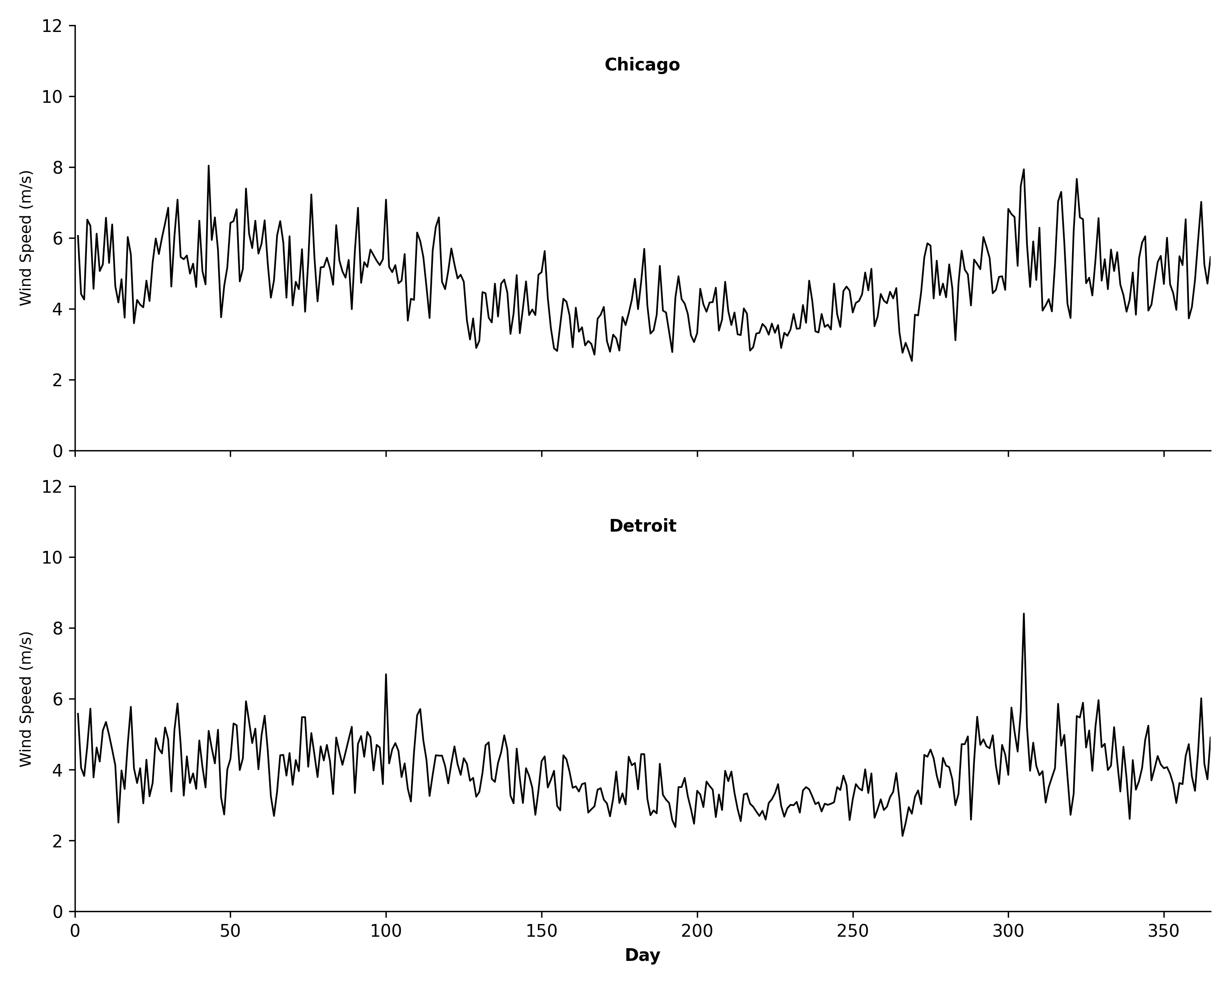
Figure 2: Wind Speed Characteristics
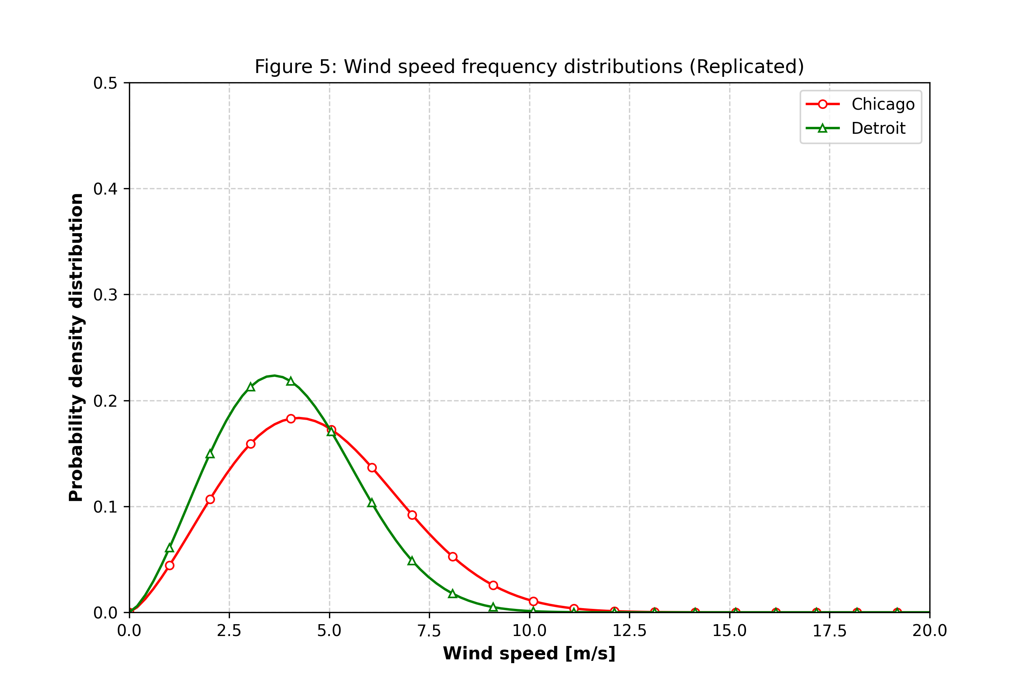
Figure 3: Weibull Frequency Distribution

3.2 Theoretical Power Generation (Target Synthesis)
A critical challenge in wind energy forecasting is the lack of public datasets containing both meteorological inputs and actual turbine power output. To address this, the target variable (Power Output) was synthesized mathematically based on the physics of a specific wind turbine.

3.2.1 Vertical Extrapolation
The raw meteorological data provided wind speeds at a standard height of 10 meters, which corresponds to the measurement standards used by services such as the OpenWeatherMap API [4]. However, commercial wind turbines operate at significantly higher altitudes. Therefore, the wind speed was extrapolated to a hub height of 50 meters using the Power Law equation:
v = v0 * (h / h0)^alpha
Where v is the wind speed at hub height (50m), v0 is the measured speed at 10m, and alpha is the Hellman exponent (set to 0.14 for open terrain).

3.2.2 The Cubic Power Curve Model
In the reference study by Demolli et al., the power generation data was derived using specific manufacturer power/speed tables. In contrast, this study utilizes a theoretical approach to ensure replicability. The relationship between wind speed and power generation was modeled using the "Four-Region" logic described in the course lecture notes by Bayindir [2].
Specifically, for the operational range (Region 2), the power output is calculated using the cubic formula visualized in Figure 1:
PT(v) ≈ P_rated * ( (v^3 - v_cutin^3) / (v_rated^3 - v_cutin^3) )
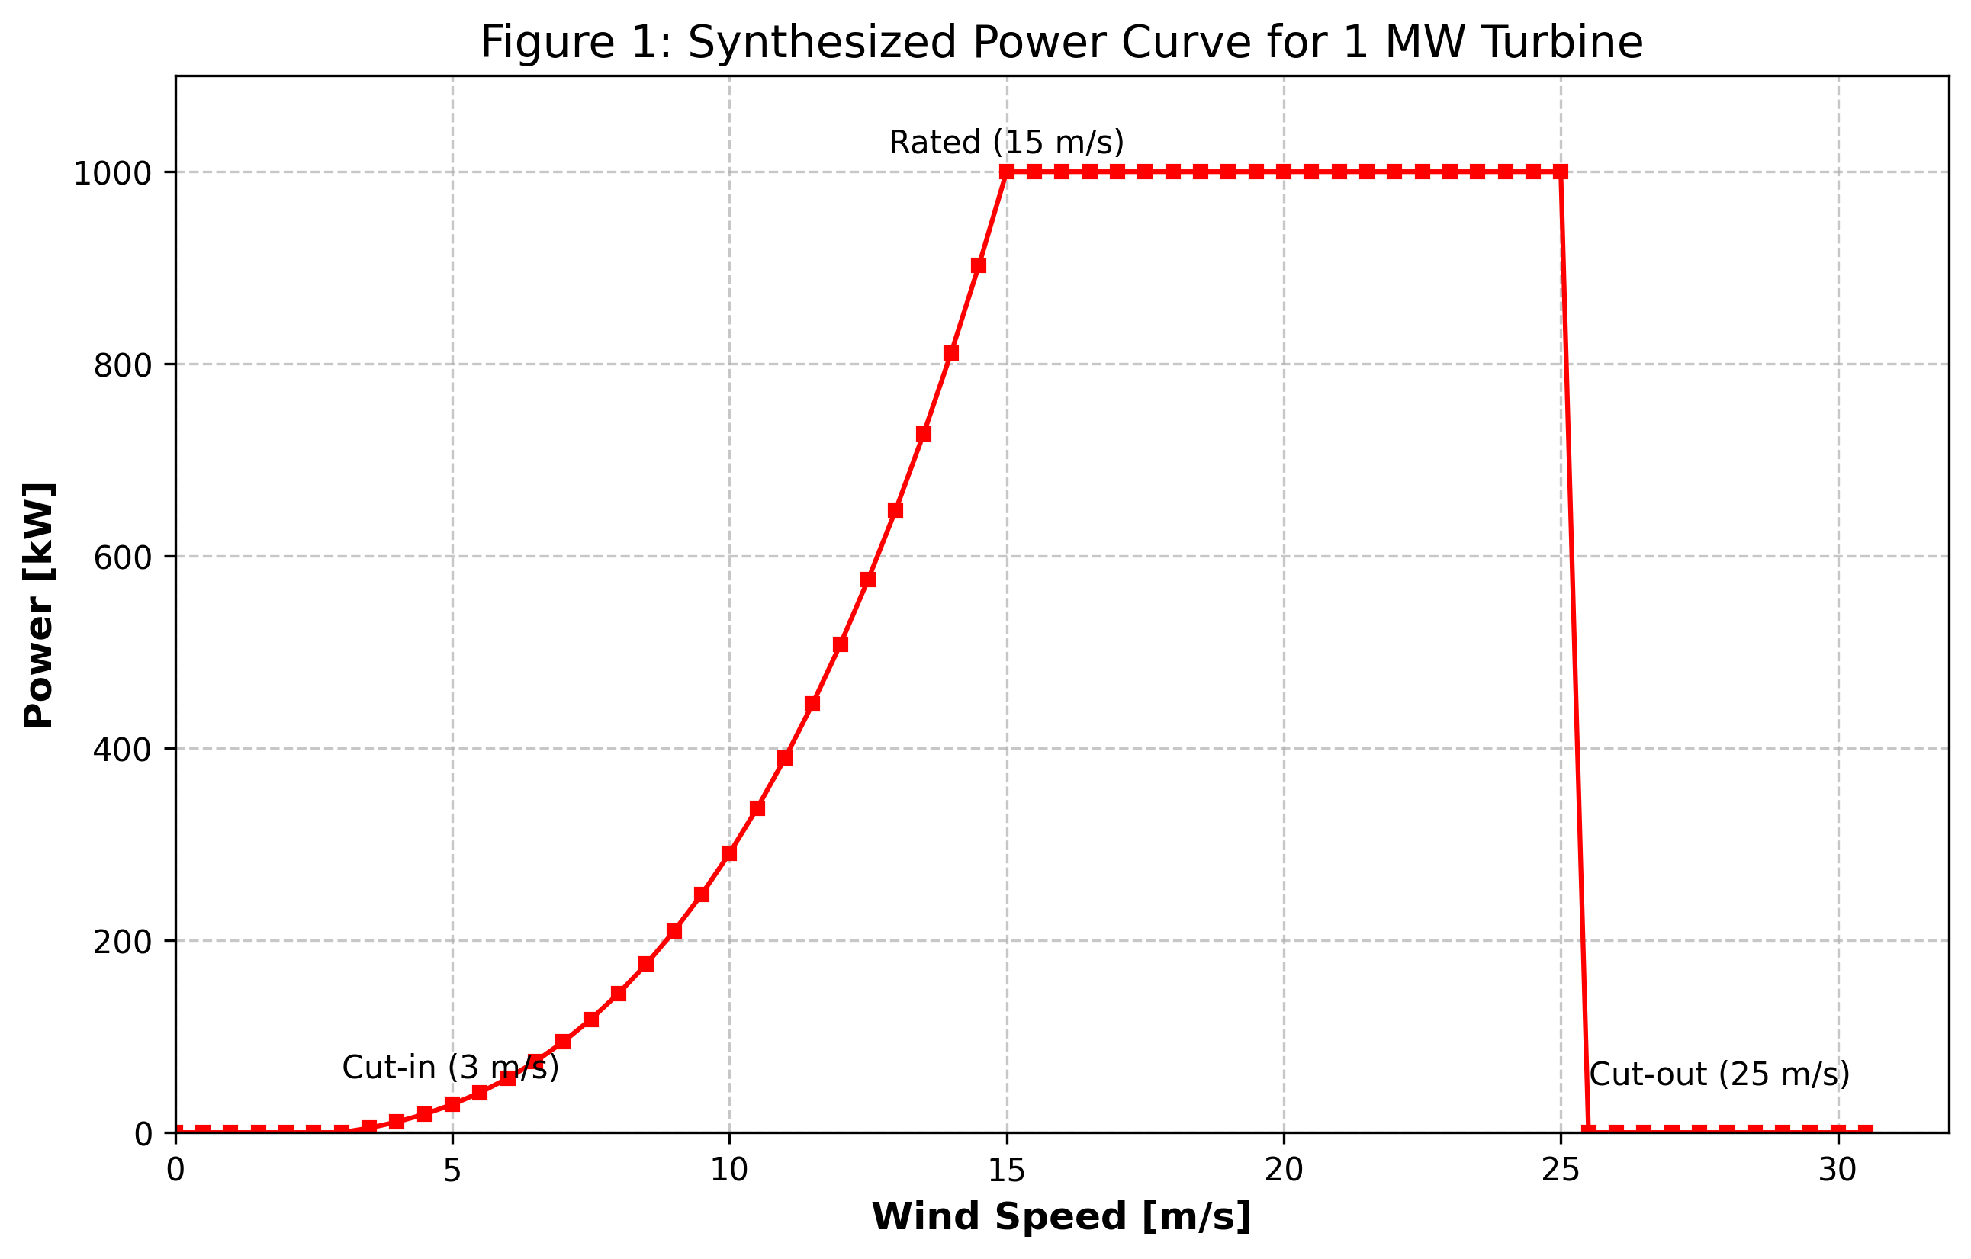
Figure 1: Theoretical Power Curve
This formula ensures that the power output follows the physical cubic law of kinetic energy, providing a realistic target variable for the regression algorithms. The turbine parameters were set to match the original study: Cut-in (3 m/s), Rated (15 m/s), and Cut-out (25 m/s).

3.3 Machine Learning Models and Hyperparameters
Six regression algorithms were implemented to model the relationship between wind statistics and power generation. To strictly validate the findings of the original study, the hyperparameters for the five benchmark models were kept **identical** to those reported by Demolli et al. [1]. No additional parameter optimization was performed for these specific models. This ensures that any deviation in performance is attributable to the data characteristics rather than algorithmic tuning.
The fixed configuration for the benchmark models is as follows:
- LASSO Regression: alpha=0.1
- k-Nearest Neighbors (kNN): k=4, Metric=Minkowski
- Random Forest (RF): n_estimators=10
- XGBoost: n_estimators=500, learning_rate=0.1
- Support Vector Regression (SVR): C=3000, gamma=0.1, epsilon=0.1, kernel=RBF
**Algorithmic Extension (LightGBM):** The sixth model, LightGBM (Light Gradient Boosting Machine), was not present in the original study. Therefore, its hyperparameters were not fixed but were instead optimized using **Optuna**, a Bayesian optimization framework. This allows for a comparison between the static parameters used in 2019 and a modern, dynamically optimized approach.

3.4 Experimental Design and Case Studies
To comprehensively evaluate the models, the methodology was structured into three distinct experimental cases. These cases are designed to exactly mirror the experimental scenarios presented in the original study [1], allowing for a direct performance comparison.

Case 1: Baseline Forecasting (Chicago)
**Objective:** To establish the baseline performance of the algorithms using the complete feature set.
**Inputs:** Daily Mean Wind Speed + Daily Standard Deviation.
**Methodology:** Training and testing were performed on the Chicago dataset. This duplicates 'Case 1' from the reference paper.

Case 2: Input Sensitivity Analysis
**Objective:** To quantify the impact of wind volatility (turbulence) on prediction accuracy.
**Inputs:** Daily Mean Wind Speed **only**.
**Methodology:** The 'Standard Deviation' feature was removed. This mirrors 'Case 2' of the original study.

Case 3: Geographical Transferability
**Objective:** To assess the generalization capability of the models when applied to a new location.
**Inputs:** Daily Mean Wind Speed + Daily Standard Deviation.
**Methodology:** Models trained on Chicago were frozen and used to predict power generation in Detroit.

3.6 Performance Metrics
To quantitatively evaluate the forecasting accuracy, three standard statistical metrics were employed:
- Coefficient of Determination (R²): Measures the proportion of variance in the dependent variable that is predictable from the independent variable(s).
- Root Mean Square Error (RMSE): Measures the square root of the average of squared differences between prediction and actual observation.
- Mean Absolute Error (MAE): Measures the average magnitude of the errors in a set of predictions, without considering their direction.

4. Results
This section presents the performance of the proposed algorithms across the three experimental cases.

4.1 Case 1 Results (Chicago: Mean + Std Dev)
Table 3 summarizes the forecasting accuracy for Case 1. XGBoost and SVR achieved the highest performance.
Figure 4: Case 1 Time Series Forecast (SVR)
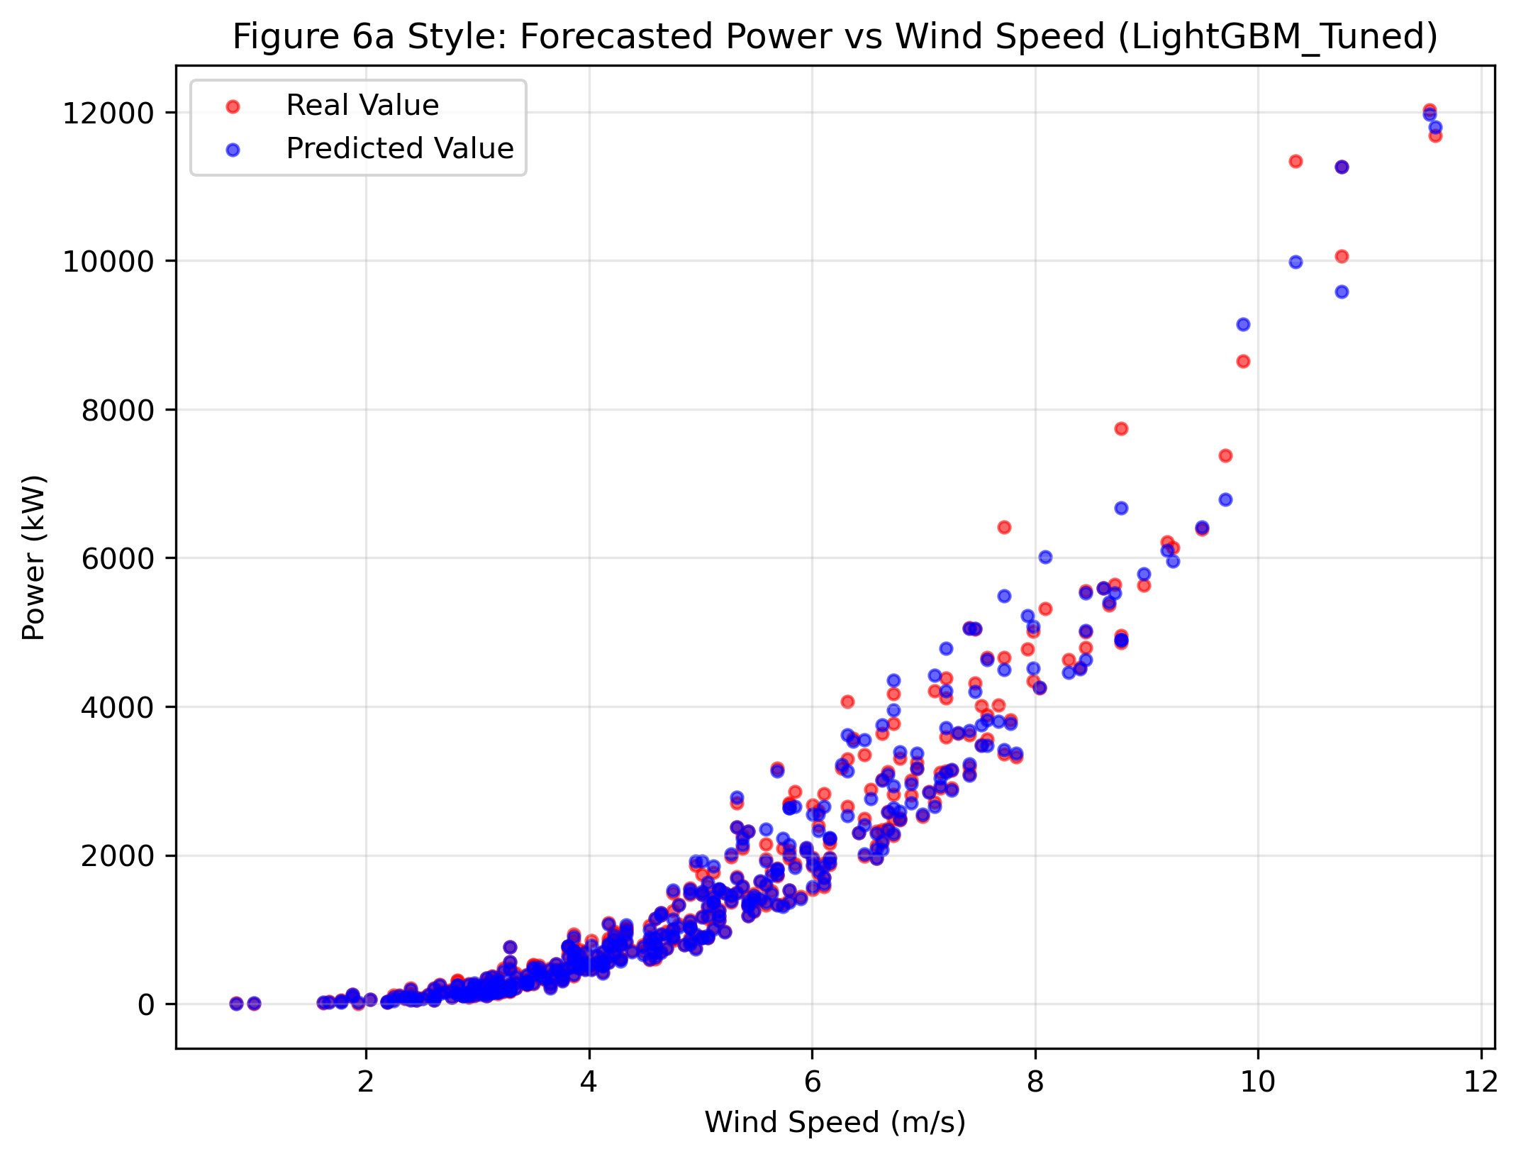

4.2 Case 2 Results (Chicago: Mean Only)
Table 4 presents the results when the standard deviation feature is removed. A noticeable drop in performance is observed compared to Case 1.
Figure 5: Case 2 Scatter Plot (Wind Speed vs Power)
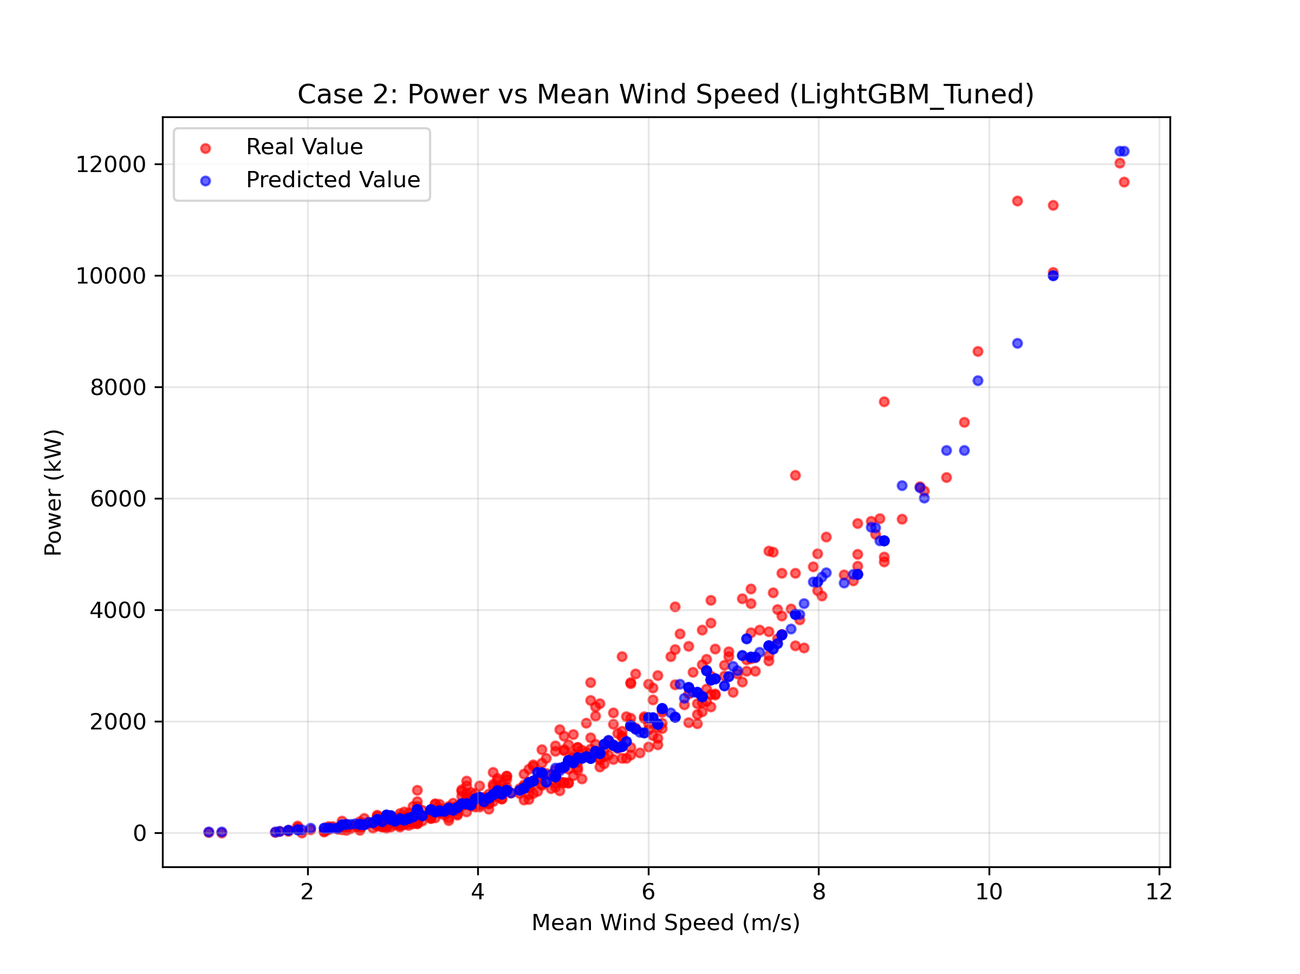

4.3 Case 3 Results (Transferability to Detroit)
Table 5 compares the transferability of the models when applied to the Detroit dataset (Blind Test).
Figure 6: Case 3 Transferability Forecast (Detroit)
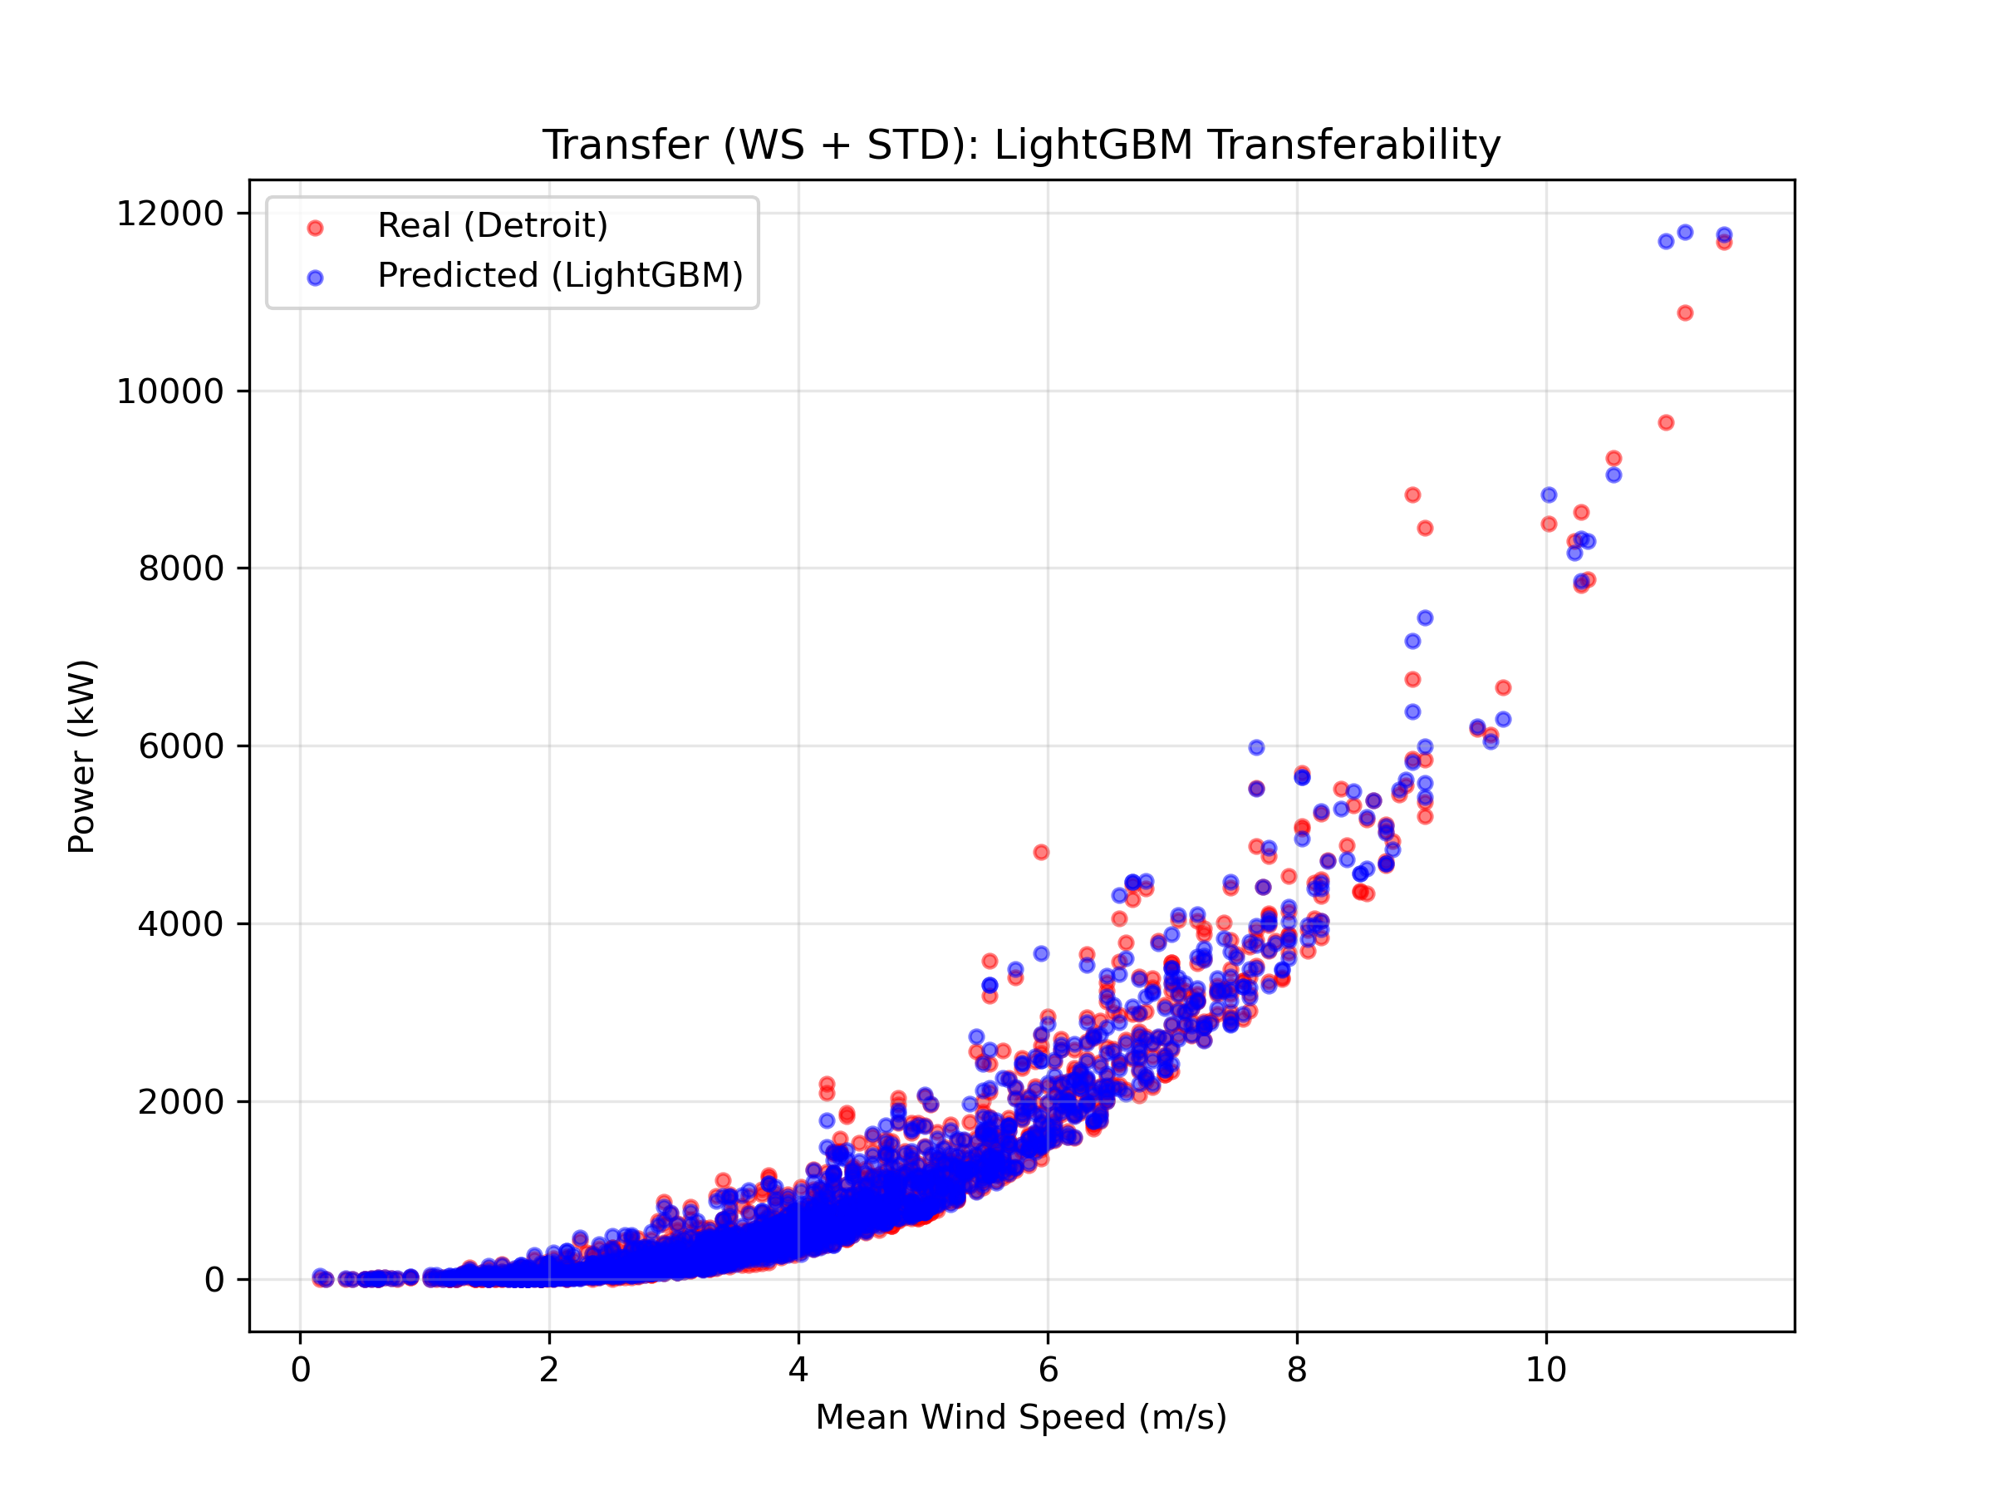

5. References
[1] H. Demolli, A. S. Dokuz, A. Ecemis, and M. Gokcek, "Wind power forecasting based on daily wind speed data using machine learning algorithms," Energy Convers. Manag., vol. 198, p. 111823, Oct. 2019.
[2] R. Bayindir, "Wind Energy Systems Lecture Notes," Department of Electrical Engineering, Gazi University. [Online].
[3] SelfishGene, "Historical Hourly Weather Data 2012-2017," Kaggle. [Online]. Available: https://www.kaggle.com/datasets/selfishgene/historical-hourly-weather-data.
[4] OpenWeatherMap, "Weather API - Current weather and forecast," OpenWeatherMap. [Online]. Available: https://openweathermap.org/api/weather-map-2.

