3. Methodology
This study adopts and extends the methodological framework proposed by Demolli et al. [1] to forecast long-term wind power generation. While the original study focused on locations in Turkey, this research applies the methodology to a new geographical context (Chicago and Detroit, USA) to test the generalizability of the proposed machine learning models. Furthermore, this study introduces a modern algorithmic extension (LightGBM) and a robust Bayesian optimization strategy (Optuna) to improve upon the original trial-and-error approach.

3.1 Data Acquisition and Site Selection
Hourly meteorological data was obtained from the open-access "Historical Hourly Weather Data 2012-2017" dataset available on Kaggle [3]. The city of Chicago was selected as the primary "Base Location" for training and initial validation due to its consistent wind characteristics. Additionally, data for a second city, Detroit, was acquired to serve as an independent test set for evaluating the geographical transferability of the models.
The dataset spans exactly five years, from October 1, 2012, to October 1, 2017. Following the protocol of the original study, the first four years (80%) were utilized for training and validation, while the final year (20%) was reserved strictly for testing.
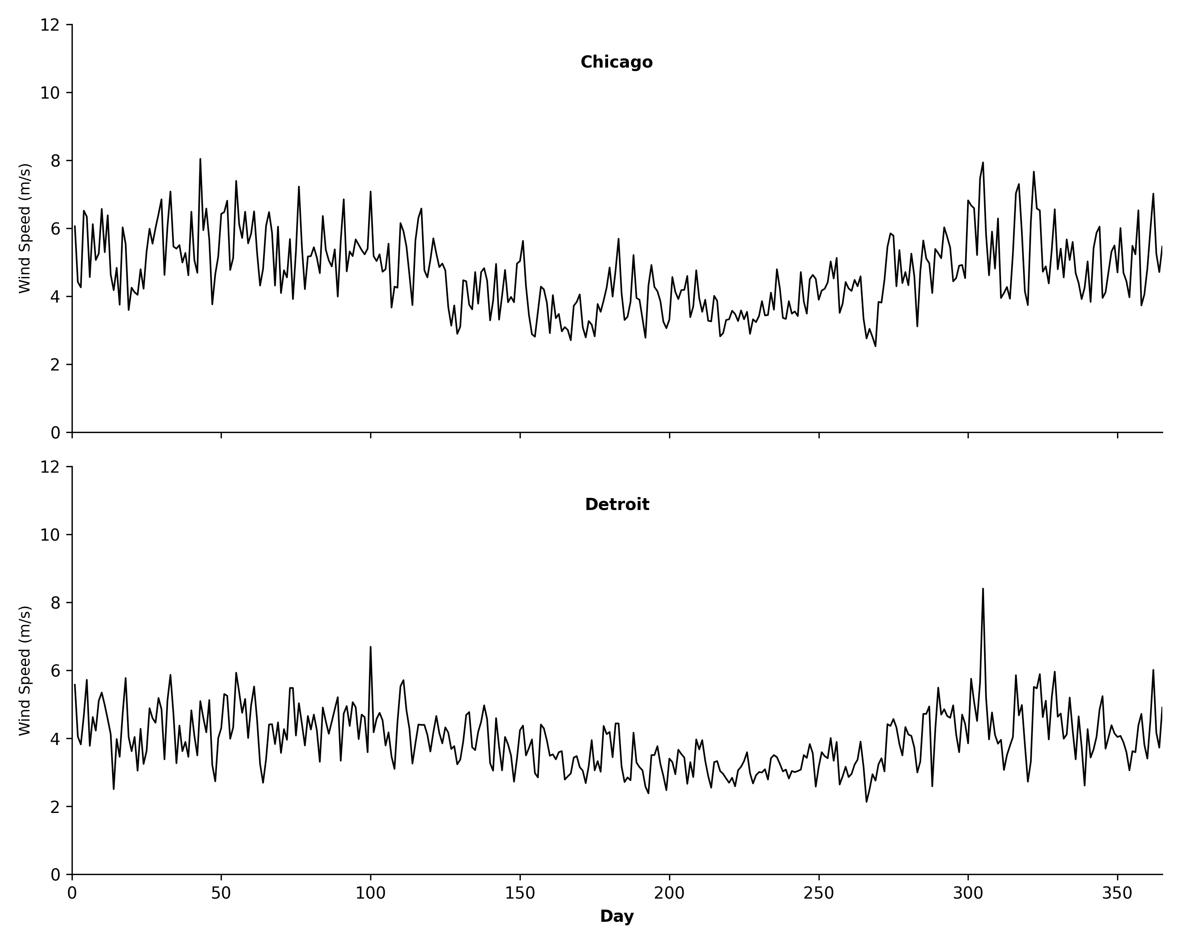
Figure 2: Wind Speed Characteristics
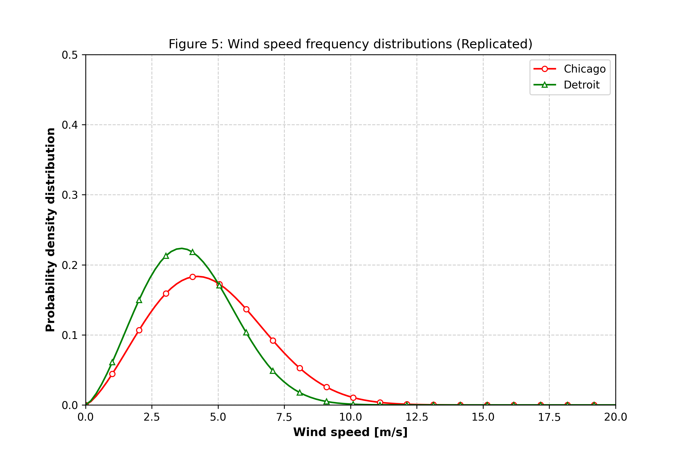
Figure 3: Weibull Frequency Distribution

3.2 Theoretical Power Generation (Target Synthesis)
A critical challenge in wind energy forecasting is the lack of public datasets containing both meteorological inputs and actual turbine power output. To address this, the target variable (Power Output) was synthesized mathematically based on the physics of a specific wind turbine.

3.2.1 Vertical Extrapolation
The raw meteorological data provided wind speeds at a standard height of 10 meters, which corresponds to the measurement standards used by services such as the OpenWeatherMap API [4]. However, commercial wind turbines operate at significantly higher altitudes. Therefore, the wind speed was extrapolated to a hub height of 50 meters using the Power Law equation:
$$v=v_{0}{\left(\frac{h}{h_{0}}\right)}^{α}$$
Where v is the wind speed at hub height (50m), v0 is the measured speed at 10m, and alpha is the Hellman exponent (set to 0.14 for open terrain).

3.2.2 The Cubic Power Curve Model
In the reference study by Demolli et al., the power generation data was derived using specific manufacturer power/speed tables. In contrast, this study utilizes a theoretical approach to ensure replicability. The relationship between wind speed and power generation was modeled using the "Four-Region" logic described in the course lecture notes by Bayindir [2].
Specifically, for the operational range (Region 2), the power output is calculated using the cubic formula visualized in Figure 1:
$$P_{T}(v)≈a∙v^{3}-b∙P_{R}$$
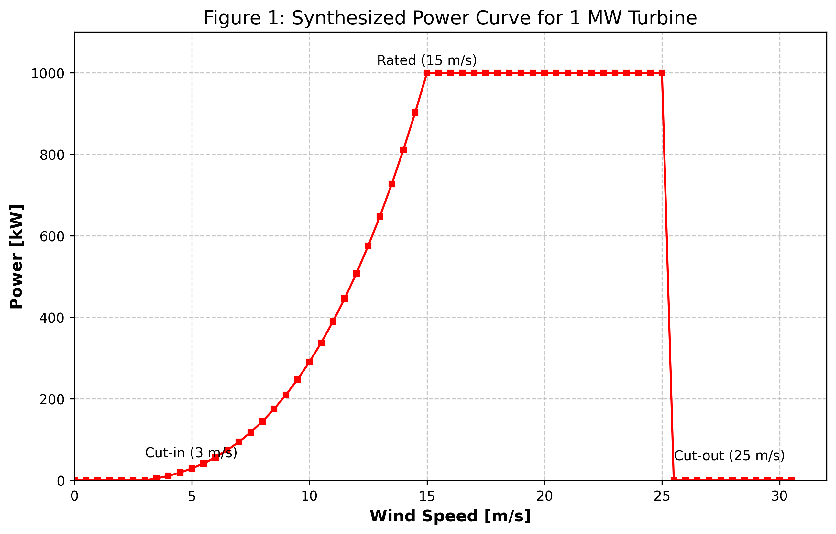
Figure 1: Theoretical Power Curve
This formula ensures that the power output follows the physical cubic law of kinetic energy. The turbine parameters were set to: Cut-in (3 m/s), Rated (15 m/s), and Cut-out (25 m/s).

3.3 Machine Learning Models and Hyperparameters
Six regression algorithms were implemented to model the relationship between wind statistics and power generation. To strictly validate the findings of the original study, the hyperparameters for the five benchmark models were kept identical to those reported by Demolli et al. [1]. No additional parameter optimization was performed for these specific models.
The fixed configuration for the benchmark models is as follows:
- LASSO Regression: alpha=0.1
- k-Nearest Neighbors (kNN): k=4, Metric=Minkowski
- Random Forest (RF): n_estimators=10
- XGBoost: n_estimators=500, learning_rate=0.1
- Support Vector Regression (SVR): C=3000, gamma=0.1, epsilon=0.1, kernel=RBF
Algorithmic Extension (LightGBM): The sixth model, LightGBM, was not present in the original study. Its hyperparameters were optimized using Optuna, a Bayesian optimization framework.

3.4 Experimental Design and Case Studies
To comprehensively evaluate the models, the methodology was structured into three distinct experimental cases.

Case 1: Baseline Forecasting (Chicago)
Objective: To establish the baseline performance of the algorithms using the complete feature set.
Inputs: Daily Mean Wind Speed + Daily Standard Deviation.
Methodology: Training and testing were performed on the Chicago dataset. This duplicates 'Case 1' from the reference paper.

Case 2: Input Sensitivity Analysis
Objective: To quantify the impact of wind volatility (turbulence) on prediction accuracy.
Inputs: Daily Mean Wind Speed only.
Methodology: The 'Standard Deviation' feature was removed. This mirrors 'Case 2' of the original study.

Case 3: Geographical Transferability
Objective: To assess the generalization capability of the models when applied to a new location.
Inputs: Daily Mean Wind Speed + Daily Standard Deviation.
Methodology: Models trained on Chicago were frozen and used to predict power generation in Detroit.

3.6 Performance Metrics
To quantitatively evaluate the forecasting accuracy, three standard statistical metrics were employed:
- Root Mean Squared Error (RMSE):
$$RMSE=\sqrt{\frac{1}{N}\sum{{\left(y_{i}-{\hat{y}}_{i}\right)}^{2}}}$$
- Mean Absolute Error (MAE):
$$MAE=\frac{1}{N}\sum{\left|y_{i}-{\hat{y}}_{i}\right|}$$
- Coefficient of Determination (R²):
$$R^{2}=1-\frac{\sum{{\left(y_{i}-{\hat{y}}_{i}\right)}^{2}}}{\sum{{\left(y_{i}-\bar{y}\right)}^{2}}}$$

4. Result and discussion
This section presents the performance of the proposed algorithms across the three experimental cases.

4.1 Case 1 Results (Chicago: Mean + Std Dev)
Table 1 summarizes the forecasting accuracy for Case 1. XGBoost and SVR achieved the highest performance.
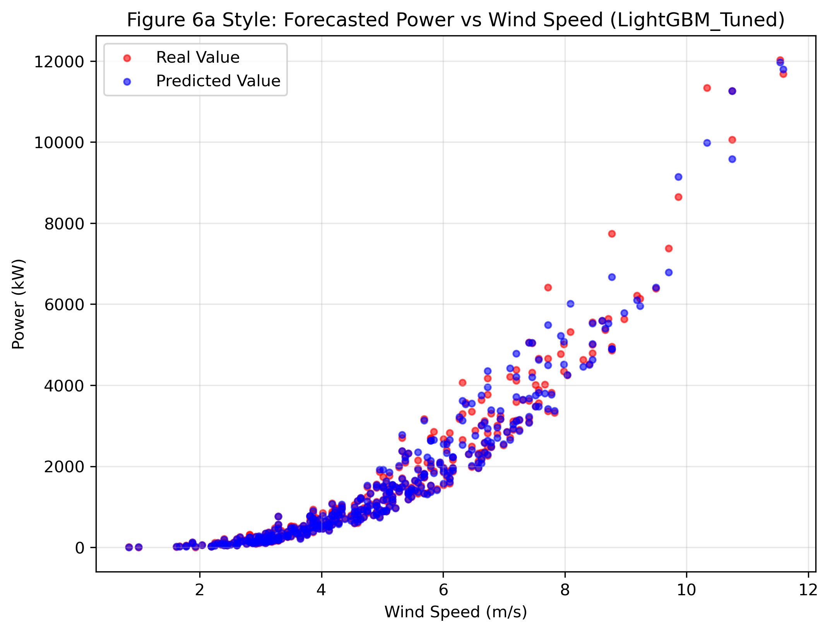
Figure 4: Case 1 Time Series Forecast (SVR)
Forecasting accuracy of the algorithms for daily wind speed and standard deviation (Case 1).
Algorithm | R2 | RMSE (kW) | MAE (kW)
LASSO | 0.8687 | 697.35 | 469.8
kNN | 0.9872 | 217.87 | 86.07
XGBoost | 0.995 | 135.6 | 57.56
Random Forest | 0.9942 | 146.86 | 67.37
SVR | 0.9968 | 108.65 | 36.03
LightGBM | 0.9949 | 137.49 | 53.69

4.2 Case 2 Results (Chicago: Mean Only)
Table 2 presents the results when the standard deviation feature is removed.
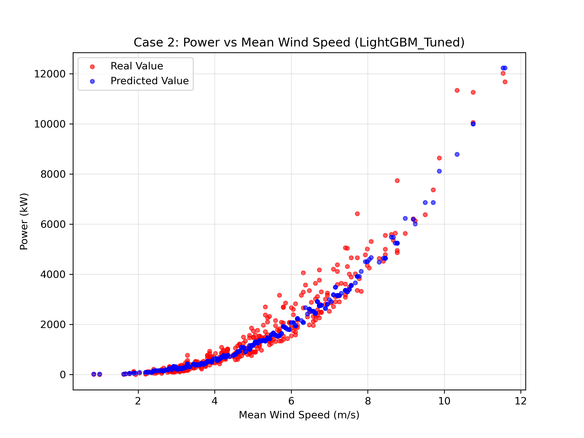
Figure 5: Case 2 Scatter Plot (Wind Speed vs Power)

Forecasting accuracy of the algorithms for daily wind speed and standard deviation (Case 1).
Algorithm | R2 | RMSE (kW) | MAE (kW)
LASSO | 0.8687 | 697.35 | 469.8
kNN | 0.9872 | 217.87 | 86.07
XGBoost | 0.995 | 135.6 | 57.56
Random Forest | 0.9942 | 146.86 | 67.37
SVR | 0.9968 | 108.65 | 36.03
LightGBM | 0.9949 | 137.49 | 53.69

4.3 Case 3 Results (Transferability to Detroit)
Table 3 compares the transferability of the models when applied to the Detroit dataset (Blind Test).

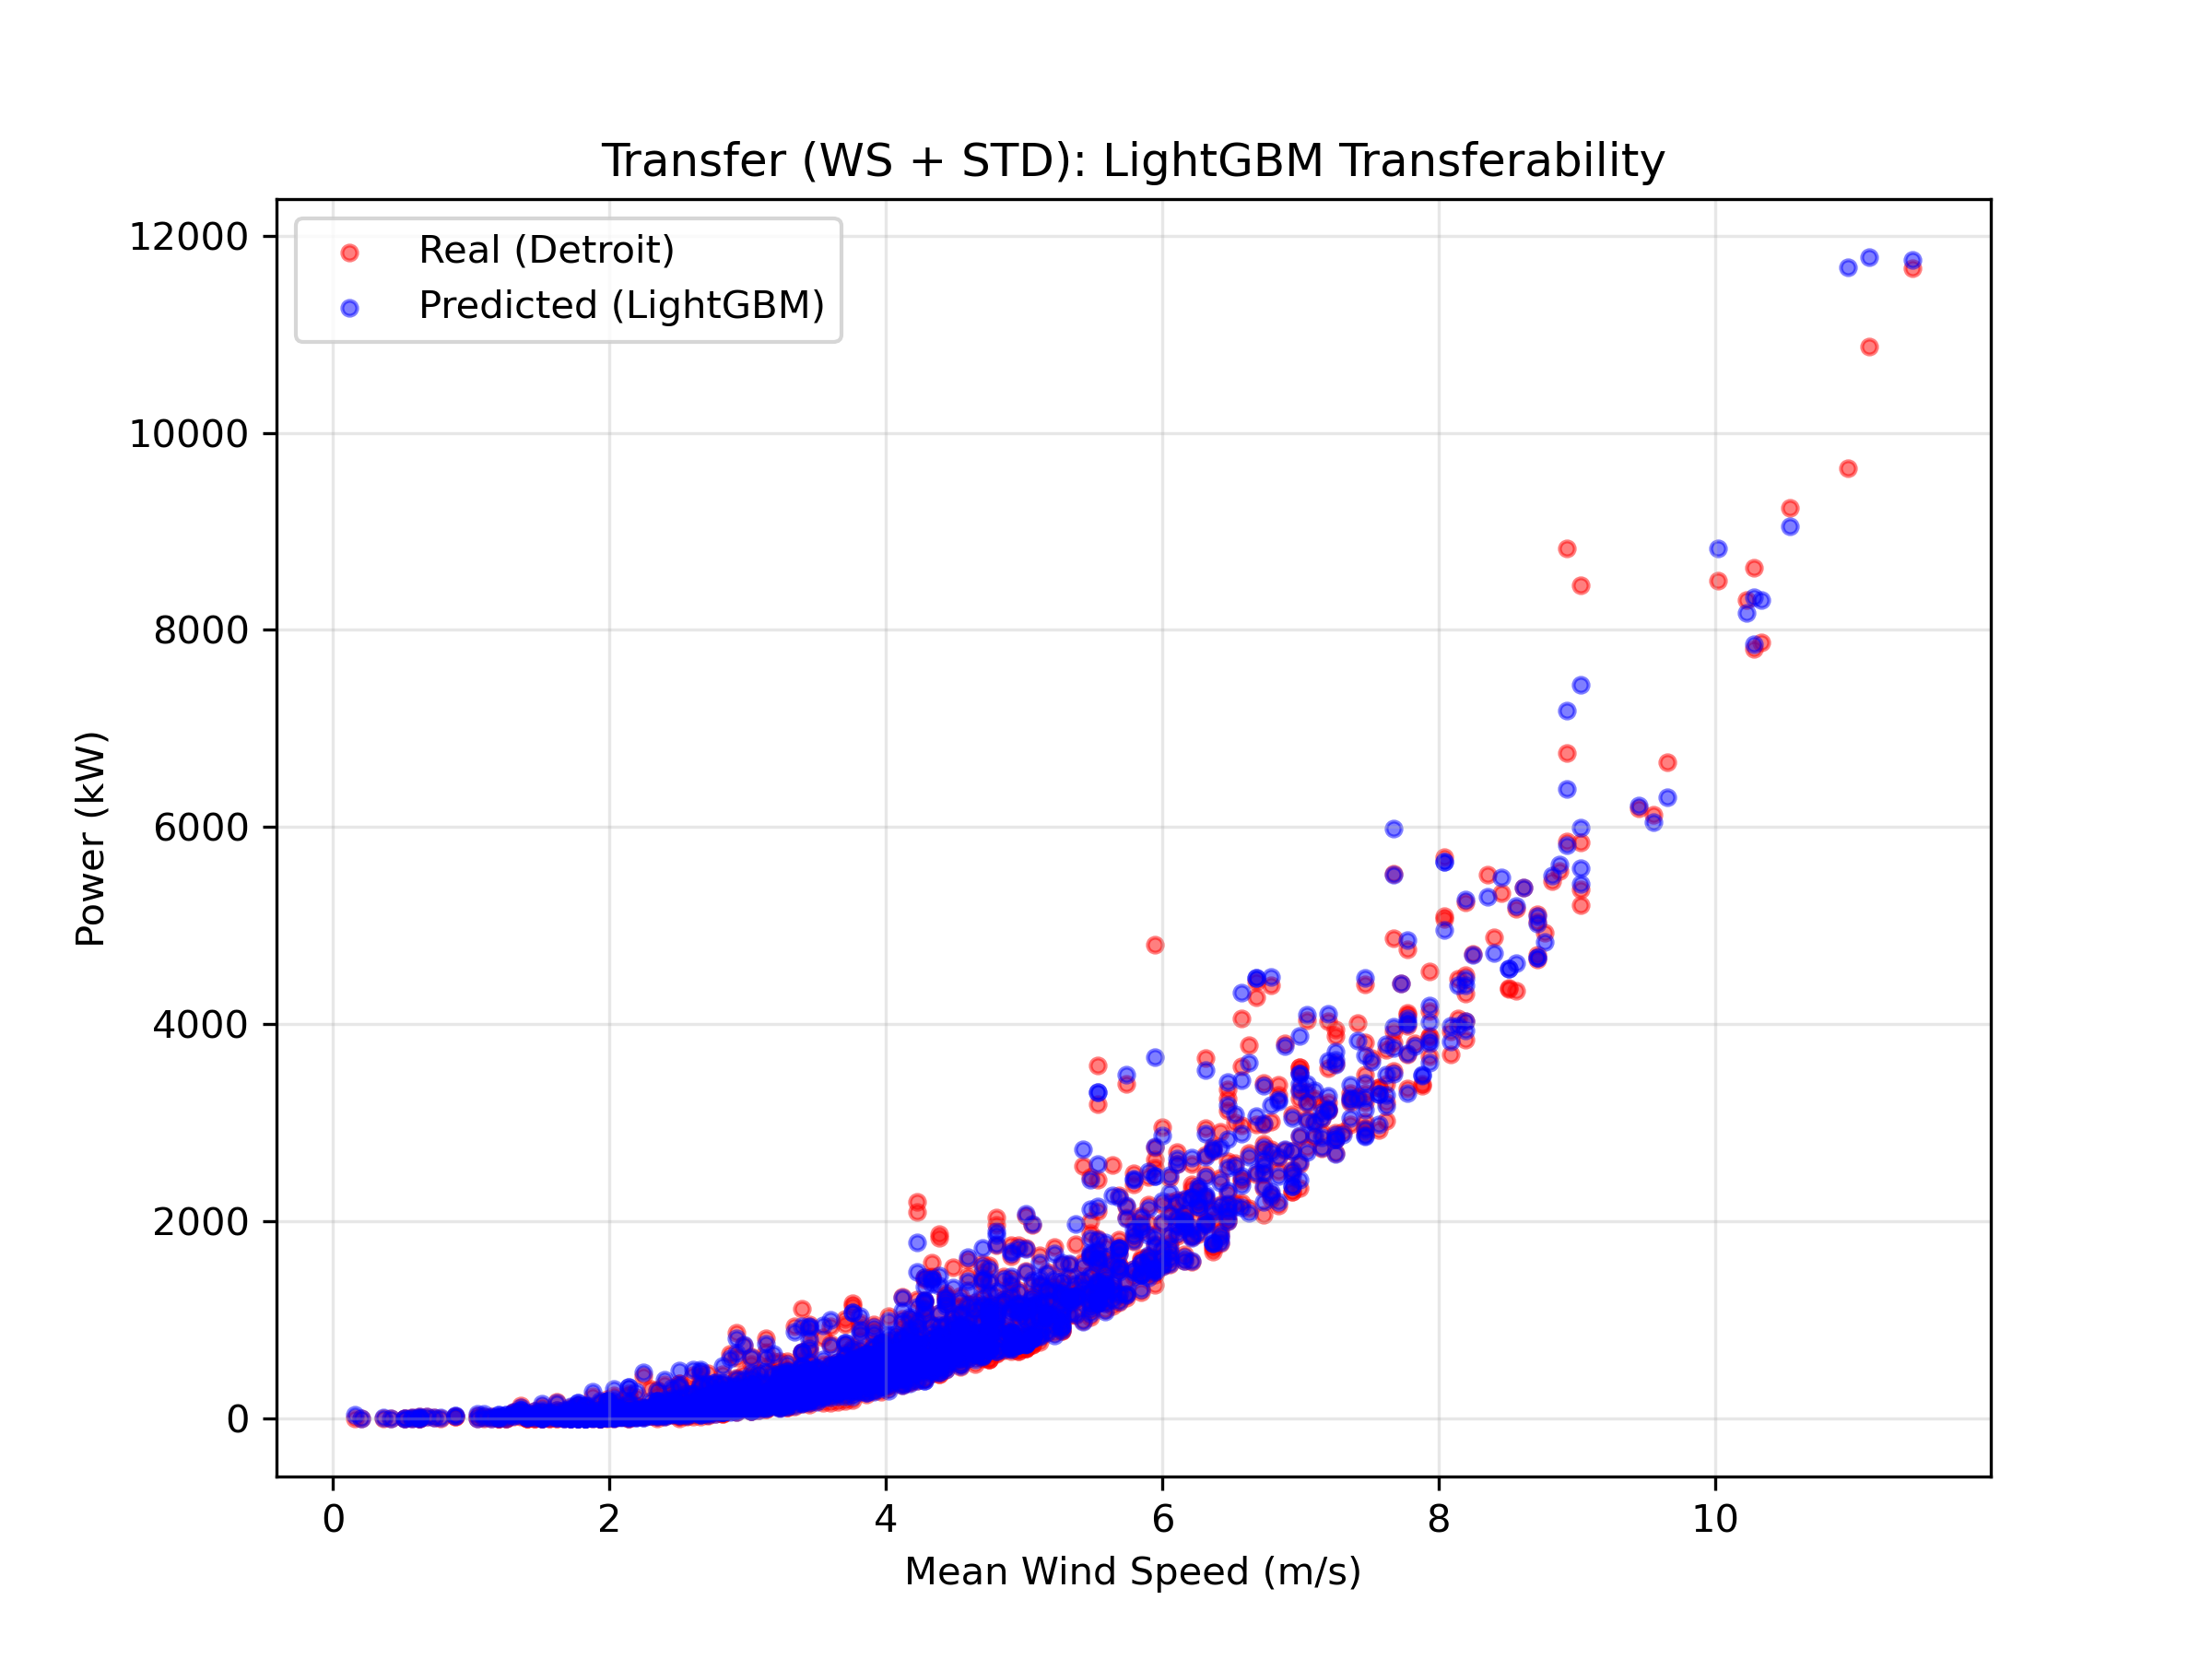
Figure 6: Case 3 Transferability Forecast (Detroit)

Forecasting accuracy of the algorithms for daily wind speed and standard deviation (Case 1).
Algorithm | R2 | RMSE (kW) | MAE (kW)
LASSO | 0.8687 | 697.35 | 469.8
kNN | 0.9872 | 217.87 | 86.07
XGBoost | 0.995 | 135.6 | 57.56
Random Forest | 0.9942 | 146.86 | 67.37
SVR | 0.9968 | 108.65 | 36.03
LightGBM | 0.9949 | 137.49 | 53.69

5. References
[1] H. Demolli, A. S. Dokuz, A. Ecemis, and M. Gokcek, "Wind power forecasting based on daily wind speed data using machine learning algorithms," Energy Convers. Manag., vol. 198, p. 111823, Oct. 2019.
[2] R. Bayindir, "Wind Energy Systems Lecture Notes," Department of Electrical Engineering, Gazi University. [Online].
[3] SelfishGene, "Historical Hourly Weather Data 2012-2017," Kaggle. [Online]. Available: https://www.kaggle.com/datasets/selfishgene/historical-hourly-weather-data.
[4] OpenWeatherMap, "Weather API - Current weather and forecast," OpenWeatherMap. [Online]. Available: https://openweathermap.org/api/weather-map-2.

