UnClean3D

Victor Antón Domínguez

Director: Marc Comino Trinidad

Master in Research and Innovation
Facultat d’Informàtica de Barcelona

July 2019

Table of Contents
Table of Contents 2
Abstract 4
1. Introduction 5
1.1 Motivation 5
1.2 Contributions 5
2. Previous work 6
2.1 Physically based approaches 6
2.1.1 Advantages 6
2.1.2 Disadvantages 6
2.1.3 Previous physically based approaches work 6
2.1.3.1 Dust accumulation 6
2.1.3.1 Impacts and scratches 6
2.2 Artistic approaches 7
2.2.1 Advantages 7
2.2.2 Disadvantages 8
2.2.3 Previous artistic approaches work 8
2.3 Heuristic approaches 8
2.2.1 Advantages 8
2.2.2 Disadvantages 8
2.2.3 Previous artistic approaches work 8
3. Software 9
3.1 Objectives 9
3.2 Architecture 9
4. Conclusions 10
5. Future work 11
Bibliography 12

Abstract
In most video games, we want the player to be completely immersed in our world. For this purpose, we sometimes need the scenes to be extremely realistic. But at the same time, we need to run the game at real time frame rates, so that the player does not lose the illusion of the uninterrupted flow of images.
One common way to improve the level of realism of an environment is to model imperfections such as dirt, scratches, flaking, etc. However, these details must still fit the quality constraints that real time frame rate imposes...
We present a software and work-flow created to add these imperfections that make a scene more realistic, while increasing as little as possible the performance hit. For this, we have created a tool to add imperfection effects over the physically based shading textures of the model. We provide a set of effects that can be tweaked and combined by an artist.
The fact that only the PBS textures are modified, provides a seamless integration of it with all well-known commercial game engines.
Keywords: aging, physically based, textures, real time.

1. Introduction

1.1 Motivation

1.2 Contributions

2. Previous work
We can classify the previous work on this topic based on whether they are physically based or artistic oriented.

2.1 Physically based approaches
Physically based approaches use physical models to generate the aging or imperfection effects. Given a set of input variables that specify physical properties of the environment, they simulate or compute the process described by the chosen physical model, and later add it to the model.

2.1.1 Advantages
Due to relying on well-tested physical models, they can provide very accurate results.
In addition, once we set the physical attributes of a model or environment, the tool can process the models all alone by itself. Thanks to this, it is really easy to automate the aging process, and it can be really efficient to use in some development environments.

2.1.2 Disadvantages
These approaches very often do not allow the user to see the results in real time, since the simulation time can take very long. In addition, tools based in physical models make it very difficult to predict or to control the final result.
These tools are normally aimed to create very realistic scenarios. Even if the physical model is very accurate, we also need to precisely define the physical properties of the environment. This can be time consuming or require a good amount of research depending on what are the needed input physical properties.

2.1.3 Previous physically based approaches work

2.1.3.1 Dust accumulation
Dust accumulation is a very common effect. It modifies the way light is reflected by the object surface. Hsu and Wong [HW95] proposed to consider dust source as light sources, considering the angle between the dust source and the normal of the surface. More recently, Guo and Pan [GP14] addressed it with a more accurate physical model, simulating the dust accumulation by taking into account the surface stickiness and surface inclination.

2.1.3.2 Impacts and scratches
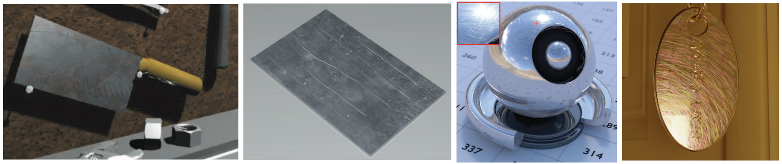
Figure 1: Different scratch results. From left to right: Merillou et al.[MDG01], Bosch et al. [Bos+04], Raymond et al. [RGB16] and Werner et al. [Wer+17]
Impacts and scratches are caused due to external bodies hitting the object over time, or because of tools or sharp objects scraping the object surface. Mérillou et al. [MDG01] and Bosch et al. [Bos+04] approached it by using the BRDF model. The first used data measured from reality, while the second derived the scratches data from a set of physical inputs. Raymond et al. [RGB16] proposed a technique that is takes into account the inter-reflections inside the scratches. And recently, Werner et al. [Wer+17] used an approach to calculate the iridescence the scratches considering the roughness of the surface as a group of line segments.

2.1.3.3 Peeling
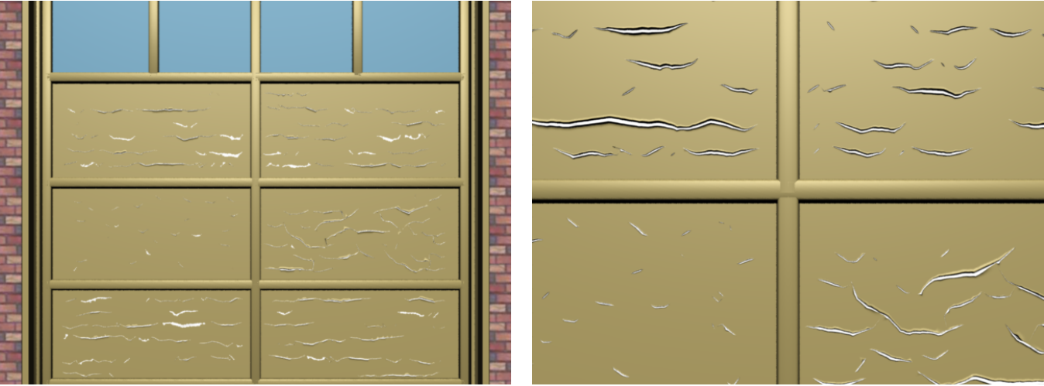
Figure 2: PPD02 Peeling approach

Peeling is a process in which the layers of a surface peel and fall off. This leaves visible the lower layer of material at some zones of the surface.
Paquette et al. [PPD02] introduced a physically based technique to compute peeling. They used a 2D grid in which they simulated the peeling process by propagating starting cracks on the surface.

2.1.3.4 Corrosion
Corrosion is a chemical natural process that gradually destroys materials (usually metals), and gives them the well known brownish appearance.
Mérillou et al. [MDG01a] first presented a model that simulated corrosion guided by physical models. Later on, Chang and Shih [CS03] proposed a technique to simulate the generation of rust in metals under sea water.

2.1.3.4 Others
There are many other effects that have been tackled using physically based approaches. These include erosion, pollution, skin aging, etc. For all of them exists previous work that is also based in an underlying physical model or simulation.

2.2 Artistic approaches
Artistic approaches are not presented as aging or imperfection software. We could say, that a tool that allow an artistic approach to this problem, is any program which allows the user to freely edit the model PBS textures or the model mesh. This way, the artist is the only responsible for manufacturing plausible imperfection effects on the model, by using the generic tools provided by the software.

2.2.1 Advantages
The main advantage of artistic approaches is the freedom that the user has to create effects. This lets the artist to stylize the aging in such a way that fits the final environment. For example, if the artist Is manufacturing models for a cartoon video game, physically based software will render useless because it will create effects that are too realistic. On the other hand, with an artistic based software, the user has much more control over the effects, and consequently can better tweak and adapt the style of the imperfections to match that of the cartoon environment.
Another advantage is that these approaches are often much faster to compute. Consequently, the tools using this approach, can be implemented in such a way that they provide real time feedback to the artist. This is really important, because this way the user can instantly see in his screen the final result and get an idea of how it will merge in the final environment.

2.2.2 Disadvantages
One of the weak points of artistic based approaches is that they usually lack of strict physical realism. Since these tools do not guide the user on the process, the physical plausibility of the effects completely rely on the skills of the user.
In addition, the aging process can not be automated. With these tools, a manufacturing user is always needed, in order to use the tools to create the imperfections for each model. This means that they demand more human and time resources, and consequently they may not be efficiently suited for some production pipelines.

2.2.3 Previous artistic approaches work
As said before, we can consider artistic approaching software all the software that provides the artist the tools to freely modify the model PBS textures and/or the model mesh itself. There are many programs that can perform this task: Blender, Maya, Zbrush, etc. Nevertheless, all this software is very generic, and does not provide more specific tools that the artist can efficiently use to add aging effects.

2.3 Heuristic approaches
Heuristic approaches provide tools to rapidly create effects that resemble the ones we see in the real world, but they are not really physically based. These technique use heuristics to approximate the physical process that we see, but they do not simulate any process from begin to end, nor they strictly follow any physical model.

2.3.1 Advantages
Since they do not need to be physically accurate, the generation time of the process can even be real time.
If they are aimed towards aging or adding imperfections, they can provide a significant boost to quality and speed of the manufacturing process. This is because with very few clicks they can provide a base over which the artist can work. After this, tweaking can be very intuitive and easy to control and stylize. In contrast with physically based approaches, these tools provide you knobs to directly and instantly alter the final result, instead of modifying the input variables and unpredictably running the process all over again.
They combine both the physically based advantage of the plausibility of the results (to some extent), and the tweaking potential of the artistic approaches.

2.3.2 Disadvantages
Again, heuristic based approaches are not following any physical underlying models. We can find cases in which they differ from what would happen in reality.

3. Software

3.1 Objectives
Solo modificar texturas bla bla

3.2 Architecture

4. Conclusions

5. Future work

Bibliography
[MPB18] I. Muñoz-Pandiella, C. Bosch, N. Mérillou, G. Patow, S. Mérillou and X. Pueyo, "Urban Weathering: Interactive Rendering of Polluted Cities," in IEEE Transactions on Visualization and Computer Graphics, vol. 24, no. 12, pp. 3239-3252, 1 Dec. 2018.
doi: 10.1109/TVCG.2018.2794526
[HW95] Siu-chi Hsu and Tien-tsin Wong. “Simulating Dust Accumulation”. In: IEEE Comput. Graph. Appl. 15.1 (1995), pages 18–22. ISSN: 0272-1716 (cited on page 8).
[PPD02] Eric Paquette, Pierre Poulin, and George Drettakis. “The simulation of paint cracking and peeling”. In: Proceedings of Graphics Interface. Canadian Human-Computer Communications Society. 2002, page 10 (cited on page 10).
[GP14] Jie Guo and Jin-Gui Pan. “Real-time simulating and rendering of layered dust”. In: The Visual Computer 30.6 (2014), pages 797–807. ISSN: 1432-2315. DOI: 10.1007/s00371- 014- 0967- 9. URL: https://doi.org/10.1007/s00371- 014- 0967-9 (cited on page 8).
[MDG01] Stephane Merillou, Jean-Michel Dischler, and Djamchid Ghazanfarpour. “Corrosion: Simulating and Rendering”. In: Proceedings of Graphics Interface 2001. GI ’01. Toronto, Ont., Canada, Canada: Canadian Information Processing Society, 2001, pages 167–174. ISBN: 0-9688808-0-0 (cited on pages 8, 12).
[Bos+04] Carles Bosch, Xavier Pueyo, Stéphane Mérillou, and Djamchid Ghazanfarpour. “A Physically-Based Model for Rendering Realistic Scratches”. In: Computer Graphics Forum 23.3 (2004), pages 361–370. ISSN: 1467-8659 (cited on page 8).
[RGB16] Boris Raymond, Gaël Guennebaud, and Pascal Barla. “Multi-scale Rendering of Scratched Materials Using a Structured SV-BRDF Model”. In: ACM Trans. Graph. 35.4 (July 2016), 57:1–57:11. ISSN: 0730-0301. DOI: 10.1145/2897824.2925945. URL: http://doi.acm.org/10.1145/2897824.2925945 (cited on pages 8, 9).
[Wer+17] Sebastian Werner, Zdravko Velinov, Wenzel Jakob, and Matthias Hullin. “Scratch Iridescence: Wave-Optical Rendering of Diffractive Surface Structure”. In: (2017). arXiv: 1705.06086 (cited on pages 8, 9).

