

**All the Departure and Arrival times are the SCHEDULED Departure and Arrival times**

**Objective**

min totcost

This lindo code is just to minimize the total cost of the time table subjected to the constraints mentioned below.

s.t.

**Constraints**

!buffers are used as running time supplements

!transfer times have a minimum value

TTMIN=3 (Minmum Transfer Time)

This is to make sure that there is a minimum of 3 minutes of time to make the transfer.

TTK11C21-TTMIN>0

TTK11C21>TTMIN **(Alken to Hasselt 1, Hasselt to Aarschot 2)**

TTK11C21 is the transfer time between the trains K1(1st) and C1(2nd) i.e. second train on the route C1 should depart Hasselt **at least** 3 minutes after the first train on the route K1 arrive at Hasselt.

TTK11C10-TTMIN>0

TTK11C10>TTMIN **(Alken to Hasselt 1, Hasselt to Liege 1)**

TTC10K20-TTMIN>0 **(Aarschot to Hasselt 1, Hasselt to Alken 2)**

TTK10E20-TTMIN>0 **(Landen to Leuven 1, Leuven to Aarschot, Diest 2)**

TTK10M20-TTMIN>0 **(Landen to Leuven 1, Leuven to Aarschot, Heist-op-den-Berg 2)**

TTE11K21-TTMIN>0 **(Diest, Aarschot to Leuven 1, Leuven to Landen 2)**

TTM11K21-TTMIN>0 **(Heist-op-den-Berg, Aarschot to Leuven 1, Leuven to Landen 2)**

TTM11K10-TTMIN>0 **(Heist-op-den-Berg, Aarschot to Leuven 1, Leuven to Brussels 1)**

!Ideal buffer times

Buffer time is the difference between the scheduled running time and the ideal running time.

Ideal buffer times are given between two trains.

!Hasselt

For connections making their transfer at Hasselt

IBK1C1=5 **(Alken to Hasselt 1, Hasselt to Aarschot 2)**

IBK1C0=9 **(Alken to Hasselt 1, Hasselt to Liege 1)**

IBC0K0=4 **(Aarschot to Hasselt 1, Hasselt to Alken 2)**

!Leuven

For trains making their transfer at Leuven

IBK0E0=2 **(Landen to Leuven 1, Leuven to Aarschot, Diest 2)**

IBK0M0=2 **(Landen to Leuven 1, Leuven to Aarschot, Heist-op-den-Berg 2)**

IBE1K1=2 **(Diest, Aarschot to Leuven 1, Leuven to Landen 2)**

IBM1K1=7 **(Heist-op-den-Berg, Aarschot to Leuven 1, Leuven to Landen 2)**

IBM1K0=10 **(Heist-op-den-Berg, Aarschot to Leuven 1, Leuven to Brussels 1)**

If the scheduled buffer time deviates from the ideal buffer time, the total waiting cost will increase.

**BUFFER TIME**: It’s the supplement time given to a train to keep it on schedule.

Ideal running time + Buffer time = Scheduled running time

**TRANSFER TIME**: It’s the difference between the scheduled departure time of the train to be connected and the scheduled arrival time of the other train which is the connecting train. (Minimal 3 minutes)

**STOPPING TIME**: The difference between the scheduled departure of the train and the scheduled arrival of the train at station.

Why the **ideal** buffer times are between two trains whereas buffer time is a feature of a single train.

Line constraints

!Different lines

!C10

The first C train in direction 0

DC10He<60

Departure of C10 from He

DC10He +STC0Aa -DC10Aa = -9 !IRCHeAa=9; ideal running times, IR train

The ideal running time from He to Aa is given as 9 minutes. Hence the equation:

(Departure time from He) + 9 + (Stopping time at Aa) = (Departure time from Aa)

DC10Aa +BC0AaHa -AC10Ha = -26 !IRCAaHa=26

(Departure time from Aa) + 26 + (**Buffer time** of C0 between Aa and Ha) = (Arrival time at Ha)

Buffer time included for transfer C10K20

No constraint for the journey from Ha to Li

STC0Aa > 1 !

!C11

The first train in direction C1

No constraint for the journey from Li to Ha

DC11Ha<60

DC11Ha+STC1Aa -DC11Aa= -26

(Departure time from Ha) + 26 + (Stopping time at Aa) = (Departure time from Aa)

DC11Aa-AC11He= -9

(Departure time from Aa) + 9 = (Arrival time at He)

STC1Aa >1

!E10

The first train in direction E0

DE10Le<60

DE10Le+STE0Aa -DE10Aa= -12 !ICELeAa= 12; ideal running times, IC train

(Departure time from Le) + 12 + (Stopping time at Aa) = (Departure time from Aa)

DE10Aa-AE10Ha=-25 !ICEAaHa= 25

(Departure time from Aa) + 25 = (Arrival time at Ha)

STE0Aa >1

!E11

DE11Ha<60

DE11Ha+STE1Aa -DE11Aa=-25

(Departure time from Ha) + 25 + (Stopping time at Aa) = (Departure time at Aa)

DE11Aa+BE1AaLe -AE11Le=-12

(Departure time at Aa) + 12 + (Buffer time of E1 between Aa and Le) = (Arrival time at Le)

AE11Le<180 **(???? and why 180????)**

STE1Aa >1

!K10

DK10Ha<60

DK10Ha+STK0Al -DK10Al=-6 !ICKHaAl=6

DK10Al+STK0St -DK10St=-8 !ICKAlSt=8

DK10St+STK0La -DK10La=-9 !ICKStLa=9

DK10La+BK0LaLe -AK10Le=-27 !ICKLaLe=27

No constraint for Le to Br

AK10Le<120 **(???? and why 120????)**

STK0Al>1

STK0St>1

STK0La>1

!K11

No constraint for Br to Le

DK11Le<60

DK11Le+STK1La -DK11La=-27

DK11La+STK1St -DK11St=-9

DK11St+STK1Al -DK11Al=-8

DK11Al+BK1AlHa -AK11Ha=-6

AK11Ha<120 **????**

STK1Al>1

STK1St>1

STK1La>1

!M10

DM10Le<60

DM10Le+STM0Aa -DM10Aa=-14 !LMLeAa=14; ideal running times, L train

DM10Aa-AM10He=-12 !LMAaHe=12

STM0Aa>1

!M11

DM11He<60

DM11He+STM1Aa -DM11Aa=-12

DM11Aa+BM1LeAa -AM11Le=-14

AM11Le<120

STM1Aa>1

AM11Le+STM1Le -DM20Le<0 !(because it is the same train turning around in Leuven)

It should be AM11Le + STM1Le - DM20Le **=** 0

STM1Le>1

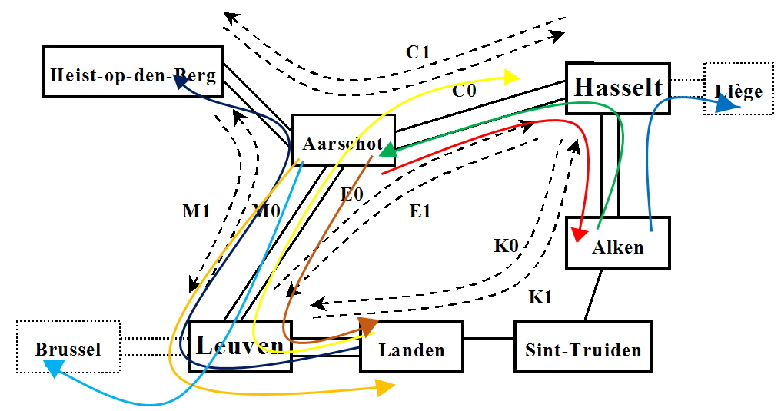

!transfers

Transfer Time is the difference between the scheduled departure time of the train to be connected and the scheduled arrival time of the other train which is the connecting train. (Minimal 3 minutes)

DK20Ha -AC10Ha-TTC10K20=0

(Departure time of K20 at Ha) – (Arrival time of C10 at Ha) = (Transfer time from C10 to K20)

DK21Le -AE11Le-TTE11K21=0

DE20Le -AK10Le-TTK10E20=0

DM20Le -AK10Le-TTK10M20=0

AC10Ha+STC0Ha -AK11Ha-TTK11C10=0

**Arrival of C10 at Ha + Stopping time of C0 at Ha** – Arrival of K11 at Ha = TTK11C10

**DC10Ha** – AK11Ha = TTK11C10

Arrival of C10 at Ha + Stopping time of C0 at Ha = Departure of C10 at Ha

DC21Ha -AK11Ha-TTK11C21=0

DK21Le -AM11Le-TTM11K21=0

AK10Le+STK0Le -AM11Le-TTM11K10=0

!Stopping times, additional ones due to transfertimes

STC0Ha>1

STK0Le>1

!compare ideal buffer times with scheduled buffer times

IBC0K0+UC0K0p-UC0K0n -BC0AaHa=0

IBE1K1+UE1K1p-UE1K1n -BE1AaLe=0

IBK0E0+UK0E0p-UK0E0n -BK0LaLe=0

IBK1C0+UK1C0p-UK1C0n -BK1AlHa=0

IBK1C1+UK1C1p-UK1C1n -BK1AlHa=0

IBK0M0+UK0M0p-UK0M0n -BK0LaLe=0

IBM1K0+UM1K0p-UM1K0n -BM1LeAa=0

IBM1K1+UM1K1p-UM1K1n -BM1LeAa=0

How do we limit the value of the ‘U’ variables?

!single track between Alken and Landen

!Sequence 10-11-20-21-30-31

Al – St - La

K10 - K11 - K20 - K21 - K30 - K31

K11 should only depart from La after K10 has arrived at La

DK11La > AK10La

K20 should only depart from Al after K11 has arrived at Al

DK20Al > AK11Al

DK21La > AK20La

DK30Al > AK21Al

DK31La > AK30La

!St-Al

DK10Al -DK11St<-8 !ICKAlSt=8

DK11St -DK20Al<-8

!St-La

DK10St -DK11La<-9 !ICKStLa=9

DK11La -DK20St<-9

!transfertimes, Stopping times in stations and deviations from the ideal running time supplements

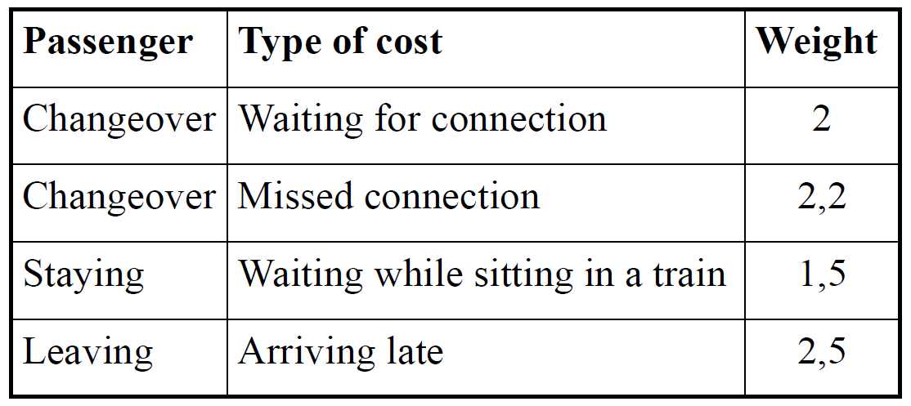

!TT>3: transfer passengers will have to wait longer in the stations, weight 2 in the station, this has no influence for other passengers

!STCOST, if a train stops in the station, the through passengers have to wait inside the train (1,5)

!deviations from the ideal buffer time are uneg or upos!!!

!all this must be multiplied bij 10^4 to calculate the real cost.

0.024TTK11C21+1.68TTK11C10+0.024TTC10K20+0.030TTK10E20

+0.028TTK10M20+0.059TTE11K21+0.049TTM11K21+2.934TTM11K10

-TTCOST=14.27 !=0

0.15STC0Aa+0.15STC1Aa+2.7STE0Aa+2.7STE1Aa+1.35STK0Al+1.35STK1Al

+0.76STK0St+0.76STK1St+0.87STK0La+0.87STK1La+0.45STM0Aa+0.45STM1Aa

+0.26STC0Ha+6.5STK0Le

-STCOST=0

0.33UK1C1p+0.9UK1C1n+1.19UK1C0p+3.65UK1C0n+0.18UC0K0p+0.58UC0K0n

+3.36UK0E0p+1.96UK0E0n+3.36UK0M0p+1.93UK0M0n+1.52UE1K1p+1.11UE1K1n

+3UM1K1p+3UM1K1n+1.08UM1K0p+2.11UM1K0n

-DEVIAT=0

TTCOST+STCOST+DEVIAT -TOTCOST=0

!To guarantee periodicity

!C20

!DC20He-DC10He=60

!DC20Aa-DC10Aa=60

!AC20Ha-AC10Ha=60

!C30

!DC30He-DC20He=60

!DC30Aa-DC20Aa=60

!AC30Ha-AC20Ha=60

!C21

DC21Ha-DC11Ha=60

!DC21Aa-DC11Aa=60

!AC21He-AC11He=60

!C31

!DC31Ha-DC21Ha=60

!DC31Aa-DC21Aa=60

!AC31He-AC21He=60

!E20

DE20Le-DE10Le=60

!DE20Aa-DE10Aa=60

!AE20Ha-AE10Ha=60

!E30

!DE30Le-DE20Le=60

!DE30Aa-DE20Aa=60

!AE30Ha-AE20Ha=60

!E21

!DE21Ha-DE11Ha=60

!DE21Aa-DE11Aa=60

!AE21Le-AE11Le=60

!E31

!DE31Ha-DE21Ha=60

!DE31Aa-DE21Aa=60

!AE31Le-AE21Le=60

!K20

DK20Ha-DK10Ha=60

!DK20Al-DK10Al=60

!DK20St-DK10St=60

!DK20La-DK10La=60

!AK20Le-AK10Le=60

!K30

!DK30Ha-DK20Ha=60

!DK30Al-DK20Al=60

!DK30St-DK20St=60

!DK30La-DK20La=60

!AK30Le-AK20Le=60

!K21

DK21Le-DK11Le=60

!DK21La-DK11La=60

!DK21St-DK11St=60

!DK21Al-DK11Al=60

!AK21Ha-AK11Ha=60

!K31

!DK31Le-DK21Le=60

!DK31La-DK21La=60

!DK31St-DK21St=60

!DK31Al-DK21Al=60

!AK31Ha-AK21Ha=60

!M20

DM20Le-DM10Le=60

!DM20Aa-DM10Aa=60

!AM20He-AM10He=60

!M30

!DM30Le-DM20Le=60

!DM30Aa-DM20Aa=60

!AM30He-AM20He=60

!M21

!DM21He-DM11He=60

!DM21Aa-DM11Aa=60

!AM21Le-AM11Le=60

!M31

!DM31He-DM21He=60

!DM31Aa-DM21Aa=60

!AM31Le-AM21Le=60

END

!for some variables it is necessary to indicate explicitly that they should be integer

!for now, these 6 are sufficient, but you might to add others here

Gin STK1Al

Gin STE1AA

Gin STM1Aa

Gin DC10He

Gin DK10Al

Gin AK11Ha