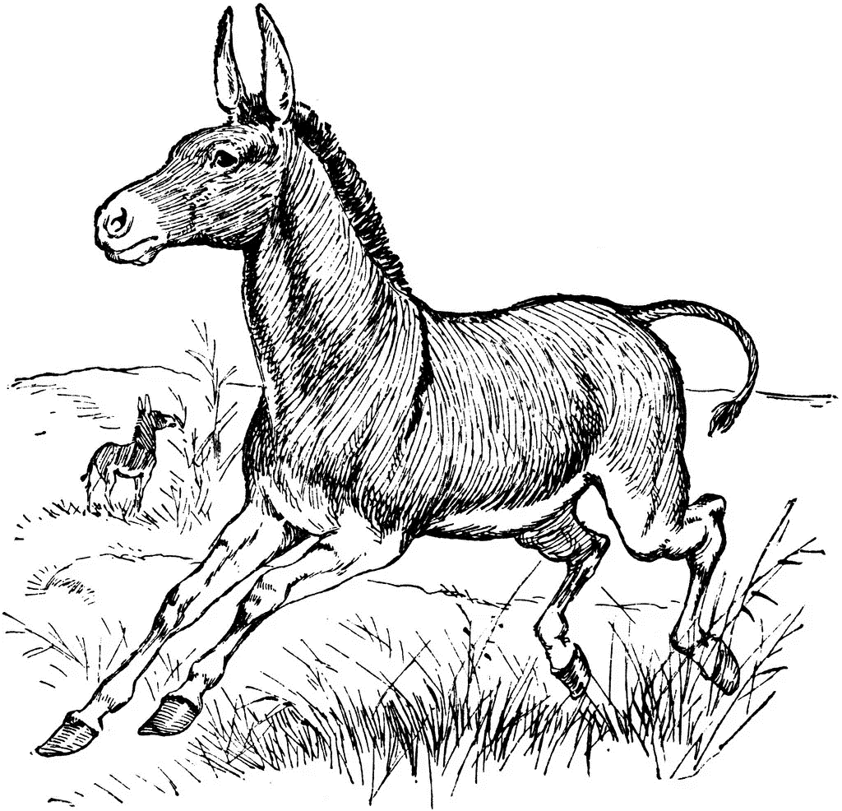

Delving into Polynomials

*Amiya*

**Rhodes Island**

*An unpractical guide*

*Learn some basic stuffs of polynomials*