First, download java from: https://www.java.com/download/ie_manual.jsp

Once downloaded, run the java installer and wait until it is done downloading.

Then, download the FastQC zip file for windows from here: https://www.bioinformatics.babraham.ac.uk/projects/download.html#fastqc

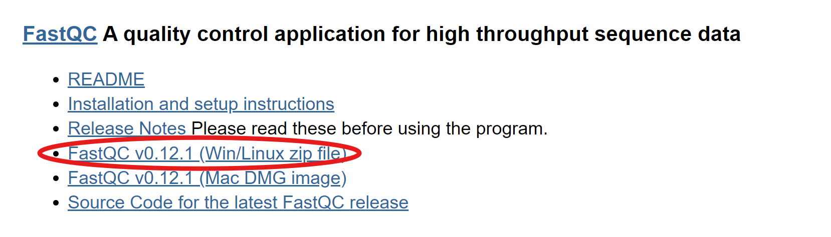
If you click on this, the download will start automatically.

Once downloaded extract the file using winrar(https://www.win-rar.com/download.html?&L=0)

After it is finished extracting, open the file folder and locate the run_fastqc windows batch file.

Once located, double click on it and it will run FastQC

