Assignment #4 — Facade Pattern
Video Conversion Facade
ShP-2216 – Software Design Patterns (OP 6B06102)
Astana IT University — School of Computer Engineering
Student: Adilzhan [surname], group [group]

1. Introduction
This report describes a Java 17 implementation of the Facade structural design pattern. The chosen domain is video conversion (Option A).
Converting a media file is not a single operation. A client would have to read the container, measure the bitrates, choose a codec that matches the target format, encode the video, normalize the audio and finally write a new container, in exactly this order. The subsystem consists of the following classes:
- ContainerReader — splits the input file into video and audio streams.
- BitrateReader — measures the video and audio bitrate of the streams.
- CodecFactory with Codec, DeflateCodec, H264Codec, Vp9Codec and XvidCodec — selects and runs the encoder for the target format.
- AudioMixer — normalizes the audio stream to a target peak level.
- ContainerWriter — writes the encoded streams into the output file.
Without a Facade every client would repeat this orchestration and would depend on all of these classes. VideoConversionFacade reduces the whole process to one call, convert(filename, format). A second, separate MediaInspectionFacade offers read-only file inspection, so the main facade is not polluted with unrelated functionality.

2. UML Class Diagram
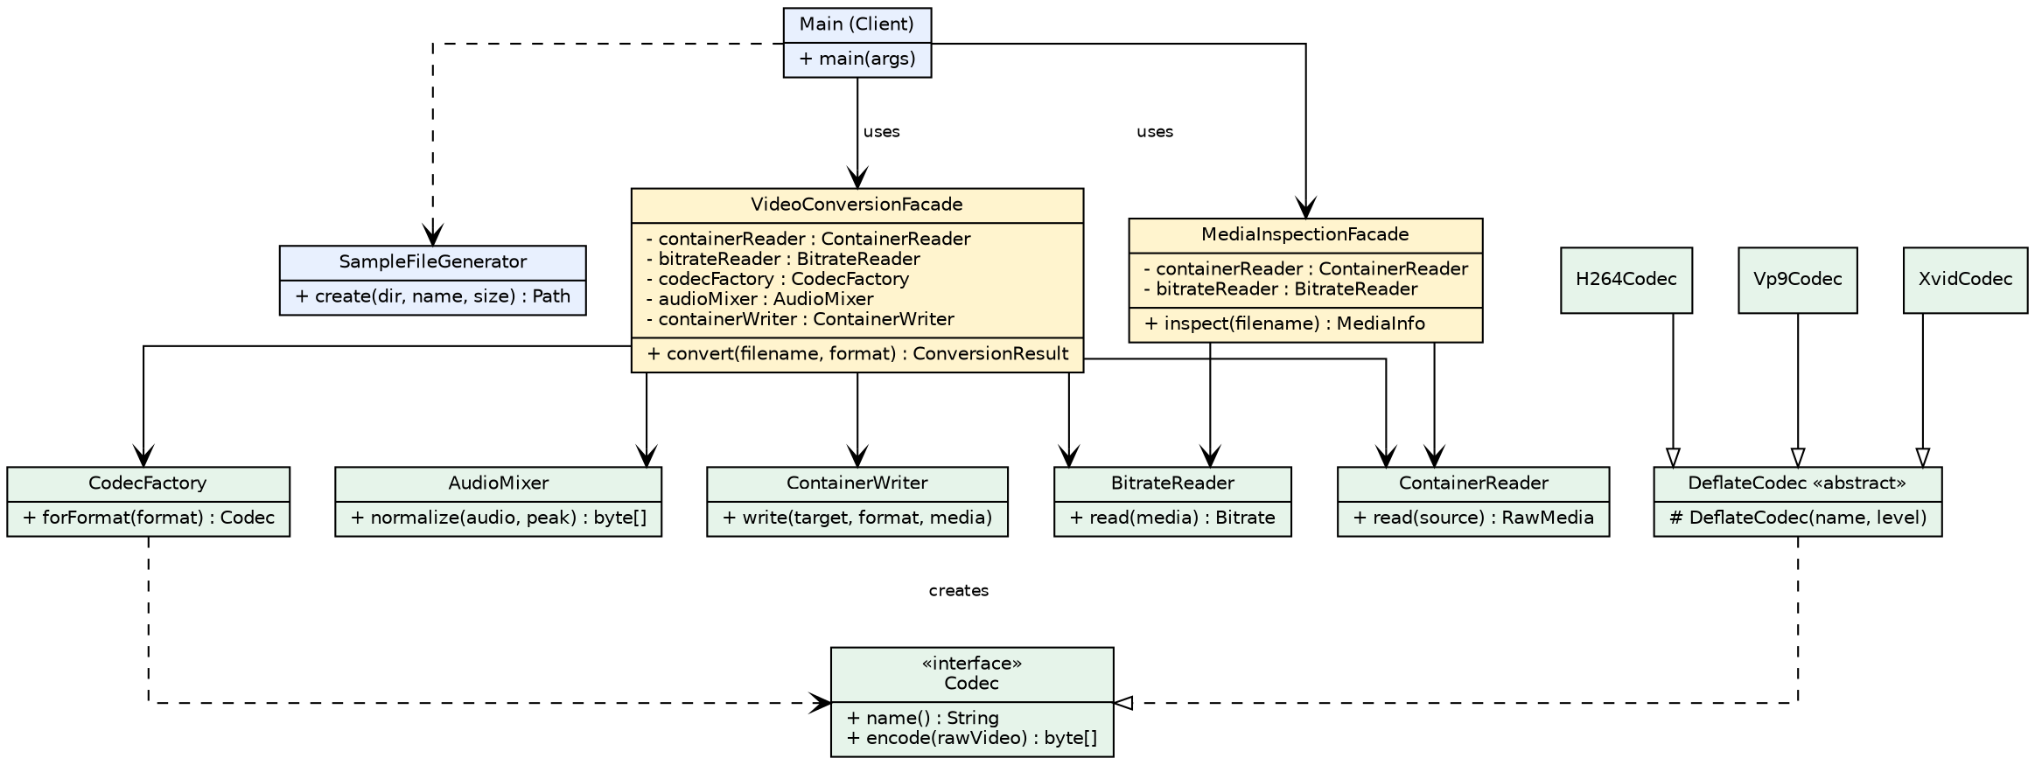
The client depends only on the two facades (and on a small helper that creates a sample file). The facades depend on subsystem classes. No subsystem class has a reference back to a facade.

3. Clean Code
Six Clean Code principles applied in the project are described below, each with a before/after excerpt.

3.1 Meaningful names
The API of the Facade should be self-explanatory. Names state intent, and constants replace anonymous numbers.
Before
VideoUtil u = new VideoUtil();
u.go("holiday.avi", "mp4", 100);
After (this project)
VideoConversionFacade converter = new VideoConversionFacade();
converter.convert("holiday.avi", "mp4");

private static final int TARGET_AUDIO_PEAK = 100;

3.2 Single Responsibility: the Facade coordinates only
The Facade decides the order of the steps but contains no compression, audio or file-format logic. All real work lives in subsystem classes.
Before
Deflater d = new Deflater(9);
d.setInput(raw);
d.finish();
After (this project)
byte[] encodedVideo = codec.encode(rawMedia.video());
byte[] mixedAudio = audioMixer.normalize(rawMedia.audio(), TARGET_AUDIO_PEAK);
containerWriter.write(output, target,
new EncodedMedia(codec.name(), bitrate, encodedVideo, mixedAudio));

3.3 No leaking of subsystem details
The public interface of the Facade uses only plain strings and facade-level types. Path handling, MediaFormat and subsystem exceptions stay hidden.
Before
public void convert(Path source, MediaFormat target)
throws MediaException, IOException, UnsupportedFormatException
After (this project)
public ConversionResult convert(String filename, String format)
throws ConversionException

3.4 Small, focused subsystem classes
Every subsystem class has one clear job and a very small public API, which makes each class easy to understand, replace and use directly.
Before
class MediaProcessor {
void read(); void measure(); void encode();
void mixAudio(); void write(); void log(); void validate();
}
After (this project)
public class BitrateReader {
public Bitrate read(RawMedia media) { ... }
}

public class AudioMixer {
public byte[] normalize(byte[] audio, int targetPeak) { ... }
}

3.5 Proper error handling
Failures are handled at the right level. The Facade fails fast for a missing file, subsystem checked exceptions are translated into one ConversionException, and invalid arguments are rejected by the subsystem itself.
Before
try { ... } catch (Exception e) { e.printStackTrace(); }
After (this project)
if (!Files.isRegularFile(source)) {
throw new ConversionException("File not found: " + filename);
}
...
} catch (MediaException | IOException e) {
throw new ConversionException("Conversion failed for " + filename + ": " + e.getMessage(), e);
}

3.6 Dependency injection and no magic values
The Facade receives its collaborators through a constructor, so subsystem parts can be replaced or tested, while a default constructor keeps the simple use case simple. Constants document every literal.
Before
int split = data.length * 3 / 4;
AudioMixer mixer = new AudioMixer();
After (this project)
private static final int VIDEO_SHARE_PERCENT = 75;

public VideoConversionFacade() {
this(new ContainerReader(), new BitrateReader(), new CodecFactory(),
new AudioMixer(), new ContainerWriter());
}

4. Conclusion
What the Facade hides: the order of the six conversion steps, the choice of codec for each format, how the container is read and written, how bitrates are measured, and the subsystem exception types. The client writes one line and receives a ConversionResult.
What remains directly accessible: all subsystem classes are public and independent of the Facade. An advanced client can still use AudioMixer, a single Codec or ContainerReader directly, for example to normalize audio without re-encoding the video. This is a defining property of the pattern, because the Facade provides a convenient entry point without restricting access.
The second facade, MediaInspectionFacade, shows that unrelated functionality can be exposed through a separate simplified interface without making the main facade grow.

5. GitHub Repository
https://github.com/[your-username]/[repository-name]

