# Remote HealthCare System using Blockchain

Sequeira Ryan Thomas (1821cs07)

Group 11

## Pre requisites

Ganache cli installed

Access to Remix IDE (<https://remix.ethereum.org/>)

## Getting started:

1. Start the ganache-cli in the directory where the project is extracted.



1. Open Remix IDE and upload **RemoteHealthcare.sol** to deploy the smart contract.

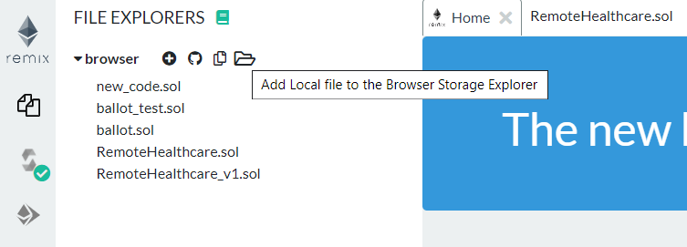

1. Connect Remix IDE with the local runtime

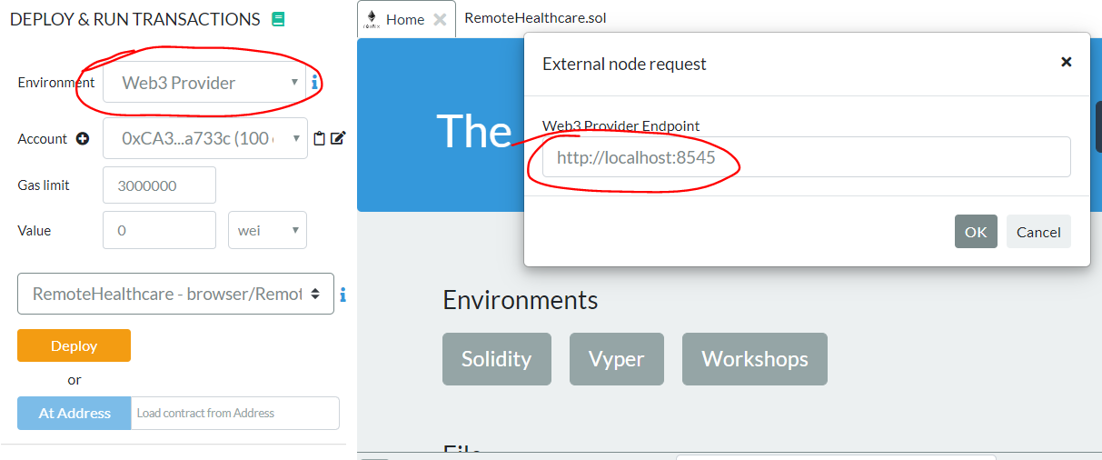

1. Deploy the smart contract as follows

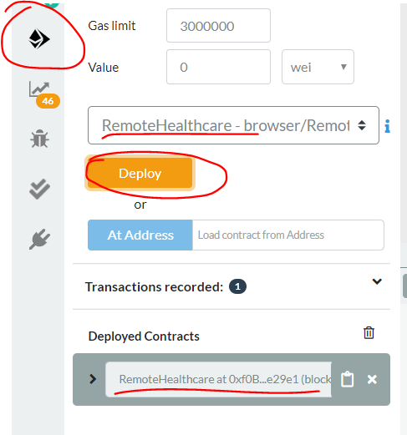

**Note**: The account selected when deploying the smart contract will be assigned as the healthcare provider.

1. The addresses for the contract and the user accounts can be obtained as follows

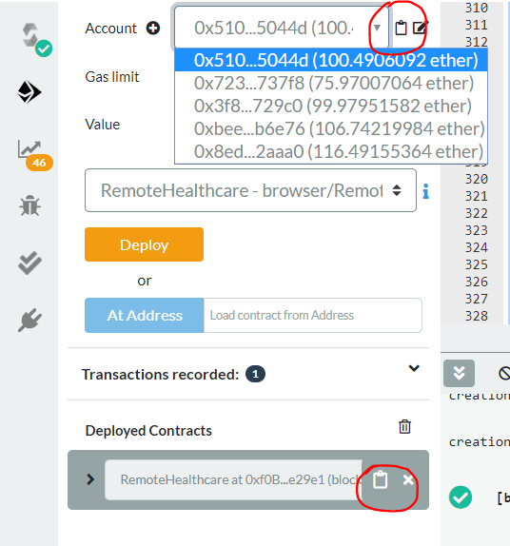

1. Finally open **login.html** in your browser to start using the project.

**Note:** If any changes are made to the solidity code, the corresponding ABI needs to be copied to contract_script.js. Use <https://www.freeformatter.com/json-escape.html> to escape the json.

# Using the app

## Creating Accounts

Using login.html, create a patient and doctor accounts. Depending on the role of the account, the user will be redirected to his homepage.

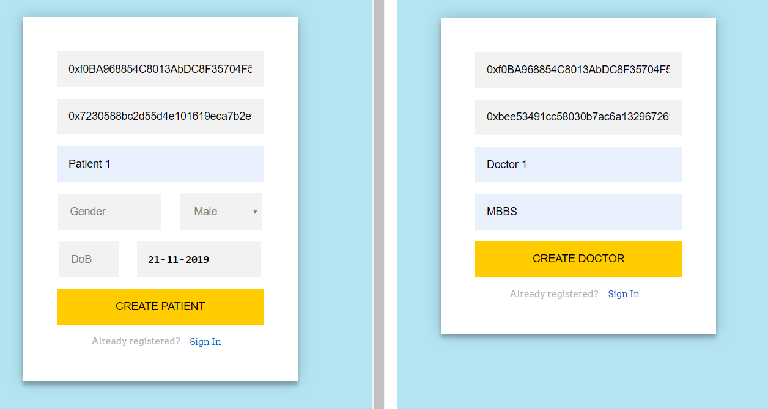

## Creating Cases

Log into the patient account and add the case as follows.

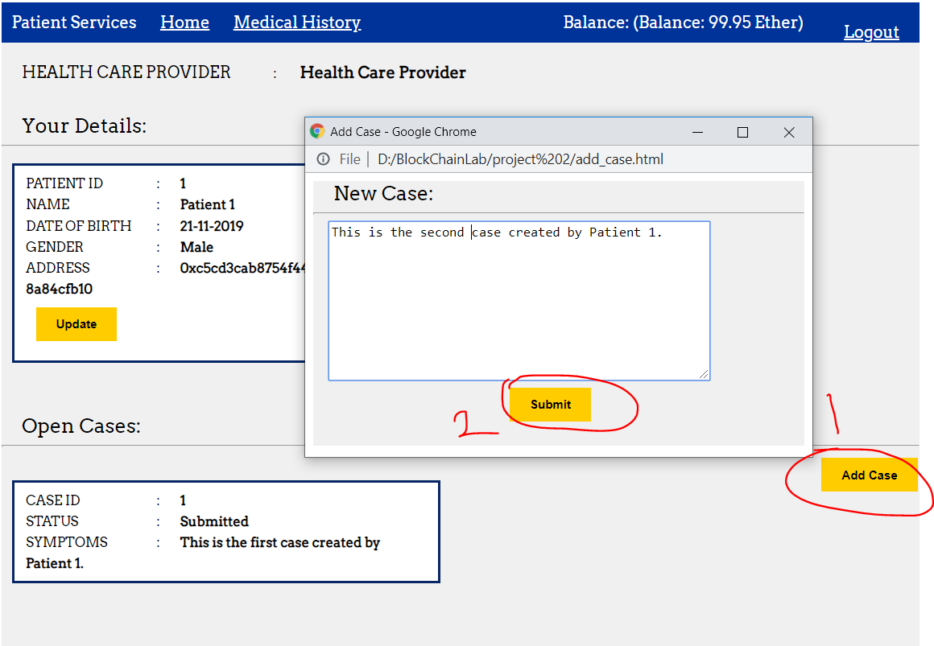

## Assigning Cases

Log into the Health Care Provider account to assign cases to Doctors as follows.

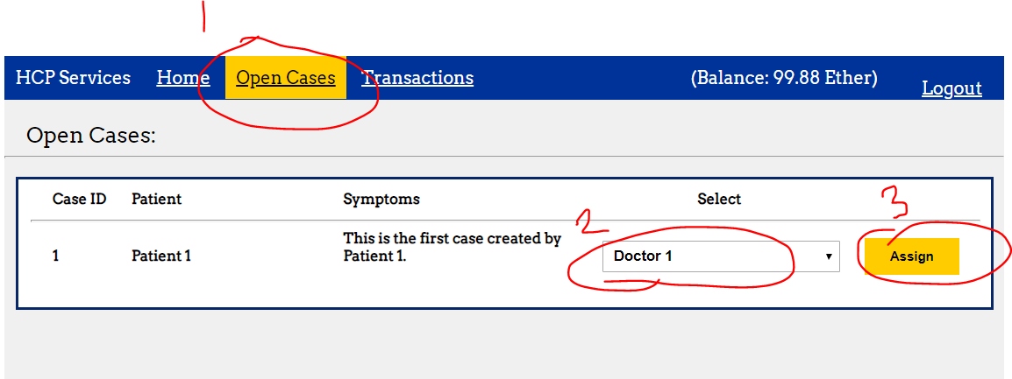

## Diagnosing Cases

Login to the respective doctor’s account to view the assigned case and diagnose it. You will also have to decide on the fee to charge the patient.

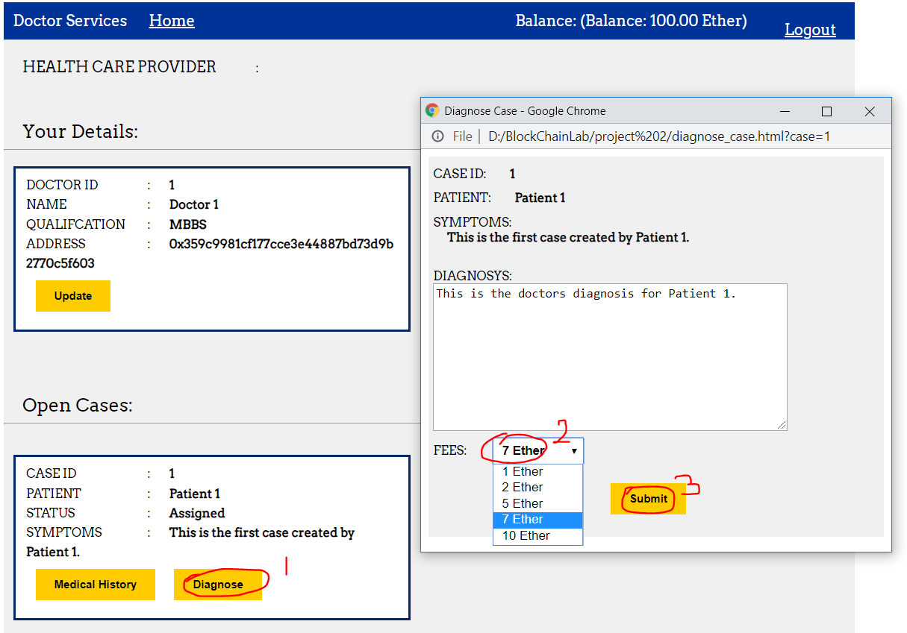

**Note**: A fixed charge of ¼ ether will be given to Health Care Provide and the remaining amount will be transferred to the doctor’s account during payment by patient.

## Payment

To pay, log into the corresponding patient account. And make the payment as follows

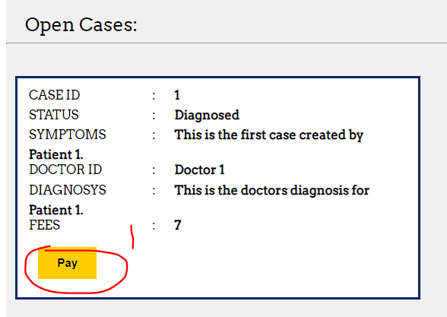

Additionally you can view open cases, pending payments and payments made using the Health Care Provider account.