Importance of Parameters and Sharpening for Edge Detection of Touching Objects via Phase Congruency

Sequoia Andrade

CSC 874: Topics in Big Data

December 17, 2022

Abstract

Schistosomiasis is a common, yet neglected, tropical parasite infecting over 230 million people globally with less than 50% of those infected receiving treatment. While there exists an effective treatment with Praziquantel, the drug does not prevent against reinfection and thus a new treatment is needed. Because drug discovery is costly, computer vision methods, specifically edge detection, can decrease the cost of drug discovery by segmenting individual parasites and accurately tracking their reaction to candidate drugs. In this paper, we explore the importance of parameters and sharpening in the phase congruency method for edge detection. Parameters are analyzed using both a qualitative and quantitative method and optimized on an idealized dataset, as well as a real-world dataset of Schistosomiasis juvenile parasites. As a result, we find the parameters do image the segmentation of touching objects, with the wavelet bank multiplier having the most. Specifically, smaller multiplier values consistently give more accurate segmented objects, while larger values fail to segment touching objects. Image sharpening is applied both pre- and post-image, with results indicating sharpening can improve segmentation of touching objects when applied to an image prior to edge detection.

# 1 Introduction

Parasitic infections affect millions of people around the world, with the greatest impact on poor nations. While increased attention has been given to viral and genetic diseases, such as cancers and influenza, there is less drug development for parasitic diseases despite the large population impacted. Schistosomiasis is a common, yet neglected [6], tropical parasite infecting over 230 million people globally with less than 50% of those infected receiving treatment [8]. Infection occurs from contact with contaminated water and is endemic in regions across sub-saharan Africa, the Middle East, South America, and Southeast Asia. [6] The parasite causes an immune response with symptoms ranging from cold-like symptoms and rash immediately after infection to liver, kidney, and spleen enlargement and failure in chronic untreated cases [6, 8]. Praziquantel is the recommended form of treatment and helps manage adult parasites in infected persons, although the drug does not prevent re-infection. As a consequence, there is a need to develop a more effective treatment for Schistosomiasis. Drug development is a costly process which involves multiple stages, including identifying candidate compounds, performing large scale experiments, and clinic trials. Computer science algorithms have great potential for aiding in this process and ultimately reducing cost.

Computer vision algorithms, specifically edge detection methods, can be used to quickly and accurately identify which candidate treatments are most effective on parasites. Instead of having an expert manually look at parasites to determine if a candidate treatment is impacting them, edge detection can outline each parasite, enabling a clear mapping of treatment effects. Different methods exist for edge detection, including gradient based methods, deep-learning methods, and the phase congruency method. Edge detection of simple objects is straightforward; however, parasite datasets are often complex and contain multiple instances of parasites touching and overlapping. In turn, conventional edge detectors tend to struggle with segmenting these touching objects. Previous work has demonstrated phase congruency methods, and in particular the Asarnow-Singh variation, outperform gradient based methods, specifically on touching objects. While the Asarnow-Singh method is effective, there is still room for improvement in cases of touching parasites. Improving accuracy of parasite segmentation even slightly can in turn result in more accurate screening of potential treatments.

To this end, in this paper we explore potential methods for improving image segmentation of touching objects by modifying the phase congruency method. Two main modifications are explored: 1) parameter tuning, and 2) image sharpening. Results indicate that the phase congruency parameters do in fact have a large impact

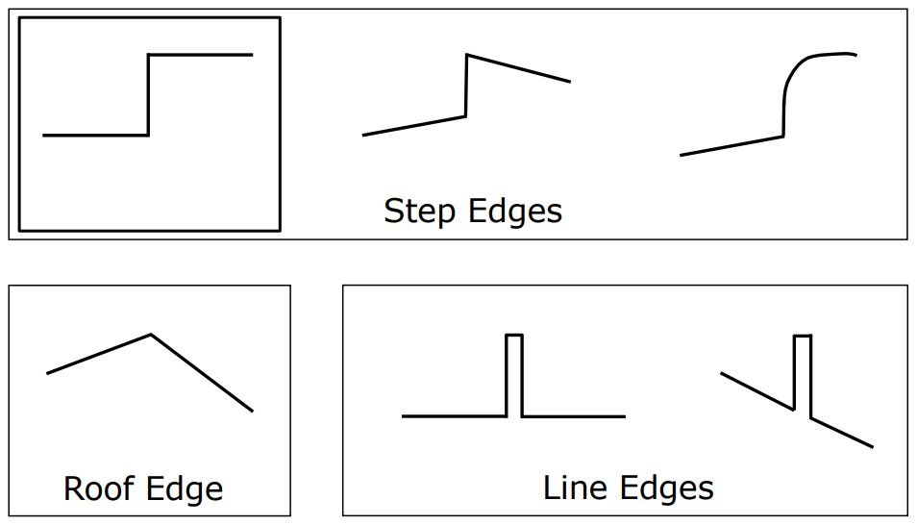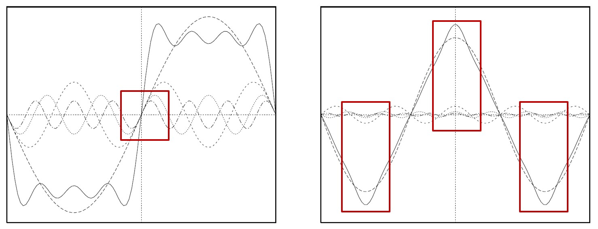

Figure 2: Example of 1-D signals and their Fourier Figure 1: Examples of step, line, and roof edges, Series, from [4]. Locations with high phase congruency from [7]. are outlined with the red boxes.

on results, especially when considering touching objects. Using a smaller wavelet bank multiplier consistently results in better segmentation of touching objects. Additionally, image sharpening is considered when applied both pre- and post-edge detection. Experimental findings suggest applying sharpening to images prior to edge detection can improve the segmentation of touching objects. The following section include an overview of relevant background information, with a focus on edge detection, phase congruency, and touching objects. Next, the datasets used in this research are discussed, followed by and overview of the methods used. Results are presented, followed by a discussion and conclusion.

# 2 Background

## 2.1 Edge Detection

Edge detection is a subset of computer vision centered around the recognition of object edges in images. While edges can easily be recognized by human observers, they are much more difficult for a computer to detect. Edges can be formally defined as discontinuities or areas with rapid change within an image. There are different types of edges, including step edges, line edges, and roof edges, as shown in Figure 1. Edge detectors should then be able to identify edge position, edge strength or magnitude, and edge orientation or direction. Simultaneously, the computation performance, accuracy, localization, and sensitivity to noise must be considered when evaluating an edge detector.

There is a variety of edge detection methods, including deep learning architectures such as auto-encoders and gradient based methods. One of the best performing gradient-based methods is the Canny edge detector [2]. The Canny edge detector is a multi-step detector that begins by smoothing an image with a Gaussian filter, then applying the Sobel filter to calculate the image gradient. Then, the Laplacian is calculated along the direction of the gradient and zero-crossings are identified as edge locations. Typically after this process, edges are filtered using a hysteresis thresholding method, where a pixel is an edge if it is above a threshold, *T*1, not and edge if it is below a second threshold, *T*2, and if the pixel value is greater than *T*2 but less than *T*1 then it is only an edge if the neighboring pixel is an edge. The Canny detector performs satisfactory on a variety of cases; however, Asarnow and Singh have demonstrated that the phase congruency method outperforms the Canny detector when objects are touching [1].

## 2.2 Phase Congruency for Edge Detection

The Phase Congruency method for edge detection was developed by Peter Kovesi in the 1990s in accordance with the theory of local energy accounting for humans’ perception of edges [4]. Essentially in this method images are considered as 2-D signals which have corresponding Fourier Series. Edges then occur at locations with high local energy, which happens to be locations where the components of the Fourier Series are in maximum congruency. In Figure 2, the locations of with maximum phase congruency are outlined with red boxes. Phase congruency is formally defined according to Equation (1); however, this equation is impossible to solve for in this form and instead Kovesi derives a method for phase congruency using local energy [4].

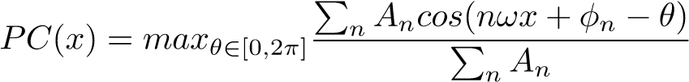 (1)

Because the input is an image, the Fourier components and their corresponding amplitudes, *An*, are estimated using a bank of wavelet filters. Wavelets in the bank include both odd and even wavelets and are scaled (logarithmically), thus each wavelet detects specific frequencies. This particular application uses log Gabor waves, which are sine and cosine waves modulated by a Gaussian. Hence, these Gabor waves are in quadrature and allow for the calculation of both amplitude and phase. Using the relationship between local energy and phase congruency, Kovesi defines phase congruency according to Equation (2), where *x* is th pixel of interest, W(x) is a weighting based on the spread of the frequencies, *δφn*(*x*) is the phase deviation, *T* is the noise circle estimated using the smallest wavelet, and *n* is the number of wavelets in the bank. This method is implemented in MATLAB and has corresponding parameters that can be tuned to refine the edge detection output. The MATLAB implementation does provide default parameters and reasonable ranges, nonetheless parameter tuning is explored in this paper. After calculating the phase congruency for an image, non-maxima suppression and hysteresis thresholding are recommended to better define edges.

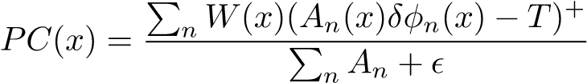 (2)

In contrast to the gradient-based Canny detector, the phase congruency method does not apply any preprocessing to an image, such as smoothing or sharpening. With this in mind, one of the contributions of this paper is applying sharpening in the phase congruency pipeline.

## 2.3 Sharpening

Sharpening is the complement of smoothing in image processing as it aims to enhance changes and differences throughout an image. One of the benefits of sharpening is that weakly defined edges become stronger to both a computer and a human. Edges appear salient in human perception primarily due to an illusion, which is especially evident with Mach bands [5]. That is, the perceived difference between similar colored bands or objects becomes more distinct to humans as two objects become closer, with a clear edge present when two objects are touching regardless of the true color similarity. As two objects or bands of color become more distance, the difference between them is less salient. Hence, edges that are quite clear to humans can be difficult for computers to detect because the true color difference is minuscule. One method to overcome this issue is to apply unsharp masking, a specific form of image sharpening [9]. This method of sharpening subtracts a blurred version of an image from the original, then adds that result to the original image to get an output image with sharpened features. Unsharp masking is congruent with how humans define edges in situations such as Mach bands and results in an image with better defined edges. Thus, it naturally follows that adding sharpening to the image processing pipeline would assist in edge detection.

# 3 Datasets

Two datasets are used to evaluate the impact of parameters on edge detection using the phase congruency method. First, an idealized dataset is created to examine which parameters have the greatest impact on touching objects. A second dataset of schistosomiasis juvenile parasites is also used to determine parameters are relevant for real world datsets. Both datasets focus on the point where two objects are in contact

## 3.1 Idealized Dataset

The idealized dataset is created by considering combinations of edge types and shapes. Five experimental datasets are created with six frames each, show in Figure 3, where each row shows the images for one experiment. Throughout the six frames of each experiment, shapes are moved progressively closer until they are touching, then they are moved away. The first experiment in the first row consists of two squares with line edges, whereas the second experiment in row two includes two squares with step edges. The third experiment includes one step edge and one line edge square. An oval and a square with step edges create the fourth experiment in order to examine how different shapes impact edge detection. The final experiment includes three squares all with line edges to analyze the impact of multiple touching objects. This idealized dataset is used to analyze the impact of parameters both qualitatively and quantitatively.

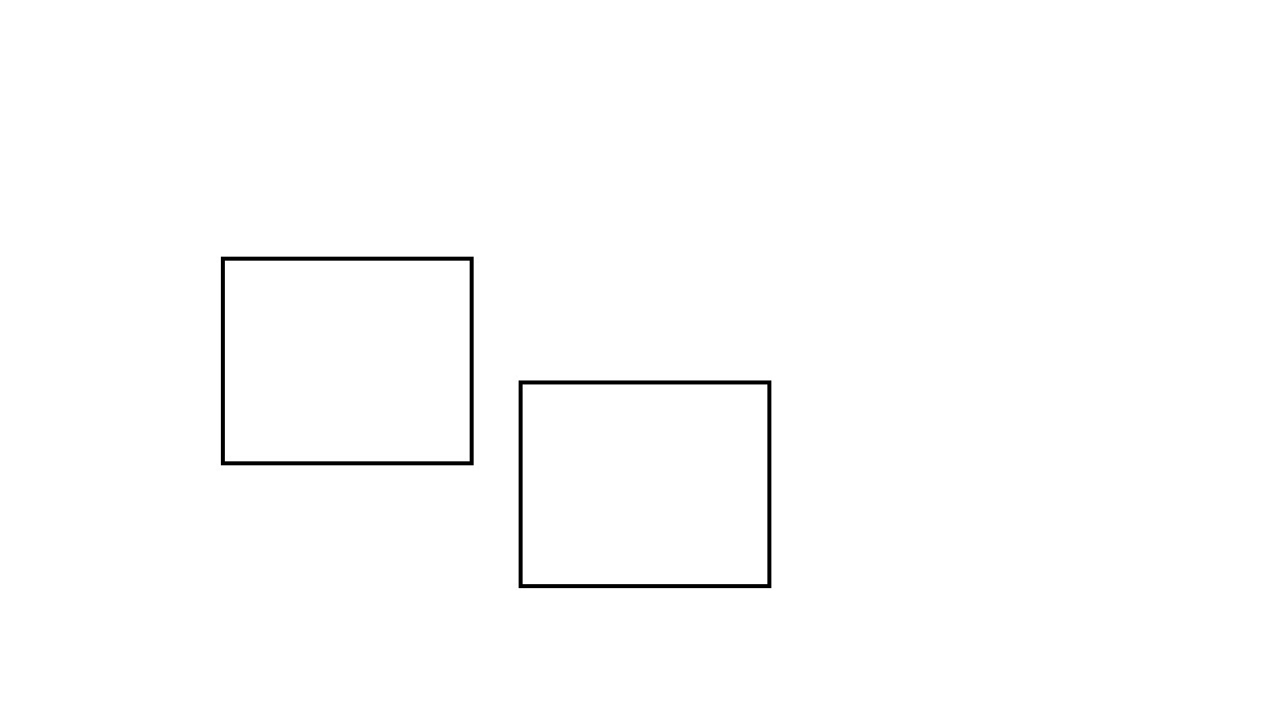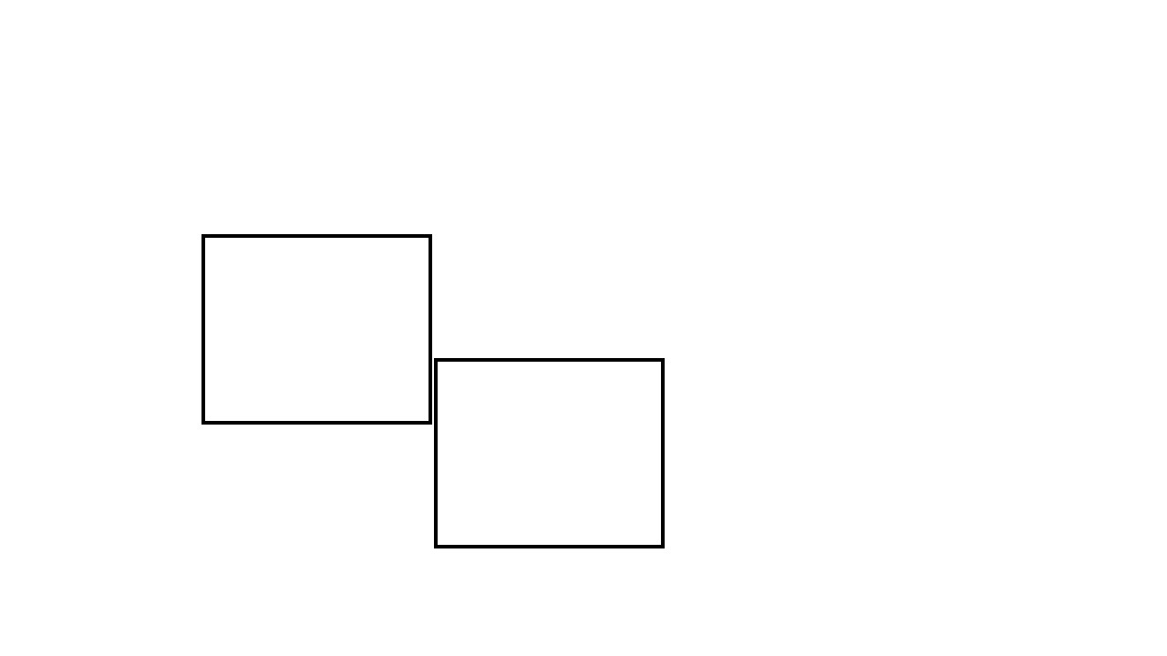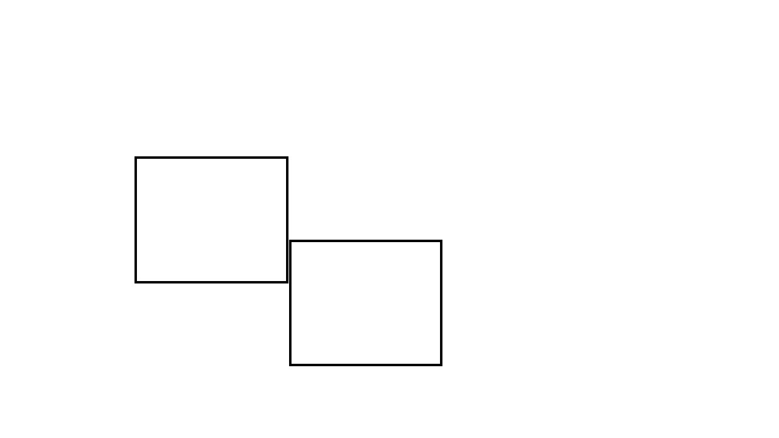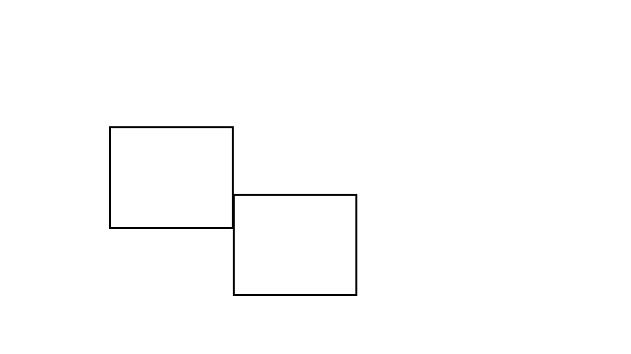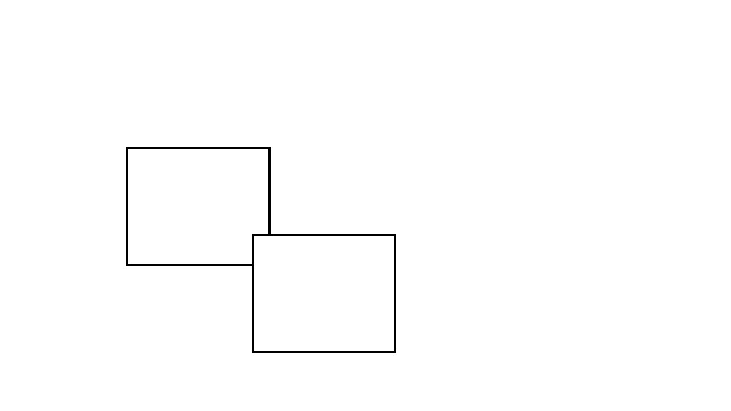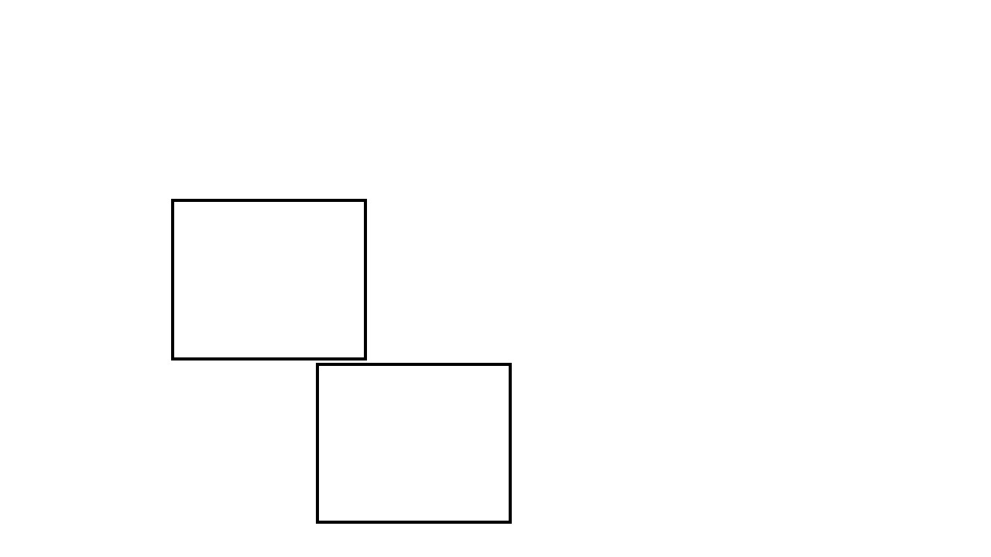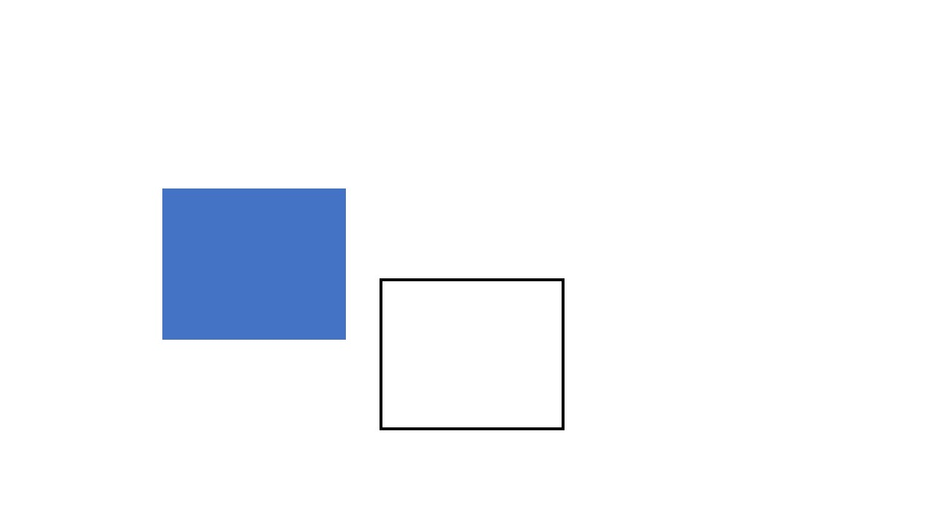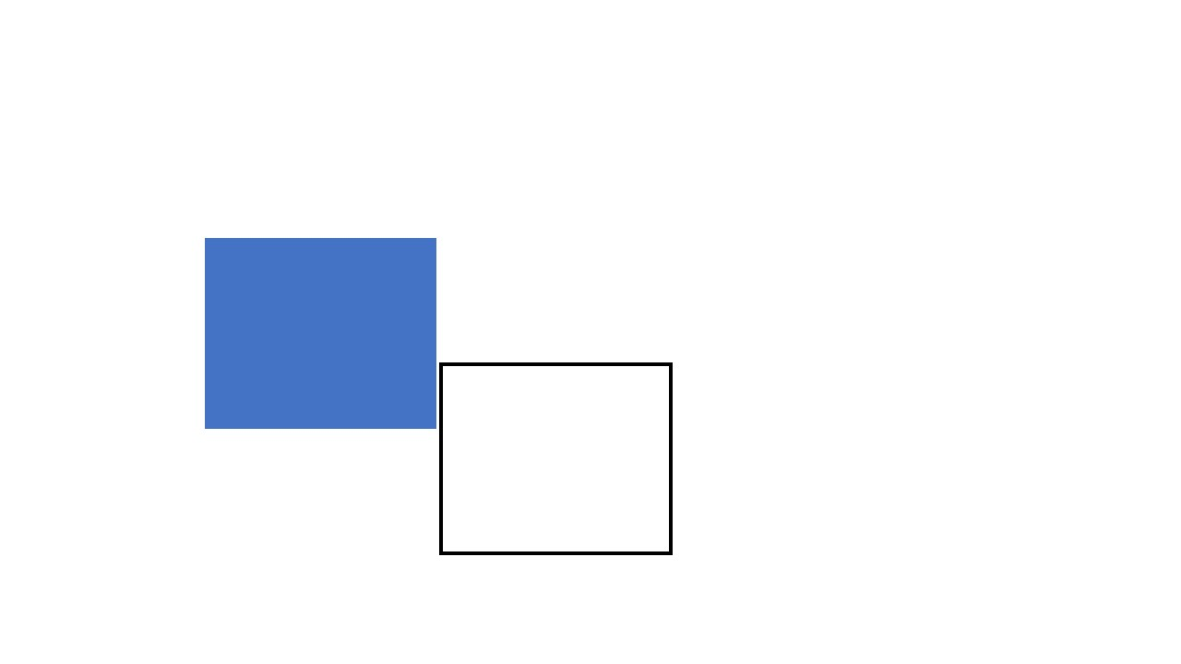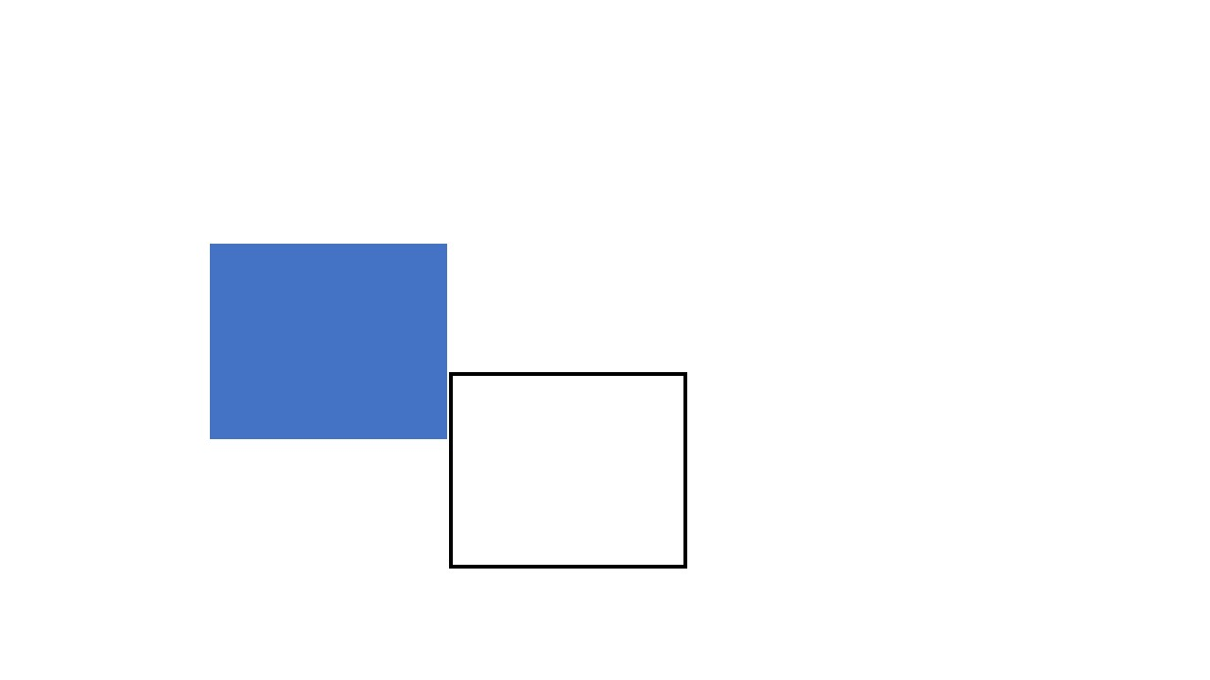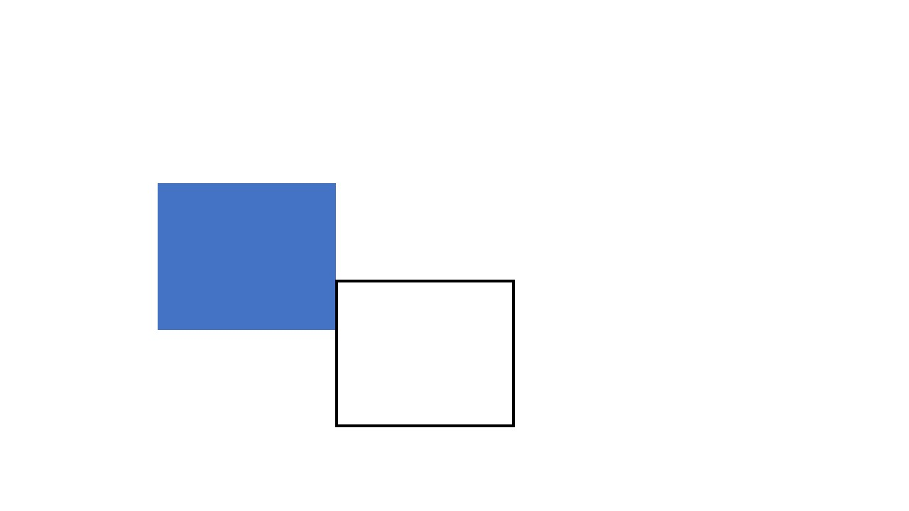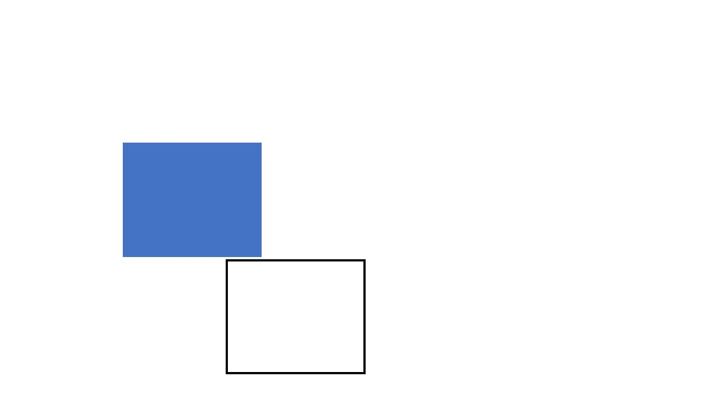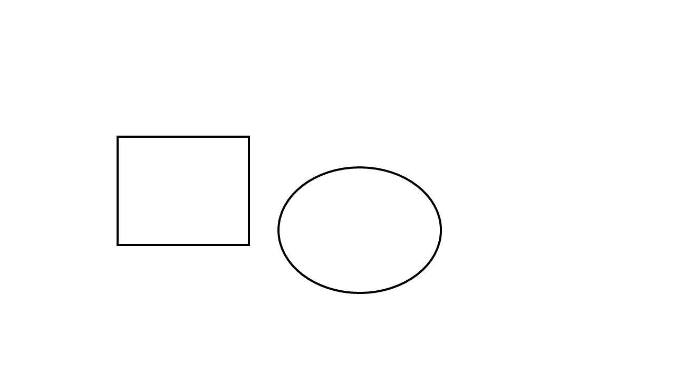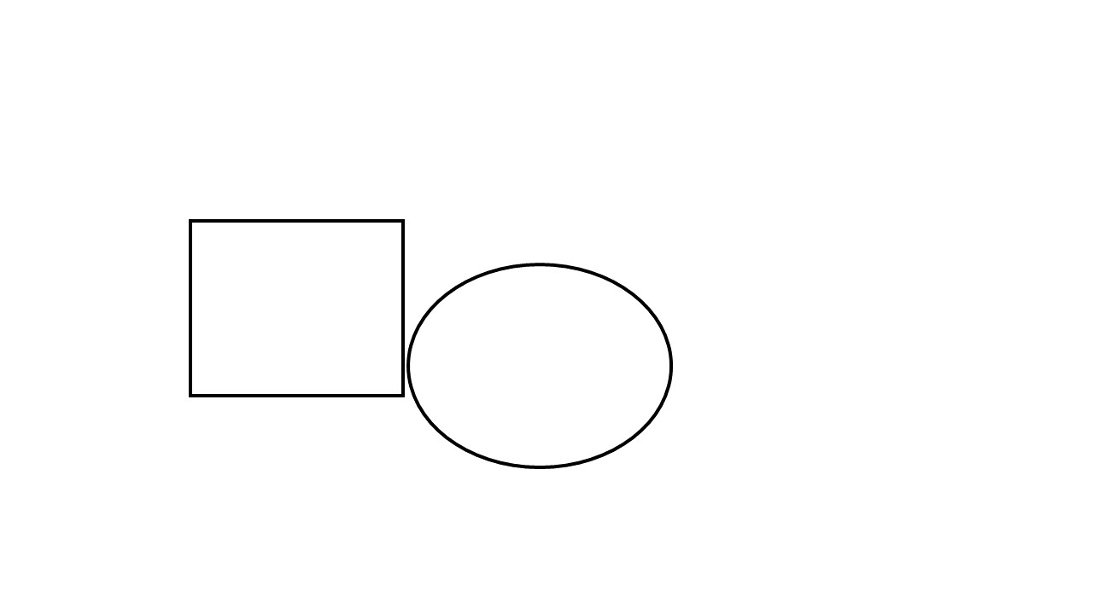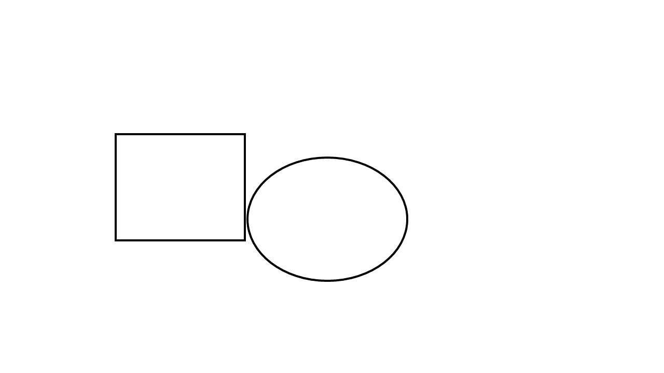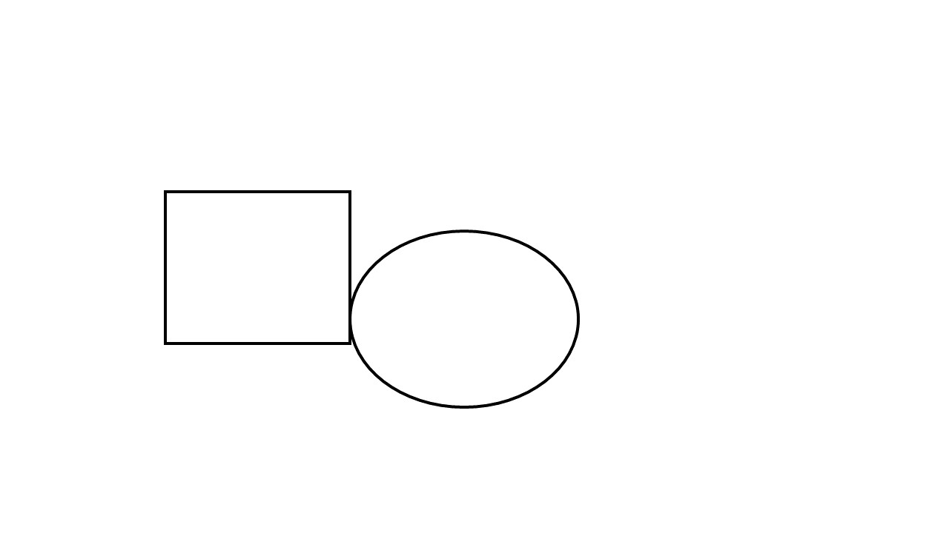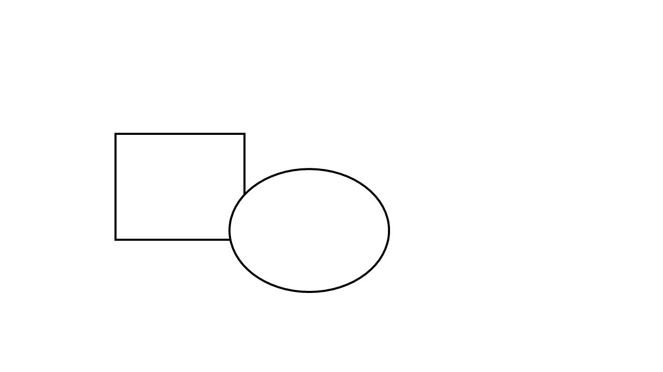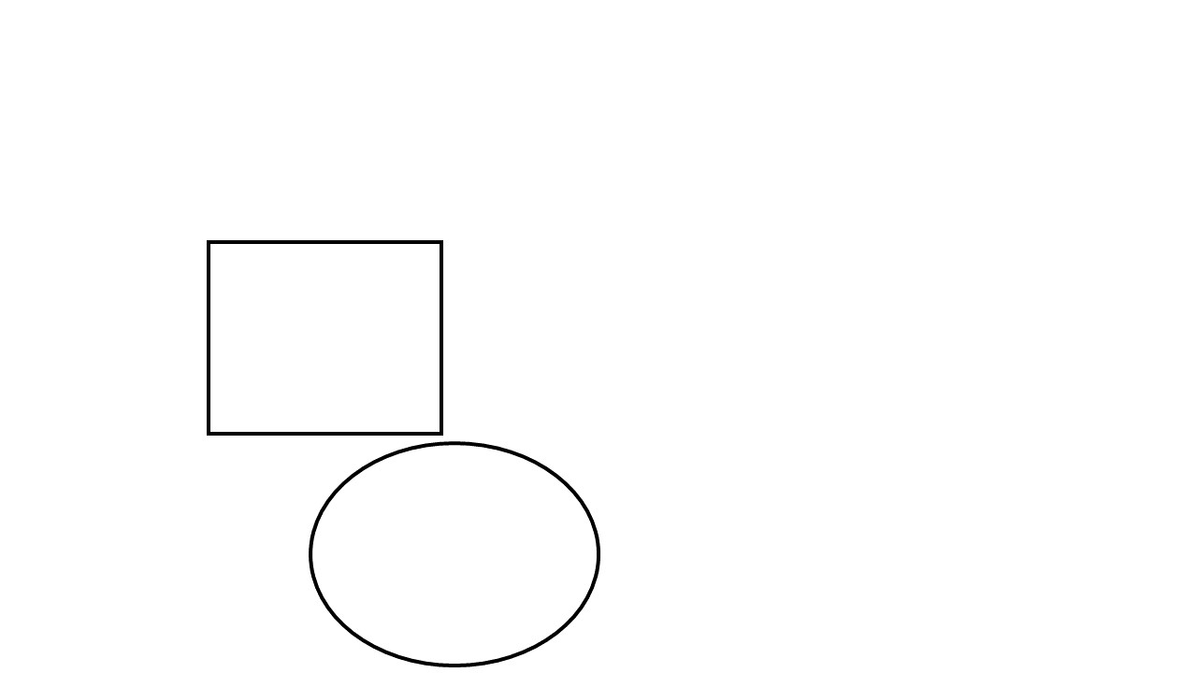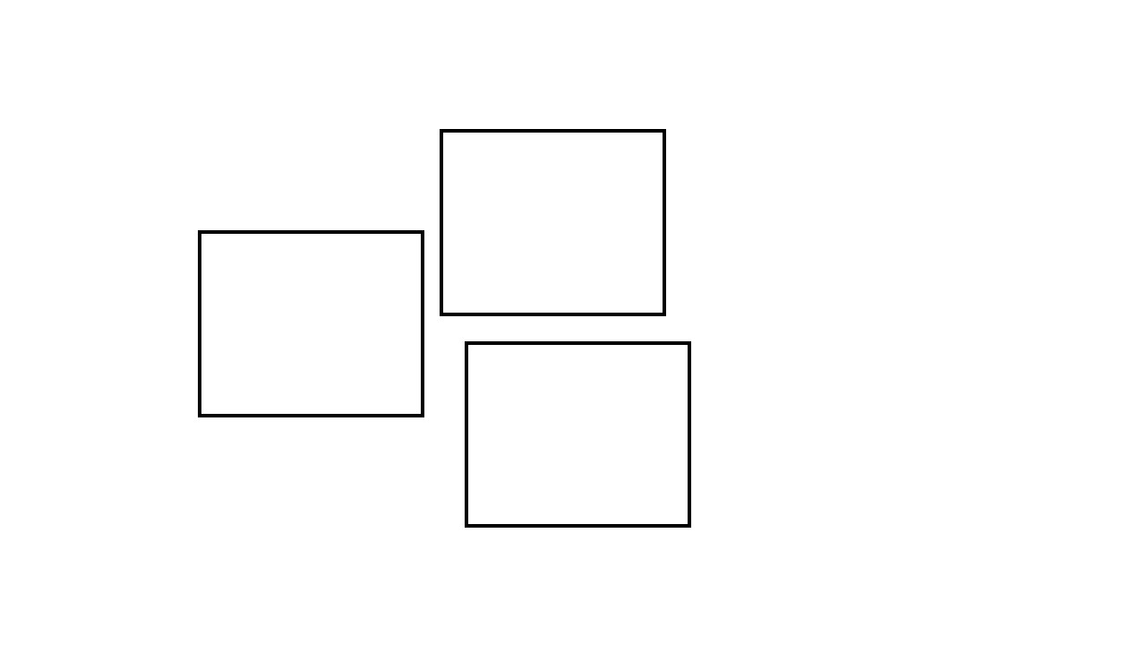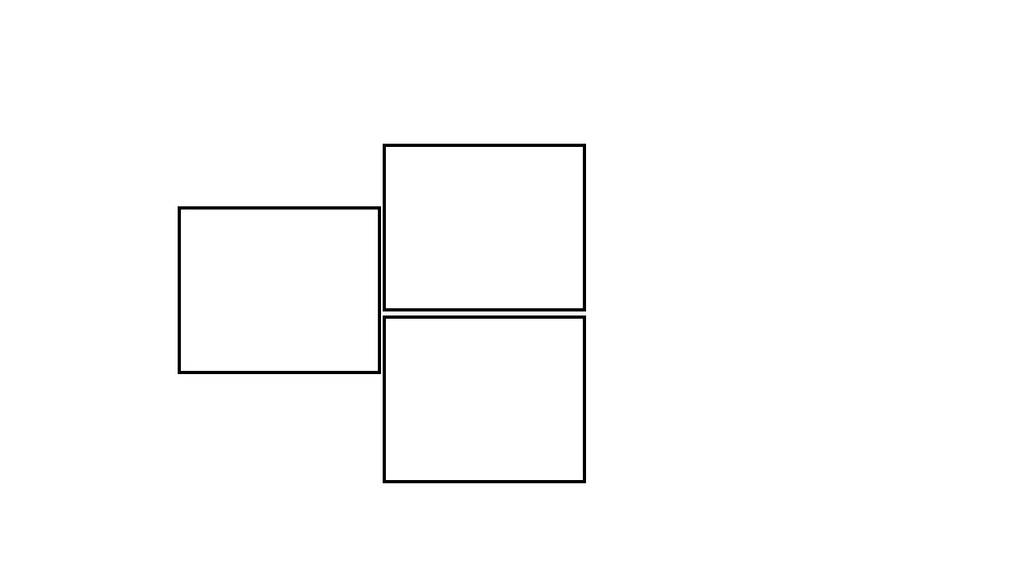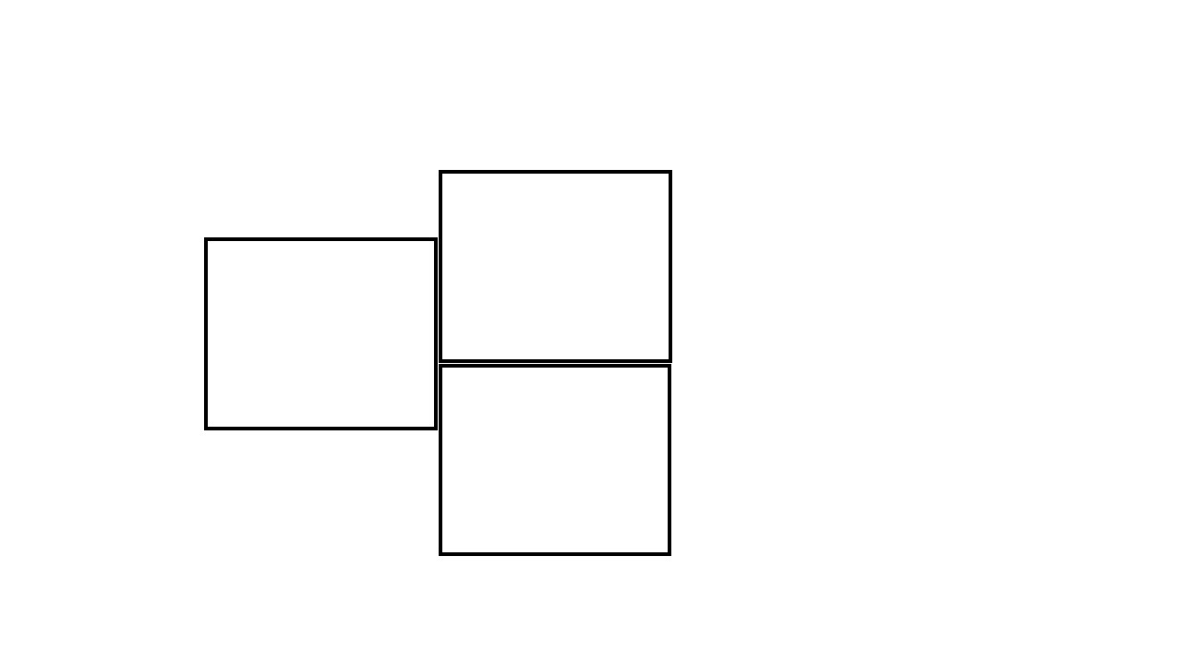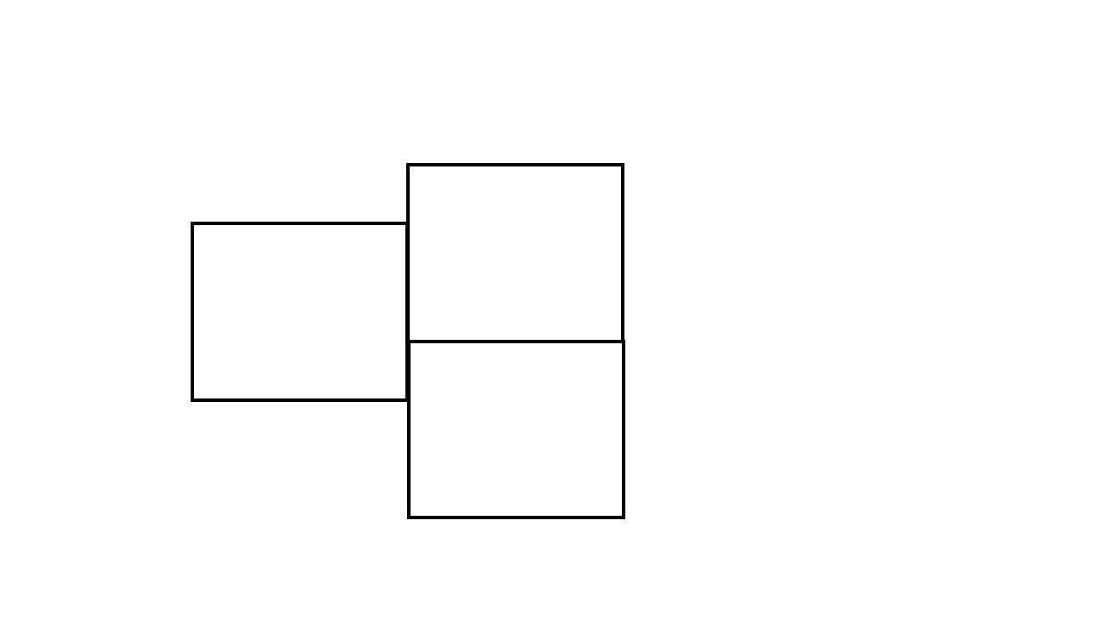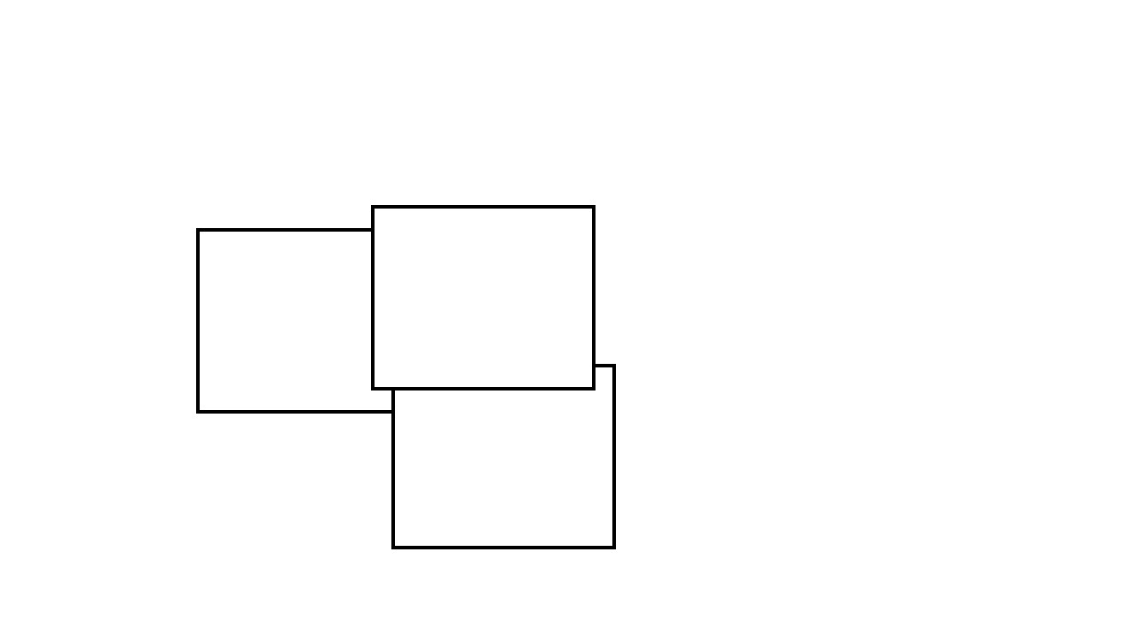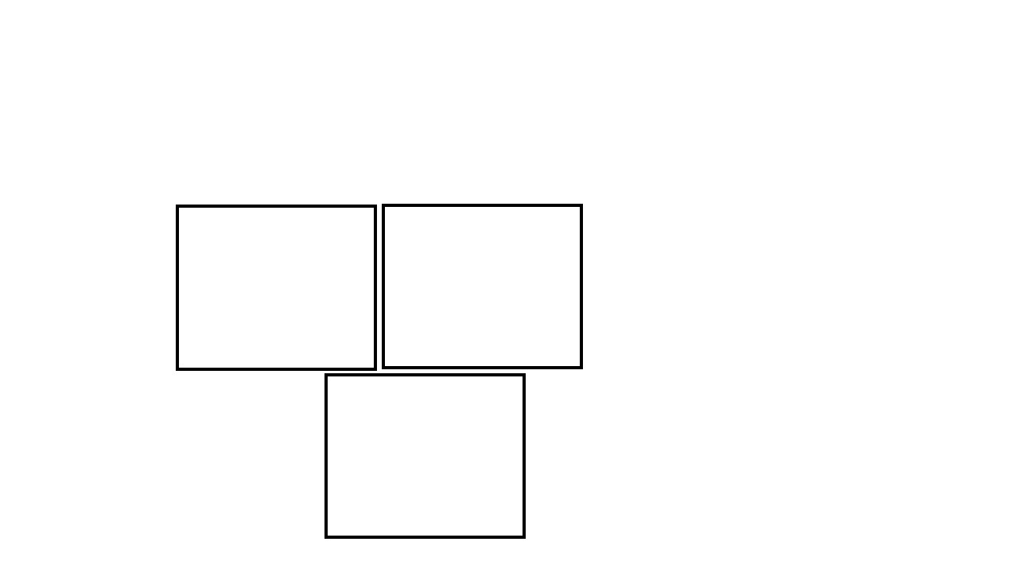

Figure 3: Idealized dataset consisting of five experiments with six frames in each experiment. Each row is one experiment.

## 3.2 Parasite Dataset

The second dataset used in this paper is a dataset of juvenile Schistosoma parasites when exposed to ten different treatments along with a control. Each treatment group has five images taken as frames from an observational video. This datset consists of both raw grey scale images, as well as black and white images segmented using the Asarnow-Singh method [1]. When evaluating parameters and sharpening methods quantitatively, the segmented images are considered the ground truth for mean squared error calculations.

# 4 Method

In this paper, two main analyses are conducted: 1) parameter tuning, and 2) the effect of sharpening.

## 4.1 Parameter Tuning

Parameter tuning is performed in two stages, and the set of all parameters is found in Table 1. The “mult” and “deviation gain” parameters are the focus because of there potential to influence edge detection of touching objects. The first stage involves a qualitative analysis to visually determine relevant parameters and the second stage includes a quantitative analysis to explicitly confirm results from the first stage. In the qualitative analysis, only the ideal dataset is used for simplicity. Both the ideal dataset and the parasite dataset are used in the quantitative analysis.

4.1.1 Qualitative Analysis

The qualitative analysis is performed according to Figure 4, where the dataset creation refers to the idealized dataset. After creating the complete ideal dataset, each of the experiments are tested to find the best parameter values for the wavelet scaling factor (i.e., mult) and the phase deviation amplification (i.e., deviation gain). The datasets are tested over the set of combinations from the scaling factor and phase deviation ranges in Table 1, resulting in a total of nine parameter combinations tested for each of the five experiments. Phase congruency is performed for each image to produce edges, then the set of images is saved as an animation for manual visual analysis. Visual analysis is performed by examining the true dataset animation compared to the phase congruency animation, as well as comparing individual images. Special attention is given to regions of touching edges, the thickness of edges, and any incorrect edges identified by phase congruency. From this process, it is possible to qualitatively identify the best parameters.

Table 1: Parameters, definitions, and tested ranges for phase congruency.

|  |  |  |
| --- | --- | --- |
| Parameter | Definition | Range |
| Nscale | number of filters/scales to use to calculate PC | 3, 4, 5 |
| minWaveLength | wavelength of smallest scale filter | 2, 3, 4 |
| Mult | scaling factor between successive filters | 1.5, 2.1, 2.5 |
| sigmaOnf | ratio of the standard deviation of the gaussian to the filter center frequency for the bank of filters | 0.45, 0.55, 0.65 |
| K | number of standard deviations noise energy must be above . | 1, 3, 10, 15 |
| cutOff | fractional measure of frequency spread below which phase congruency values get penalized | 0.4, 0.5, 0.6 |
| G | controls the sharpness of the transition in the sigmoid function used to weight phase congruency for frequency spread | 5, 10, 15 |
| deviationGain | amplification to apply to the calculated phase deviation result, sharpens edges | 1, 1.5, 2 |
| NoiseMethod | method for noise statistics (median, mode, none) | -2, -1, 1 |

**Phase II Method**

**Dataset Creation**

Experiment 1

Experiment 2

Experiment 3

Experiment 4

Experiment 5

**Perform Experiment**

Identify Best

Parameters

Perform Phase

Congruency

**Results Output**

Save Animation of

Phase Congruency

Analyze Results

Figure 4: Qualitative analysis method performed on the ideal dataset.

4.1.2 Quantitative Analysis

While the qualitative analysis provides some intuition about the impact of parameters on detecting edges of touching objects, the method is subjective and not rigorous. It is also unclear if the qualitative results are consistent when other parameters are varied. As a consequence, a quantitative parameter analysis is performed according to Algorithm 1. In Algorithm 1, we first take a parameter from Table 1, labeled *Pi*, and ensure it has a range of values to test for. Then, for each combination of the wavelet scaling factor, deviation gain, and the values of the parameter of interest a phase congruency edge detector is constructed and applied to the set of input images. Here the mean squared error (MSE) is calculated to determine the performance of the edge detector, with MSE defined in Equation (3) where *Yi* is the true image and *Y*ˆ*i* is the edges detection image produced by phase congruency.

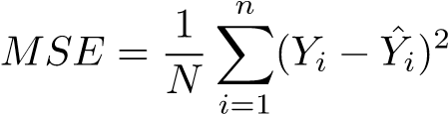 (3)

The MSE is calculated for each of these combinations, then a MSE range is constructed for each of the parameters of interest. Hence, this algorithm is a modification of a conventional grid search for parameter tuning. This quantitative parameter tuning algorithm is applied to both the ideal dataset and the entire parasite dataset to identify the best parameters for each and confirm results from the qualitative analysis.

Algorithm 1 Parameter Tuning Algorithm

Ensure: parameter ranges, *Pi*, are defined

*multVals* ← [1.5*,* 2*.*1*,* 2*.*5]

*deviationGainVals* ← [1*,*1.5 ,2]

*Pi* ← [*val*1*,...*]

for *mult* in *multVals* do

for *deviationGain* in *deviationGainVals* do

for *Pi* in parameters do

for *val* in *Pi* do

perform phase congruency

calculate MSE

end for

calculate MSE range= [*min*(*MSE*)*,max*(*MSE*)]

end for

record range values in table

end for

end

## 4.1 Sharpening

After finding the best parameters for the parasite dataset, the impact of sharpening on edge detection is tested using the two proposed pipelines in Figure 5. The first proposed pipeline, Method 1, applies sharpening post-phase congruency to thin or sharpen the phase congruency output. Thus, sharpening in Method 1 could improve edge detection by post-processing. In contrast, Method 2 applies sharpening to the input image prior to phase congruency to enhance the edges in the final output. Applying sharpening to an image prior to phase congruency can increase detail in an image, in turn creating more frequencies in the Fourier representation and improving edge detection. A control of regular phase congruency with the same parameters is also performed to evaluate results. Both methods and the control are tested over the complete set of parasite images.

# 3 Results

## 3.1 Parameter Tuning

Overall parameter tuning indicates the wavelet scaling factor, or “mult” parameter, has a significant impact on edge detection for touching objects. In particular, both the qualitative and quantitative analysis indicate large scaling factors result in poorer edge detection while smaller values improve edge detection. Intuitively it is logical that large values of the wavelet scaling factor produce worse results as larger values decrease the range of frequencies phase congruency can identify. Results are more mixed for the phase deviation amplifier, yet larger values tend to give worse results. That is, larger wavelet scaling values capture global features, where as smaller values capture local features, such as edges between touching objects. Figure 6 shows an example output of parasite images, with Figure 6b using small scaling and deviation gain values and Figure 6c using larger scaling and deviation gain values.

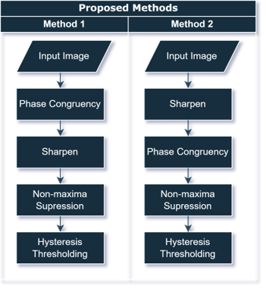

Figure 5: Two methods tested for analyzing the impact of sharpening.

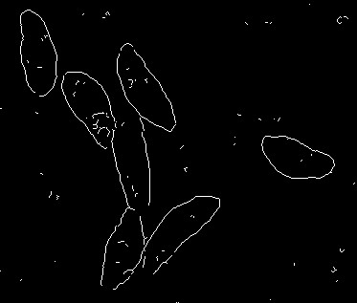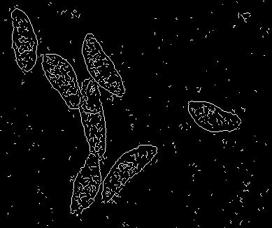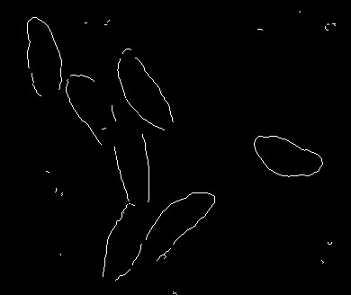

(a) Image Segmentation with default (b) Image segmentation with the best (c) Image segmentation with worst parameters. parameters. parameters.

Figure 6: Results from quantitative parameter tuning on the parasite dataset.

The impact that the scaling factor has tends to be consistent across ranges of other parameters for the ideal and parasite dataset. Quantitative results for the ideal dataset are shown in Table 2. Small values of MSE are considered better, so entries with lower minimum and maximum values indicate better performance. Smaller range values imply that the parameter has less of an impact and large range values entail the parameter has a larger impact on performance. From Table 2 it is clear that the columns with mult=1.5 have the lowest MSE values. Similarly, columns with smaller deviation gain have lower MSE values compared to those with the maximum deviation gain. Deviation gain also may impact the range, as the last column in Table 2 has a larger range compared to the first. Overall the MSE scores and ranges are fairly consistent, but the Nscale, k, and G parameters tend to give the best MSE scores when paired with the scaling factor and deviation gain.

Table 2: MSE results from parameter tuning the ideal dataset. Each cell contains the minimum MSE, maximum MSE, and range for each parameter.

|  |  |  |  |  |  |  |  |  |  |  |
| --- | --- | --- | --- | --- | --- | --- | --- | --- | --- | --- |
| Parameter | Metric | Deviation Gain=1 | | | Deviation Gain=1.5 | | | Deviation Gain=2 | | |
| mult=1.5 | mult=2.1 | mult=2.5 | mult=1.5 | mult=2.1 | mult=2.5 | mult=1.5 | mult=2.1 | mult=2.5 |
| nscale | min | 1.012 | 1.012 | 1.012 | 1.012 | 1.012 | 1.012 | 1.012 | 1.012 | 1.012 |
|  | max | 1.696 | 1.703 | 1.706 | 1.693 | 1.699 | 1.711 | 1.691 | 1.704 | 1.718 |
|  | range | 0.68 | 0.69 | 0.69 | 0.68 | 0.69 | 0.7 | 0.68 | 0.69 | 0.71 |
| minWave | min | 1.012 | 1.012 | 1.012 | 1.012 | 1.012 | 1.012 | 1.012 | 1.012 | 1.012 |
| Length | max | 1.704 | 1.707 | 1.709 | 1.701 | 1.704 | 1.711 | 1.697 | 1.705 | 1.714 |
|  | range | 0.69 | 0.69 | 0.7 | 0.69 | 0.69 | 0.7 | 0.68 | 0.69 | 0.7 |
| sigmaOnf | min | 1.014 | 1.012 | 1.012 | 1.012 | 1.012 | 1.012 | 1.012 | 1.012 | 1.012 |
|  | max | 1.697 | 1.702 | 1.708 | 1.692 | 1.704 | 1.712 | 1.69 | 1.711 | 1.718 |
|  | range | 0.68 | 0.69 | 0.7 | 0.68 | 0.69 | 0.7 | 0.68 | 0.7 | 0.71 |
| k | min | 1.016 | 1.012 | 1.012 | 1.016 | 1.012 | 1.012 | 1.012 | 1.012 | 1.012 |
|  | max | 1.686 | 1.702 | 1.703 | 1.684 | 1.697 | 1.7 | 1.683 | 1.697 | 1.704 |
|  | range | 0.67 | 0.69 | 0.69 | 0.67 | 0.68 | 0.69 | 0.67 | 0.68 | 0.69 |
| cutOff | min | 1.016 | 1.012 | 1.012 | 1.016 | 1.012 | 1.012 | 1.012 | 1.012 | 1.012 |
|  | max | 1.696 | 1.705 | 1.708 | 1.691 | 1.702 | 1.71 | 1.688 | 1.706 | 1.714 |
|  | range | 0.68 | 0.69 | 0.7 | 0.68 | 0.69 | 0.7 | 0.68 | 0.69 | 0.7 |
| g | min | 1.016 | 1.012 | 1.012 | 1.016 | 1.012 | 1.012 | 1.012 | 1.012 | 1.012 |
|  | max | 1.685 | 1.703 | 1.705 | 1.685 | 1.699 | 1.704 | 1.683 | 1.698 | 1.707 |
|  | range | 0.67 | 0.69 | 0.69 | 0.67 | 0.69 | 0.69 | 0.67 | 0.69 | 0.69 |
| noise | min | 1.016 | 1.012 | 1.012 | 1.016 | 1.012 | 1.012 | 1.012 | 1.012 | 1.012 |
| Method | max | 1.692 | 1.704 | 1.708 | 1.69 | 1.702 | 1.706 | 1.69 | 1.703 | 1.711 |
|  | range | 0.68 | 0.69 | 0.7 | 0.67 | 0.69 | 0.69 | 0.68 | 0.69 | 0.7 |

Similar results are found for the parasite dataset, with MSE values shown in Table 3. Table 3 confirms that the best scaling factor and deviation gain parameter values are in the first column (mult=1.5, deviation gain=1), as this column has the lowest minimum MSE compared to the others. For these inputs, the range and maximum MSE also tend to be lower with the exception of the minimum wavelength and G parameter. The noise method has the largest range out of all the parameters, likely due to the variation of different methods. Since the results in Table 3 are consistent with the results in Table 2, findings from the ideal dataset generalize to the parasite dataset. Together these results identify lower scaling factor values and lower deviation gain values as optimal for edge detection of touching objects.

## 5.2 Sharpening

The two proposed pipelines implementing sharpening (Method 1 and Method 2) use the optimized parameter inputs found during tuning and are also evaluated using MSE. An example output of the two methods and the control are displayed in Figure 7. When compared to the control in Figure 7a, the impact of sharpening with Method 1 and Method 2 is minimal; however, some edges of touching objects may be clearer with the proposed pipelines. Method 1 in Figure 7b has much more noise than Method 2 and the control. In contrast, in Figure 7c it appears Method 2 has less noise outside of the parasites than in the control.

Quantitative metrics comparing the proposed methods and the control are shown in Table 4. Here a lower MSE score indicates better performance, thus Method 2 outperforms both Method 1 and the control. While Method 2 does perform better than the control and Method 1, the difference is very subtle. Method 2 and the control have the same minimum MSE, but Method 2 has a lower median, maximum, mean, and standard deviation. The greatest differences between Method 2 and the control is in the median and mean values, which indicates Method 2 may have more cases with lower MSE than the control. From Table 4 it follows that applying sharpening to an input image prior to phase congruency is a better implementation that applying sharpening post-phase congruency. Additional, sharpening an image before edge detection gives marginally more accurate results than without sharpening.

Table 3: MSE results from parameter tuning the parasite dataset. Each cell contains the minimum MSE, maximum MSE, and range for each parameter.

|  |  |  |  |  |  |  |  |  |  |  |
| --- | --- | --- | --- | --- | --- | --- | --- | --- | --- | --- |
| Parameter | Metric | Deviation Gain=1 | | | Deviation Gain=1.5 | | | Deviation Gain=2 | | |
| mult=1.5 | mult=2.1 | mult=2.5 | mult=1.5 | mult=2.1 | mult=2.5 | mult=1.5 | mult=2.1 | mult=2.5 |
| nscale | min | 0.048 | 0.049 | 0.049 | 0.049 | 0.049 | 0.05 | 0.049 | 0.049 | 0.05 |
|  | max | 0.093 | 0.099 | 0.099 | 0.094 | 0.099 | 0.099 | 0.095 | 0.098 | 0.098 |
|  | range | 0.04 | 0.05 | 0.05 | 0.04 | 0.05 | 0.05 | 0.05 | 0.05 | 0.05 |
| minWave | min | 0.048 | 0.049 | 0.051 | 0.049 | 0.05 | 0.051 | 0.049 | 0.05 | 0.05 |
| Length | max | 0.13 | 0.099 | 0.099 | 0.124 | 0.099 | 0.099 | 0.118 | 0.099 | 0.098 |
|  | range | 0.08 | 0.05 | 0.05 | 0.07 | 0.05 | 0.05 | 0.07 | 0.05 | 0.05 |
| sigmaOnf | min | 0.048 | 0.05 | 0.051 | 0.048 | 0.05 | 0.051 | 0.049 | 0.05 | 0.051 |
|  | max | 0.093 | 0.098 | 0.1 | 0.094 | 0.099 | 0.1 | 0.095 | 0.099 | 0.099 |
|  | range | 0.04 | 0.05 | 0.05 | 0.05 | 0.05 | 0.05 | 0.05 | 0.05 | 0.05 |
| k | min | 0.048 | 0.05 | 0.05 | 0.049 | 0.05 | 0.05 | 0.049 | 0.05 | 0.05 |
|  | max | 0.134 | 0.099 | 0.1 | 0.127 | 0.099 | 0.099 | 0.12 | 0.099 | 0.098 |
|  | range | 0.09 | 0.05 | 0.05 | 0.08 | 0.05 | 0.05 | 0.07 | 0.05 | 0.05 |
| cutOff | min | 0.048 | 0.049 | 0.051 | 0.048 | 0.05 | 0.051 | 0.049 | 0.05 | 0.051 |
|  | max | 0.092 | 0.098 | 0.099 | 0.093 | 0.099 | 0.099 | 0.093 | 0.099 | 0.099 |
|  | range | 0.04 | 0.05 | 0.05 | 0.04 | 0.05 | 0.05 | 0.04 | 0.05 | 0.05 |
| g | min | 0.048 | 0.05 | 0.051 | 0.049 | 0.05 | 0.051 | 0.049 | 0.05 | 0.051 |
|  | max | 0.092 | 0.098 | 0.099 | 0.092 | 0.099 | 0.099 | 0.093 | 0.099 | 0.098 |
|  | range | 0.04 | 0.05 | 0.05 | 0.04 | 0.05 | 0.05 | 0.04 | 0.05 | 0.05 |
| noise | min | 0.048 | 0.05 | 0.051 | 0.049 | 0.05 | 0.051 | 0.049 | 0.05 | 0.051 |
| Method | max | 0.264 | 0.212 | 0.15 | 0.26 | 0.157 | 0.111 | 0.253 | 0.124 | 0.102 |
|  | range | 0.22 | 0.16 | 0.1 | 0.21 | 0.11 | 0.06 | 0.2 | 0.07 | 0.05 |

Table 4: Summary statistics of MSE for each method. The best values are bold.

|  |  |  |  |
| --- | --- | --- | --- |
| Metric | Control | Method 1 | Method 2 |
| Min | 0.0483 | 0.0495 | 0.0483 |
| Median | 0.0649 | 0.0737 | 0.0628 |
| Max | 0.0914 | 0.0919 | 0.0912 |
| Mean | 0.0683 | 0.0747 | 0.0666 |
| Std Dev | 0.0121 | 0.0126 | 0.0120 |

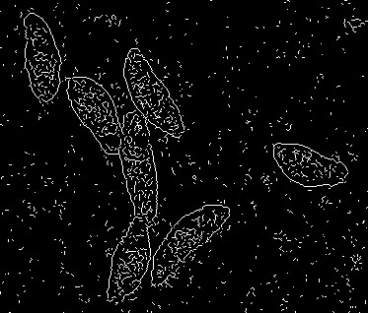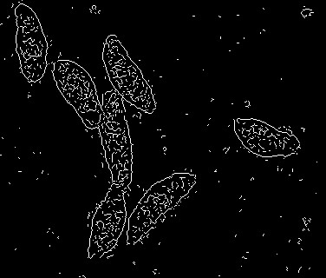

(b) Image Segmentation with sharping

applied post-phase congruency

(a) Image segmentation with the best (c) Image segmentation with sharp-

parameters. ening applied pre-phase congruency.

Figure 7: Results from examining the effect of sharpening on image segmentation.

# 6 Discussion

The results of the parameter tuning study identify large wavelet bank scaling factors as less optimal for segmenting touching objects. This finding can be explained when considering what the scaling factor does in phase congruency calculations. Since phase congruency is calculated using a bank of wavelets at different scales, the difference between two wavelets is determined by the scaling factor. Figure 8 shows two example wavelet banks, with the default bank in Figure 8a and a bank with a larger scaling factor in Figure 8b. From Figure 8 the effect of the scaling factor is clear, with the larger scaling factor resulting in a smaller range of wavelets in the bank. Additionally, the wavelets in Figure 8b get larger quicker due to the larger scaling factor, which results in the inability of the wavelets to detect small frequencies or details in the signal. Hence, the wavelet bank in Figure 8b will capture global features of the signal at the expense of detailed, local features. The edges where objects touch are local rather than global features, which is why the larger scaling factor results in worse segmentation of touching objects. Together these findings suggest that parameters should be considered when segmenting touching objects with phase congruency.

The sharpening study indicates that applying sharpening to an image before segmentation can slightly improve the segmentation of touching objects. Sharpening enhances the fine details or local features of the image signal, resulting in more frequencies in the Fourier Series. These extra frequencies add to the existing frequencies of the original signal, ultimately contributing to an increased phase congruency and better edge detection. However, sharpening does add additional computational cost to the image segmentation task.

# 7 Conclusion

This paper included two main contributions which addressed the importance of parameters when detecting edges using phase congruency and how image sharpening can be applied in an edge detector pipeline. Findings indicate that parameters do have an impact on edge detection, especially of touching objects. In particular, smaller wavelet scaling factors should be used instead of larger values when dealing with the segmentation of touching objects. Two proposed pipelines for leveraging sharpening were implemented and evaluated, with one method applying sharpening after phase congruency and the othe method applying sharpening to an image before phase congruency. This study indicates that sharpening can improve image segmentation results when applied before edge detection, yet the improvements are marginal and come at a computation cost.

Future work needs to investigate further the tradeoff between accuracy and computational cost when implementing sharpening. The actual computational cost has not been fully identified and it should be considered in the context of methods without sharpening. Given that sharpening is useful and not overly computationally costly, future work should implement it into the existing Asarnow-Singh method as an image pre-processing step.

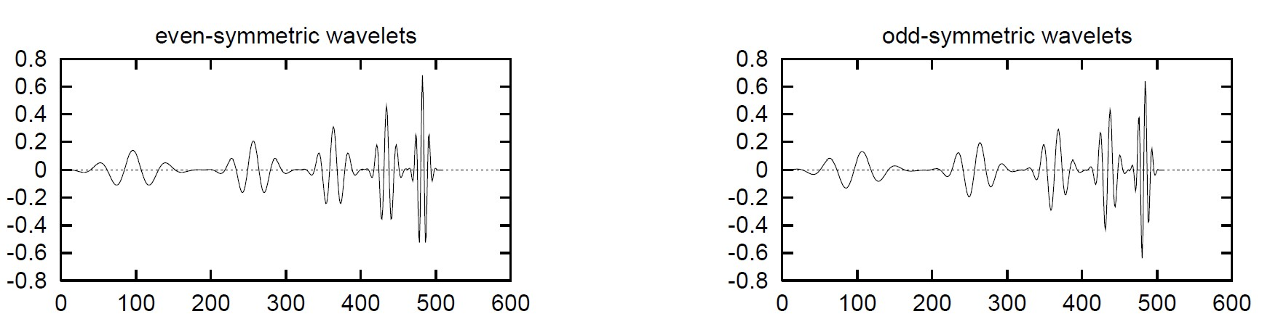

1. Original wavelet banks from [3].

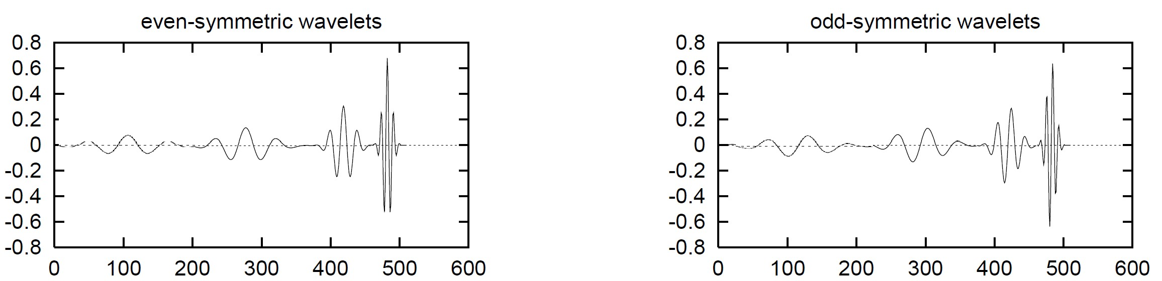

1. Wavelet banks with a larger scaling factor, adapted from [3].

Figure 8: Two example wavelet banks showing the impact that larger scaling factors have on the overall bank.

# References

1. Daniel E Asarnow and Rahul Singh. Segmenting the etiological agent of schistosomiasis for high-content screening. *IEEE Transactions on Medical Imaging*, 32(6):1007–1018, 2013.
2. John Canny. A computational approach to edge detection. *IEEE Transactions on pattern analysis and machine intelligence*, (6):679–698, 1986.
3. Peter Kovesi. Image features from phase congruency, 1995.
4. Peter Kovesi et al. Image features from phase congruency. *Videre: Journal of computer vision research*, 1(3):1–26, 1999.
5. R Beau Lotto, S Mark Williams, and Dale Purves. Mach bands as empirically derived associations. *Proceedings of the National Academy of Sciences*, 96(9):5245–5250, 1999.
6. Donald P McManus, David W Dunne, Moussa Sacko, Jurg Utzinger, Birgitte J. Vennervald, and Xiao-Nong¨ Zhou. Schistosomiasis. 2018.
7. Shree K. Nayar. Edge detection. University Lecture, 2022.
8. The World Health Organization. Schistosomiasis. https://www.who.int/news-room/factsheets/detail/schistosomiasis.
9. Wikipedia contributors. Unsharp masking — Wikipedia, the free encyclopedia, 2022. [Online; accessed 15-December-2022].