

Cameron Bartee

Julian Douglas

Connor Heinzmann

Kole Pottorff

Graydon Svendson

Table of Contents

Gameplay Overview 3

Brief Summary 3

Inter-Corporate War Mechanics: Three Corporations Battle to Accrue the Most Points 3

The Player’s Role 4

Rounds 4

Game End 4

Credit Tokens and the Upgrade Shop 5

Player Death 5

Diagrams – Gameplay Overview 6

Player Spacecraft 12

Player Controls/Handling 12

Aiming/Ship Direction: 12

Forward Movement: 12

Firing Weapons: 12

Boost-Dodge: 12

Player Controls - Diagrams 13

Player Upgrades 17

Increased Thruster Power: 17

Increased Laser Damage: 17

Increased Ship Armor: 17

Deployable Turret: 17

Homing Barrage: 17

Decoy Flares: 17

Extra Boost-Dodge Charge Segments: 17

And Possibly More… 17

NPCs and AI 18

Corporation Strategy AI 18

Enemy Types (Fighter Class) 18

Enemy Types (Frigate Class) 20

Lore 21

Presentation Ideas 21

# Gameplay Overview

## Brief Summary

In this game, the player controls a mercenary piloting a spacecraft in outer space. The player’s goal is to earn as much money as possible before the game ends. Three corporations are warring for points, and will send drone spacecraft to claim them until one emerges as a victor. The player earns money by participating in the conflict by destroying these drones; and so must destroy the drones strategically in order to maximize the length of the conflict and thus maximize monetary earnings.

## Inter-Corporate War Mechanics: Three Corporations Battle to Accrue the Most Points

In this game, three corporations – Red, Green, and Blue – compete to control four zones; three smaller outer zones and one big inner zone. The zones themselves consist of some central space station-like structure, which is surrounded with a large spherical volume which determines the boundaries of the zone. Since this game takes place in outer space, the map will be nothing but a large empty space with a star field skybox populated only by these four zones and their accompanying space station structures.

The gameplay will take place over the course of an indeterminate number of rounds; these rounds will continue until one of the corporations emerges as the victor, at which point the game will end. At the start of each round, each corporation will spawn in a wave of ships at one of three spawn points located along the edge of the map. Which corporation gets which spawn point is chosen at random each round. This wave of ships will then fly towards the four zones at the center of the map and begin congregating around them and battling each other there. Whichever corporation has the most units inside of a particular zone will then become “king of the hill” in that particular zone. Once a corporation is “king of the hill” of a particular zone, they begin earning points. The number of points they earn is affected by the number of units they have in that particular zone; more units mean more points are earned per second. Also, some zones are “richer” than others, and will provide an additional bonus to points earned.

Each round, every corporation must earn some minimum number of points in order to survive; if the round ends before a corporation has attained the minimum number of points, that corporation is out for all future rounds.

As long as there exists some corporation that has not yet reached the minimum number of points for the round, then reinforcements will spawn in at particular intervals of time. Each corporation will also have a population cap; reinforcements will not spawn if this population cap has been reached for that corporation. Once all corporations have reached the minimum number of points or above, then reinforcement waves will stop spawning.

There also exists a maximum number of points that is possible for a corporation to earn each round; once one corporation earns the maximum number of points, the round immediately ends and the corporations collect whatever points they earned that round. This maximum should be *significantly* larger than the minimum; perhaps a good standard would be 5 times the minimum or above.

In summary, there are two ways a round can end. The first way is if one corporation reaches some predetermined maximum number of points for a round; the second way is if all corporations have reached the minimum number of points required and then all units are destroyed.

Each corporation has a point total associated with them that persists between rounds. After each round, assuming a corporation has earned above the minimum and has not been eliminated from the game, the points that corporation earned during the round are added to their total. All the corporations are competing to get their total over some predetermined amount, at which point that corporation wins the game and the game ends.

So, there are two ways for the game to end; the first is when a corporation reaches the point total goal, the second is if two corporations are eliminated for failing to reach the minimum required points in a round.

## The Player’s Role

So what is the player’s role in all this? The player is attempting to accrue as much money as they can before one of the corporations emerges as the victor. In order to best accomplish this goal, the player must attempt to prolong the conflict for as many rounds as possible in order to maximize earning potential. They prolong the conflict by assisting or thwarting the corporations in an attempt to balance their point earnings.

The player earns money for each kill of an enemy craft. The amount of money earned depends on the type of craft destroyed – more dangerous craft grant higher bounties. Also, every 10th enemy fighter the player destroys will spawn a collectable credit token, which can be used by the player in-between rounds to purchase ship upgrades. Frigates will always spawn a credit token.

Initially, all three corporations consider the player their enemy and will attack the player. However, the player can become friends with one corporation by getting at least 5 consecutive kills on spacecraft belonging to the other two corporations WITHOUT breaking the streak by killing any of the craft belonging to the corporation the player wants to befriend. Once the player is considered an ally by a corporation, their craft will no longer attack the player. However, this ally status can be broken by getting 2 kills on your ally’s craft; at this point the alliance will be broken and they will resume attacking the player.

At the end of the game, after one corporation has emerged the victor, the player’s earnings will be tallied and the player will be awarded either a bronze, silver, gold, or platinum medal depending on their performance.

## Rounds

This game takes place in a series of rounds. The basic pattern will be as follows: The game begins, and the first round starts. Gameplay occurs, an outcome for that round is decided, and then the round ends. Corporations add the points earned during that round to their game point totals, and the player adds money earned during that round to their game money total. Between rounds, the player is given the opportunity to spend any collected credit tokens on upgrades. After they are finished, another round begins, and this continues indefinitely until one corporation emerges as the victor.

## Game End

After each round, the corporations add their points earned that round to their game totals. Once one corporation’s game total reaches a certain goal, then that corporation is considered the victor and the game ends. At this point, the player will be evaluated based on how much money they accrued over the course of the game, and will be awarded a medal – either Bronze, Silver, Gold, or Platinum – depending on how well they did.

## Credit Tokens and the Upgrade Shop

For every 10th enemy fighter the player destroys, or any frigate-class ship the player destroys, a credit token will spawn at the location of the destroyed enemy. By colliding with this token, the player will collect it. In-between rounds, the player will be given access to a shop where credit tokens can be spent on a variety of upgrades.

## Player Death

If the player’s craft is destroyed during the course of gameplay, they will respawn immediately, however they will incur a money penalty that worsens with each successive death. This increased penalty persists between rounds.

## Diagrams – Gameplay Overview

**NOTE:** These diagrams are shown in 2 dimensions; but bear in mind that in the actual game the gameplay will take place in 3-dimensional space.

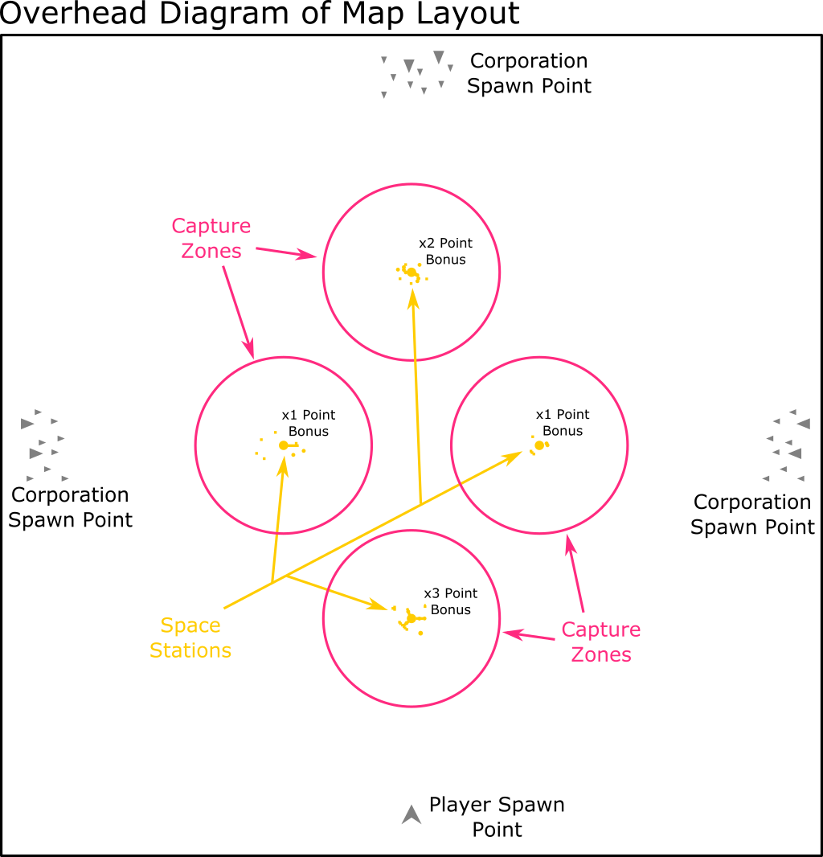

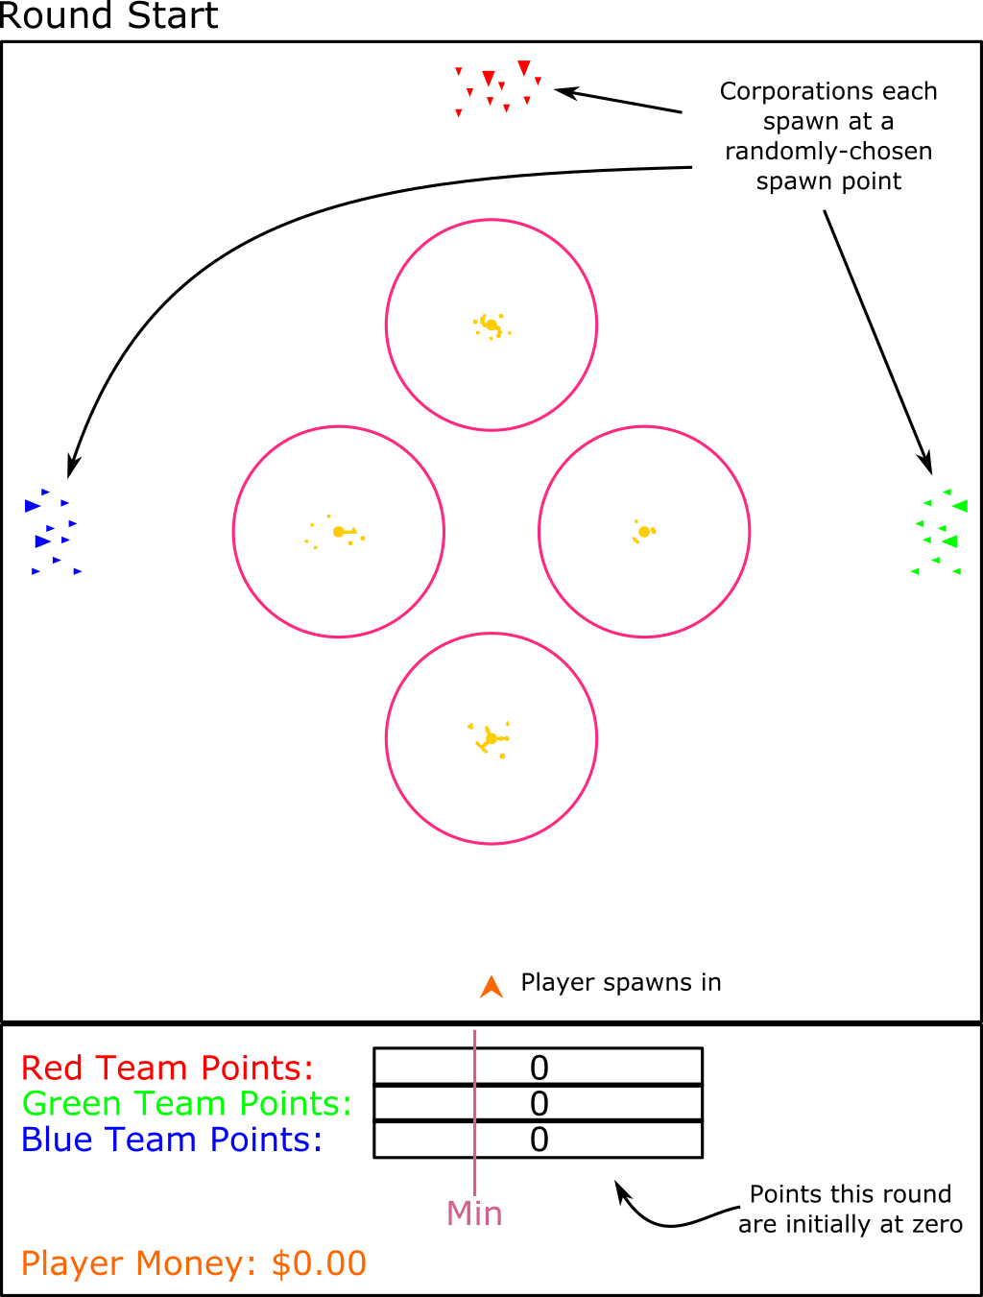

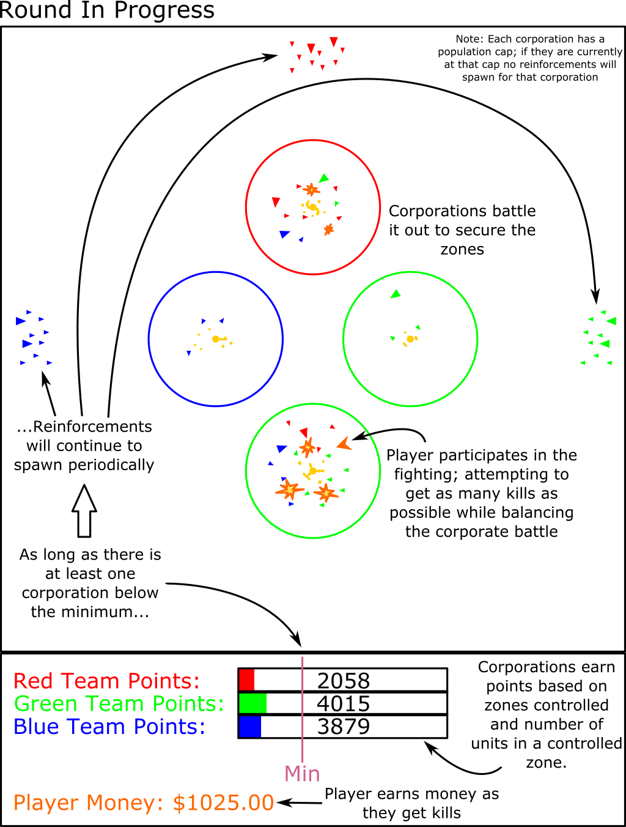

**Note:** A zone is controlled by the corporation that currently has the largest number of units in that zone.

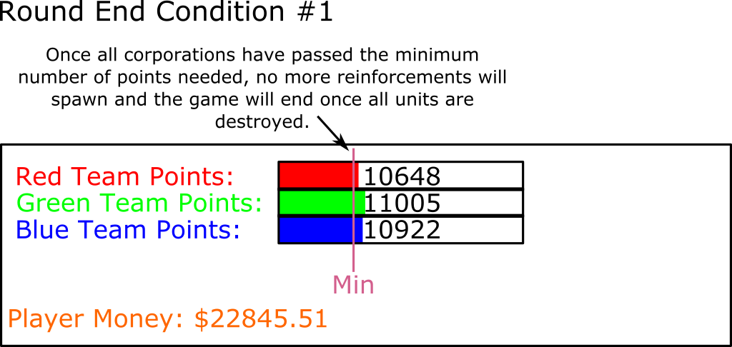

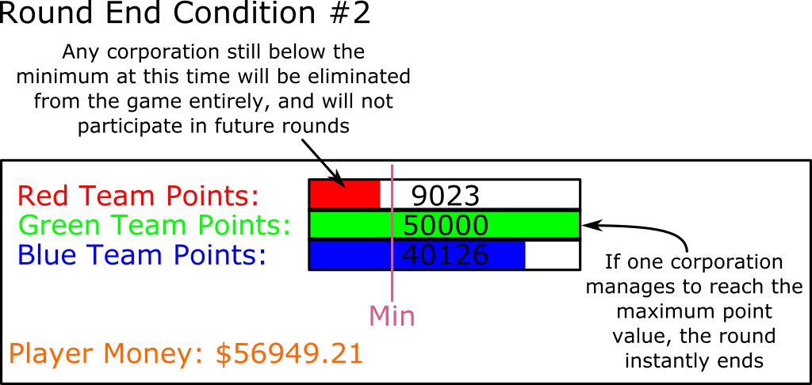

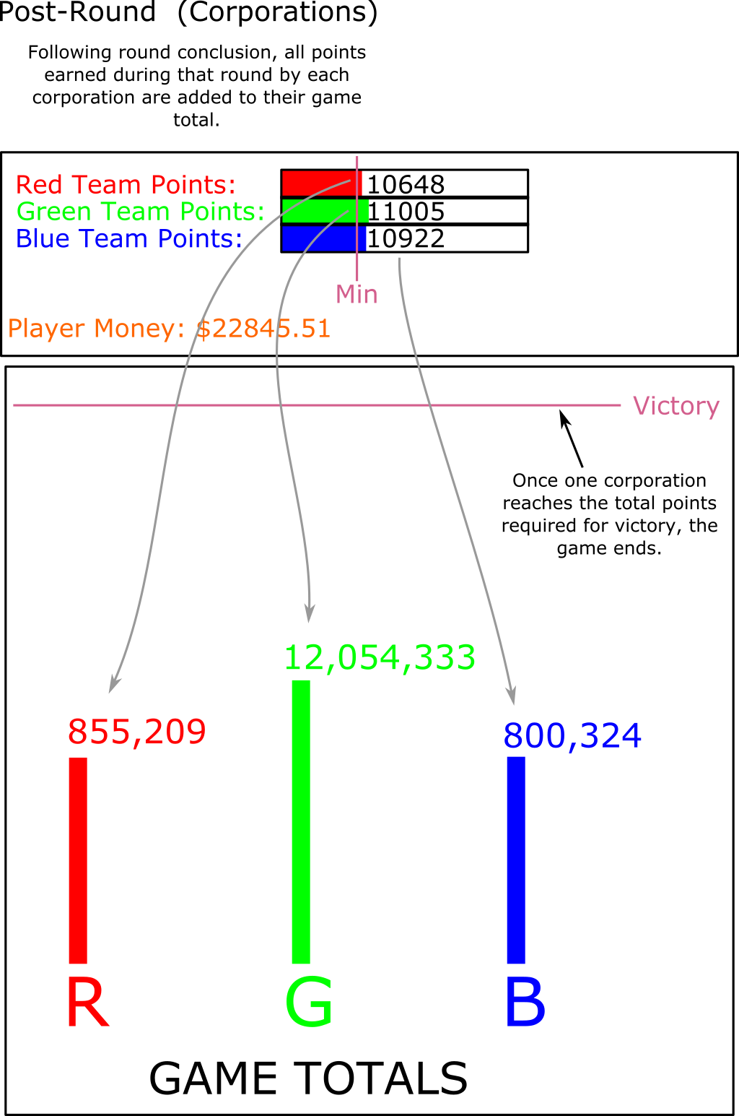

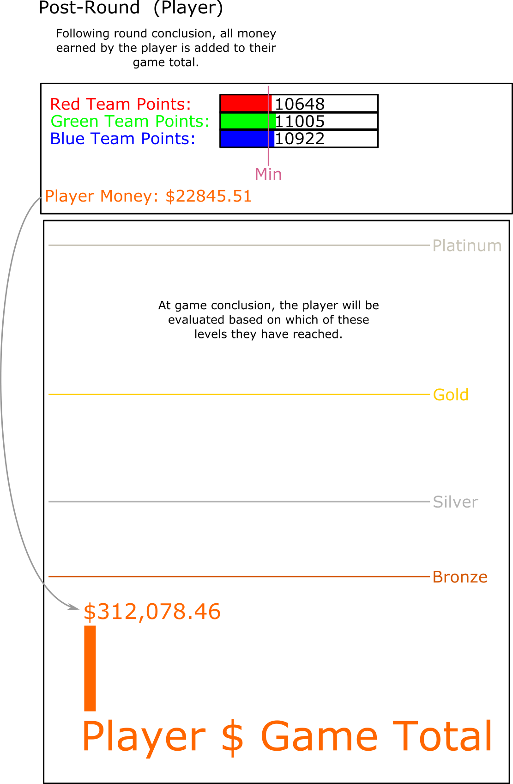

# Player Spacecraft

## Player Controls/Handling

### Aiming/Ship Direction:

The player will control their ship’s pitch and yaw by moving the mouse. In this way, they can change the ship’s facing and aim at targets with ease. The ship’s pitch or yaw will change at the same speed that the user moves the mouse at; however, there will be a cap on the turn speed, so the ship may not necessarily be able to turn as fast as the player can move the mouse.

### Forward Movement:

The ship will have a throttle which will at any given time be set to a certain speed. If the user taps the ‘w’ key, the throttle’s speed will be set a certain increment higher and then the ship will accelerate to match that speed. If the user taps the ‘s’ key, the throttle’s speed will be set a certain increment lower and then the ship will decelerate to match that speed. The player may also bring the ship to a complete stop in this manner.

### Firing Weapons:

The player may use a left mouse click to fire their primary weapon, and a right mouse click to trigger whatever special weapon/ability they have equipped (if they have any equipped).

### Boost-Dodge:

By tapping ‘a’, ’d’, spacebar, or ‘c’, they can initiate a “Boost-Dodge” in a direction depending on which key was pressed (left, right, up, or down, respectively). The Boost-Dodge is a very short thruster burst that allows the player’s ship to quickly move a short distance in the desired direction. This will be useful for dodging incoming attacks. The Boost-Dodge is stored as two charges; when the player performs a Boost-Dodge, one charge will be consumed and the player must wait for a cooldown period before that charge can be used again. Thus, if both charges are ready, the player may Boost-Dodge at most twice in quick succession before having to wait for the cooldown period. Only one charge can be re-charging at any given time, so if both charges are used up then one must re-charge before the other can begin charging.

## Player Controls - Diagrams

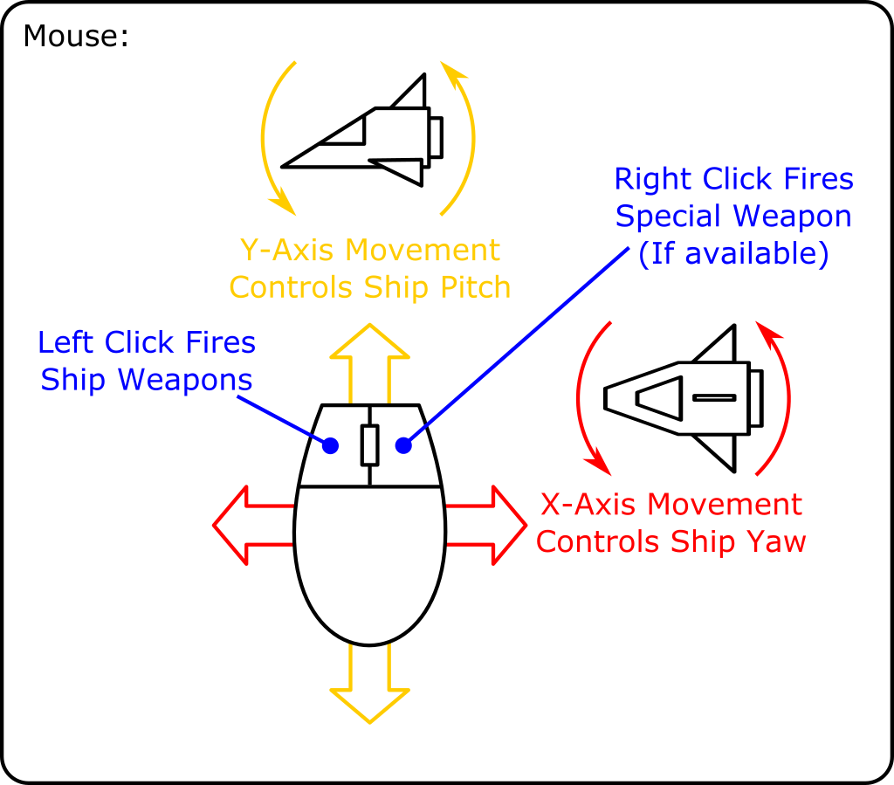

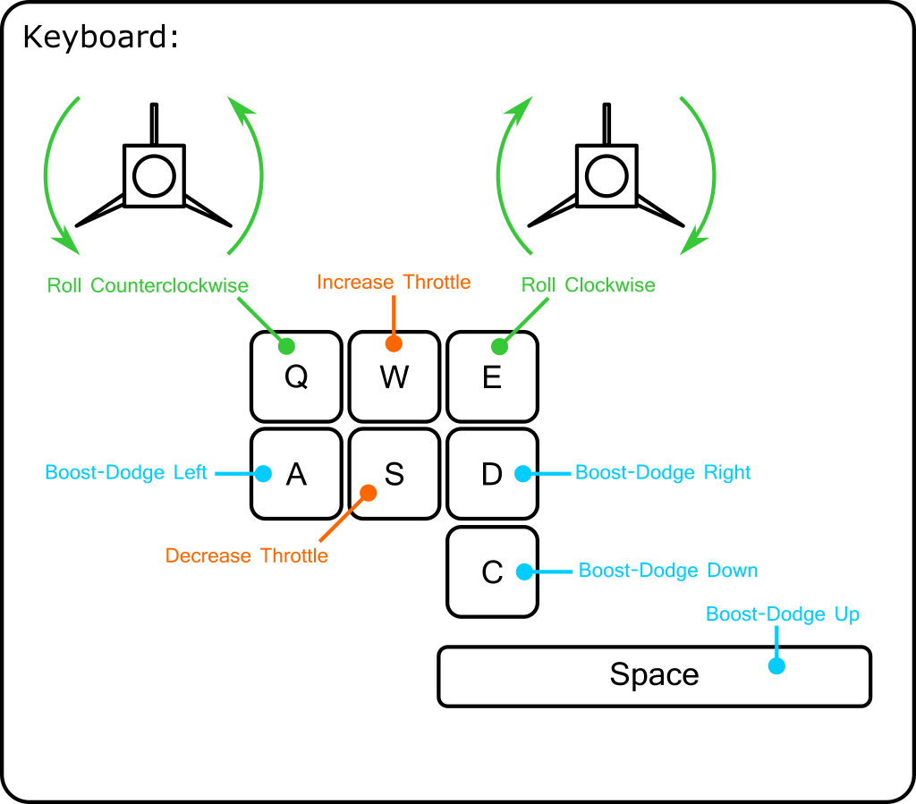

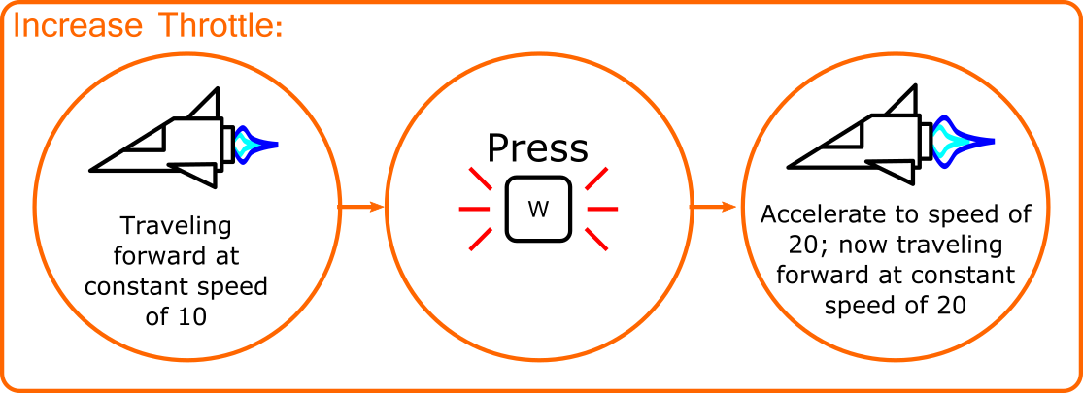

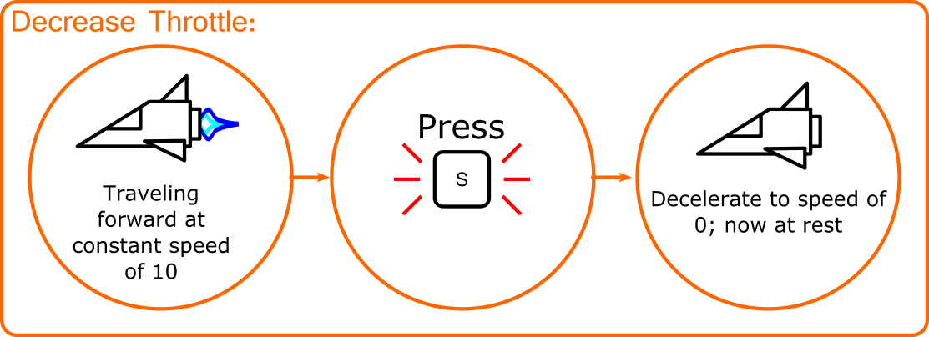

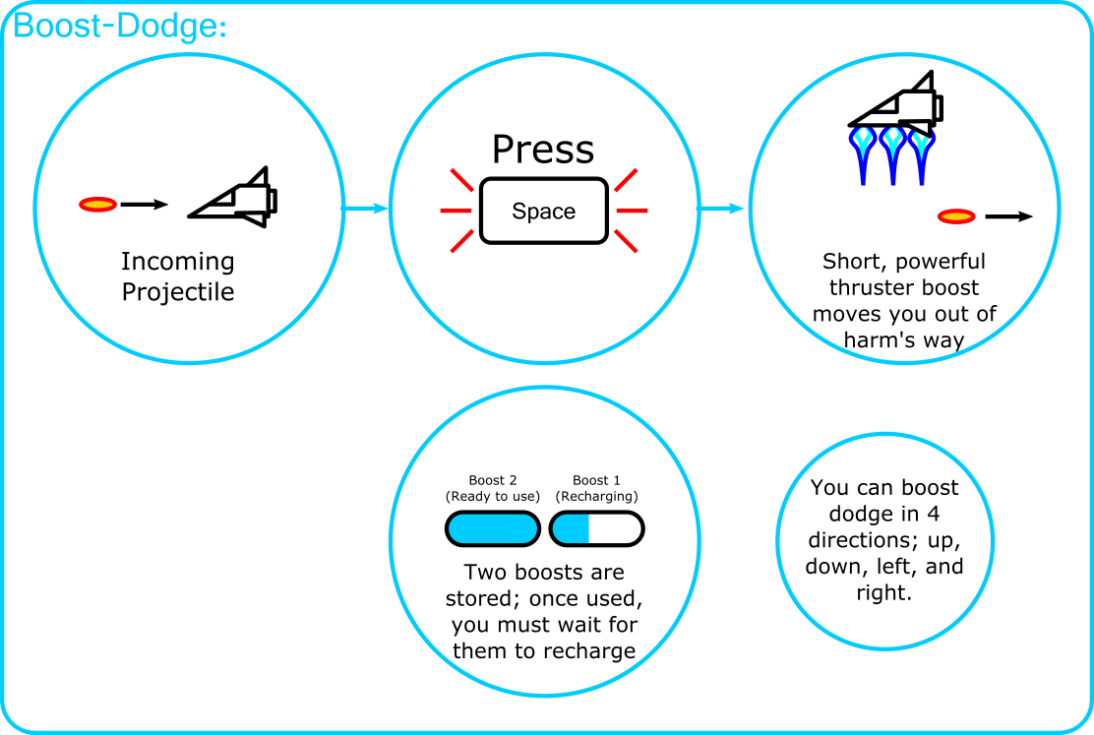

## Player Upgrades

In-between rounds, the player may purchase upgrades for their ship with the credit tokens they have earned. Upgrades may consist of things such as:

### Increased Thruster Power:

Increases the speed of the ship by a certain percentage. Can be purchased multiple times to boost speed further.

### Increased Laser Damage:

Your main weapon does more damage. Can be purchased multiple times to boost attack power further.

### Increased Ship Armor:

Increases the number of hits your ship can take before being destroyed. Can be purchased multiple times to boost toughness further.

### Deployable Turret:

Allows you to drop a turret in space. You can control which corporations it is set to target, and this setting can be changed at any time during combat. Further upgrades for the turret can be purchased, such as the ability to lay more than one turret, or increasing turret toughness, or increasing turret firepower, or granting the turret a low-level cloaking field that makes it less likely to be targeted by enemies.

### Homing Barrage:

Special weapon granting the ability to fire in all directions a barrage of homing missiles. The player can customize which corporations they will target before firing. Has a cooldown timer limiting its use.

### Decoy Flares:

Fires a barrage of flares, causing all enemies to temporarily ignore you.

### Extra Boost-Dodge Charge Segments:

Grants the player more boost-dodge charge segments, allowing them to boost-dodge more times in quick succession. Can be purchased multiple times to gain even more charge segments.

### And Possibly More…

We may add even more upgrades if new ideas are discovered during development.

# NPCs and AI

## Corporation Strategy AI

The corporations will need an AI to handle their overall strategy, i.e. when to defend the zones that they own, when to attack and attempt to capture other zones, and if attacking, which zones to attack.

As a general rule of thumb, a corporation will focus all its forces on one zone at a time. A corporation should send all its forces to attack the highest point value zone where its force size is at least 85% the size of the forces of the corporation that currently owns that zone. It will then continue to attack that zone until its troops in that zone have been reduced to 25% the size of the enemy force currently controlling the zone, at which point the corporation’s forces retreat and pick a new zone as a target. If at any point a corporation does not have a force size at least 85% the size of the forces of any controlled zone, they will seek to occupy the nearest unoccupied zone, where they will wait until their force size is comparable to the enemy’s force sizes.

## Enemy Types (Fighter Class)

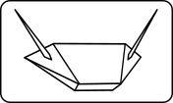 Hunter-Killer:

Basic fighter craft that will fly around the battlefield and attack enemies with its forward guns. Picks a target, does a strafing run against them, then loops back around for another strafing run.

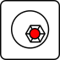 Rover:

Spherical enemy that will drift around the battlefield, firing on nearby targets. Fires thruster in a random direction and drifts that way for a bit, firing on nearby targets. Then fires thruster in another random direction and drifts while firing on targets, etc. If no targets are nearby, fly directly towards potential targets, then resume drift-fire attack pattern.

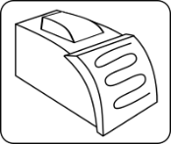 Rhino:

Flies in close to enemies, faces them, then fires powerful thrusters to close on their target and ram them. Still retains a small amount of steering control when ramming.

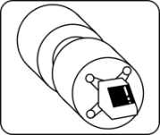 Ion Field Generator:

Small, bulky craft that generates a spherical damaging ion field extending some distance around itself. It flies towards its target until the target is enveloped in the ion field, then cloaks itself (becoming much harder to see). Any hostile ships caught in the ion field will begin to emit sparks, and will soon begin taking damage if they do not escape the field or destroy the Ion Field Generator. The Ion Field Generator must reveal itself when moving.

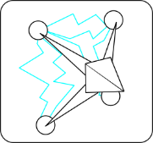 Net-Caster:

Fires wide projectiles that will stun any hostile units struck by the projectile for a small amount of time.

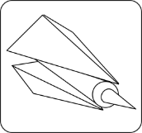 Homing Bomber:

Slow, relatively tough craft that flies around the battlefield, periodically launching slow moving seeker missiles. The missiles can be destroyed if fired on. If the missile flies for too long, it will lose power, then explode.

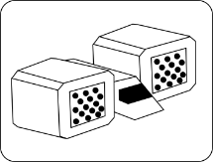 Tsunami:

Fires a large barrage of dumb-fire missiles at its target, attempting to overwhelm them.

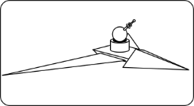 Swallow:

Small, fast craft. Flies randomly around the battlefield at high speed. Has a turret mounted on top that will rotate to fire at nearby targets. Grants double the point earnings to a corporation as compared to a normal unit.

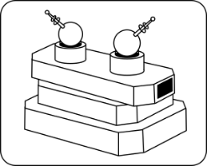 Harvester:

Similar to Swallow, but uses toughness rather than speed. Larger, tough craft with mounted rotary turrets. Patrols around the zone it is in, and fires on nearby targets. Takes many hits to destroy. Grants 2.5 times the point earnings to a corporation as compared to a normal unit.

## Enemy Types (Frigate Class)

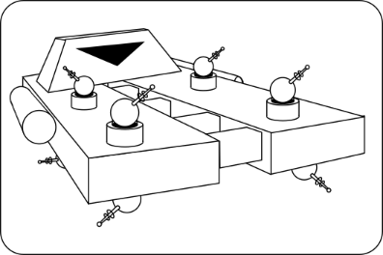Multigun Frigate:

Large, flat frigate with four auto turrets each on its top and on its bottom (eight turrets total). Turrets will automatically and independently aim and fire on nearby targets. Turrets may be temporarily destroyed, but they will soon regenerate. Destroying this frigate requires that you take out the shield generators mounted to either side of it, and then target the engine block to send the ship up in a massive explosion.

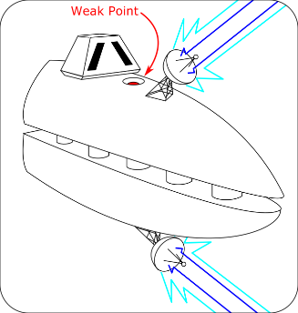Beam Frigate:

Frigate with one satellite dish-shaped turret on both its topside and its underside (two turrets total). When an enemy target is detected, these special turrets will immediately begin firing a large, continuous beam in whatever direction they happen to be facing. They will then slowly begin to rotate to face the target, all while still firing the beam. These turrets rotate very slowly, however, so if the target remains in motion, they will likely escape the beam. However, the beam will keep coming, so if they stop for even a moment…

To destroy this frigate, the player must destroy two weak points on both its top and bottom. However, these weak points are inset into fairly deep holes on the ship, so the player’s approach vector is limited to approaching straight from the top or bottom. This will add challenge by complicating the matter of avoiding the beams.

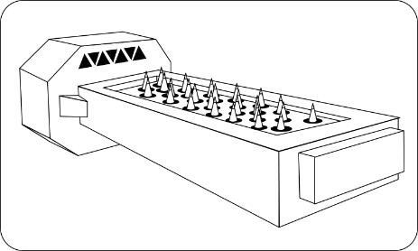Homing Battery Frigate:

Large, rectangular frigate. Has a large bank of missile launching tubes on topside and bottom side, and continuously launches slow-moving homing missiles from them. The homing missiles will seek nearby targets. The homing missiles have a long lifespan, but they will eventually sputter out if left to fly without hitting a target for long enough. This frigate has a lot of health, but it can be damaged by shooting it anywhere.

# Lore

Way back in the year 5541, the intergalactic market flooded with products from one YELLOW Corporation. Second to none in the popularity polls, everyone agreed that YELLOW’s products stood head and shoulders above the products from rival corporations RED, GREEN, and BLUE. But it wasn’t to last. In the year 5822, the great cosmic storms that swept through the Zellaga system, YELLOW’s main base of operations. YELLOW’s factories were destroyed, and their company headquarters – where they kept all their product designs and recipes – were lost, blown away by the storms. Soon after, YELLOW, unable to maintain profits, was forced to go out of business. RED, GREEN, and BLUE stepped in to fill the void; but everyone agreed it just wasn’t the same.

The present year is the year 6241. A deep space explorer in the Zellaga system has stumbled upon something in the dark space between the planets – the space stations that housed YELLOW’s lost company headquarters! He reported his discovery – all their computer systems were still intact, and their blueprints and recipes still survived on them! Intergalactic law states that whoever can first obtain complete copies of the blueprints and recipes can then file them for copyright. RED, GREEN, and BLUE wasted no time in assembling unmanned drone armies, each drone equipped with a remote data download unit, to descend upon the stations and begin lapping up that precious data. Even after all this time, RED, GREEN and BLUE had never matched the popularity of YELLOW’s products – the first one to claim and copyright YELLOW’s designs would make a fortune!

Meanwhile, one drifting mercenary, looking over a job posting board, saw warning notices from each of the three corporations. These warning notices said that they would destroy any ships that flew near to YELLOW’s stations with a remote data download unit and attempted to siphon off data. However, he noticed some small print on all of the warnings that no one else saw – each of the corporations was offering a bounty for enemy kills around the area of YELLOW’s stations, assuming you didn’t bring a remote data recorder. This bounty was always automatically added to your account when the drones detected that you made an enemy kill, and had no other conditions other than that. A devious plan began to form in his mind… If he could prolong the fight for as much time as possible and get lots of kills in the meantime, he could make a fortune! Before long, he was in his ship and headed for the Zellaga system…

## Presentation Ideas

* When the corporations reach certain point milestones, they unlock one of YELLOW’s long-lost products. A text ticker that the player can view tells what product they got the rights to, what they decided to do with the brand, and how it turned out for them. These would hopefully be humorous in nature (See the text ticker in Cookie Clicker for an example). Depending on which corporation gets which products, they will handle their marketing in different ways, hopefully leading to varied humorous situations as the player sees the different distinct approaches, styles, and “personalities” of each of the corporations.
* When a corporation unlocks one of YELLOW’s long lost brands, logos for that brand begin to appear on their drones.