

Functional Safety Concept Lane Assistance

**Document Version: 1.1**

**2019-03-29**

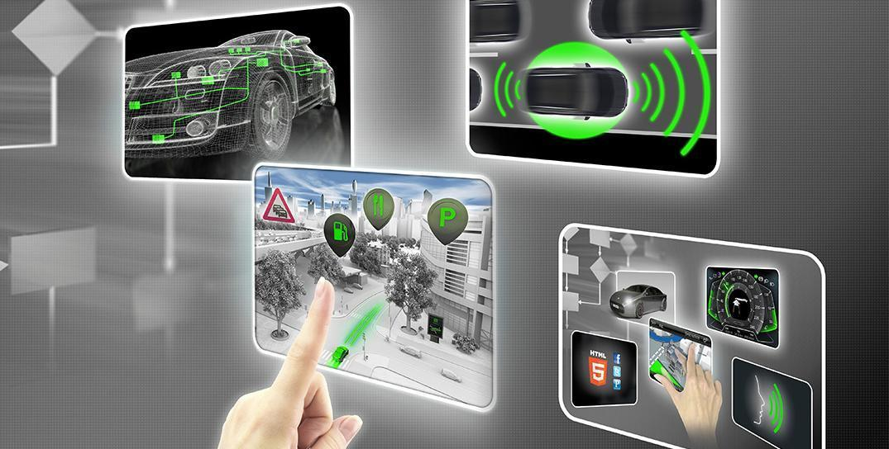

# Document history

|  |  |  |  |
| --- | --- | --- | --- |
| Date | Version | Editor | Description |
| 2019-03-28 | 1.0 | Sergey Morozov | Completed all document sections |
| 2019-03-29 | 1.1 | Sergey Morozov | Refined functional safety requirements |
|  |  |  |  |
|  |  |  |  |
|  |  |  |  |

# 

# Table of Contents

**Document history** **2**

**Table of Contents** **3**

**Purpose of the Functional Safety Concept** **4**

**Inputs to the Functional Safety Concept** **5**

Safety goals from the Hazard Analysis and Risk Assessment 5

Preliminary Architecture 5

Description of architecture elements 5

**Functional Safety Concept** **7**

Functional Safety Analysis 7

Functional Safety Requirements 8

Refinement of the System Architecture 10

Allocation of Functional Safety Requirements to Architecture Elements 10

Warning and Degradation Concept 11

# 

# 

# Purpose of the Functional Safety Concept

The purpose of the functional safety concept is to refine the safety goals in what are called functional safety requirements and then allocate these safety requirements to the relevant parts of the system diagram. This involves expanding the system architecture with new element blocks, if necessary, and refining the system architecture to handle the new requirements. The functional safety concept does not go into technical details; it looks at the general functionality of the Item.

# 

# Inputs to the Functional Safety Concept

## Safety goals from the Hazard Analysis and Risk Assessment

|  |  |
| --- | --- |
| **ID** | **Safety Goal** |
| Safety_Goal_01 | The oscillating steering torque from the lane departure warning function shall be limited. |
| Safety_Goal_02 | The lane keeping assistance function shall be time limited and the additional steering torque shall end after a given time interval so that the driver cannot misuse the system for autonomous driving. |

## Preliminary Architecture

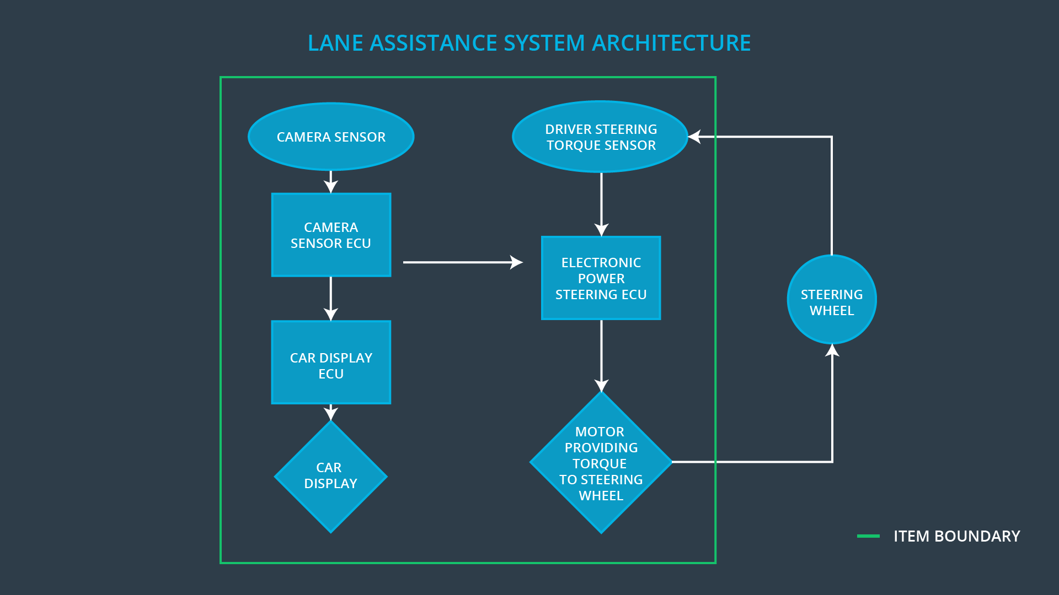

### Description of architecture elements

|  |  |
| --- | --- |
| **Element** | **Description** |
| Camera Sensor | Captures images of the road. |
| Camera Sensor ECU | Identifies when the vehicle has accidentally departed its lane and sends appropriate messages to the Car Display ECU and the Electronic Power Steering ECU. |
| Car Display | Provides the driver with visual notifications about the current state of the lane assistance item. |
| Car Display ECU | Determines the statuses of lane assistance item subsystems based on the input provided by the Camera Sensor ECU and controls the Car Display to represent this information to the driver in the form of visual notifications. |
| Driver Steering Torque Sensor | Measures the steering torque applied by the driver to the steering wheel. |
| Electronic Power Steering ECU | Controls the Motor by determining the actual amount of torque to be applied to the steering wheel based on the input provided by the Camera Sensor ECU and sensory information from the Driver Steering Torque Sensor. |
| Motor | Applies the torque to the steering wheel as it was determined by the Electronic Power Steering ECU. |

# 

# Functional Safety Concept

The functional safety concept consists of:

* Functional safety analysis
* Functional safety requirements
* Functional safety architecture
* Warning and degradation concept

## Functional Safety Analysis

|  |  |  |  |
| --- | --- | --- | --- |
| **Malfunction ID** | **Main Function of the Item Related to Safety Goal Violations** | **Guidewords (NO, WRONG, EARLY, LATE, MORE, LESS)** | **Resulting Malfunction** |
| Malfunction_01 | Lane Departure Warning (LDW) function shall apply an oscillating steering torque to provide the driver a haptic feedback. | MORE | The lane departure warning function applies an oscillating torque with very high torque amplitude (above limit). |
| Malfunction_02 | Lane Departure Warning (LDW) function shall apply an oscillating steering torque to provide the driver a haptic feedback. | MORE | The lane departure warning function applies an oscillating torque with very high torque frequency (above limit). |
| Malfunction_03 | Lane Keeping Assistance (LKA) function shall apply the steering torque when active in order to stay in ego lane. | NO | The lane keeping assistance function is not limited in time duration which leads to misuse as an autonomous driving function. |

## Functional Safety Requirements

Lane Departure Warning (LDW) Requirements:

|  |  |  |  |  |
| --- | --- | --- | --- | --- |
| **ID** | **Functional Safety Requirement** | **ASIL** | **Fault Tolerant Time Interval** | **Safe State** |
| Functional  Safety  Requirement  01-01 | The lane keeping item (Electronic Power Steering ECU) shall ensure that the lane departure oscillating torque amplitude is below Max_Torque_Amplitude. | C | 50 mS | The torque is zero. Warning displayed on the Car Display. |
| Functional  Safety  Requirement  01-02 | The lane keeping item (Electronic Power Steering ECU) shall ensure that the lane departure oscillating torque frequency is below Max_Torque_Frequency. | C | 50 mS | The torque is zero. Warning displayed on the Car Display. |

Lane Departure Warning (LDW) Verification and Validation Acceptance Criteria:

|  |  |  |
| --- | --- | --- |
| **ID** | **Validation Acceptance**  **Criteria and Method** | **Verification Acceptance**  **Criteria and Method** |
| Functional  Safety  Requirement  01-01 | Test how drivers react to different torque amplitudes to prove that the Max_Torque_Amplitude is an appropriate value. | When the torque amplitude crosses the limit Max_Torque_Amplitude, the lane assistance output is set to zero within the 50 mS FTTI and the appropriate warning is displayed on the Car Display. Do a software test inserting a fault into the system and seeing what happens. |
| Functional  Safety  Requirement  01-02 | Test how drivers react to different torque frequencies to prove that the Max_Torque_Frequency is an appropriate value. | When the torque frequency crosses the limit Max_Torque_Frequency, the lane assistance output is set to zero within the 50 mS FTTI and the appropriate warning is displayed on the Car Display. Do a software test inserting a fault into the system and seeing what happens. |

Lane Keeping Assistance (LKA) Requirements:

|  |  |  |  |  |
| --- | --- | --- | --- | --- |
| **ID** | **Functional Safety Requirement** | **ASIL** | **Fault Tolerant Time Interval** | **Safe State** |
| Functional  Safety  Requirement  02-01 | The lane keeping item (Electronic Power Steering ECU) shall ensure that the lane keeping assistance torque is applied for only Max_Duration. | B | 500 mS | The torque is zero. Warning displayed on the Car Display. |

Lane Keeping Assistance (LKA) Verification and Validation Acceptance Criteria:

|  |  |  |
| --- | --- | --- |
| **ID** | **Validation Acceptance**  **Criteria and Method** | **Verification Acceptance**  **Criteria and Method** |
| Functional  Safety  Requirement  02-01 | Test how drivers react to different duration values for the lane keeping assistance to prove that Max_Duration is an appropriate value and that it dissuades drivers from taking their hands off the wheel. | Verify that the system really does turn off if the lane keeping assistance when Max_Duration time is exceeded and the appropriate warning is displayed on the Car Display. |

## Refinement of the System Architecture

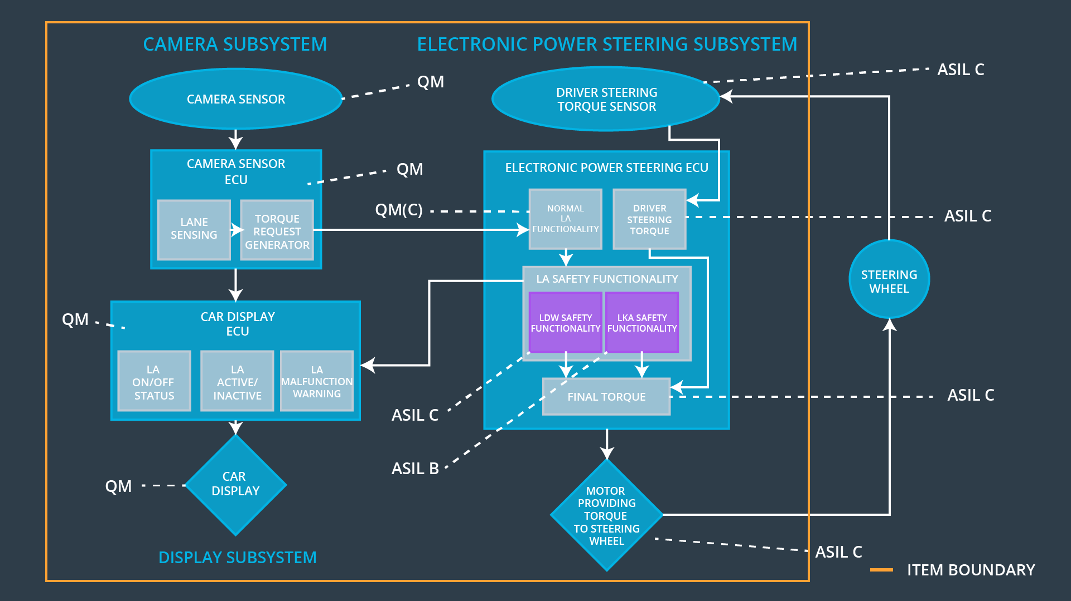

## Allocation of Functional Safety Requirements to Architecture Elements

|  |  |  |  |  |
| --- | --- | --- | --- | --- |
| **ID** | **Functional Safety Requirement** | **Electronic Power Steering ECU** | **Camera ECU** | **Car Display ECU** |
| Functional  Safety  Requirement  01-01 | The lane keeping item (Electronic Power Steering ECU) shall ensure that the lane departure oscillating torque amplitude is below Max_Torque_Amplitude. | **X** | **-** | **-** |
| Functional  Safety  Requirement  01-02 | The lane keeping item (Electronic Power Steering ECU) shall ensure that the lane departure oscillating torque frequency is below Max_Torque_Frequency. | **X** | **-** | **-** |
| Functional  Safety  Requirement  02-01 | The lane keeping item (Electronic Power Steering ECU) shall ensure that the lane keeping assistance torque is applied for only Max_Duration. | **X** | **-** | **-** |

## Warning and Degradation Concept

|  |  |  |  |  |
| --- | --- | --- | --- | --- |
| **ID** | **Degradation Mode** | **Trigger for Degradation Mode** | **Safe State invoked?** | **Driver Warning** |
| WDC-01 | Turn off LDW function. | Malfunction_01, Malfunction_02 | Yes | Warning displayed on the Car Display |
| WDC-02 | Turn off LKA function. | Malfunction_03 | Yes | Warning displayed on the Car Display. |