

Technical Safety Concept Lane Assistance

**Document Version: 1.0**

**2019-03-29**

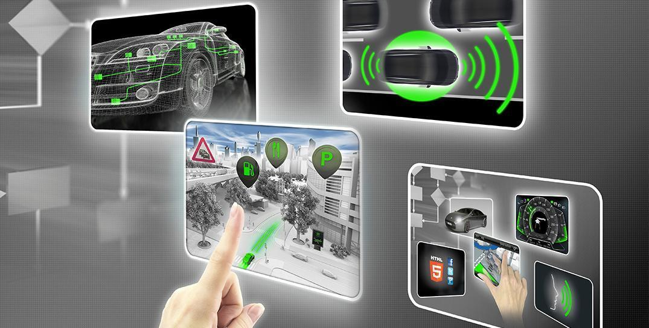

# 

# Document history

|  |  |  |  |
| --- | --- | --- | --- |
| Date | Version | Editor | Description |
| 2019-03-29 | 1.0 | Sergey Morozov | Completed all document sections |
|  |  |  |  |
|  |  |  |  |
|  |  |  |  |
|  |  |  |  |

# 

# 

# Table of Contents

**Document history** **2**

**Table of Contents** **3**

**Purpose of the Technical Safety Concept** **4**

**Inputs to the Technical Safety Concept** **5**

Functional Safety Requirements 5

Refined System Architecture from Functional Safety Concept 6

Functional overview of architecture elements 6

**Technical Safety Concept** **8**

Technical Safety Requirements 8

Refinement of the System Architecture 14

Allocation of Technical Safety Requirements to Architecture Elements 14

Warning and Degradation Concept 14

# 

# 

# Purpose of the Technical Safety Concept

The Technical Safety Concept looks at the technical implementation of the Item. The purpose of the Technical Safety Concept is to turn functional safety requirements into technical safety requirements and allocate those technical safety requirements to the system architecture. The Technical Safety Concept considers the system at a more technical level, thinks about sensors, control units, and actuators. Technical safety requirements are general hardware and software requirements but without getting into specific details.

# 

# Inputs to the Technical Safety Concept

## Functional Safety Requirements

|  |  |  |  |  |
| --- | --- | --- | --- | --- |
| **ID** | **Functional Safety Requirement** | **ASIL** | **Fault Tolerant Time Interval** | **Safe State** |
| Functional  Safety  Requirement  01-01 | The lane keeping item shall ensure that the lane departure oscillating torque amplitude is below Max_Torque_Amplitude. | C | 50 mS | The torque is zero. Warning displayed on the Car Display. |
| Functional  Safety  Requirement  01-02 | The lane keeping item shall ensure that the lane departure oscillating torque frequency is below Max_Torque_Frequency. | C | 50 mS | The torque is zero. Warning displayed on the Car Display. |
| Functional  Safety  Requirement  02-01 | The lane keeping item shall ensure that the lane keeping assistance torque is applied for only Max_Duration. | B | 500 mS | The torque is zero. Warning displayed on the Car Display. |

## Refined System Architecture from Functional Safety Concept

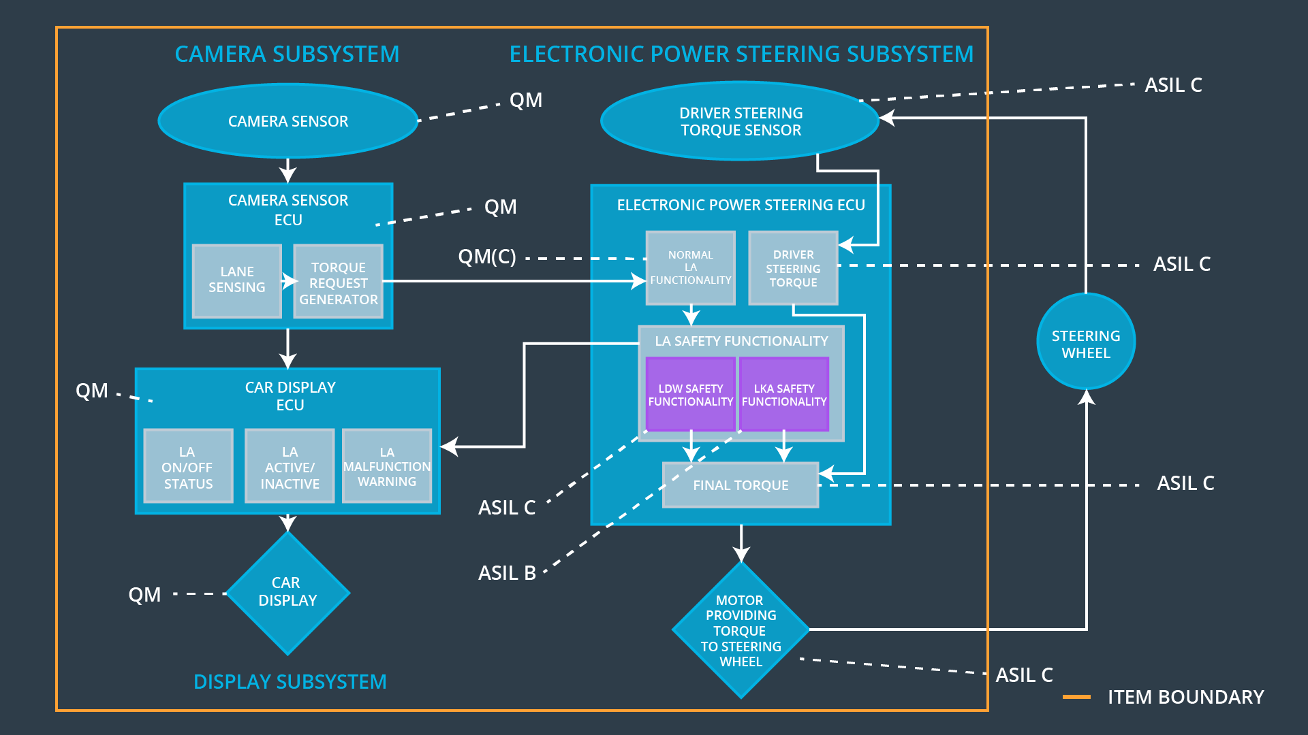

### Functional overview of architecture elements

|  |  |
| --- | --- |
| **Element** | **Description** |
| Camera Sensor | Captures images of the road. |
| Camera Sensor ECU - Lane Sensing | Detects lane lines on the road based on the camera images. |
| Camera Sensor ECU - Torque request generator | Generate torque requests based on the information provided by the Camera Sensor ECU - Lane Sensing when identifies that the vehicle accidentally departed its lane. |
| Car Display | Provides the driver with visual notifications about the current state of the lane assistance item. |
| Car Display ECU - Lane Assistance On/Off Status | Controls the On/Off status of the lane assistance system on the Car Display. |
| Car Display ECU - Lane Assistant Active/Inactive | Controls the Active/Inactive status of the lane assistance system on the Car Display. |
| Car Display ECU - Lane Assistance malfunction warning | Controls the malfunction warning notification of the lane assistance system on the Car Display. |
| Driver Steering Torque Sensor | Measures the steering torque applied by the driver to the steering wheel. |
| Electronic Power Steering (EPS) ECU - Driver Steering Torque | Receives the steering torque measured by the Driver Steering Torque Sensor and applies the appropriate amplification. |
| EPS ECU - Normal Lane Assistance Functionality | Converts the torque request received from the Camera Sensor ECU - Torque request generator into the appropriate torque request while not applying safety thresholds identified during the functional safety process. |
| EPS ECU - Lane Departure Warning Safety Functionality | Converts the torque requests received from the EPS ECU - Normal Lane Assistance Functionality into the LDW torque requests that respect maximum torque amplitude and frequency identified during the functional safety process and reports errors to the Car Display ECU - Lane Assistance malfunction warning. |
| EPS ECU - Lane Keeping Assistant Safety Functionality | Converts the torque requests received from the EPS ECU - Normal Lane Assistance Functionality into the LKA torque requests that respect maximum torque duration identified during the functional safety process and reports errors to the Car Display ECU - Lane Assistance malfunction warning. |
| EPS ECU - Final Torque | Combines torque requests from the EPS ECU - Lane Departure Warning Safety Functionality, EPS ECU - Lane Keeping Assistant Safety Functionality, and Electronic Power Steering (EPS) ECU - Driver Steering Torque and sends the result to the Motor. |
| Motor | Applies the torque to the steering wheel as it was determined by the Electronic Power Steering ECU. |

# Technical Safety Concept

## Technical Safety Requirements

**Lane Departure Warning (LDW) Requirements:**

Functional Safety Requirement 01-01 with its associated system elements

(derived in the functional safety concept):

|  |  |  |  |  |
| --- | --- | --- | --- | --- |
| **ID** | **Functional Safety Requirement** | **Electronic Power Steering ECU** | **Camera ECU** | **Car Display ECU** |
| Functional  Safety  Requirement  01-01 | The lane keeping item shall ensure that the lane departure oscillating torque amplitude is below Max_Torque_Amplitude. | X | **-** | **-** |

Technical Safety Requirements related to Functional Safety Requirement 01-01 are:

|  |  |  |  |  |  |
| --- | --- | --- | --- | --- | --- |
| **ID** | **Technical Safety Requirement** | **ASIL** | **Fault Tolerant Time Interval** | **Architecture Allocation** | **Safe State** |
| Technical  Safety  Requirement  01-01-01 | The LDW safety component shall ensure that the amplitude of the 'LDW_Torque_Request' sent to the 'Final electronic power steering Torque' component is below 'Max_Torque_Amplitude.' | C | 50 mS | LDW Safety | LDW is deactivated with appropriate notification on the Car Display. LDW_Torque_Request is set to zero. |
| Technical  Safety  Requirement  01-01-02 | As soon as the LDW function deactivates the LDW feature, the 'LDW Safety' software block shall send a signal ‘LDW_Error_Status’ to the Car Display ECU to turn on a warning light. | C | 50 mS | LDW Safety | LDW is deactivated with appropriate notification on the Car Display. LDW_Torque_Request is set to zero. |
| Technical  Safety  Requirement  01-01-03 | As soon as a failure is detected by the LDW function, it shall deactivate the LDW feature and the 'LDW_Torque_Request' shall be set to zero. | C | 50 mS | LDW Safety | LDW is deactivated with appropriate notification on the Car Display. LDW_Torque_Request is set to zero. |
| Technical  Safety  Requirement  01-01-04 | The validity and integrity of the data transmission for 'LDW_Torque_Request' signal shall be ensured. | C | 50 mS | Data Transmission Integrity Check | LDW is deactivated with appropriate notification on the Car Display. LDW_Torque_Request is set to zero. |
| Technical  Safety  Requirement  01-01-05 | Memory test shall be conducted at start up of the EPS ECU to check for any faults in memory. | A | Ignition cycle | Safety Startup (Memory Test) | LDW is deactivated with appropriate notification on the Car Display. LDW_Torque_Request is set to zero. |

Functional Safety Requirement 01-02 with its associated system elements

(derived in the functional safety concept):

|  |  |  |  |  |
| --- | --- | --- | --- | --- |
| **ID** | **Functional Safety Requirement** | **Electronic Power Steering ECU** | **Camera ECU** | **Car Display ECU** |
| Functional  Safety  Requirement  01-02 | The lane keeping item shall ensure that the lane departure oscillating torque frequency is below Max_Torque_Frequency. | X | **-** | **-** |

Technical Safety Requirements related to Functional Safety Requirement 01-02 are:

|  |  |  |  |  |  |
| --- | --- | --- | --- | --- | --- |
| **ID** | **Technical Safety Requirement** | **ASIL** | **Fault Tolerant Time Interval** | **Architecture Allocation** | **Safe State** |
| Technical  Safety  Requirement  01-02-01 | The LDW safety component shall ensure that the frequency of the 'LDW_Torque_Request' sent to the 'Final electronic power steering Torque' component is below 'Max_Torque_Frequency.' | C | 50 mS | LDW Safety | LDW is deactivated with appropriate notification on the Car Display. LDW_Torque_Request is set to zero. |
| Technical  Safety  Requirement  01-02-02 | As soon as the LDW function deactivates the LDW feature, the 'LDW Safety' software block shall send a signal ‘LDW_Error_Status’ to the Car Display ECU to turn on a warning light. | C | 50 mS | LDW Safety | LDW is deactivated with appropriate notification on the Car Display. LDW_Torque_Request is set to zero. |
| Technical  Safety  Requirement  01-02-03 | As soon as a failure is detected by the LDW function, it shall deactivate the LDW feature and the 'LDW_Torque_Request' shall be set to zero. | C | 50 mS | LDW Safety | LDW is deactivated with appropriate notification on the Car Display. LDW_Torque_Request is set to zero. |
| Technical  Safety  Requirement  01-02-04 | The validity and integrity of the data transmission for 'LDW_Torque_Request' signal shall be ensured. | C | 50 mS | Data Transmission Integrity Check | LDW is deactivated with appropriate notification on the Car Display. LDW_Torque_Request is set to zero. |
| Technical  Safety  Requirement  01-02-05 | Memory test shall be conducted at start up of the EPS ECU to check for any faults in memory. | A | Ignition cycle | Safety Startup (Memory Test) | LDW is deactivated with appropriate notification on the Car Display. LDW_Torque_Request is set to zero. |

**Lane Keeping Assistance (LKA) Requirements:**

Functional Safety Requirement 02-01 with its associated system elements

(derived in the functional safety concept):

|  |  |  |  |  |
| --- | --- | --- | --- | --- |
| **ID** | **Functional Safety Requirement** | **Electronic Power Steering ECU** | **Camera ECU** | **Car Display ECU** |
| Functional  Safety  Requirement  02-01 | The lane keeping item shall ensure that the lane keeping assistance torque is applied for only Max_Duration. | X | - | - |

Technical Safety Requirements related to Functional Safety Requirement 02-01 are:

|  |  |  |  |  |  |
| --- | --- | --- | --- | --- | --- |
| **ID** | **Technical Safety Requirement** | **ASIL** | **Fault Tolerant Time Interval** | **Architecture Allocation** | **Safe State** |
| Technical  Safety  Requirement  02-01-01 | The LKA safety component shall ensure that the duration of the 'LKA_Torque_Request' sent to the 'Final electronic power steering Torque' component is no longer than 'Max_Duration.' | B | 500 mS | LKA Safety | LKA is deactivated with appropriate notification on the Car Display. LKA_Torque_Request is set to zero. |
| Technical  Safety  Requirement  02-01-02 | As soon as the LKA function deactivates the LKA feature, the 'LKA Safety' software block shall send a signal ‘LKA_Error_Status’’ to the Car Display ECU to turn on a warning light. | B | 500 mS | LKA Safety | LKA is deactivated with appropriate notification on the Car Display. LKA_Torque_Request is set to zero. |
| Technical  Safety  Requirement  02-01-03 | As soon as a failure is detected by the LKA function, it shall deactivate the LKA feature and the 'LKA_Torque_Request' shall be set to zero. | B | 500 mS | LKA Safety | LKA is deactivated with appropriate notification on the Car Display. LKA_Torque_Request is set to zero. |
| Technical  Safety  Requirement  02-01-04 | The validity and integrity of the data transmission for 'LKA_Torque_Request' signal shall be ensured. | B | 500 mS | Data Transmission Integrity Check | LKA is deactivated with appropriate notification on the Car Display. LKA_Torque_Request is set to zero. |
| Technical  Safety  Requirement  02-01-05 | Memory test shall be conducted at start up of the EPS ECU to check for any faults in memory. | A | Ignition cycle | Safety Startup (Memory Test) | LKA is deactivated with appropriate notification on the Car Display. LKA_Torque_Request is set to zero. |

## Refinement of the System Architecture

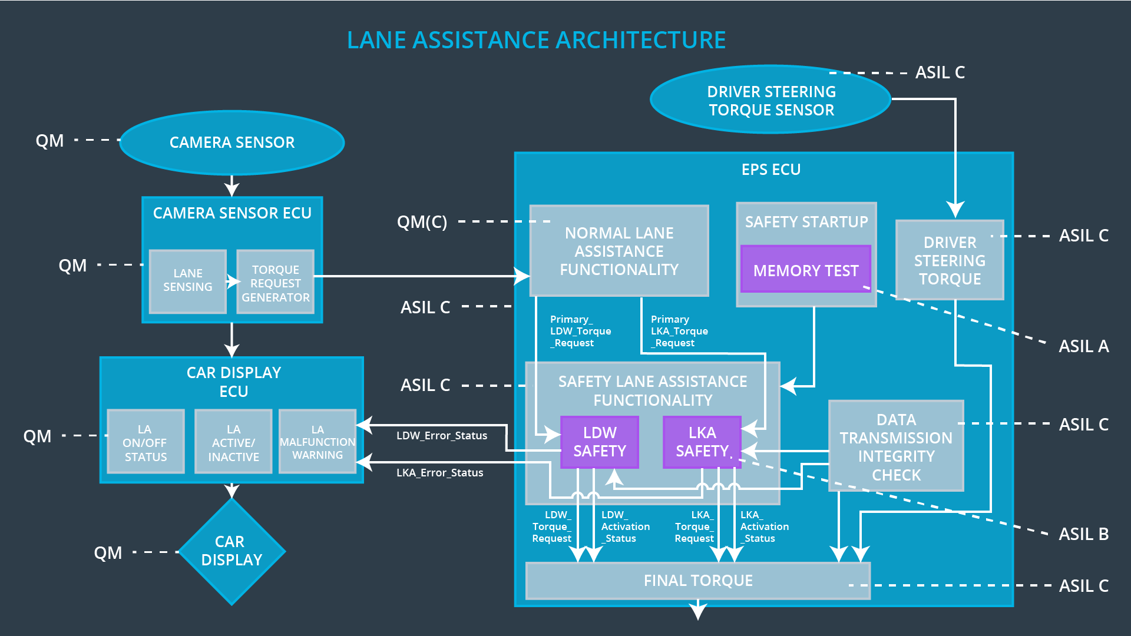

## Allocation of Technical Safety Requirements to Architecture Elements

All technical safety requirements are allocated to the Electronic Power Steering ECU.

## Warning and Degradation Concept

|  |  |  |  |  |
| --- | --- | --- | --- | --- |
| **ID** | **Degradation Mode** | **Trigger for Degradation Mode** | **Safe State invoked?** | **Driver Warning** |
| WDC-01 | Turn off LDW function. | Malfunction_01, Malfunction_02 | Yes | Warning displayed on the Car Display |
| WDC-02 | Turn off LKA function. | Malfunction_03 | Yes | Warning displayed on the Car Display. |