User Guide For Palo PDI's Plugin FOR PDI 3.x branch

Presentation Palo
Palo is an opensource MOLAP server

Plugin SISP4IPOC

- Presentation
« SISP4IPOC Is a Simple Plugin For Insert into Palo's OLAP's Cube »

- Use JAVA API provide by Tensegrity ( Jpalo.net ) under GPL
- Connection is provided by a native C-API

- Goal
  - Inserts datas
  - Create new database in Palo server
  - Create new Dimension in a database Palo
  - Create new cube in a database Palo
  - Insert data in many cube at the same time
  - Create consolidation ( aggregate values )

- Configuration
  - Menu PDI

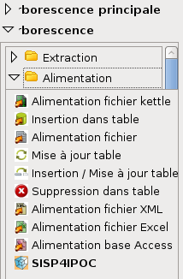

- Edition

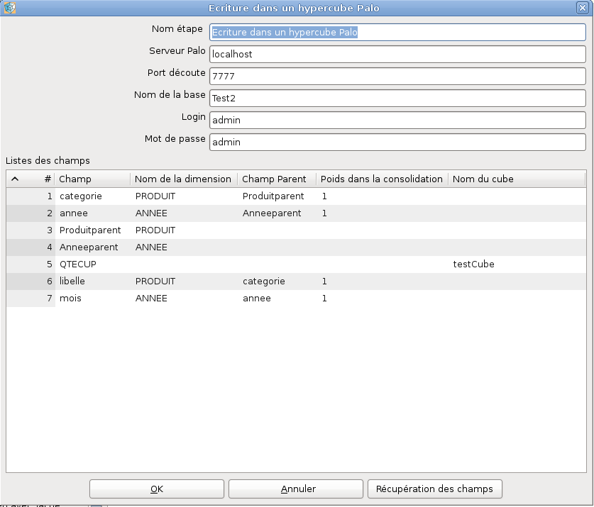

Column « Fields » is arriving flow

Column « Dimension Name » is the name of the dimension where the field will be added. ( EX : PRODUIT, ANNEE)
WARNING : if this column is empty, it is the value field and « cube Name » column must be filled (name of the cube where data are saved ) ( EX : QTECUP with testCube as cube )

Column « Parent Field » indicate if this field is a child of a consolidated value.
If this column is empty, the field is a root value in its dimension. ( EX : Produitparent)
Else it must reference a field (Ex : categorie references Produitparent) and must have a weight Value ( floating value)

If database, dimensions or cubes didn't exist in Palo server, then they will be created.

Others :
- values field are cast into Float : non-stopping exception is generate if casting error
- Only support numeric value as « Value Field » ( but dimension values can be String )

