**Installing GitLab Runner on Ubuntu and CentOS**

[Sean Bradley](https://sean-bradley.medium.com/?source=post_page-----80f3a2de0290--------------------------------)

[Sean Bradley](https://sean-bradley.medium.com/?source=post_page-----80f3a2de0290--------------------------------)

[May 7, 2020·1 min read](https://sean-bradley.medium.com/installing-gitlab-runner-on-ubuntu-and-centos-80f3a2de0290?source=post_page-----80f3a2de0290--------------------------------)

Step 1

Add the GitLab official repository to your servers package manager.

Debian/Ubuntu

curl -L <https://packages.gitlab.com/install/repositories/runner/gitlab-runner/script.deb.sh> | sudo bash

RHEL/CentOS

curl -L <https://packages.gitlab.com/install/repositories/runner/gitlab-runner/script.rpm.sh> | sudo bash

Step 2

Install the GitLab Runner service.

Debian/Ubuntu

sudo apt-get install gitlab-runner

RHEL/CentOS

sudo yum install gitlab-runner

Step 3

Test that the GitLab Runner is running

Debian/Ubuntu/RHEL/Centos

sudo service gitlab-runner status

https://miro.medium.com/max/30/1*9G6q9xcdce_ZSXUJA9iA9w.png?q=20

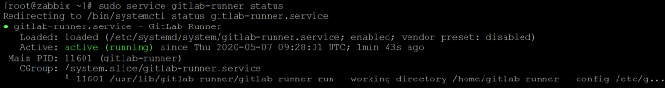

GitLab Runner is running successfully

Step 4

Now you can use your new GitLab Runner. See my article on setting up CI/CD for a full stack app with GitLab runner, at